**K**ONGU **A**RTS AND **S**CIENCE **C**OLLEGE

(AUTONOMOUS)

 DEPARTMENT OF **C**OMPUTER **S**CIENCE (UG)

DATE: 23.06.2016

***NEWS WORLD­***

**Infosys Finacle to power Paytm banking**

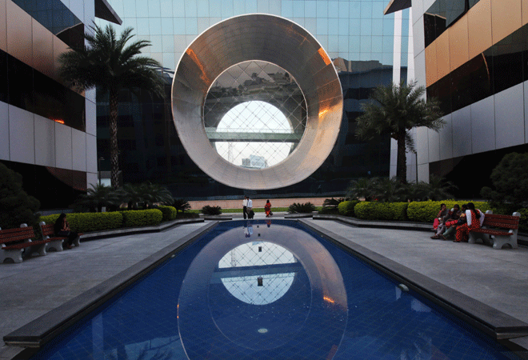

Software [firm Infosys](http://www.businesstoday.in/current/corporate/infosys-bets-big-on-blockchain-technology/story/231480.html) would provide its core banking solution Finacle to e-commerce platform Paytm for its payments bank business, the firm said. "Paytm will leverage Finacle for its deposit products and payments platform, enabling it to roll out innovative offerings," the outsourcing firm said. The flagship banking product is part of the [company](http://www.businesstoday.in/current/corporate/govt-clears-infosys-proposal-to-set-up-sez-in-bengaluru/story/232200.html) 's subsidiary EdgeVerveSystems.

The application programme interfaces of Finacle will enable Paytm to integrate payments bank services to its wallet business at a reduced cost and simplify its banking operations."Our premier product will enable Paytm to offer a bouquet of current account and savings-based products and services, besides wallet offering," the statement noted.Finacle's scalability will allow Paytm to meet growth needs and manage expansion in the scale of its operations."We have chosen Finacle as it is a scalable solution for small value, high volume transactions for millions of customers," Paytm Chief Executive Shinjini Kumar said.With 126-million user base across the country, Paytm is on a mission to put half-a-million citizens on way to use mobile payment banking services cost-effectively."Payments banks are set to revolutionise banking space, helping the un-banked and under-banked. Paytm also pioneered the growth of mobile payments and e-commerce in the country," EdgeVerve President Andy Deysai

http://www.kasc.ac.in/images/kvittlarge.gif**STAFF INCHARGE SUBMITTED BY**

Mr. D. Gopinath AGILAN. M

**K**ONGU **A**RTS AND **S**CIENCE **C**OLLEGE

(AUTONOMOUS)

 DEPARTMENT OF **C**OMPUTER **S**CIENCE (UG)

DATE:11.07.2017

***NEWS WORLD­***

**Threading the way to touch-sensitive robots.**

Fabrics containing flexible electronics are appearing in many novel products, such as clothes with in-built screens and solar panels. More impressively, these fabrics can act as electronic skins that can sense their surroundings and could have applications in robotics and prosthetic medicine. Now developed smart threads that detect the strength and location of pressures exerted on them.

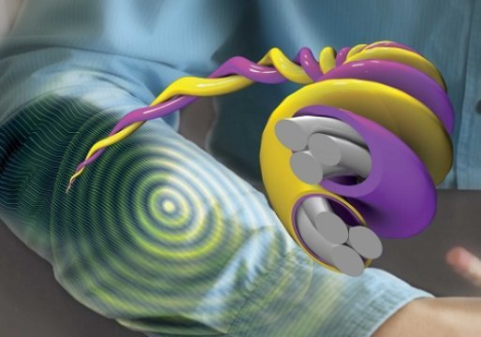

Most flexible sensors function by detecting changes in the electrical properties of materials in response to pressure, temperature, humidity or the presence of gases. Electronic skins are built up as arrays of several individual sensors. These arrays currently need complex wiring and data analysis, which makes them too heavy, large or expensive for large-scale production. Smart threads made from cotton threads coated with layers of one of the miracle materials of nanotechnology: single-walled carbon nanotubes. The researchers showed their threads had decreased resistance when subjected to stronger mechanical strains, and crucially the amplitude of the resistance change also depended on the thickness of the SWCNT coating.These findings led the researchers to their biggest breakthrough: they developed threads of graded thickness with a thick SWCNT layer at one end tapering to a thin layer at the other end. Then, by combining threads in pairs -- one with graded thickness and one of uniform thickness -- the researchers could not only detect the strength of an applied pressure load, but also the position of the load along the threads. The researchers have used their smart threads to build two- and three-dimensional arrays. We hope that electronic skins made from our smart threads could benefit any robot or medical prosthetic in which pressure sensing is important, such as artificial hands.

http://www.kasc.ac.in/images/kvittlarge.gif**STAFF INCHARGE SUBMITTED BY**

Mr. D. Gopinath S.Angukarthikeyan

**K**ONGU **A**RTS AND **S**CIENCE **C**OLLEGE

(AUTONOMOUS)

 DEPARTMENT OF **C**OMPUTER **S**CIENCE (UG)

DATE: 11.08.2016

***NEWS WORLD­***

**Scientists amplify light using sound on a silicon chip**

Yale scientists have found a way to greatly boost the intensity of light waves on a silicon microchip using the power of sound. Peter Rakich describes a new waveguide system that harnesses the ability to precisely control the interaction of light and sound waves. This work solves a long-standing problem of how to utilize this interaction in a robust manner on a silicon chip as the basis for powerful new signal-processing technologies.

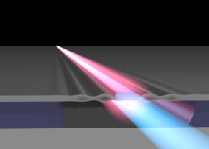

The prevalence of silicon chips in today's technology makes the new system particularly advantageous, the researchers note. Silicon is the basis for practically all microchip technologies. The ability to combine both light and sound in silicon permits us to control and process information in new ways that weren't otherwise possible .The combining of the two capabilitiesis like giving a UPS driver an amphibious vehicle -- you can find a much more efficient route for delivery when traveling by land or water. These opportunities have motivated numerous groups around the world to explore such hybrid technologies on a silicon chip. However, progress was stifled because those devices weren't efficient enough for practical applications. The Yale group lifted this roadblock using new device designs that prevent light and sound from escaping the circuits.Figuring out how to shape this interaction without losing amplification was the real challenge.With precise control over the light-sound interaction, we will be able to create devices with immediate practical uses, including new types of lasers. The researchers said there are commercial applications for the technology in a number of areas, including fiber-optic communications and signal processing. The system is part of a larger body of research the Rakich lab has conducted for the past five years, focused on designing new microchip technologies for light.Heedeuk Shin, a former member of the Rakich lab who is now a professor at the Pohang University of Science and Technology in Korea, is the study's other co-author. We're glad to help advance these new technologies, and are very excited to see what the future holds.

http://www.kasc.ac.in/images/kvittlarge.gif**STAFF INCHARGE SUBMITTED BY**

Mr. D. Gopinath J.Balaji.





-- **K**ONGU **A**RTS AND **S**CIENCE **C**OLLEGE

(AUTONOMOUS)

 DEPARTMENT OF **C**OMPUTER **S**CIENCE (UG)

DATE : 02.09.2016

***NEWS WORLD­***

**Robotic Tubular Steel Building Construction**

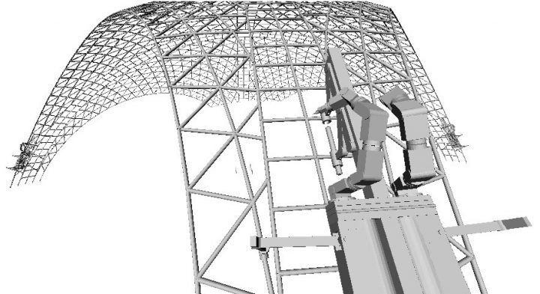

For some time robots have been put to work in factories to manufacture many of the products we use. Right now Revcad Ltd, a specialised engineering CAD software company based in the UK, look set to open a whole new chapter on robotic manufacture by developing their software to manufacture and erect spectacular tubular steel buildings.This means huge robots, that look like giant ants or termites, are fitted with a car size electric battery and unleashed from their moorings to climb and build these structures. The robots are used to cut and manufacture the tubes, and then climb the structure, carrying the tubes, with on-board welding equipment to actually erect the building, setting each tube steel component in place one by one.For decades now Revcad have been developing complex geometrical software for design and manufacture in the sheet metal and construction steel industries. Their software is used around the world by many companies ranging from the small metal shops to the large corporates, often as the very basis of their business. At the same time, over this period, Revcad have often taken on major contractual challenges for clients developing software for complex mechanisms, such as the virtual design and analysis of engines and gearboxes for the automotive industry

http://www.kasc.ac.in/images/kvittlarge.gif**STAFF INCHARGE SUBMITTED BY**

Mr. D. Gopinath BALAKRISHNAN.M

-- **K**ONGU **A**RTS AND **S**CIENCE **C**OLLEGE

(AUTONOMOUS)

 DEPARTMENT OF **C**OMPUTER **S**CIENCE (UG)

DATE :04.10.2016

***NEWS WORLD­***

**FREE DATA VISUALIZATION WITH MICROSOFT POWER.**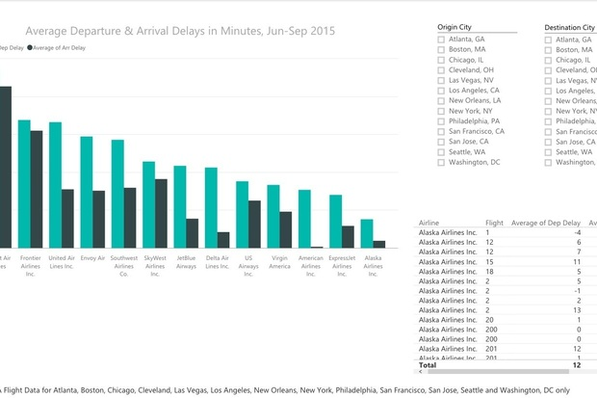

Microsoft has jumped into the free, self-service data analysis space with Power BI offers basic data wrangling capabilities similar to Excel's Power Query. It also lets you create interactive visualizations, reports and dashboards with a few clicks or drag-and-drops; type natural-language questions about your data on a dashboard; and handle files that are too large for Excel. This unlocked, multi-mode phone will work on all US carriers including AT&T, Verizon, T-Mobile and...It can work with dozens of data types -- not only Excel, Access and CSV files, but also Salesforce, Google Analytics, MailChimp, GitHub, QuickBooks Online and dozens of others. And, it will run R scripts -- meaning that any data you can pull in and massage via R you can import into Power BI.A guide to Power BI In this article, I've put together a step-by-step guide to starting with Power BI includes both a downloadable desktop program and a cloud service, each of which offers different but overlapping capabilities. Data wrangling is desktop-only; visualizations and reports can be created in either; dashboards and report sharing are cloud-only. In addition, there are mobile apps for iOS, Android and Windows that let you view your Power BI or  reports and dashboards.At least for now, you can take advantage of most Power BI capabilities without paying -- although Microsoft is clearly betting that you'll like the basic cloud service enough to spring for a $9.99/month paid account. Chief benefits of the paid account are increased data storage

http://www.kasc.ac.in/images/kvittlarge.gif**STAFF INCHARGE SUBMITTED BY**

Mr. D. Gopinath JANANI.S

 **K**ONGU **A**RTS AND **S**CIENCE **C**OLLEGE

(AUTONOMOUS)

 DEPARTMENT OF **C**OMPUTER **S**CIENCE (UG)

DATE :21.02.2017

***NEWS WORLD­***

**AMD mulls a CPU+GPU super-chip in a server reboot**

**[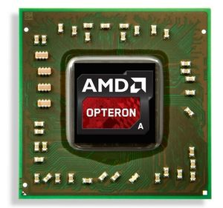](http://www.itnews.com/article/3099188/amd-mulls-a-cpugpu-super-chip-in-a-server-reboot.html)**

AMD emerged as a serious threat to Intel in servers more than a decade ago, but after a series of missteps and bad chips, the company's server business is hanging on by a thread.Now, AMD is rebooting its server chip business with the upcoming Zen CPU, which will also be used in PCs. AMD is getting creative with Zen and considering merging the CPU with a high-performance GPU to create a mega-chip for high-performance tasks.Now, AMD is rebooting its server chip business with the upcoming Zen CPU, which will also be used in PCs. AMD is getting creative with Zen and considering merging the CPU with a high-performance GPU to create a mega-chip for high-performance tasks."It's fair to say we do believe we can combine a high-performance CPU with the high-performance GPU," AMD CEO Lisa Su said during an earnings call on Thursday.Su's comment was in response to a question on whether AMD would ultimately combine its Zen CPU with a GPU based on the upcoming Vega architecture into one big chip for enterprise servers and supercomputing."Obviously, it'll come in time," Su said. "It's an area where combining the two technologies makes a lot of sense."It wouldn't be the first time AMD has built a mega-chip. It has already combined full-featured CPUs and GPUs on made-to-order chips for the Xbox One and PlayStation 4 gaming consoles. The 5-billion transistor Xbox One chip uses an eight-core AMD CPU code-named Jaguar and a Radeon graphics processor.GPUs are being used as co-processors in some of the world's fastest computers for tasks like weather modeling, economic forecasting, and weapons design. They are also used by Google in data centers for deep learning tasks. Nvidia has cornered the supercomputing space while AMD has struggled with its FirePro high-performance GPUs.

http://www.kasc.ac.in/images/kvittlarge.gif**STAFF INCHARGE SUBMITTED BY**

Mr. D. Gopinath SRI MATHI. S

-- **K**ONGU **A**RTS AND **S**CIENCE **C**OLLEGE

(AUTONOMOUS)

 DEPARTMENT OF **C**OMPUTER **S**CIENCE (UG)

DATE :08.03.2017

***NESWS WORLD­***

**Apple Car launch date slips back a year to 2021**

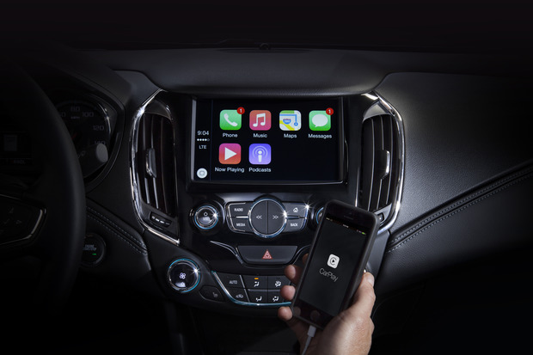

Apple has not confirmed if it’s even working on a car, but rumors continue to come out at full speed. This week, [The Information](https://www.theinformation.com/at-apple-the-sumner-boys-help-build-a-car?unlock=LiYv8HF-q-4&token=PCKtziUB-ZwV4-k8z1Y7oQ)revealed that [Apple’s forthcoming car](http://www.macworld.com/article/3003139/car-tech/what-can-you-expect-from-the-much-rumored-apple-car.html) has been pushed back to launch in 2021. The original rumors claimed that Apple hoped to have its Apple Car on the road by 2020. According to The Information*,* Apple’s super-secret team working on the car, known internally as Project Titan, has faced some roadblocks putting a vehicle together. Project Titan’s top executive left back in January.  The delay, which was also reported by [9to5Mac](http://9to5mac.com/2016/07/21/apple-car-intro-date/), was briefly mentioned in The Information’s profile of the three Sumner brothers, Apple engineers who all worked together on the Siri team before transferring to Project Titan. **Why this matters:** Apple hasn’t even acknowledge that the company is getting into the auto industry, so not much has been confirmed about Apple Car. We’re not even sure if it will be electric or self-driving. What we do know is that it has been a bumpy road for Project Titan. Even though Apple seemed to be making headway last year—[filing permits to build a “auto work area”](http://www.macworld.com/article/2896754/the-latest-apple-car-evidence-building-permits-and-a-mysterious-company.html) near Cupertino, [leasing a drive-testing facility](http://www.macworld.com/article/2971227/car-tech/apple-car-accelerates-as-cupertino-reportedly-seeks-a-testing-facility.html), [meeting with the California DMV](http://www.macworld.com/article/2984879/car-tech/apple-meets-with-california-dmv-hinting-that-public-car-tests-could-happen-soon.html), hiring a bunch of experts in self-driving tech, and [registering apple.auto and apple.car](http://www.macworld.com/article/3020484/car-tech/apple-registers-applecar-and-appleauto-fueling-rumors-about-electric-car.html)—the Apple Car is a big enough project that delays are inevitable. At the very beginning, Apple was aiming for a 2019 launch date. That slipped to 2020 and now it seems we’ll be waiting another year.

.

http://www.kasc.ac.in/images/kvittlarge.gif**STAFF INCHARGE SUBMITTED BY**

Mr. D. Gopinath VIGNESH.P