KONGU ARTS AND SCIENCE COLLEGE
DEPARTMENT OF COMPUTER SCIENCE (UG)
IT-NEWS WORLD
DATE: 28.06.12
HISTORY OF MOBILE PHONES:
The history of mobile phones charts improvements to communication devices which connect wirelessly to the public switched telephone network. The transmission of speech by radio has a long and varied history going back to Reginald Fessenden’s invention and shore-to-ship demonstration of radio telephony. In the United States, engineers from Bell Labs began work on a system to allow mobile users to place and receive telephone calls from automobiles, leading to the inauguration of mobile service on 17 June 1946 in St. Louis, Missouri. Shortly after, AT&T offered Mobile Telephone Service. A wide range of mostly incompatible mobile telephone services offered limited coverage area and only a few available channels in urban areas. The introduction of cellular technology, which allowed re-use of frequencies many times in small adjacent areas covered by relatively low powered transmitters, made widespread adoption of mobile telephones economically feasible.
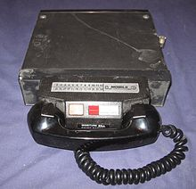
The advances in mobile telephony can be traced in successive generations from the early "0G" services like MTS and its successor Improved Mobile Telephone Service, to first generation (1G) analog cellular network, second generation (2G) digital cellular networks, third generation (3G) broadband data services to the current state of the art, fourth generation (4G) native-IP networks.
STAFF INCARGE SUBMITTED BY,
E.ARTHI
K.G SANTHIYA II Bsc CS (A)
KONGU ARTS AND SCIENCE COLLEGE
DEPARTMENT OF COMPUTER SCIENCE (UG)
IT-NEWS WORLD
DATE: 04.07.12

Google+ is not a social network, says Google exec
Computerworld - A year after Google+ was launched, it seems Google is saying it's not really a social network after all.
Now this might be confusing to the 150 million people who actively use Google+ every month. They catch up with colleagues and friends on Google+ Circles. They chat with family members in Google+ Hangouts. They post photos. They watch videos.
So aren't those the things you do on a social network? Google has other thoughts on this.
According to a report from Mashable, Vic Gundotra, Google's senior vice president of social business, and Bradley Horowitz, Google+'s vice president of product, said Google+ may be social, but it's more than that. Instead of a social network, Google+ is an upgrade to all Google products.
"Google+ is just an upgrade to Google," Gundotra told Mashable. "People have a hard time understanding that. I think they like to compare us with other social competitors, and they see us through that lens instead of really seeing what's happening: Google is taking its amazing products, and by bringing them together, they just become more awesome."
STAFF INCARGE SUBMITTED BY,
T.AMUTHAN,
K.G SANTHIYA II Bsc CS (B).
KONGU ARTS AND SCIENCE COLLEGE
DEPARTMENT OF COMPUTER SCIENCE (UG)
IT-NEWS WORLD
DATE: 01.08.12

Windows 8

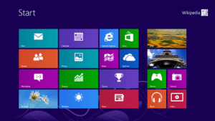

Windows 8 is a version of Microsoft Windows (an operating system developed by Microsoft) for use on personal computers, including home and business desktops, laptops, tablets, and home theater PCs. Development of Windows 8 started before the release of its predecessor, Windows 7, in 2009. It was announced at CES 2011, and followed by the release of three pre-release versions from September 2011 to May 2012. The operating system was released to manufacturing on August 1, 2012, and was released for general availability on October 26, 2012

In addition, Windows 8 takes advantage of new or emerging technologies like USB 3.0, 4Kn Advanced Format, near field communications, cloud computing, and the low-power ARM architecture. It includes new security features such as built-in antivirus capabilities, a new installation process optimized for digital distribution, and support for secure boot (a UEFI feature which allows operating systems to be digitally signed to prevent malware from altering the boot process). Synchronization of certain apps and settings between multiple devices is supported.

Windows 8.1 is scheduled for release in late 2013 and, according to Microsoft, will change "key aspects" of how Windows 8 is used, including the reinstatement of the Start button.
STAFF INCARGE SUBMITTED BY,
S.KIRUTHIKA,
K.G SANTHIYA III Bsc CS (B).
KONGU ARTS AND SCIENCE COLLEGE
DEPARTMENT OF COMPUTER SCIENCE (UG)
IT-NEWS WORLD
DATE: 03.09.12

Face book to allow apps to send notifications directly to users
IDG News Service - Facebook is tweaking its development platform to allow third-party applications to communicate directly with their users by sending notifications to their profiles.
A new Notifications API (application programming interface), now in beta testing, will allow developers to send "short, custom" messages to users of their Facebook applications.
"Notifications are a great way to re-engage users by informing them of important events, invites from friends, or actions they need to take in your app," wrote Facebook official Bo Zhang in a blog post on Friday.
Once a Facebook user has linked an application to their account, the application will be able to generate these notifications without additional permissions from the users.
However, users have the option to decline notifications, and opt out of receiving them altogether, according to Zhang.
Facebook advises developers to monitor and analyze data on the notifications they send via their Insights dashboard, which will show how often notifications are accepted, declined and completely turned off by users.
"You should watch Insights closely to make sure your notifications are well received by users and not in danger of being shut-off," Zhang wrote.
STAFF INCARGE SUBMITTED BY,
R.JAGADESAN,
K.G SANTHIYA II Bsc CS (B).

KONGU ARTS AND SCIENCE COLLEGE
DEPARTMENT OF COMPUTER SCIENCE (UG)
IT-NEWS WORLD
DATE: 03.10.12
CLOUD COMPUTING
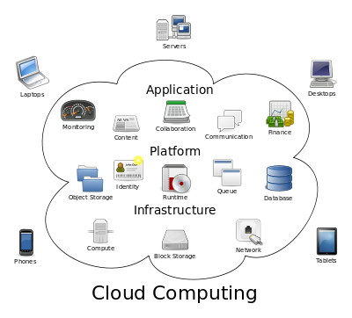
Cloud computing is a colloquial expression used to describe a variety of different types of computing concepts that involve a large number of computers that are connected through a real-time communication network (typically the Internet).^{[1]} Cloud computing is a jargon term without a commonly accepted non-ambiguous scientific or technical definition. In science, cloud computing is a synonym for distributed computing over a network and means the ability to run a program on many connected computers at the same time. The popularity of the term can be attributed to its use in marketing to sell hosted services in the sense of application service provisioning that run client server software on a remote location.
Cloud computing relies on sharing of resources to achieve coherence and economies of scale similar to a utility (like the electricity grid) over a network. At the foundation of cloud computing is the broader concept of converged infrastructure and shared services.
STAFF INCARGE SUBMITTED BY,
C.GOKUL
K.G SANTHIYA II Bsc CS (A)

KONGU ARTS AND SCIENCE COLLEGE
DEPARTMENT OF COMPUTER SCIENCE (UG)
IT-NEWS WORLD
DATE: 21.01.13

Windows Phone 8

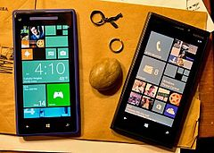
Windows Phone 8 is the second generation of the Windows Phone mobile operating system from Microsoft. It was released on October 29, 2012, and like its predecessor, it features the interface known as Metro (or Modern UI).
Windows Phone 8 replaces its CE-based architecture used on Windows Phone 7 devices with the Windows NT kernel found on many Windows 8 components. Current Windows Phone 7.x devices cannot run or update to Windows Phone 8 and new applications compiled specifically for Windows Phone 8 are not made available for Windows Phone 7.x devices
\Windows Phone 8 is the first mobile OS from Microsoft to use the Windows NT kernel, which is the same kernel that runs Windows 8. The operating system adds improved file system, drivers, network stack, security components, media and graphics support. Using the NT kernel, Windows Phone can now support multi-core CPUs of up to 64 cores, as well as 1280x720 and 1280x768 resolutions, in addition to the base 800x480 resolution already available on Windows Phone 7. Furthermore, Windows Phone 8 also adds support for MicroSD cards, which are commonly used to add extra storage to phones.
STAFF INCARGE SUBMITTED BY,
S.ANITHA,
K.G SANTHIYA III Bsc CS (B)
KONGU ARTS AND SCIENCE COLLEGE
DEPARTMENT OF COMPUTER SCIENCE (UG)
IT-NEWS WORLD
DATE: 14.02.13
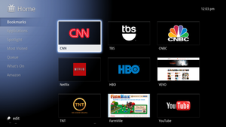
Google TV is a Smart TV platform from Google co-developed by Intel, Sony, and Logitech that was launched in October 2010. Google TV initially, with official devices from Sony and Logitech. Google TV integrates the Google Chrome browser to create an interactive television overlay on top of existing Internet television and WebTV sites to add a 10-foot user interface.
Google TV's first generation devices were created and commercialized by Sony and Logitech. The first generation of devices were based on x86 architecture processor by Intel. For the second generation of devices new partners have joined, including LG, Samsung, Vizio, and Hisense, some of which include 3D capabilities. The second generation of Google TV devices are based on ARM architecture processors.
In 2013, more Google TV supported devices were announced by Hisense, Netgear, TCL, and Asus.
Xyologic has compiled a list of the early Google TV apps with the largest number of installations. As of November 2012, the most installed apps are Napster, Pandora Radio, and CNBC.
STAFF INCARGE SUBMITTED BY,
S.SUSHIL,
K.G SANTHIYA II Bsc CS (A)

KONGU ARTS AND SCIENCE COLLEGE
DEPARTMENT OF COMPUTER SCIENCE (UG)
IT-NEWS WORLD
DATE: 06.03.13
ANDROID
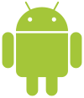
Android is a Linux-based operating system designed primarily for touch screen mobile devices such as smart phones and tablet computers. Initially developed by Android, Inc., which Google backed financially and later bought in 2005, Android was unveiled in 2007 along with the founding of the Open Handset Alliance: a consortium of hardware, software, and telecommunication companies devoted to advancing open standards for mobile devices. The first Android-powered phone was sold in October 2008.
Android is open source and Google releases the code under the License. This open source code and permissive licensing allows the software to be freely modified and distributed by device manufacturers, wireless carriers and enthusiast developers. Additionally, Android has a large community of developers writing applications ("apps") that extend the functionality of devices, written primarily in a customized version of the Java programming language. In October 2012, there were approximately 700,000 apps available for Android, and the estimated number of applications downloaded from Google Play, Android's primary app store, was 25 billion\

STAFF INCARGE SUBMITTED BY,
S.YAMINI DEVI,
K.G SANTHIYA I Bsc CS (B

