Under About

VISION
❖ To bring students to the enquiry mode so as to develop qualities of questioning, reflecting and understanding instead of accepting, reading and memorizing.
❖ To empower student’s through leadership, advocacy and support.

MISSION
❖ Providing teaching excellence and support services and enabling students to have opportunity to succeed.
❖ Incorporating innovative and creative methods and processes in student’s curricular activities.
❖ Ensuring academic freedom and freedom of speech during student’s activities.

Courses Offered
- B.Sc (Biotechnology), 3 years; Full Time

Eligibility : A pass in +2 with subjects having Physics, Chemistry, Biology, Botany, Zoology, Microbiology, Biochemistry & Environmental science

Subjects covered: Biochemistry, Cell Biology, Microbiology, Genetics,Bio - instrumentation, Genetic Engineering, Recombinant DNA technology, Immunology, Microbial Biotechnology, Environmental Biotechnology, Biology of cloning vectors & Medical Biotechnology

Intake
50

Value Added Course
- Medical Laboratory Techniques

Under Features

Laboratory and Equipment

- The Department has independent laboratory fully equipped with instruments
- It caters the student's need to make them familiar with basic techniques.
- Our laboratory aims to offer necessary technical inputs and to provide the students with basic knowledge and skills in application-oriented experiments in biosciences.
- Our laboratory constitutes main lab with
- Working area,
- Instrumentation Room,
- Culture Room,
- Cold Room,
- Store Room and
- Utility Room

- Sophisticated Equipments like

- Walk in Cold room
- Refrigerated High Speed Centrifuge
- Deep Freezer (-20ºC)
- UV Spectrophotometer
- Ice flakes machine
- Shaker Incubator
- Western Blotting Apparatus
- Autoclave
More (link- Annexure I)

Department library
- Apart from the main library, the Department has a separate library
- It is equipped with nearly 100 text books and are updated regularly with latest books according to students curriculum

Book details (link – Annexure ii)

Under Activities
One of the necessary and vital aims of the department is to guide the students for their better future. To meet the goal, the department organizes Seminars, Workshops, Industrial Visits, Training programme and Placement training.

DATE | PARTICULARS | CHIEF GUEST
28/08/08 | Department association inauguration | Dr. Girija, Department of Biotehnology, Bharathiar University, Coimbatore
28/07/09 | Department association Inauguration | Dr. A. Celestine Rajmanohar, Dena, Perundurai Medical College and Hospital, Perundurai
17/08/09 & 18/08/09 | Personality Development Programme | Ms. Akalya, JCI, Traineer
31/08/09 | Guest Lecture | Dr. Francois Malherbe, Associate Dean and Falcuty of Life Science and Social Science, Swinburne University of Technology, Melbourne
06/08/10 | Department association Inauguration | Mr.M. Chandramohan, M. Tech, Micorcore Research Lab, Erode
30/08/10 | Workshop | Mr. S. Boopathy, EASMA Institute of technology, Karur
23/09/10 | Industrial visit | Central Marine Fisheries Research Institute (CMFRI), Cochin
26/12/10 | Guest Lecture | Dr. Sathyamoorthi Perumal, Ph.D., Managing Partner and Technical Director, Vinzi Sperri – Coimbatore.
12/07/11 | Department Association Inauguration | Dr. K. R. Rajesh, Professor, Department of Microbiology, Vinayaka Mission Kirupanandha Variyar Medicall College, Salem
04 & 05/08/11 | Training on Lab Instrumentation handling | Mr. Dinesh, Co-ordinator, KL Institute of Technology, Coimbatore
19 & 20/08/11 | Personality Development Programme | Mr. J. Deenadayalan, Traineer, JCI, Erode. Dr. J. Venkataprabhu, Associate Professor, Directorate of Open and Distance education, TNAU, CBE.
29/08/11 | Guest Lecture | Mr. S. Balaji, Assistant Professor, Department of Microbiology, Hindustan Arts and Science College, CBE
05/09/11 | Farm visit | Mushroom cultivation visit, TNAU, Coimbatore
22 & 23/09/11 | Work shop on Bioinstrumentation | Mr. S. Sudalaimuthu Raja, Head, Department of Microbiology, Bharathiar University College.
29/09/11 | Industrial visit | Pasteur Institute of India (Conoor)
28/01/12 | Industrial visit | Honey bee cultivation center, Sivagiri
30/01/12 | Farm visit | Sri Akshaya Vermicompost, Arachalur  Surya Aqua Farms, Saminathapuram
25/07/12 | Department association inauguration ‘”CREAUCTUS – 2012” | Dr. S. Kalai Selvi, Assistant Professor, Department of Biotechnology, Biochemistry & Bioinformatics, Avinashilingam University for Women, CBE
27/07/12 | Model presentation | Theme on Resource conservation
17/08/12 | Visit to open house exhibition | Organised by Kongu Engineering College,
29 & 30/08/12 | Personoality Development Programme | Jc. S. Arun Prasad (National; Trainer), Vice President, JCI, Erode
30 & 31/08/12 | Two days workshop on “ BIOINSTRUMENTATION” | Mr. J. Dinesh, Planome Life Science Research Service, CBE.
29/09/12 | Industrial visit | Indian Space research Organization (ISRO), Trivandrum

Under Achievements

Rank holders

- K. MONISHA
- 6th rank
- 2009

- B. THAZEEM
- 1st rank with Gold Medal
- 2011

- S. POORNA CHANDRIKA
- 8th rank
- 2011
- M. SARANYA
- 1st rank with Gold medal
- 2012

Placement
- Arul Deepan. M

- TCS,Chennai

- Saranya. M

- WIPRO,WiSTA, Bangalore

- Cindhu. R. S

- WIPRO,WiSTA, Bangalore,

- HCL Technologies, Chennai

- Dhivya. S

- HCL Technologies, Chennai

- Sujatha. S

- AMBROSIA Vegetables, Bangalore

- Thilagavathi. M

- ORIENT RACING BLOODSTOCK Pvt Ltd, Bangalore

- Jaya Lakshmi. N

- ORIENT RACING BLOODSTOCK Pvt Ltd, Bangalore

- Ramesh Kumar. R

- Human Biological Institute, Ooty

- Monisha. K

- KG Information System Pvt, Ltd, CBE

Under Foot print

State level seminar
State Level Seminar on ‘Current scenario in Life Sciences’ on 26/09/2008.
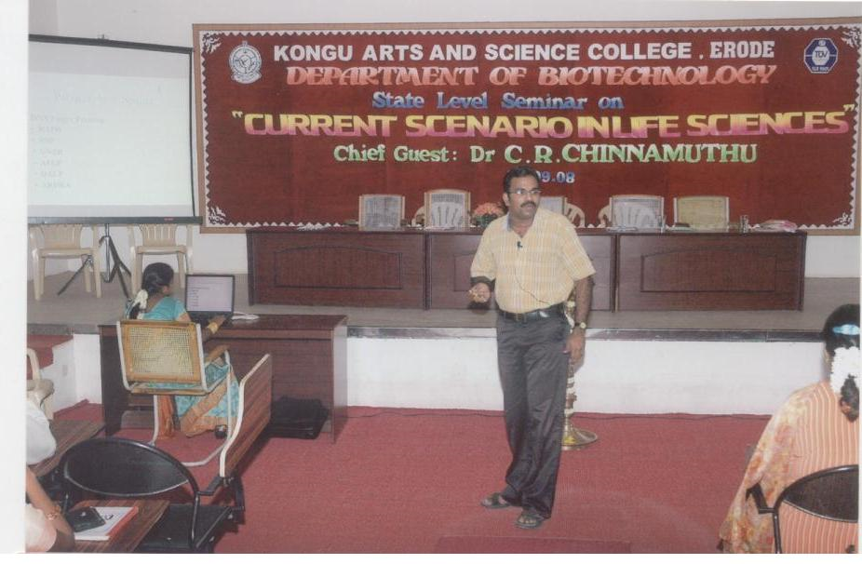
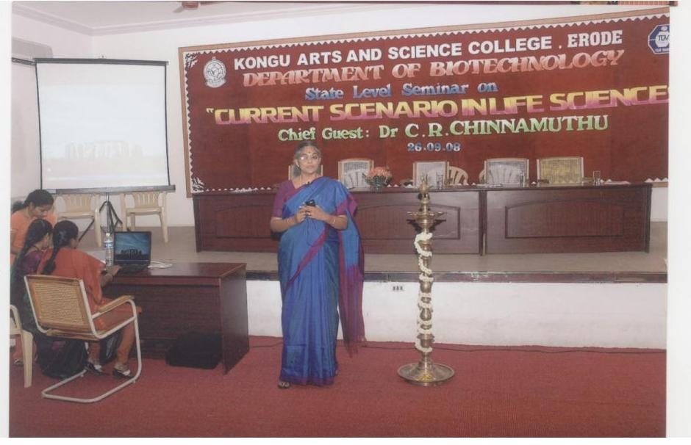

Interschool competition BIOCOMPETE – 2011

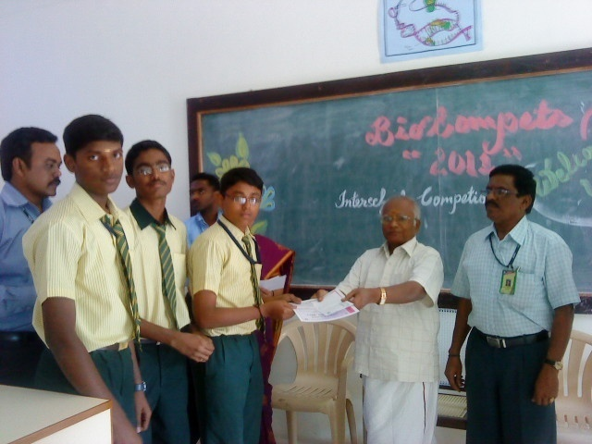
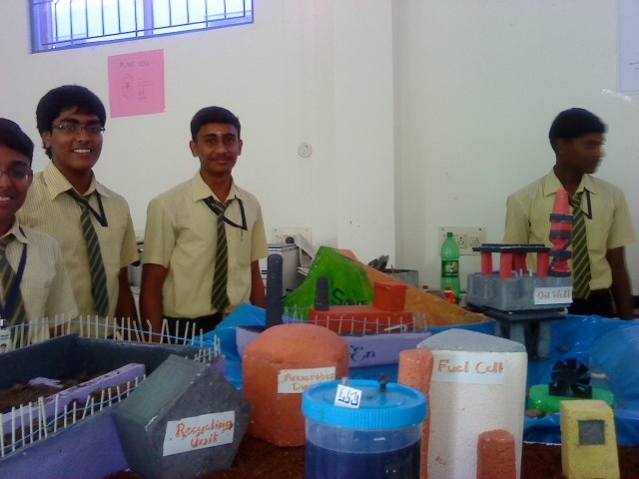

State level workshop
TWO DAYS STATE LEVEL WORKSHOP ON ‘ BIOINSTRUMENTATION’ 22-23, SEP 2011.
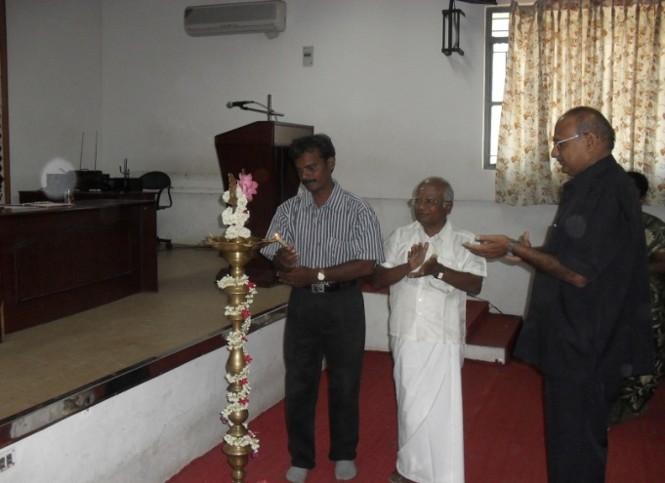
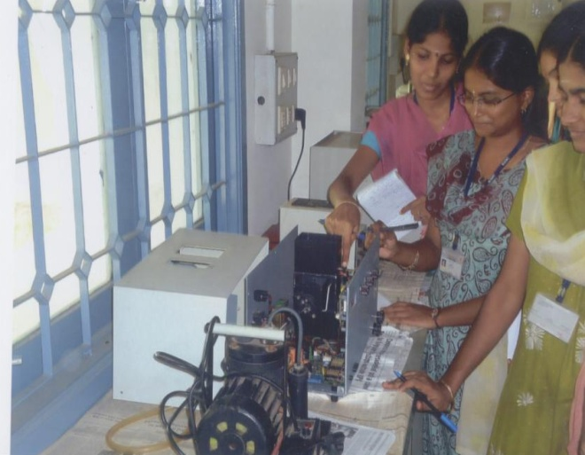

National seminar
National Level Seminar on ‘Exploring the Frontiers of Neuroscience’ on 11/02/2012.
