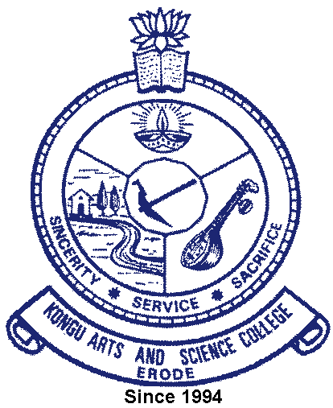 | KONGU ARTS AND SCIENCE COLLEGE
 | (An Autonomous Institution, Affiliated to Bharathiar University, Coimbatore)
 | ERODE – 638 107

1.3.2 Consolidated list of Value Added Courses
offered during last five years

S.No | Academic Year | Consolidated list
1 | 2021-2022 | 
2 | 2020-2021
3 | 2019-2020
4 | 2018-2019
5 | 2017-2018

