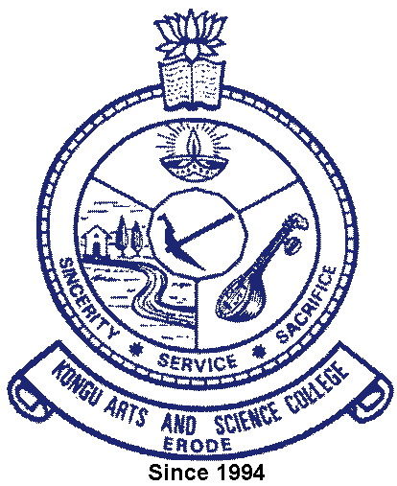 | Kongu Arts and Science College  (Autonomous)
 | Erode – 638 107

6.5.3 e-copies of accreditations and certification

Quality Assurance initiatives of the institution
Accreditation and Certifications | Link
NAAC | 
ISO
All India Ranking
SWACHHTA RANKING
India Today – MDRA Survey : The Best Colleges of India
Outlook-ICare Ranking : India’s Best Colleges
Education World :EW India Higher Education Rankings

