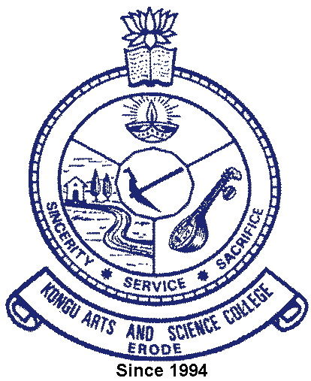 | KONGU ARTS AND SCIENCE COLLEGE
 | (An Autonomous Institution, Affiliated to Bharathiar University, Coimbatore)
 | ERODE – 638 107

6.4.1 Additional Information

Institution conducts Internal and external financial audits regularly
Internal and external financial audits | Link
Appointment of Internal Auditor | 
Internal Audit Report
Audit Report Explanation
Audited Statement of Accounts

