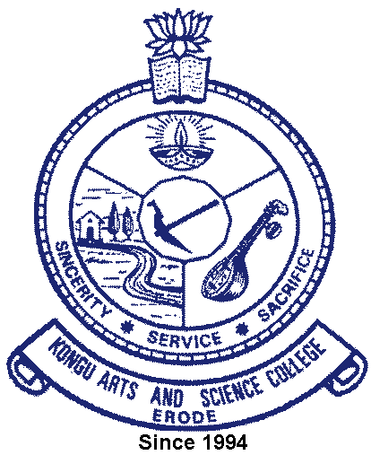 | KONGU ARTS AND SCIENCE COLLEGE
 | (An Autonomous Institution, Affiliated to Bharathiar University, Coimbatore)
 | ERODE – 638 107

6.3.4 Additional Information

TEACHERS UNDERGOING ONLINE/ FACE-TO-FACE FACULTY DEVELOPMENT
PROGRAMMES DURING THE LAST FIVE YEARS

S. No. | Particulars | Link to the relevant document
1 | 2021-2022 | View
2 | 2020-2021 | View
3 | 2019-2020 | View
4 | 2018-2019 | View
5 | 2017-2018 | View

