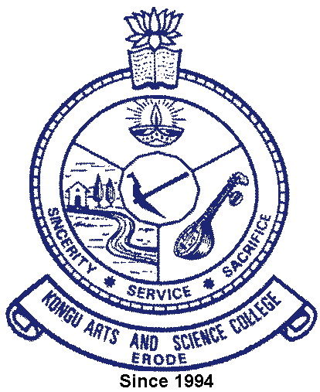 | KONGU ARTS AND SCIENCE COLLEGE
 | (An Autonomous Institution, Affiliated to Bharathiar University, Coimbatore)
 | ERODE – 638 107

6.3.4 Additional Information

Average percentage of teachers undergoing online/ face-to-face Faculty Development Programmes during the last five years
Faculty Development Programmes Attended | Link
Summary Report of the Programme | 
E copy of Certificates

