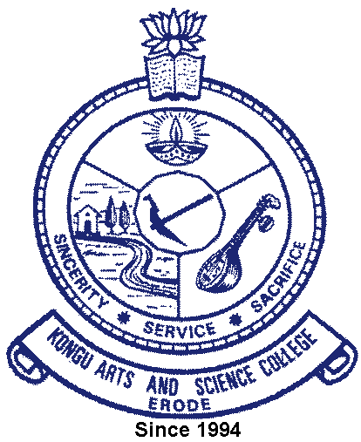 | KONGU ARTS AND SCIENCE COLLEGE
 | (An Autonomous Institution, Affiliated to Bharathiar University, Coimbatore)
 | ERODE – 638 107

5.1.2 NUMBER OF STUDENTS BENEFITTED BY SCHOLARSHIPS AND FREESHIPS PROVIDED BY THE INSTITUTION AND NON-GOVERNMENT AGENCIES

S.No | Year | Student Table
1 | 2021-2022 | 
2 | 2020-2021
3 | 2019-2020
4 | 2018-2019
5 | 2017-2018

