2020-2021

NAMELIST OF STUDENTS RECEIVED SCHOLARSHIPS AND FREESHIPS PROVIDED BY THE GOVERNMENT – 2020-2021

S.NO. | PARTICULARS | TOTAL NUMBER OF STUDENTS BENEFITED | LINK TO THE PAGE
1. | ADI DRAVIDAR AND TRIBAL WELFARE SCHOLARSHIP | 38 | View Document
2. | CENTRAL SECTOR SCHEME OF SCHOLARSHIP FOR COLLEGE AND UNIVERSITY STUDENTS | 314 | View Document
3. | POST MATRIC SCHOLARSHIP FOR MINORITY STUDENTS | 02 | View Document
4. | BC/MBC SCHOLARSHIP | 03 | View Document
TOTAL NUMBER OF STUDENTS BENIFITED THROUGH FREESHIPS AND SCHOLARSHIPS PROVIDED BY THE GOVERNMENT |  | 357*

*One Student benefited by more than one scheme has been counted as one only

ADI DRAVIDAR AND TRIBAL WELFARE SCHOLARSHIP

ADW-NL

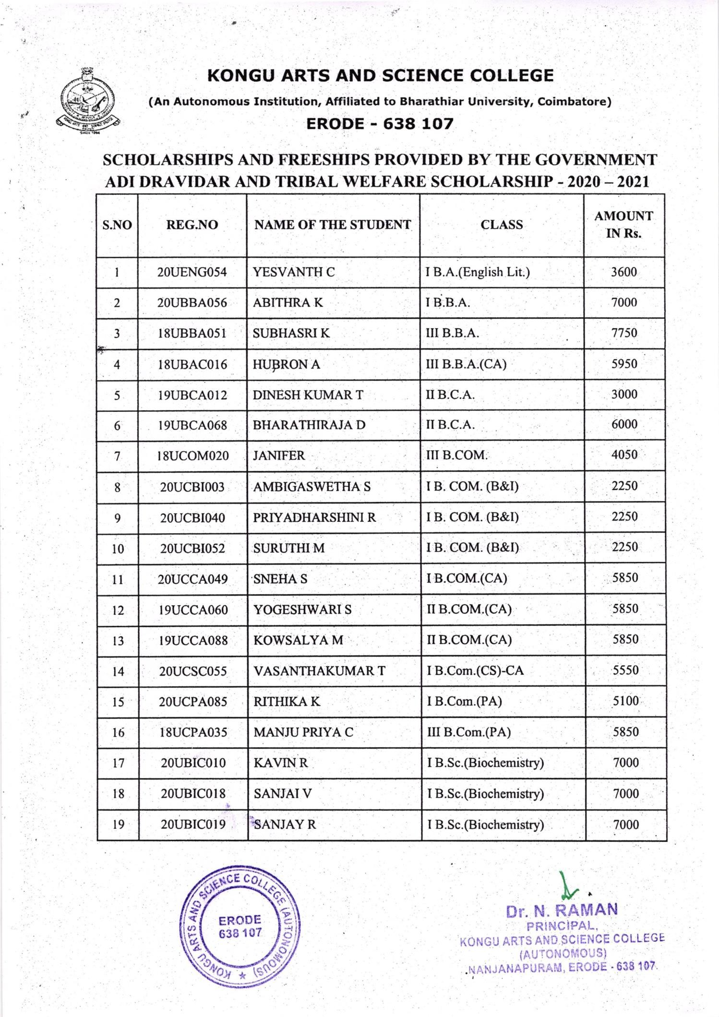

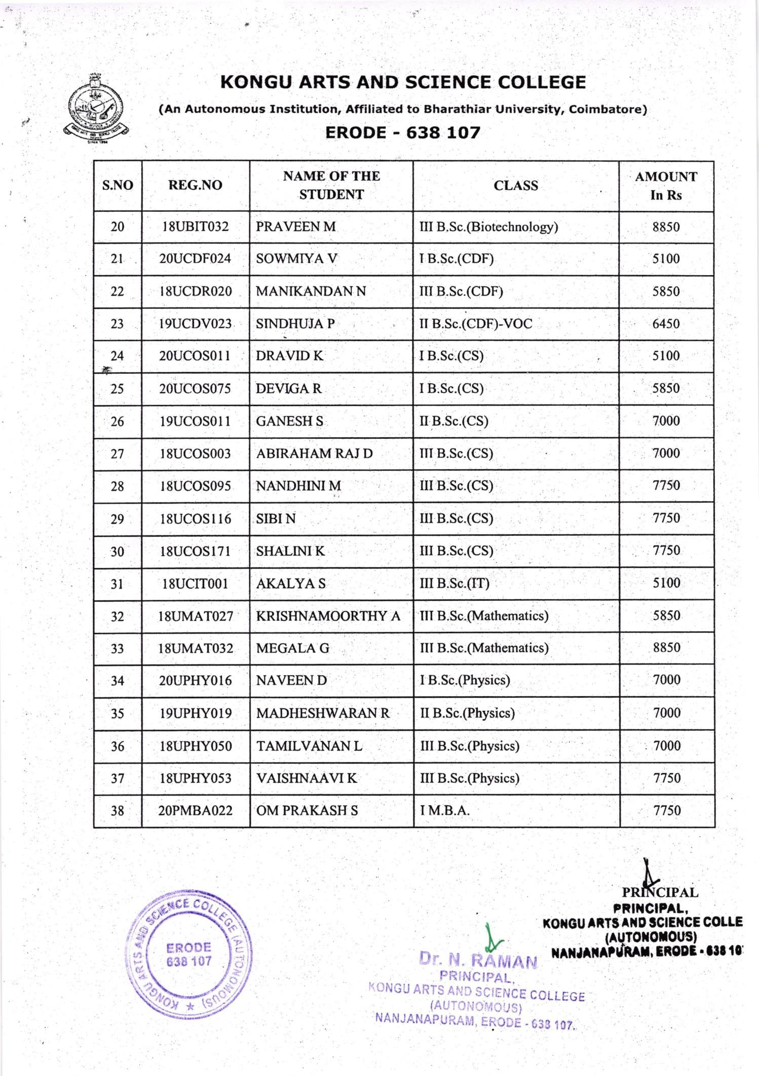

CENTRAL SECTOR SCHEME OF SCHOLARSHIP FOR COLLEGE AND UNIVERSITY STUDENTS

CSSS-NL
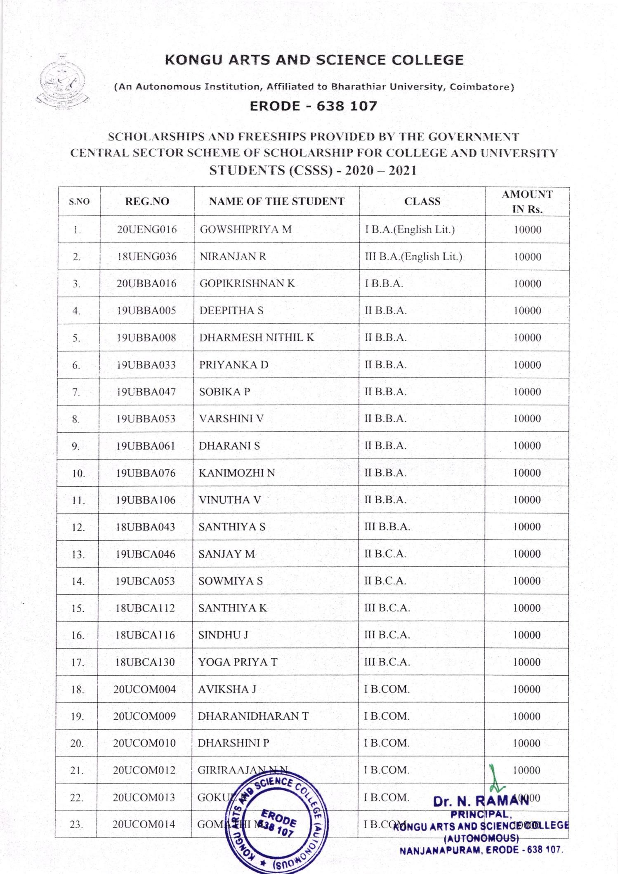

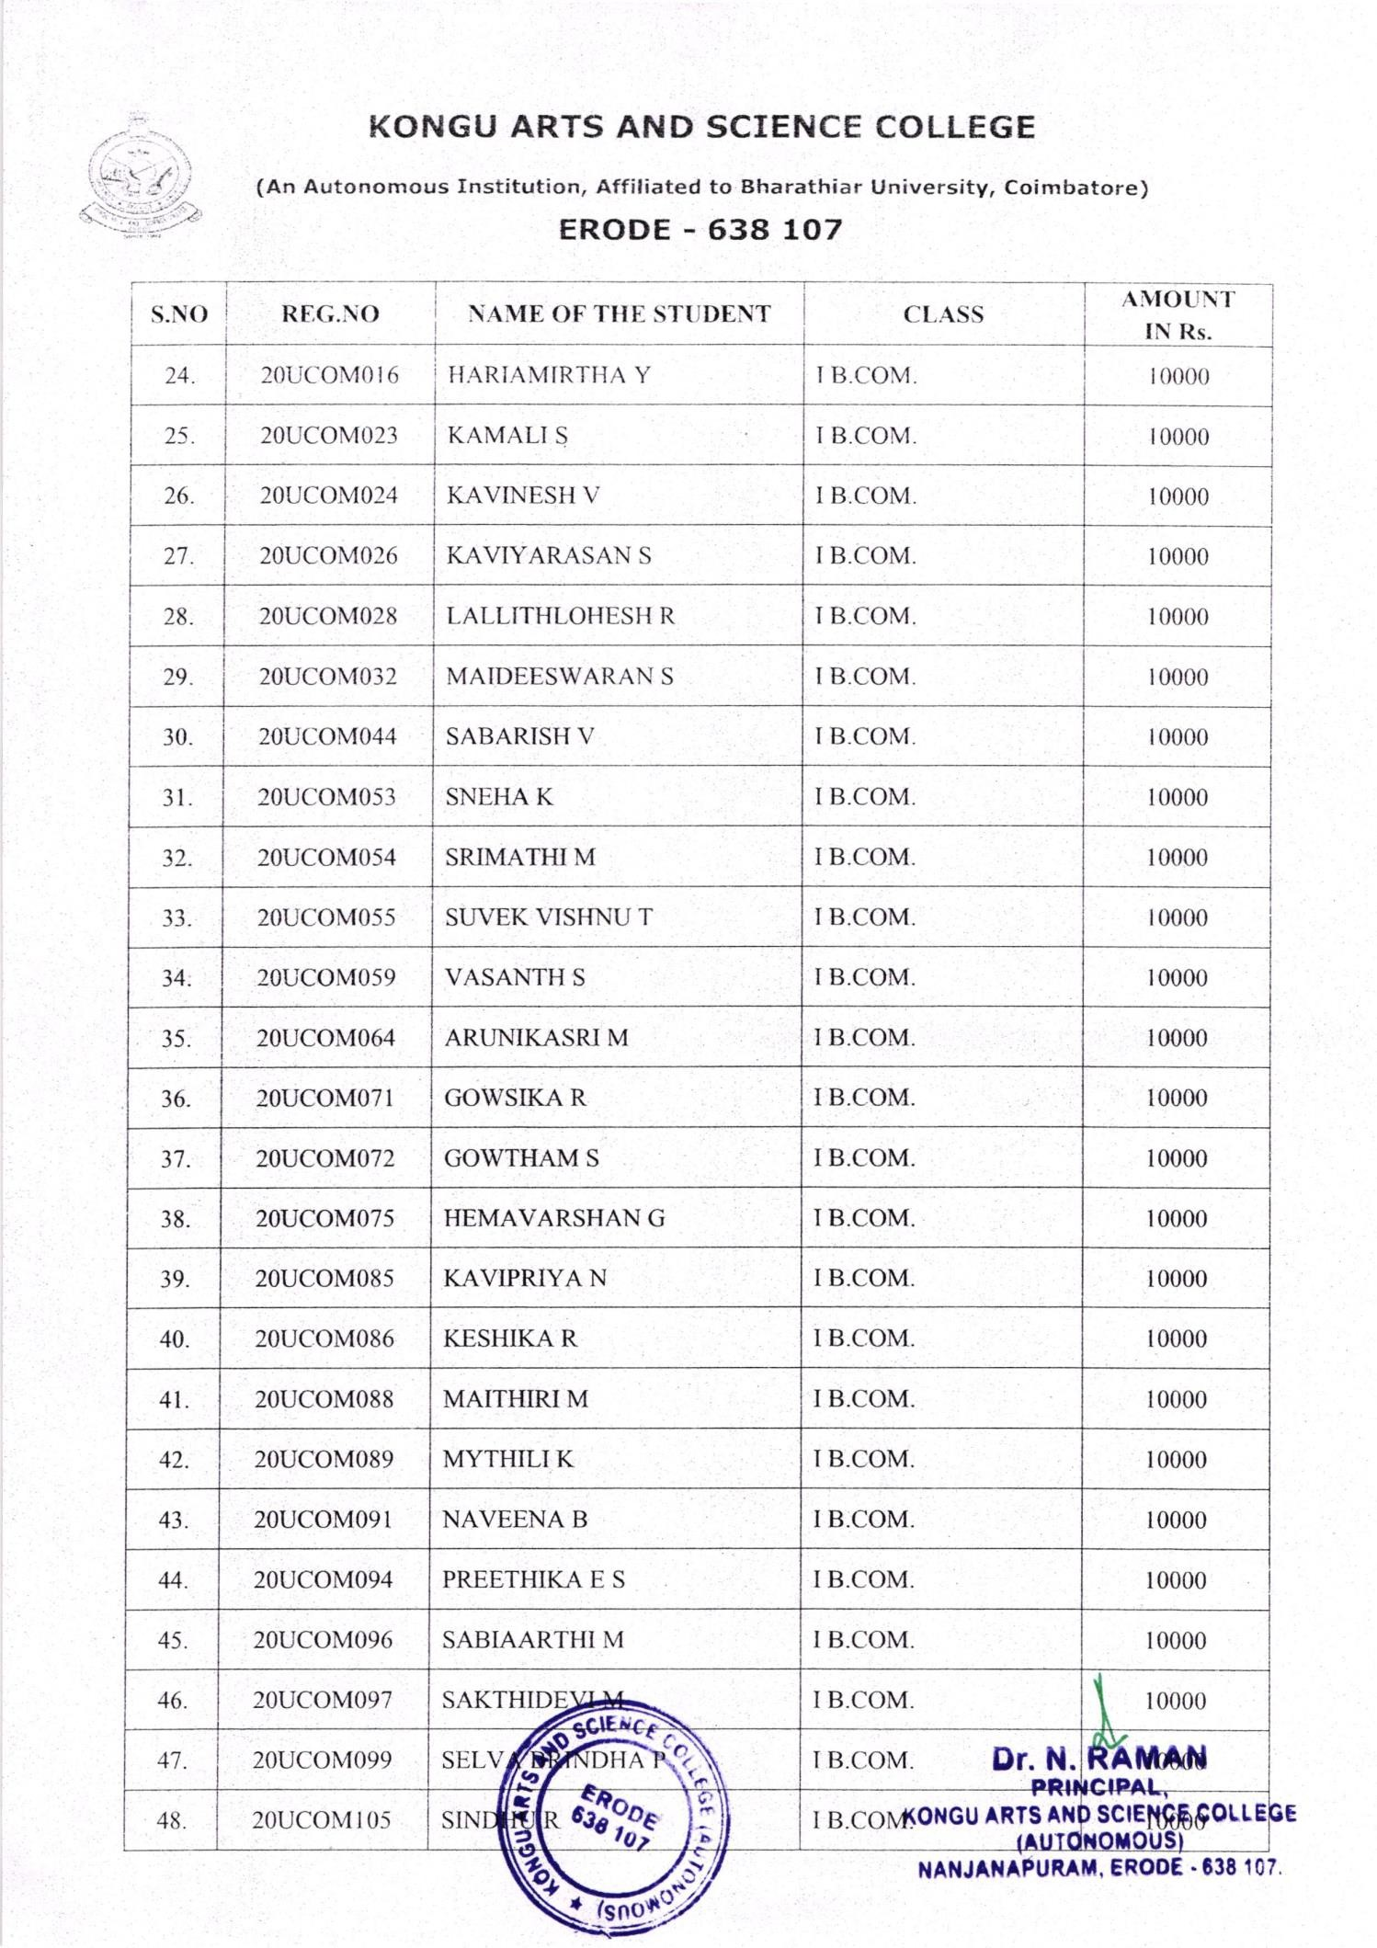

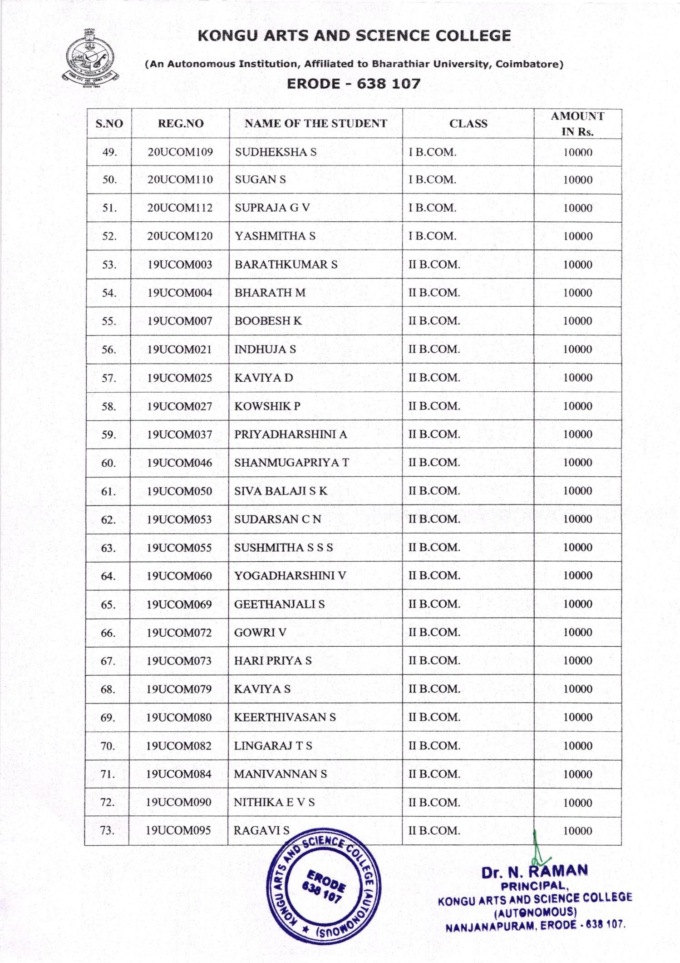

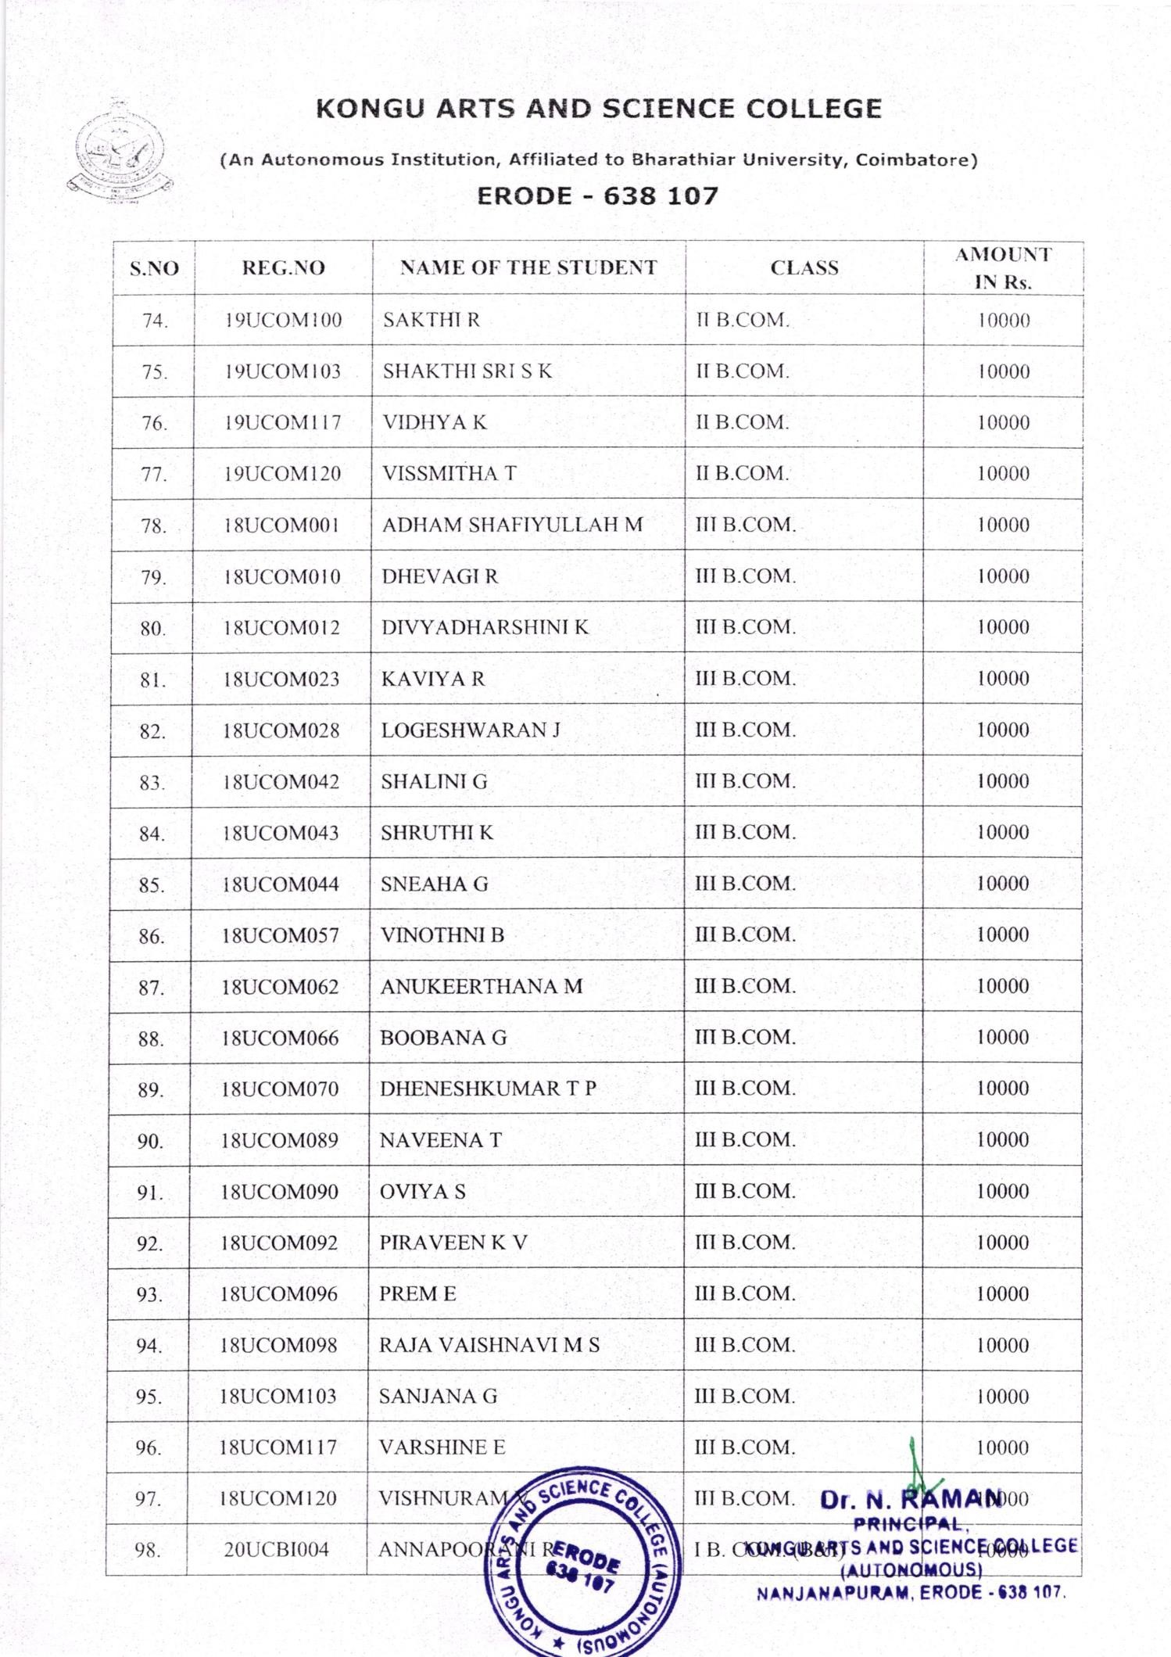

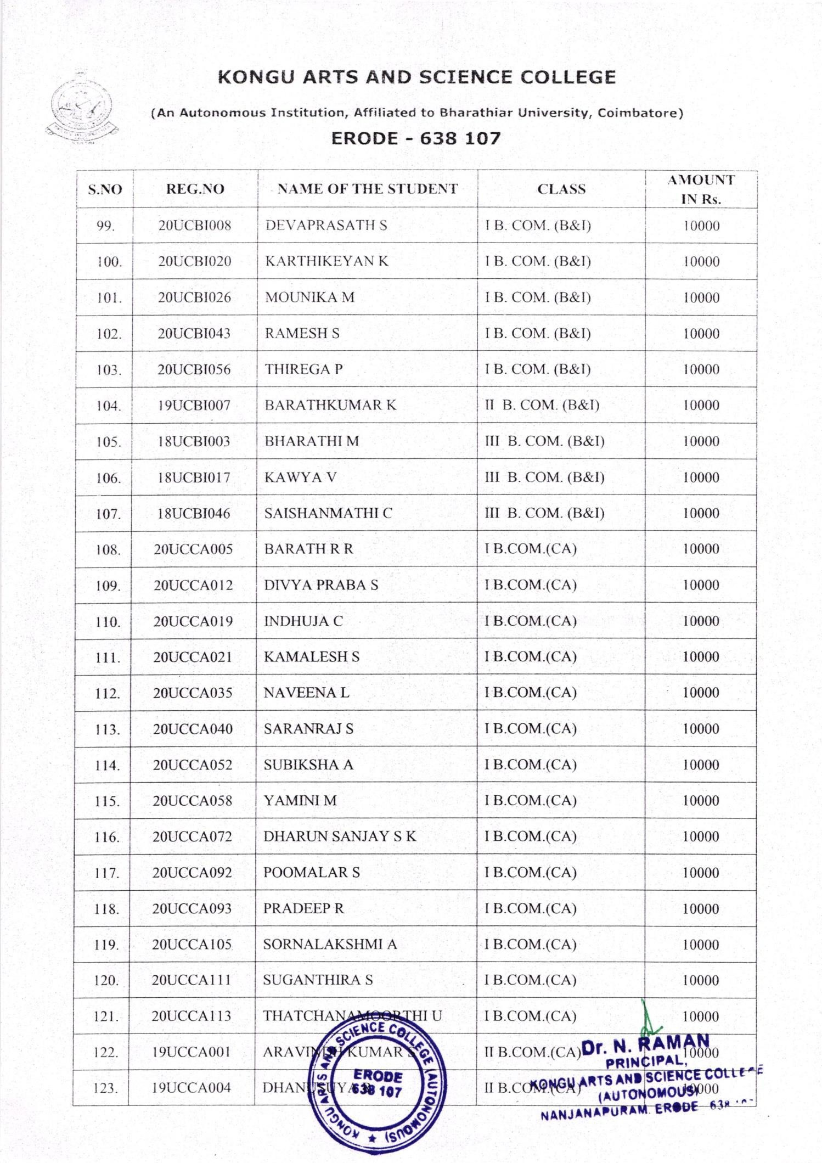

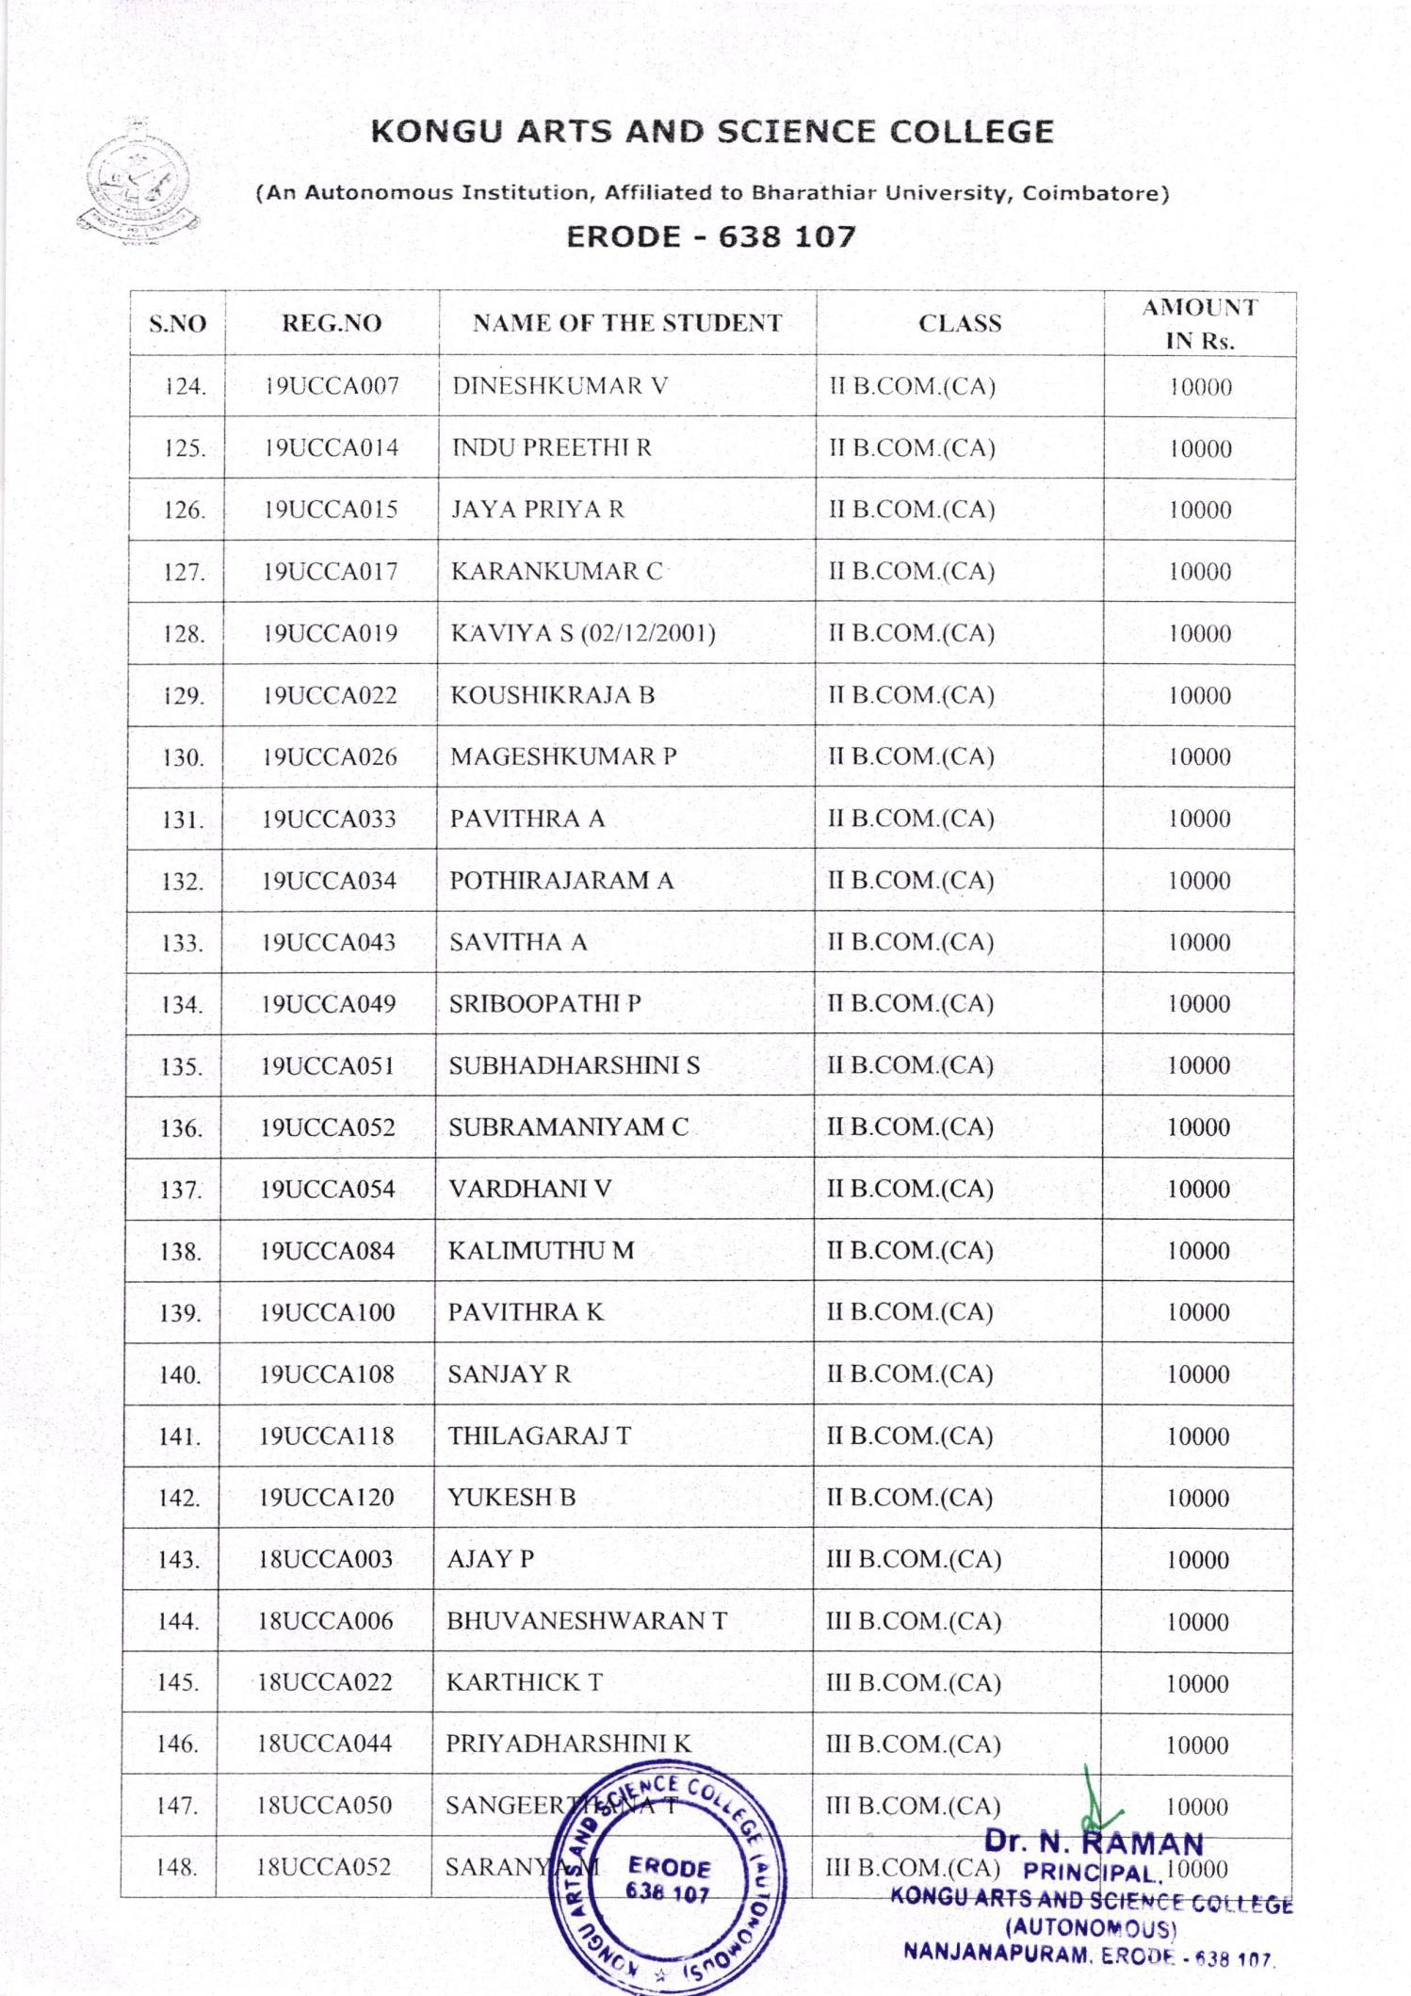

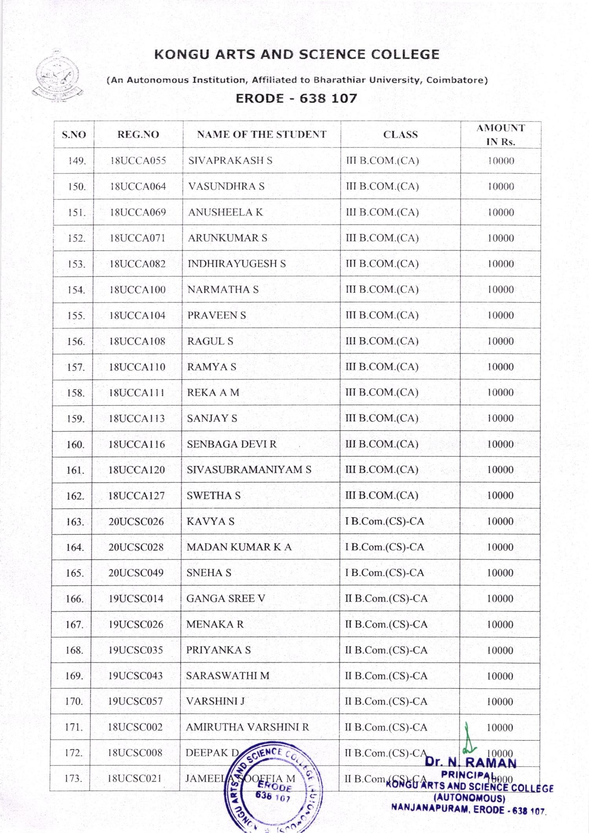

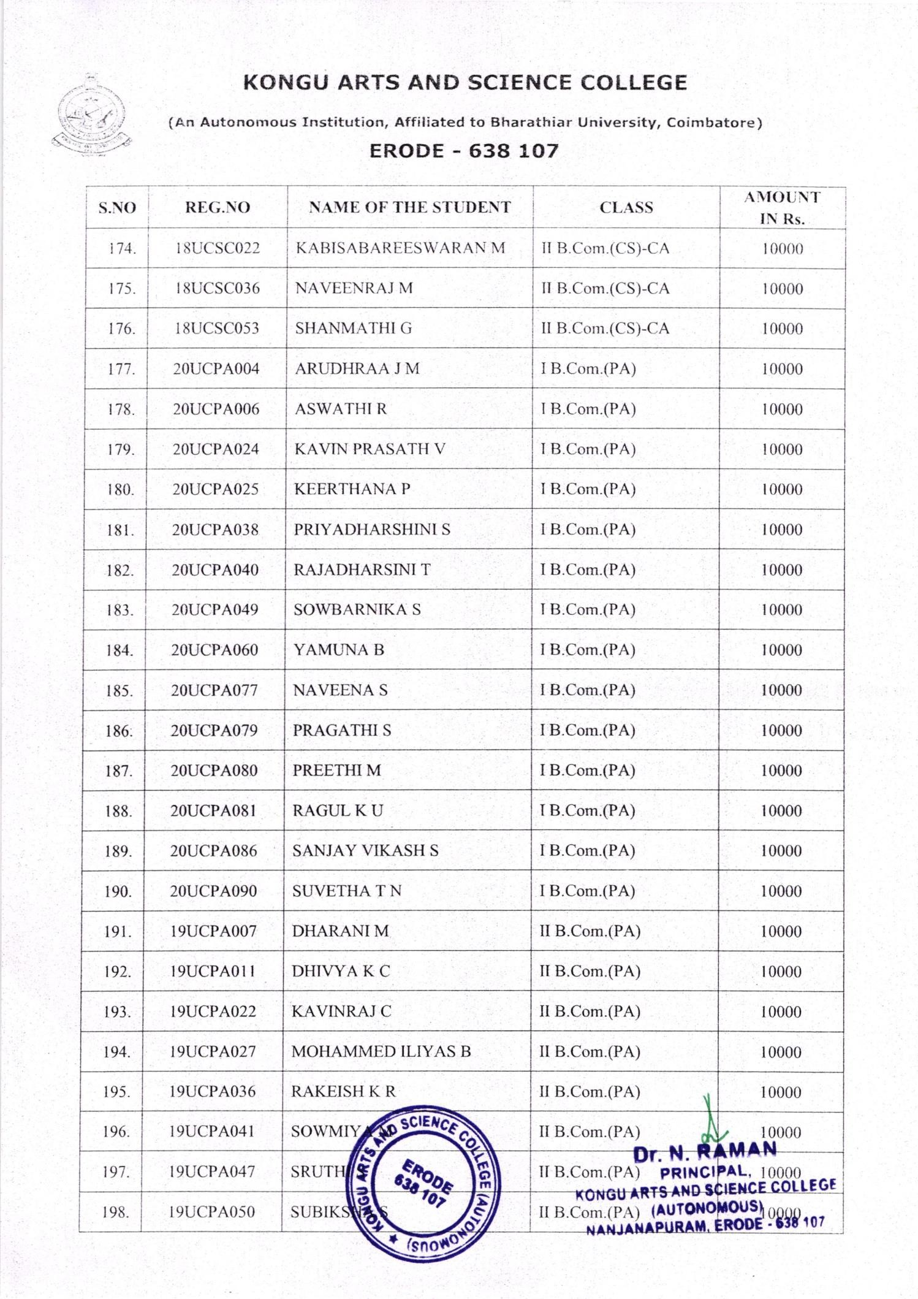

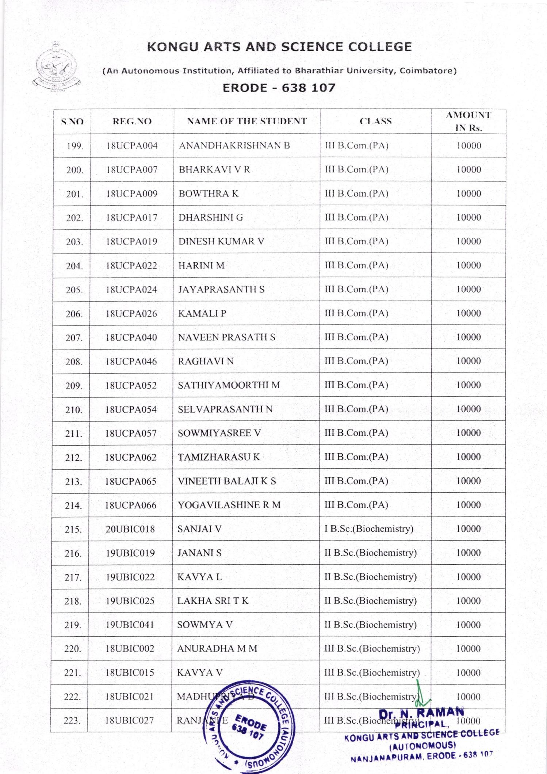

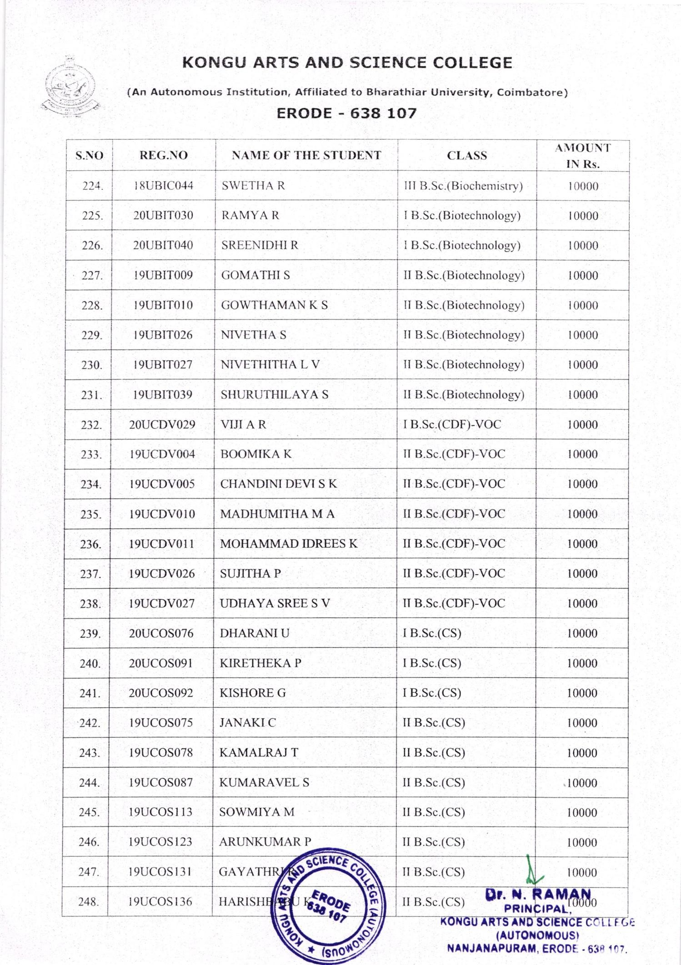

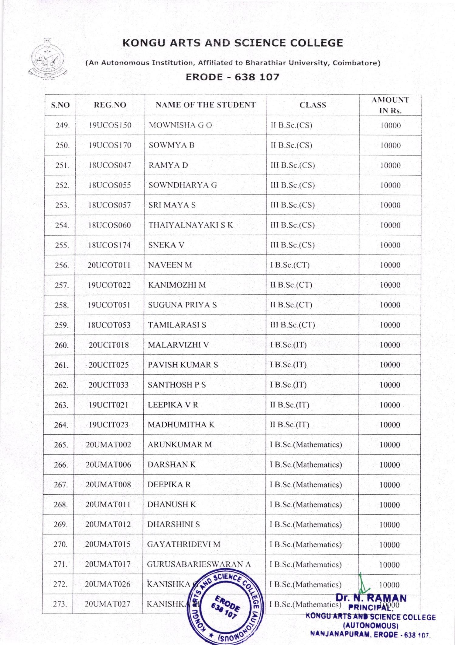

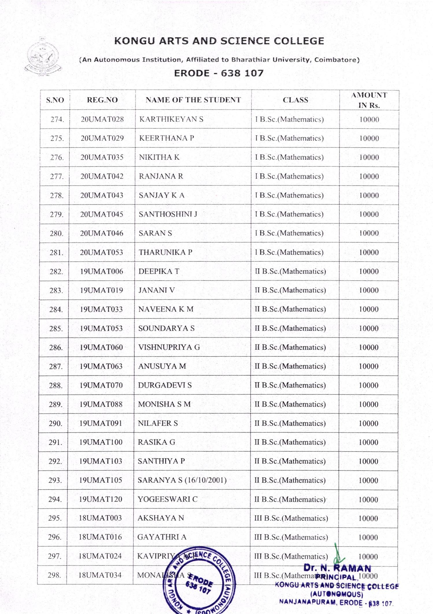

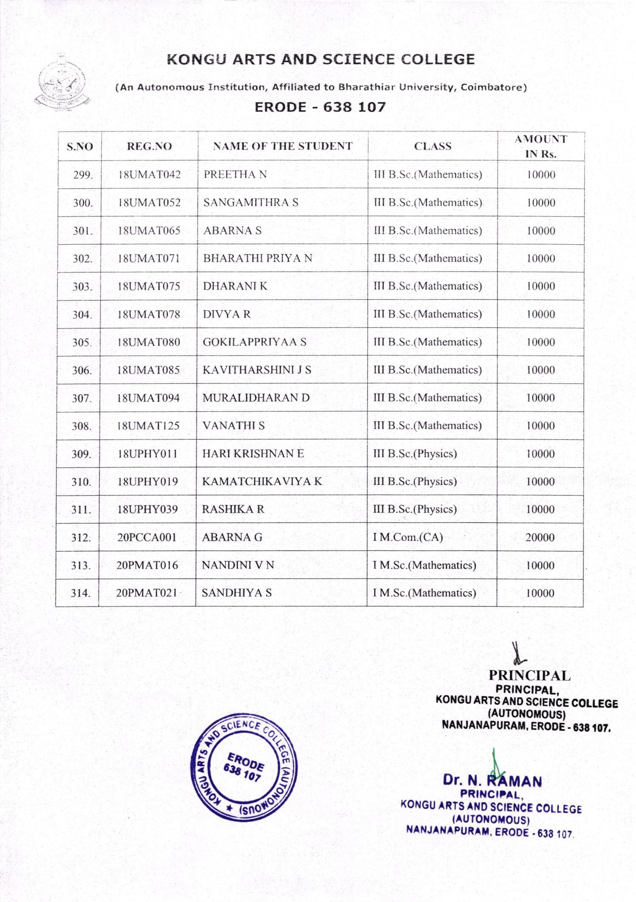

POST MATRIC SCHOLARSHIP FOR MINORITY STUDENTS

Postmatric- NL
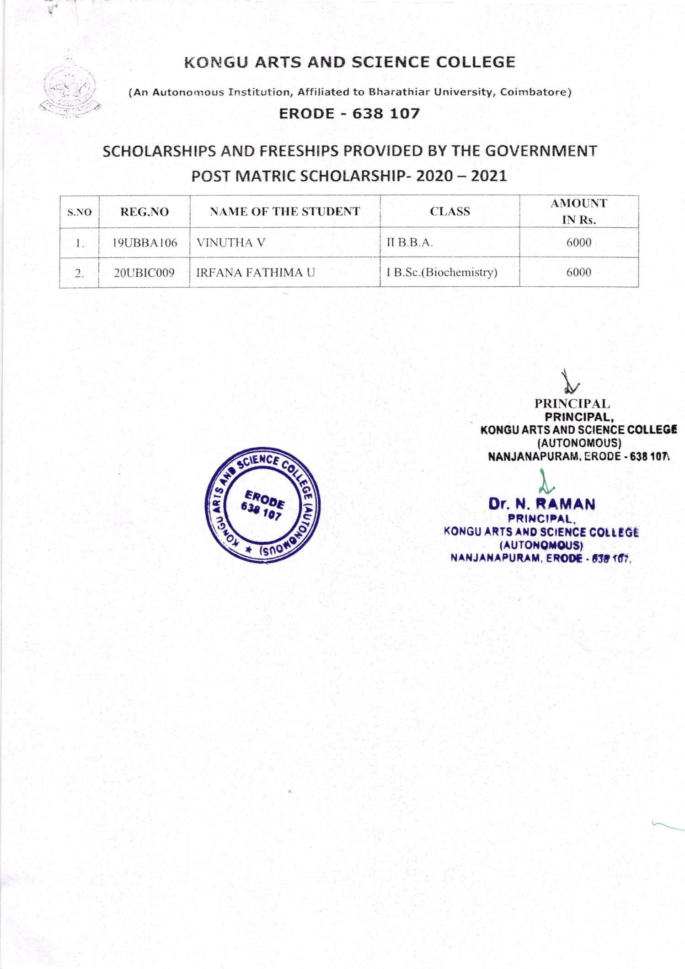

BC/MBC
SCHOLARSHIP

BC/MBC - NL
