2021-2022

NAMELIST OF STUDENTS RECEIVED SCHOLARSHIPS AND FREESHIPS PROVIDED BY THE GOVERNMNET – 2021-2022

S.NO. | PARTICULARS | TOTAL NUMBER OF STUDENTS BENEFITED | LINK TO THE PAGE
1. | ADI DRAVIDAR AND TRIBAL WELFARE SCHOLARSHIP | 46 | View Document
2. | CENTRAL SECTOR SCHEME OF SCHOLARSHIP FOR COLLEGE AND UNIVERSITY STUDENTS | 306 | View Document
3. | UGC/AICTE – POST GRADUATE INDRA GANDHI SCHOLARSHIP FOR SINGLE GIRL CHILD | 03 | View Document
4. | SWAYAM NPTEL FEE WAIVER SCHOLARSHIP | 33 | View Document
5. | PRIME MINISTER’S SCHOLARSHIIP SCHEME | 02 | View Document
6. | POST MATRIC SCHOLARSHIP FOR MINORITY STUDENTS | 03 | View Document
TOTAL NUMBER OF STUDENTS BENIFITED THROUGH FREESHIPS AND SCHOLARSHIPS PROVIDED BY THE GOVERNMENT |  | 393*

*One Student benefited by more than one scheme has been counted as one only

ADI DRAVIDAR AND TRIBAL WELFARE SCHOLARSHIP

ADW - NL

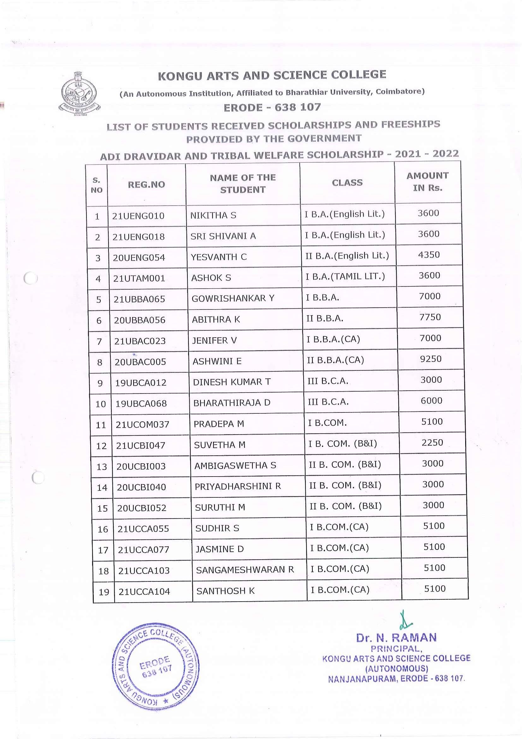

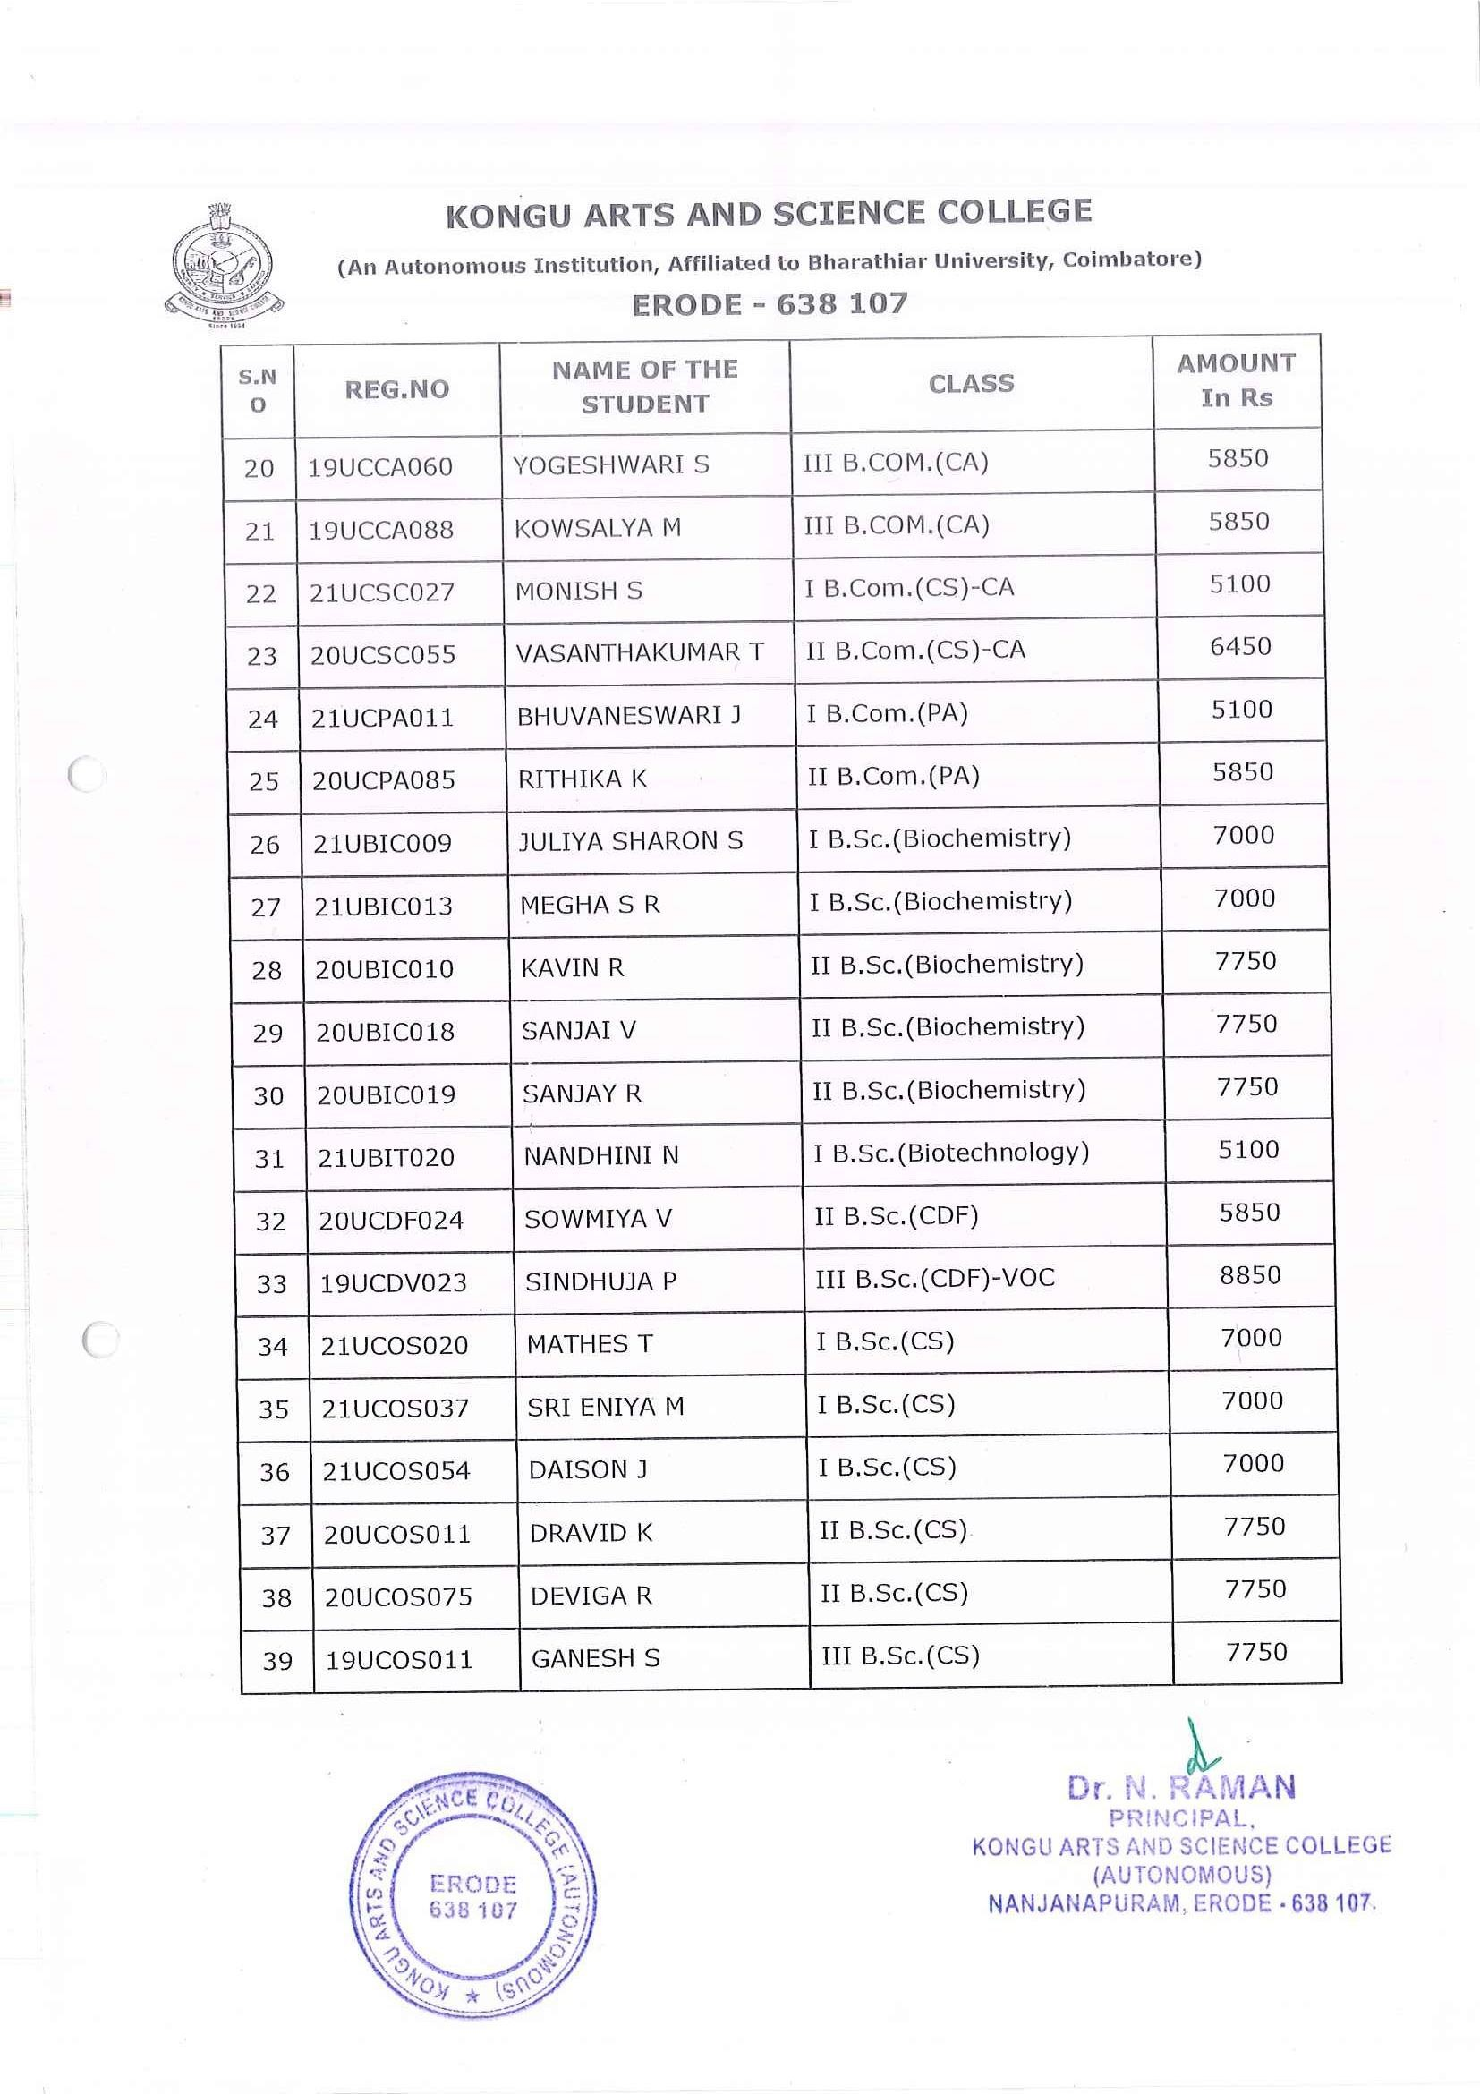

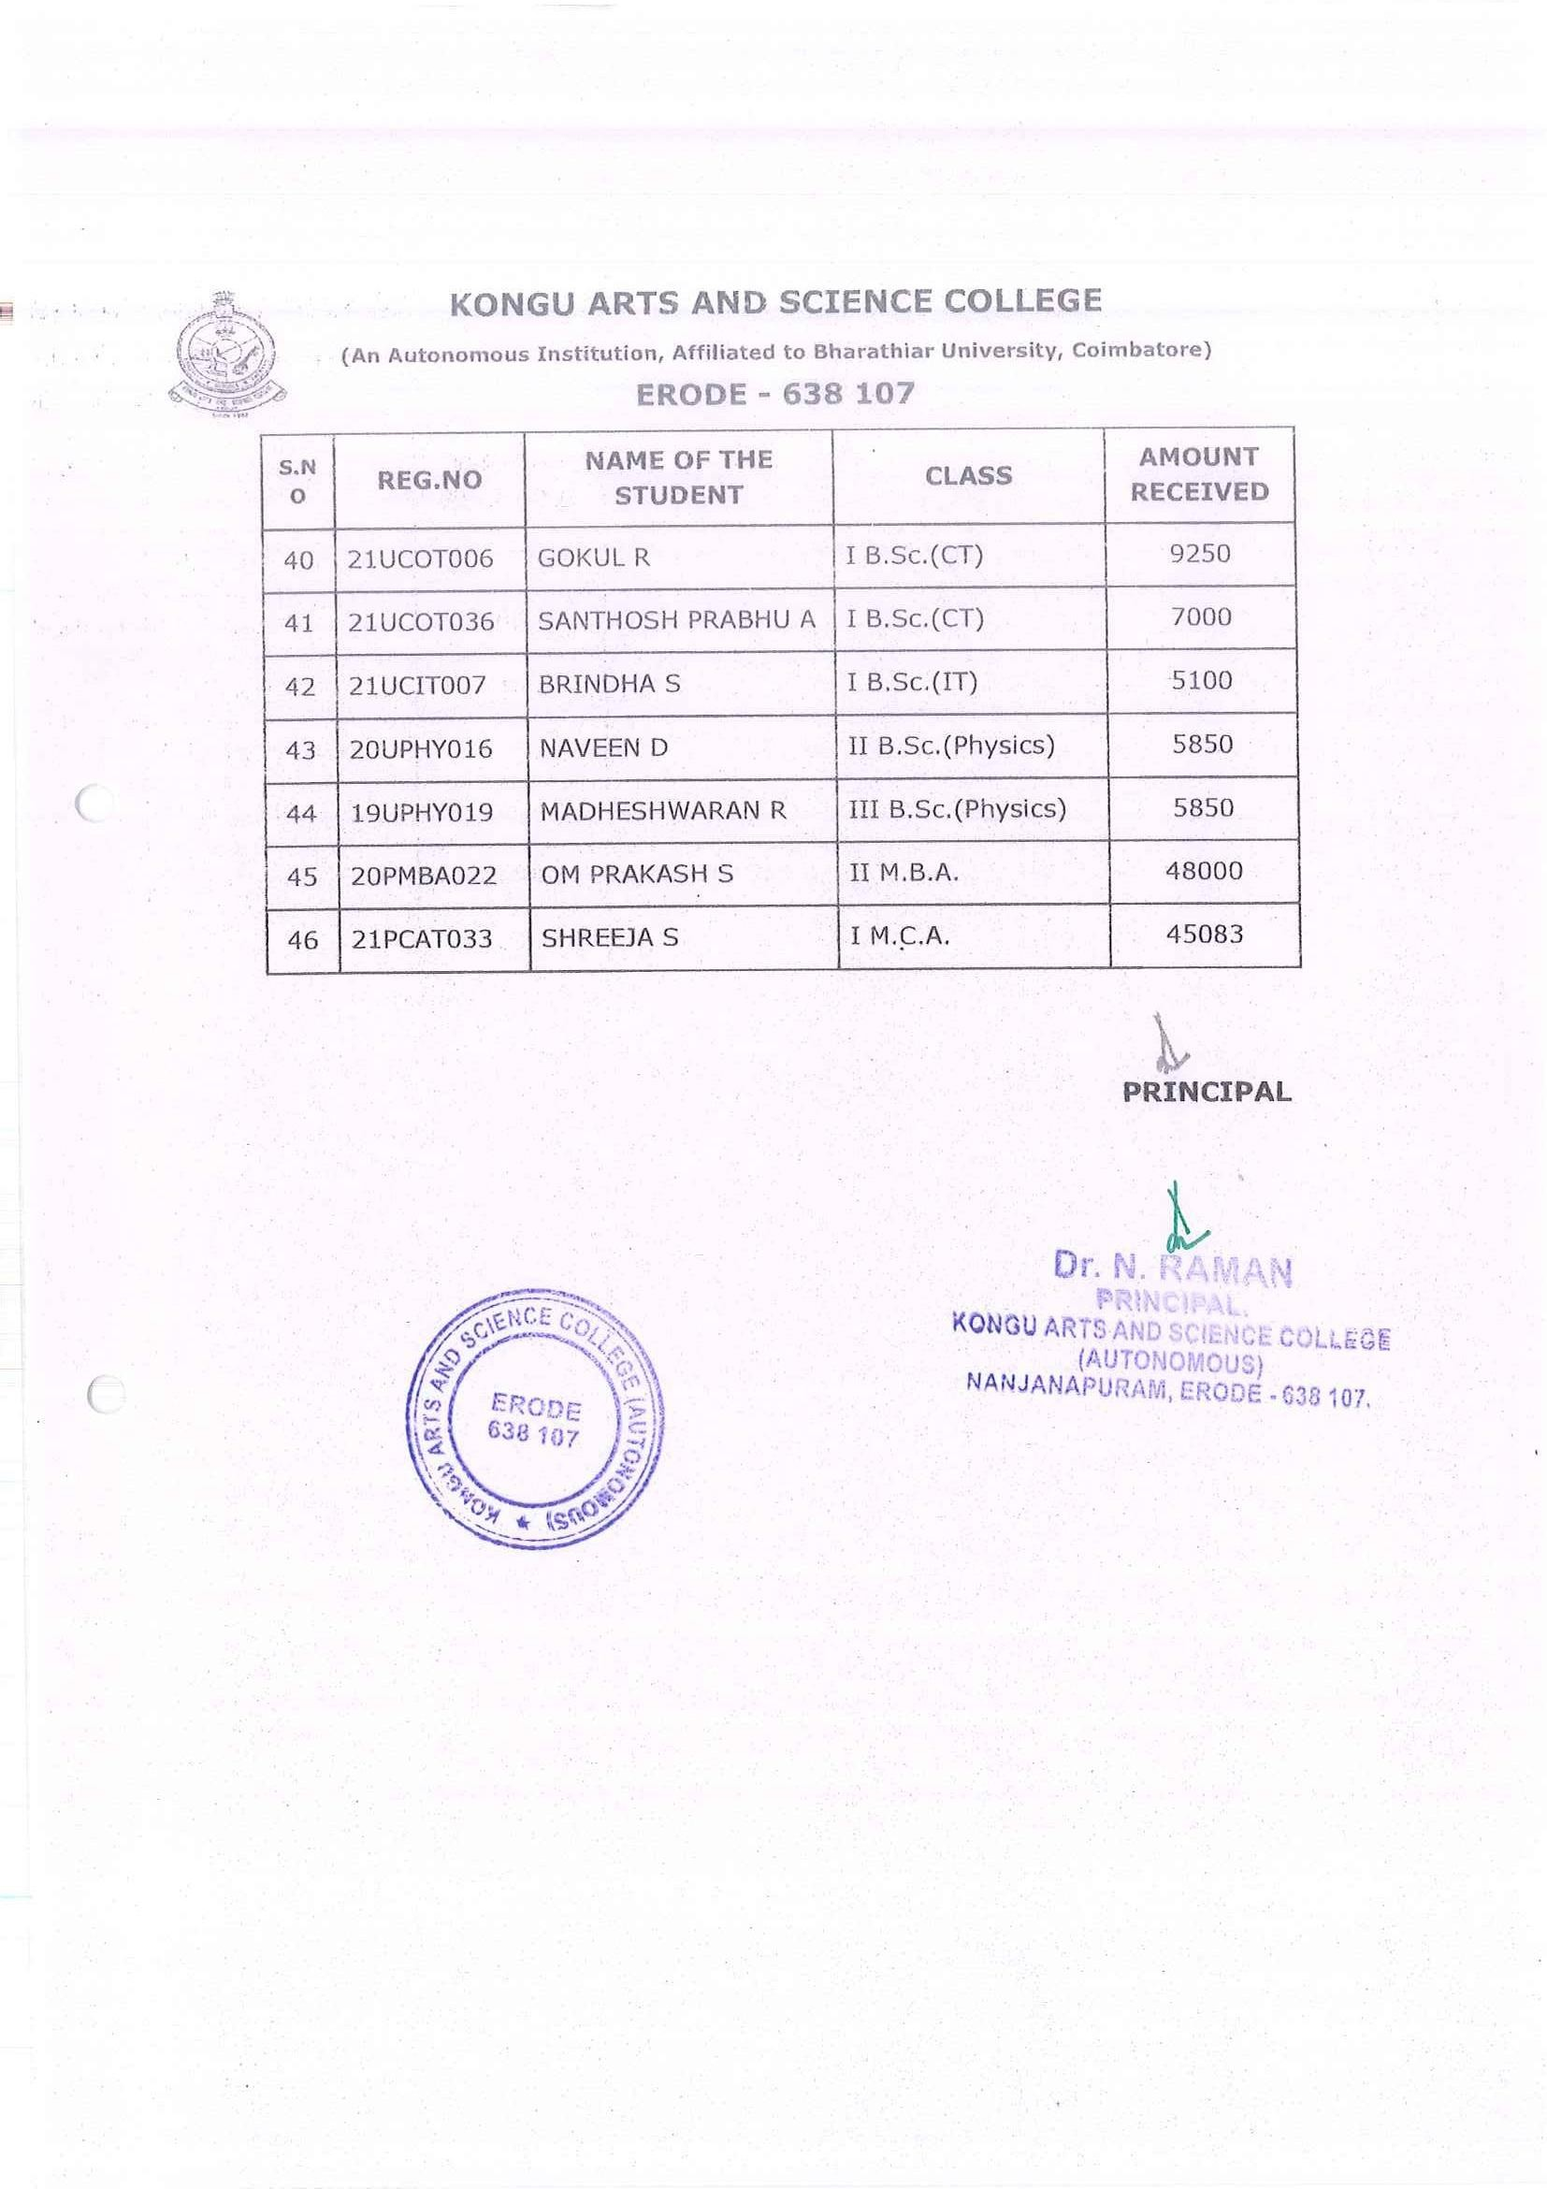

CENTRAL SECTOR SCHEME OF SCHOLARSHIP FOR COLLEGE AND UNIVERSITY STUDENTS
CSSS-NL

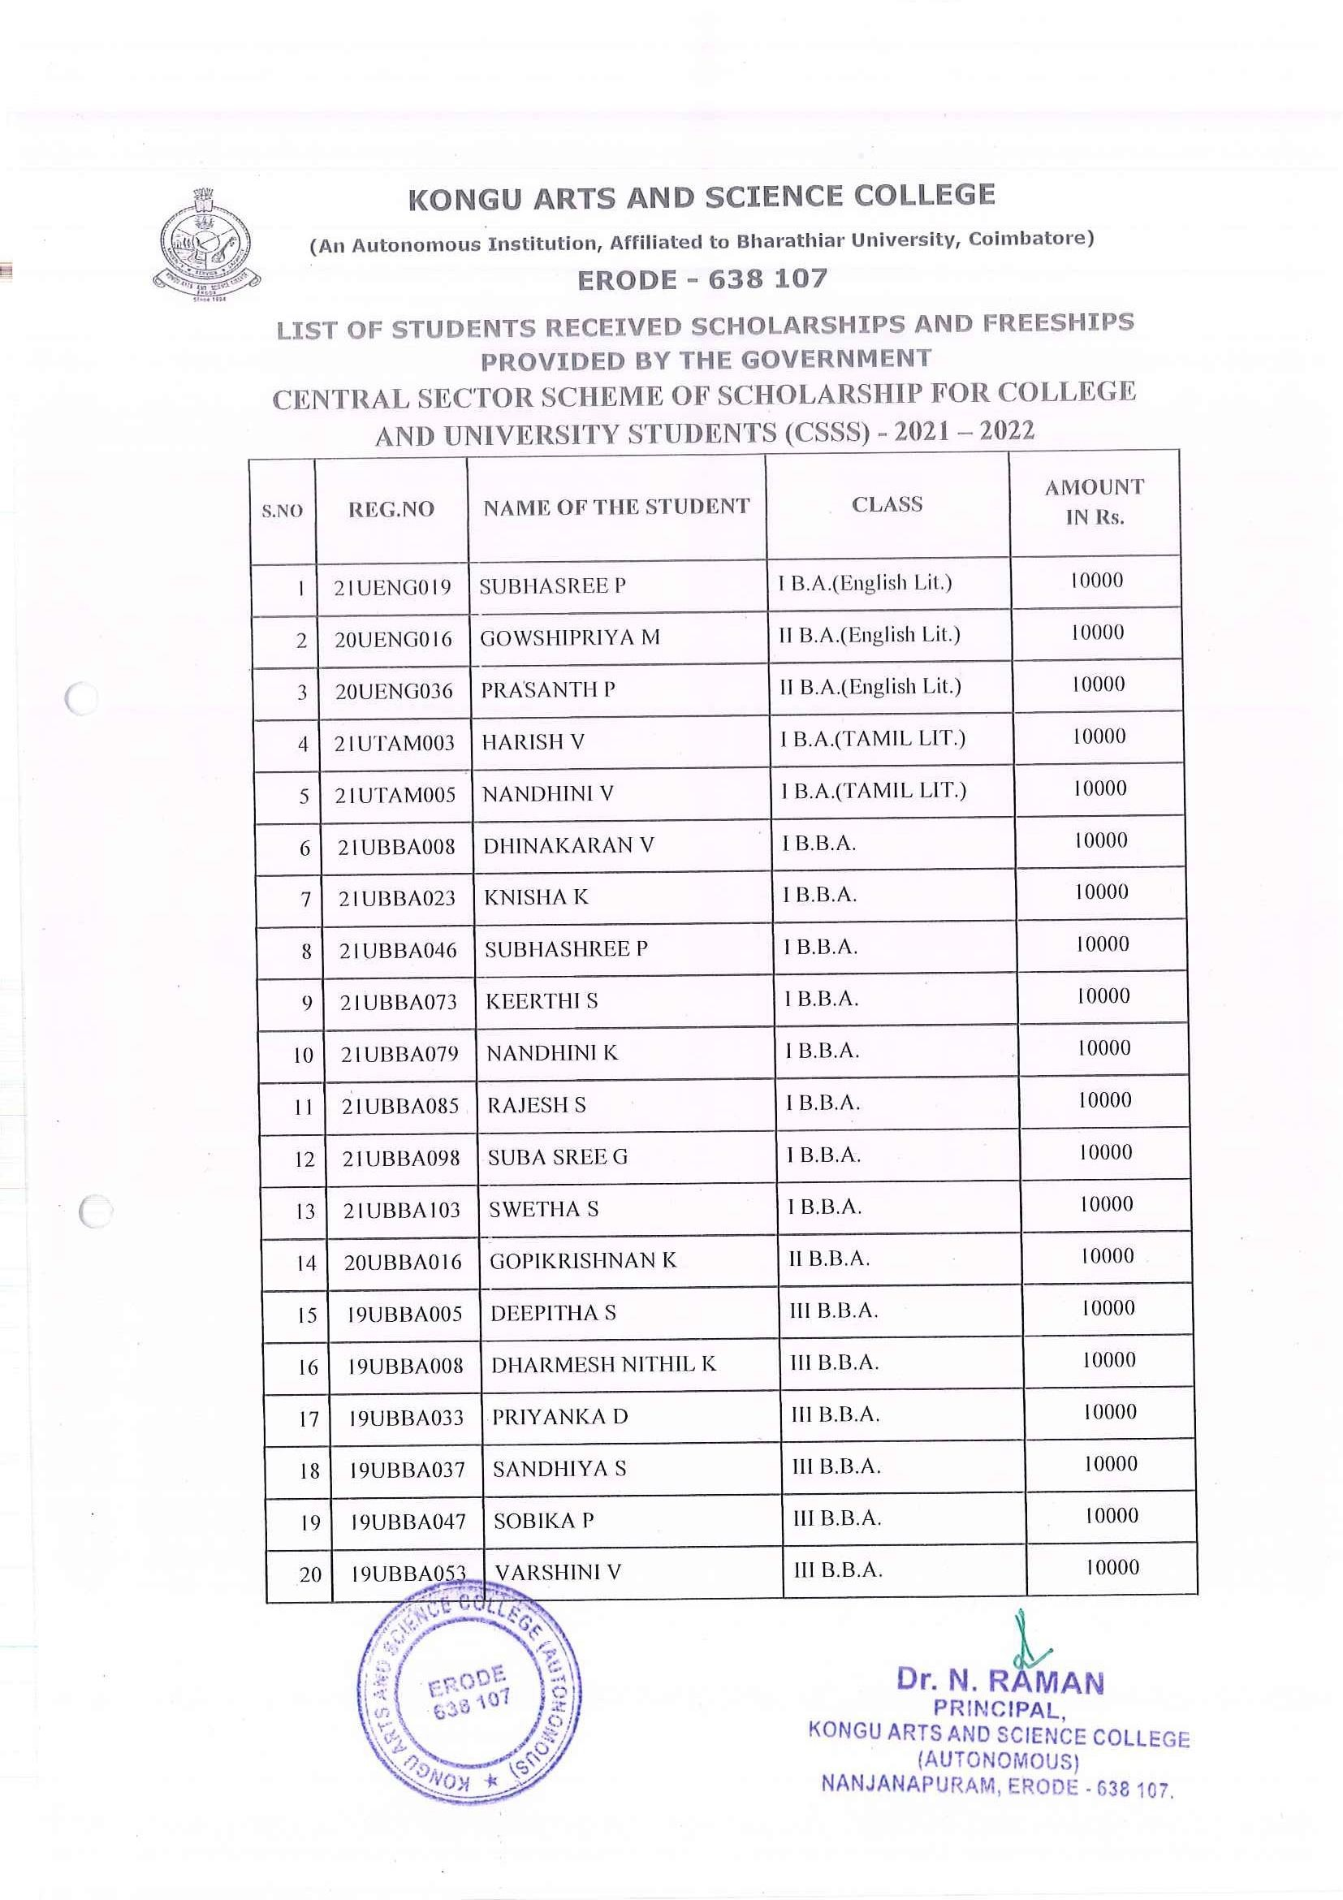

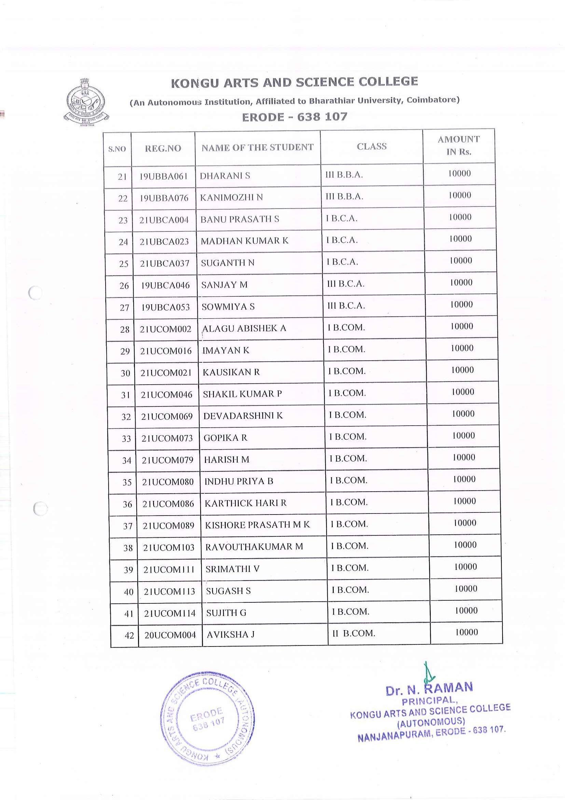

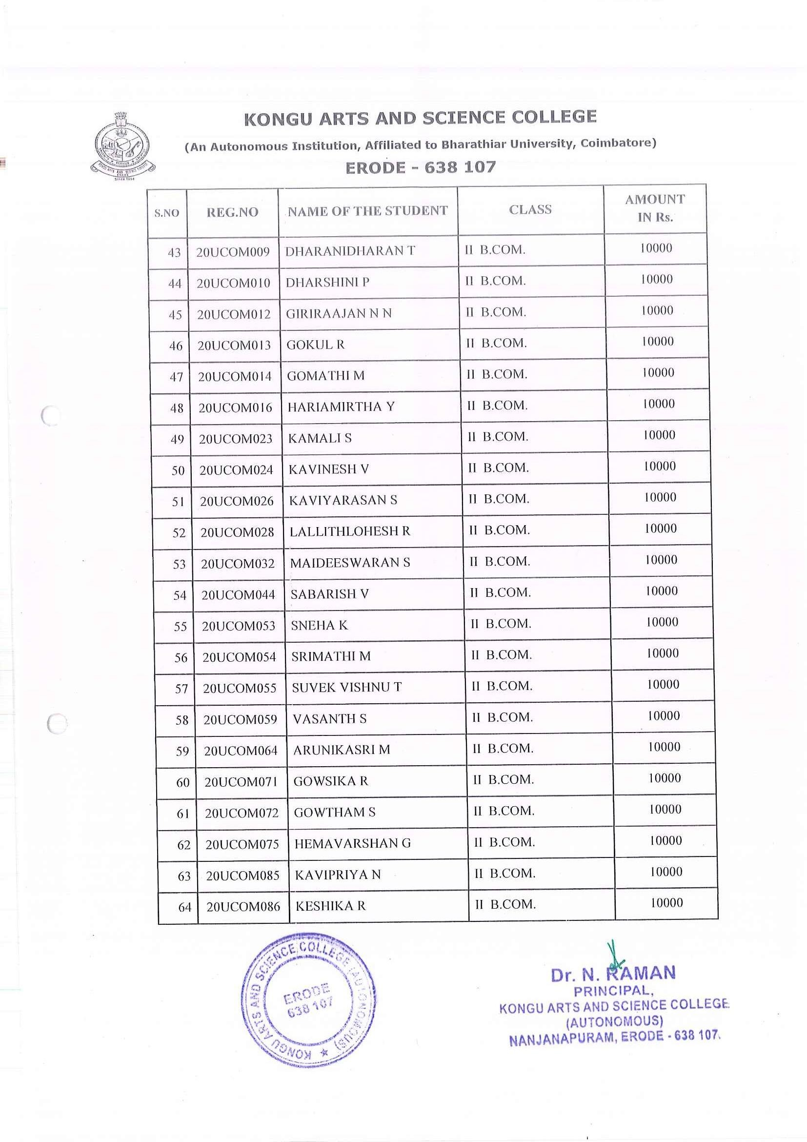

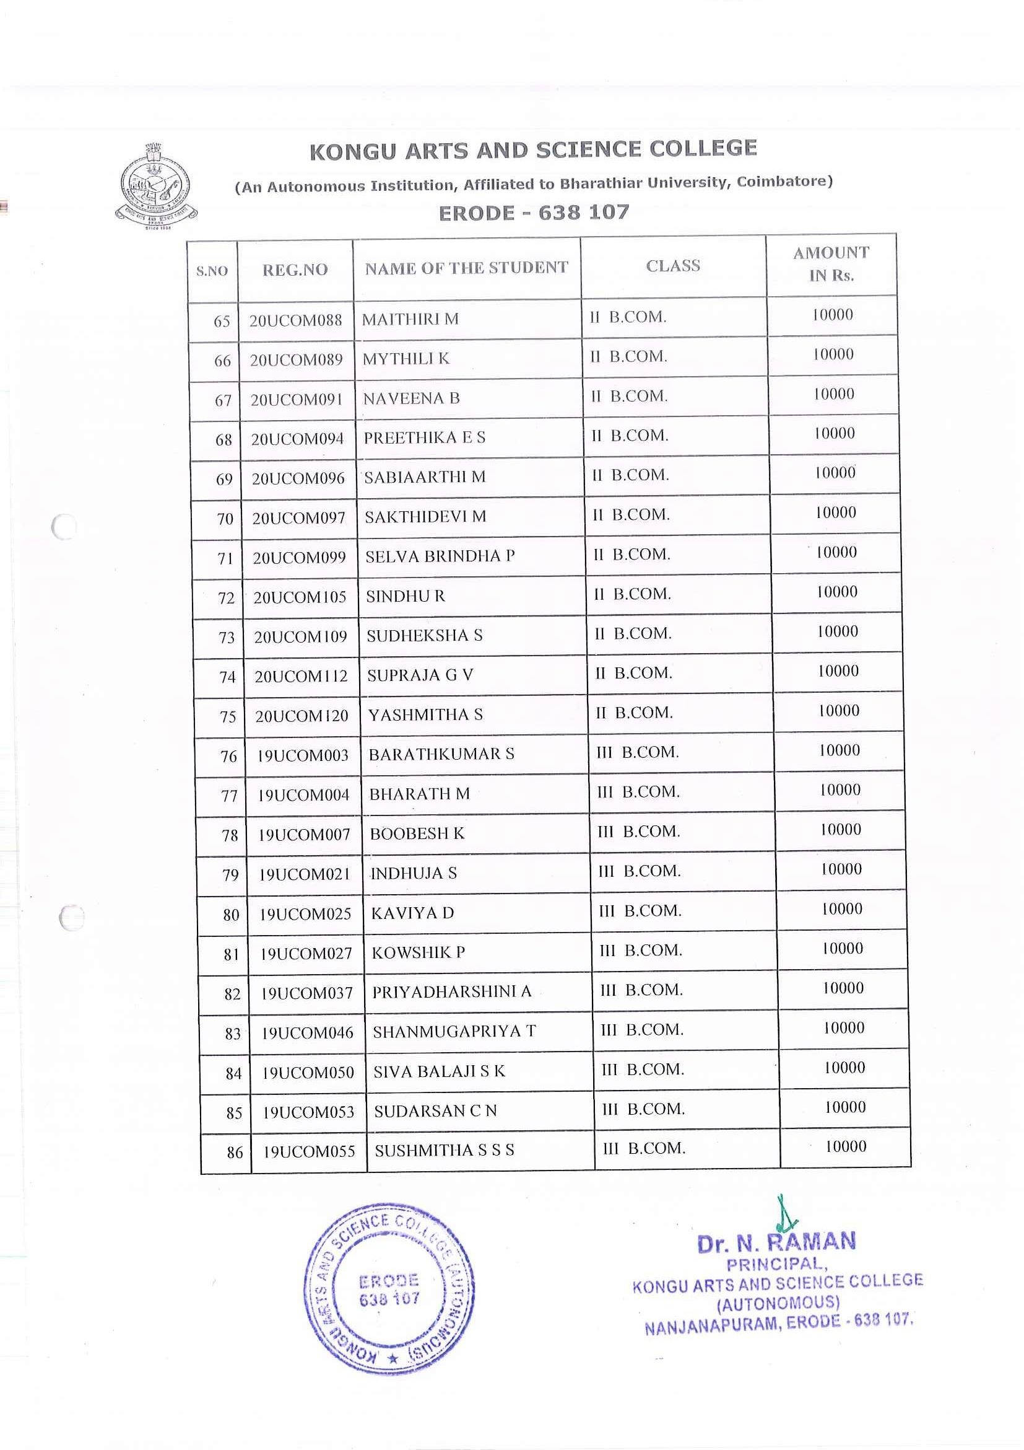

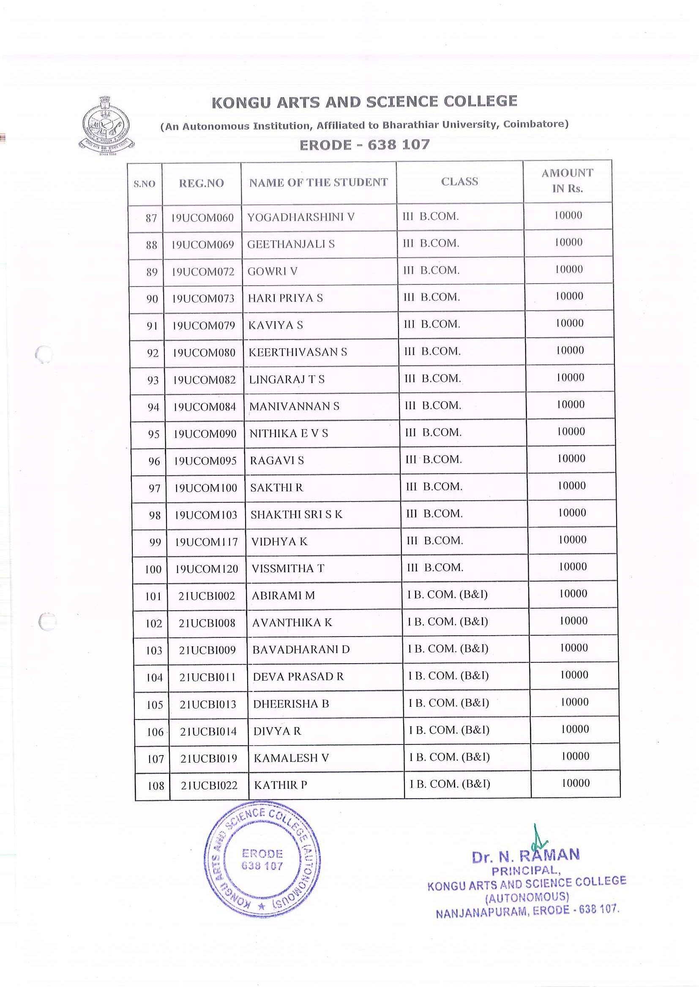

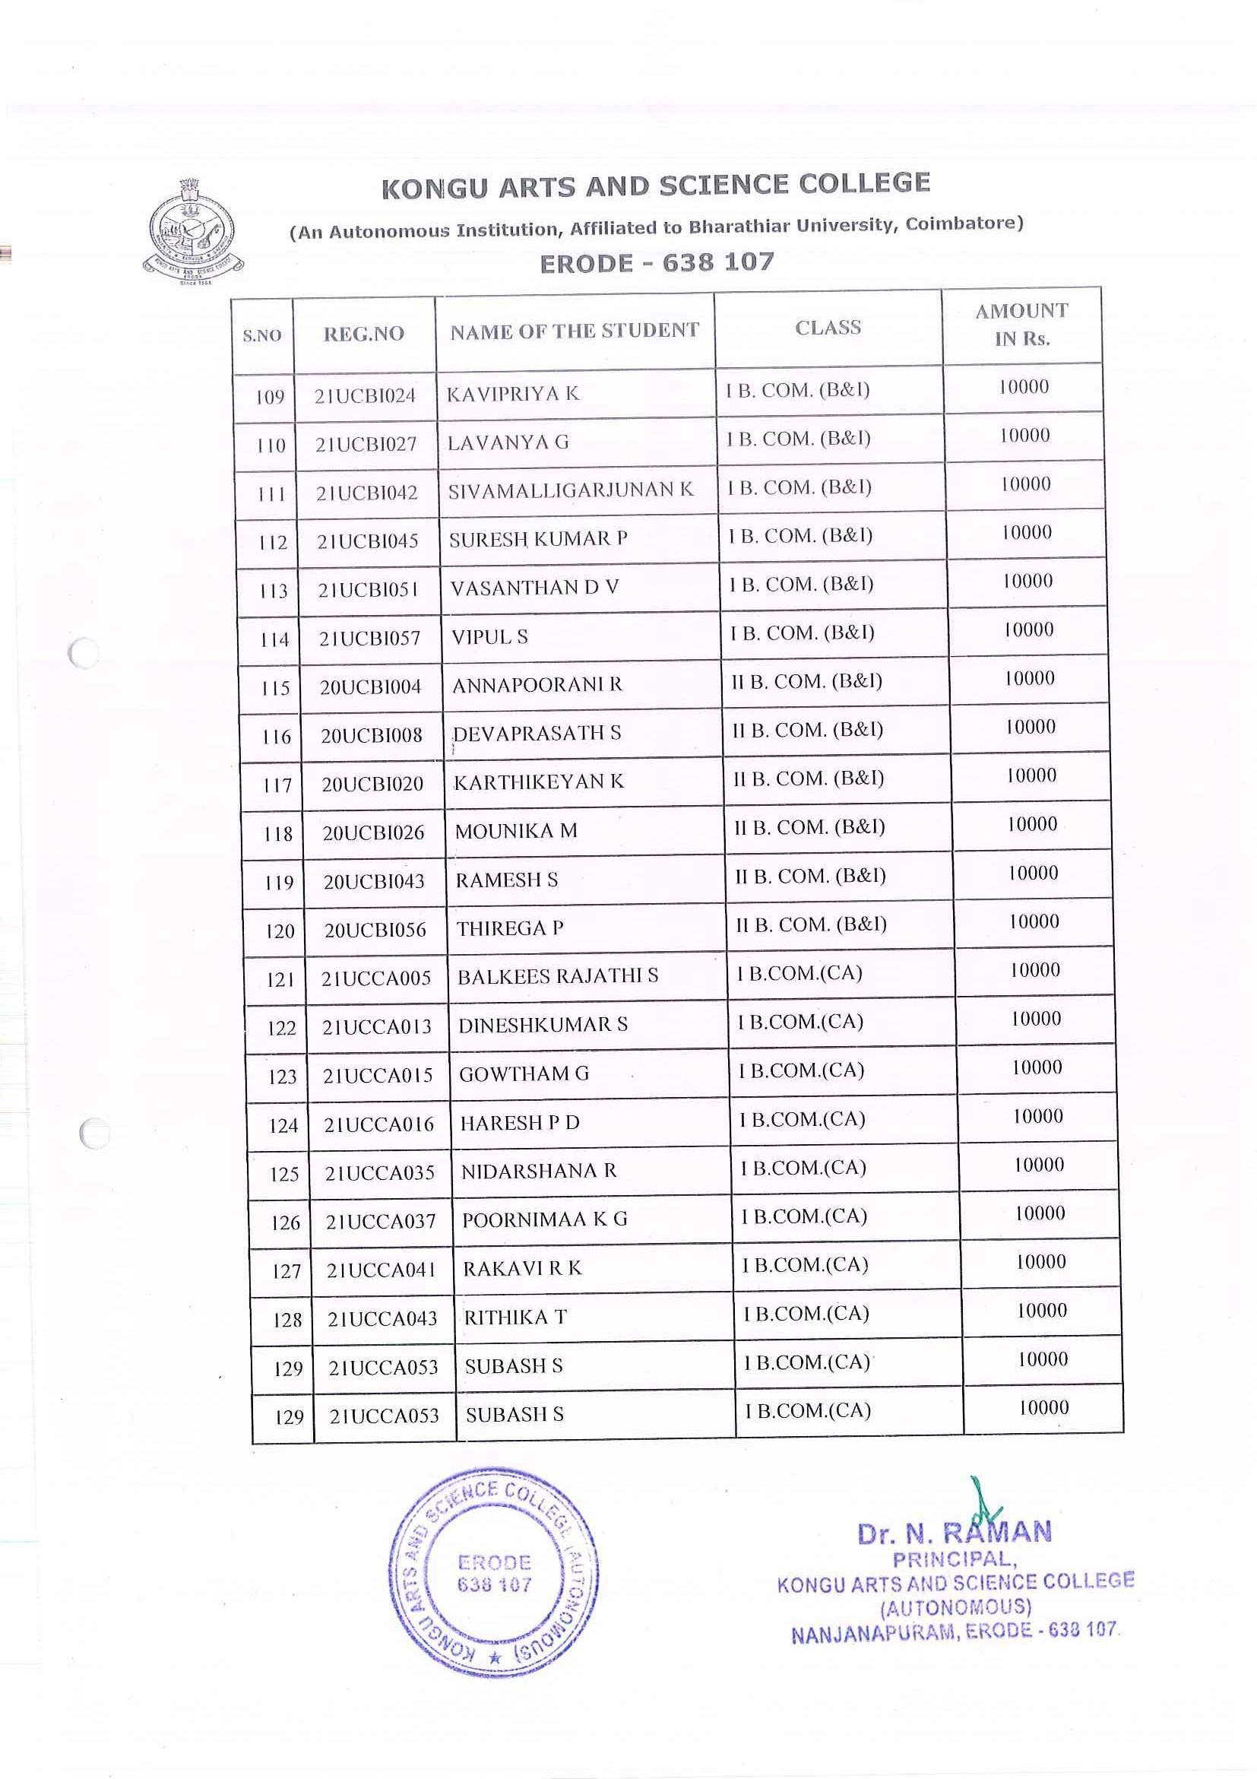

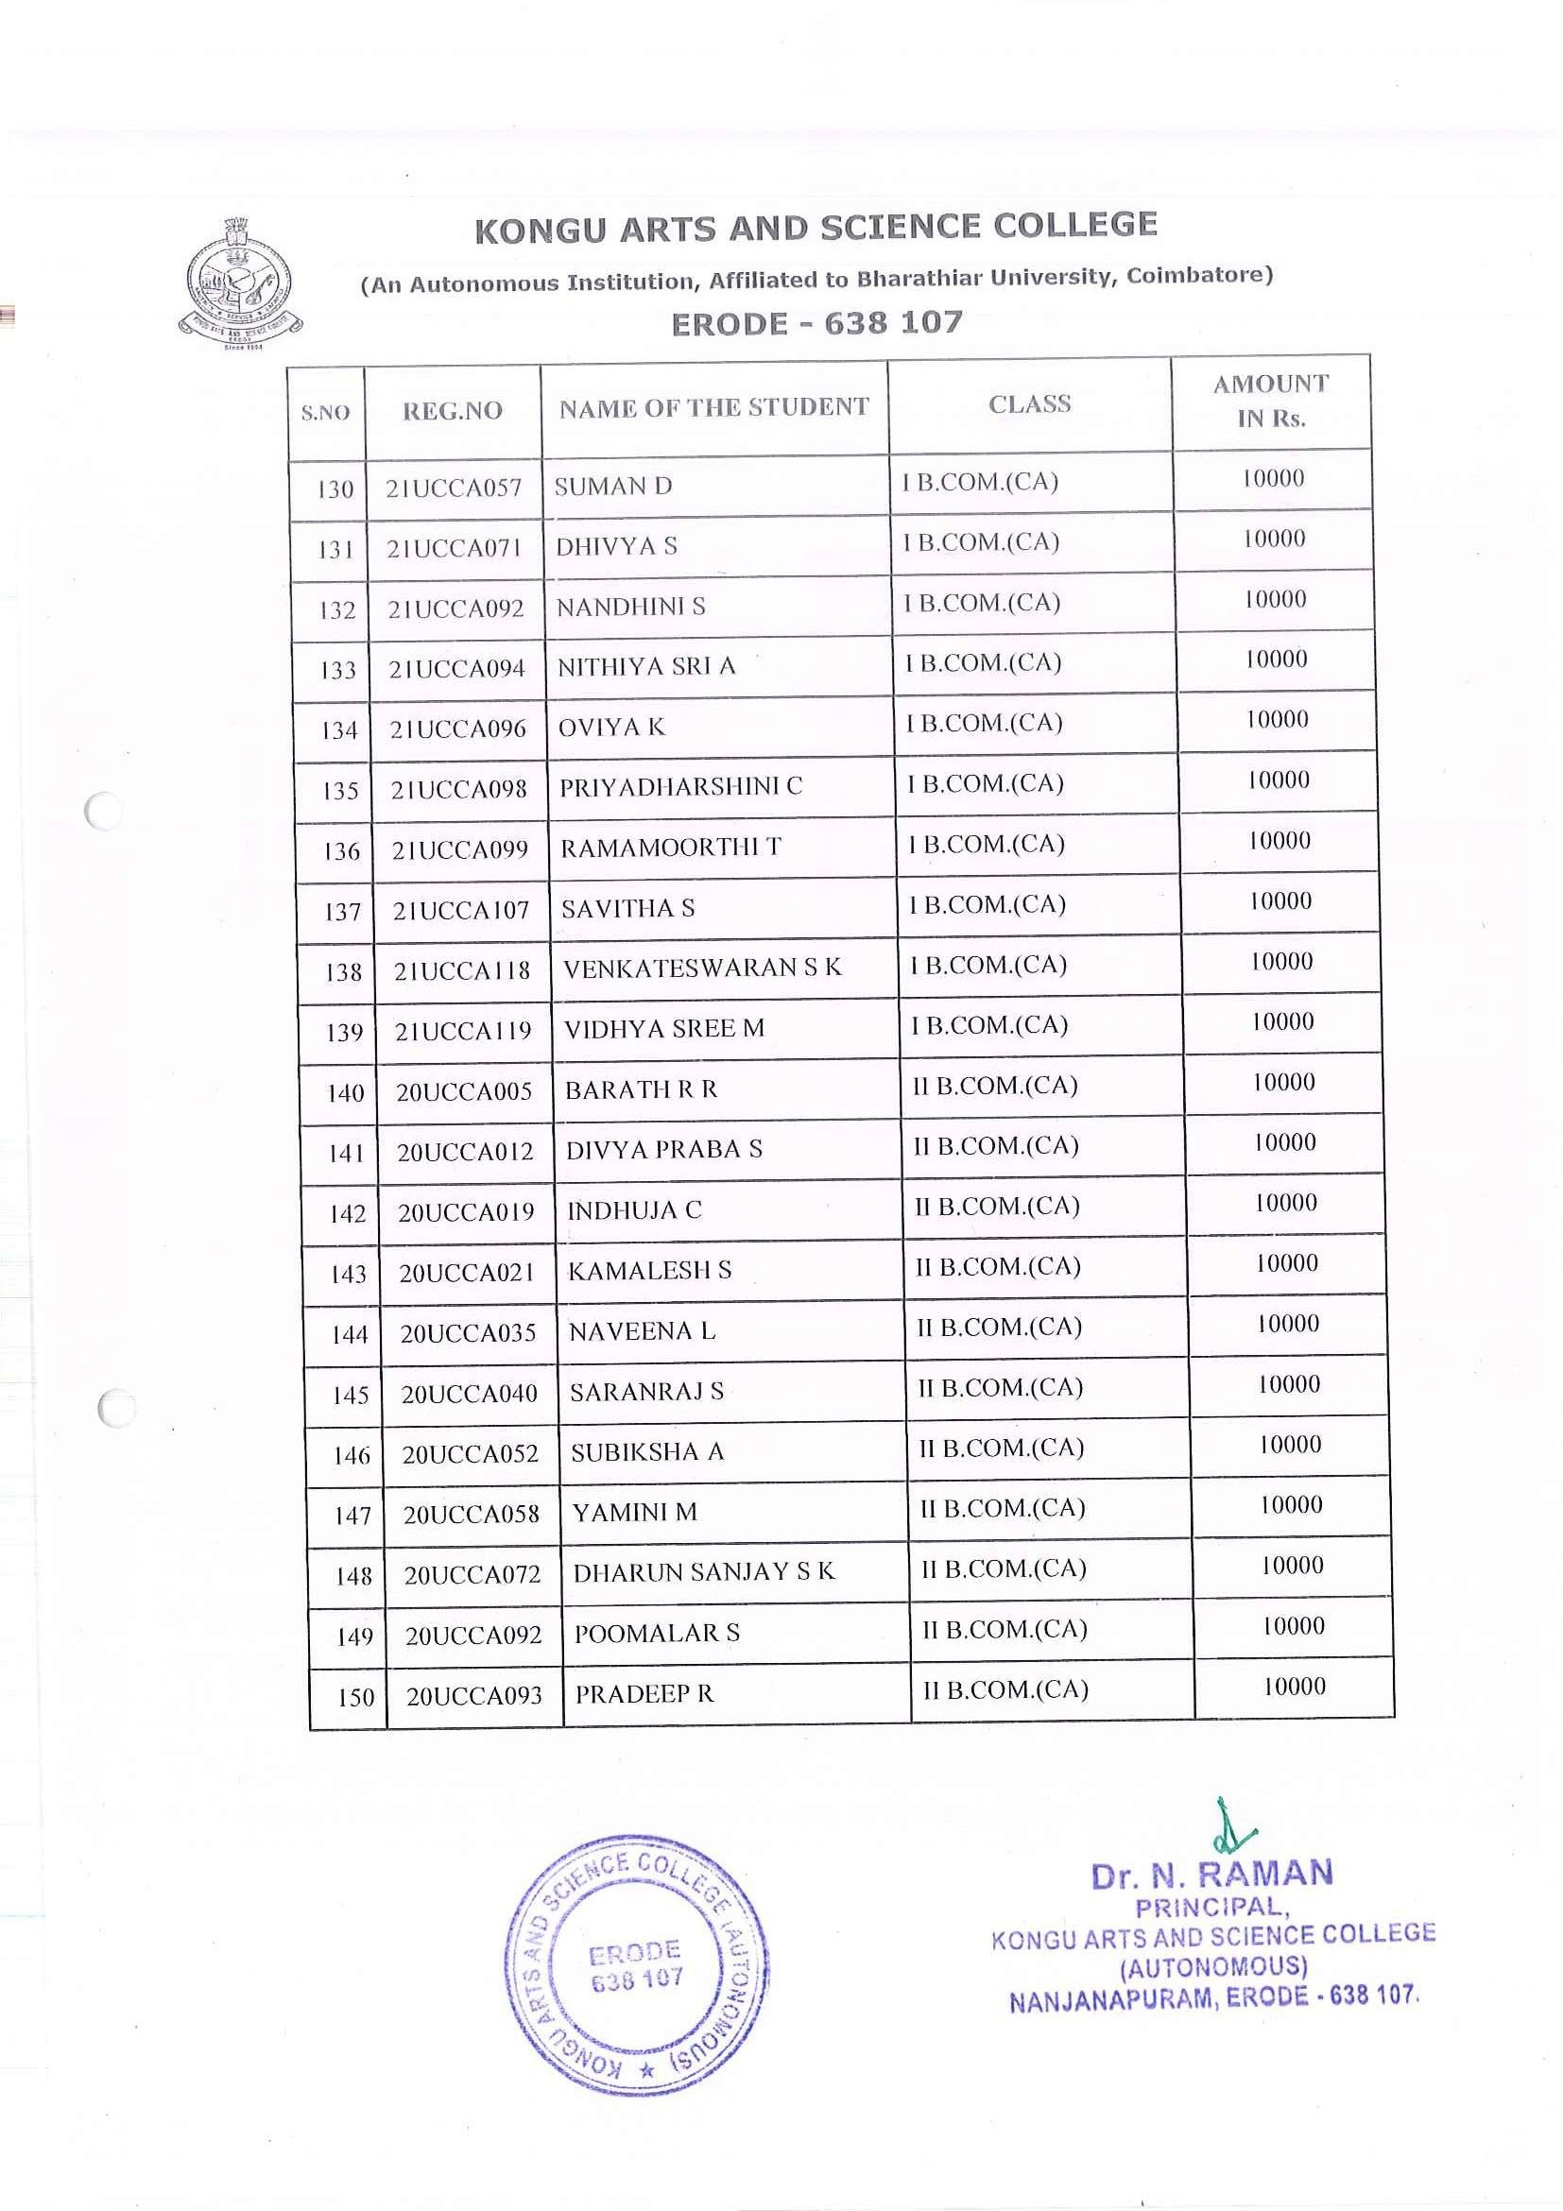

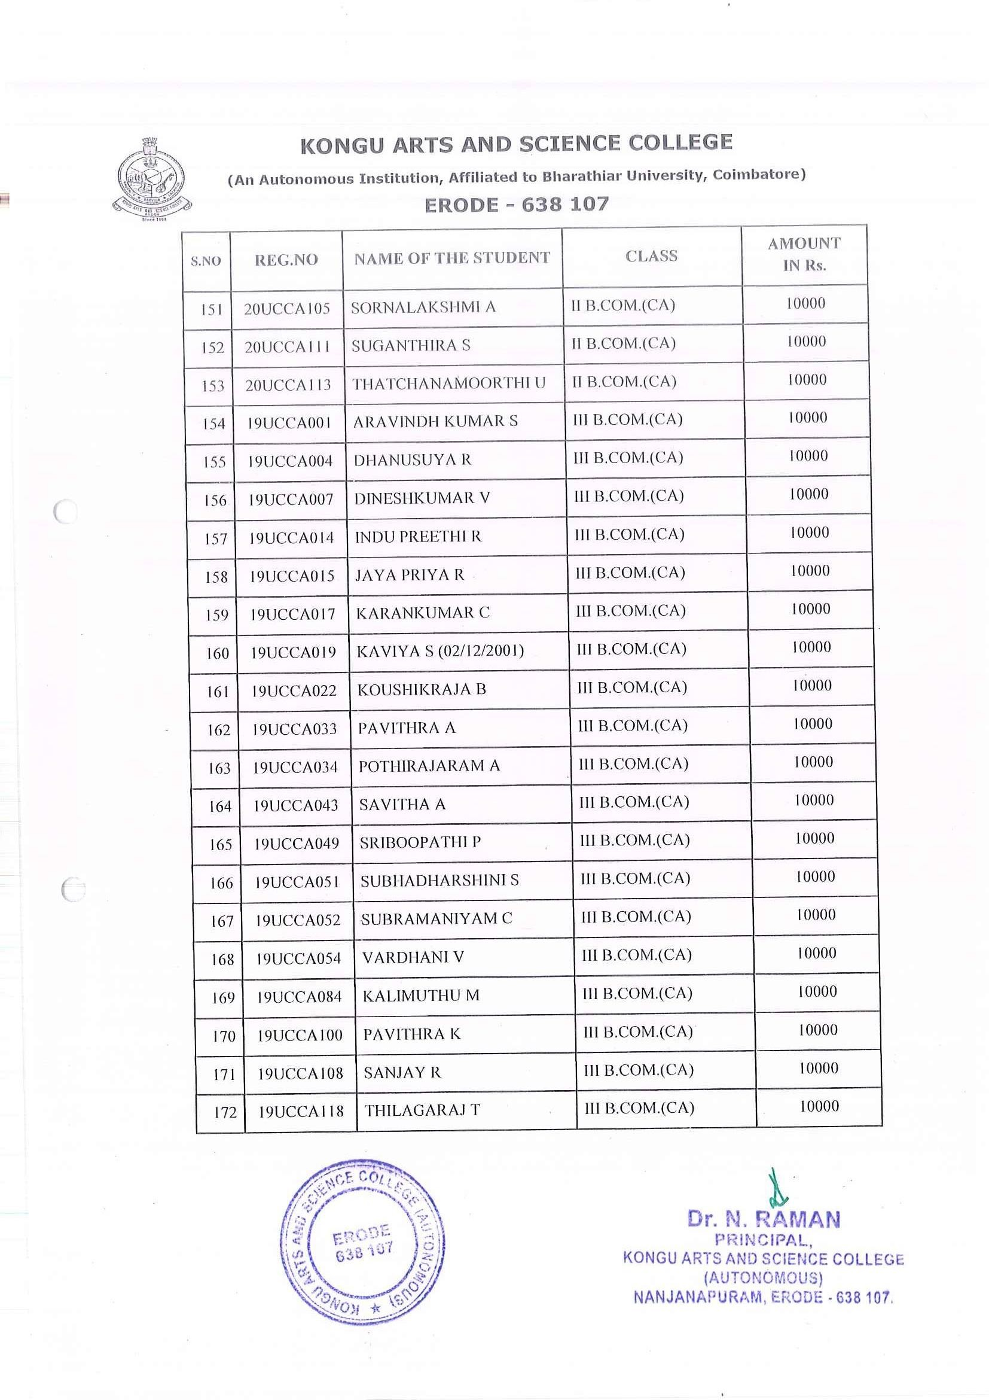

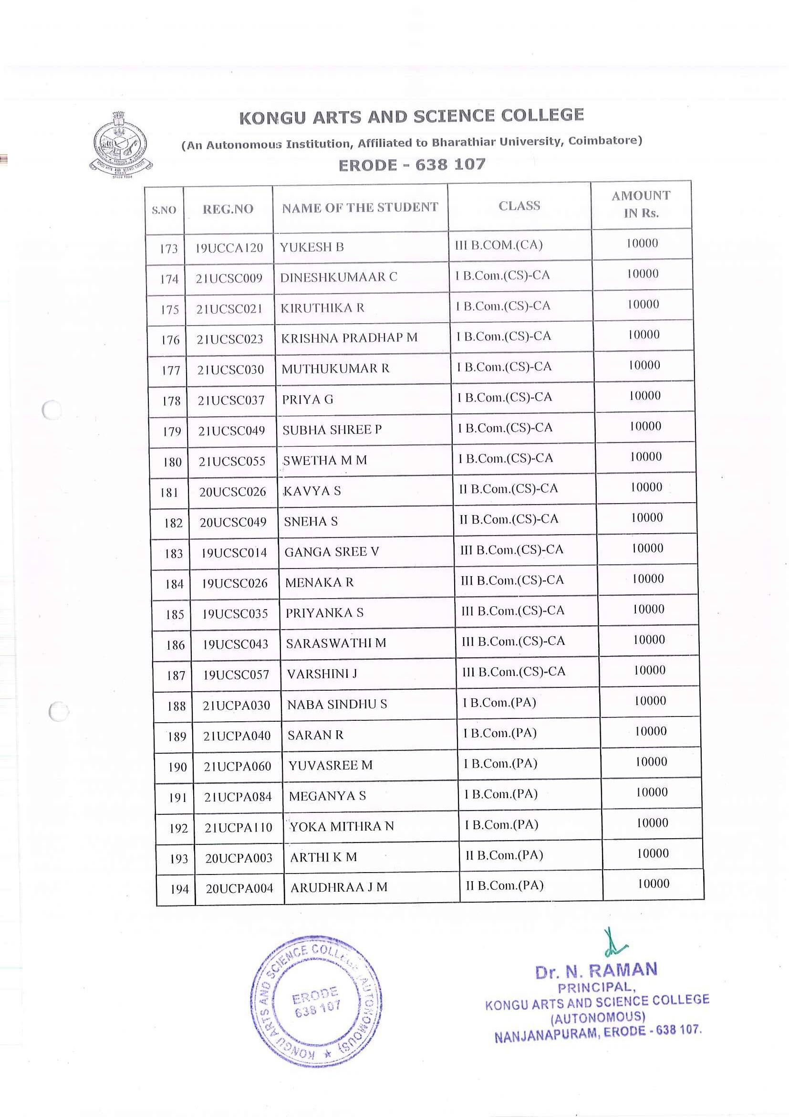

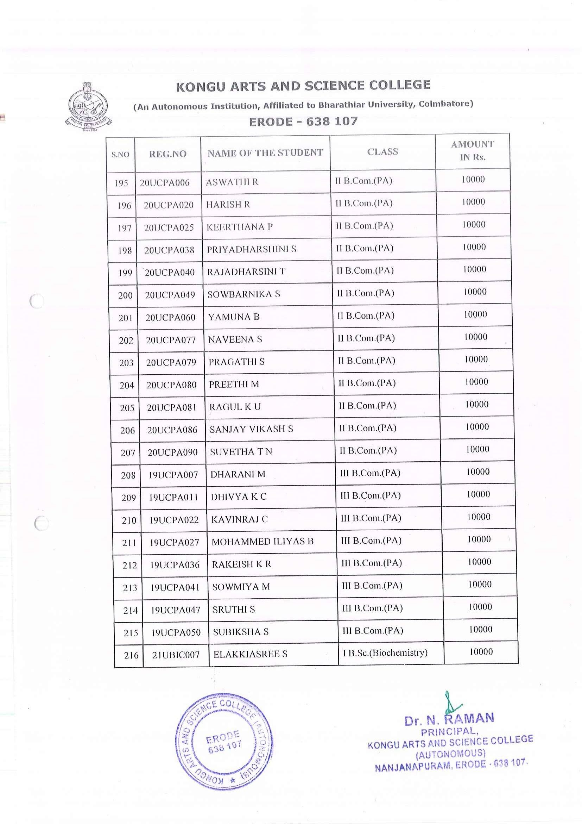

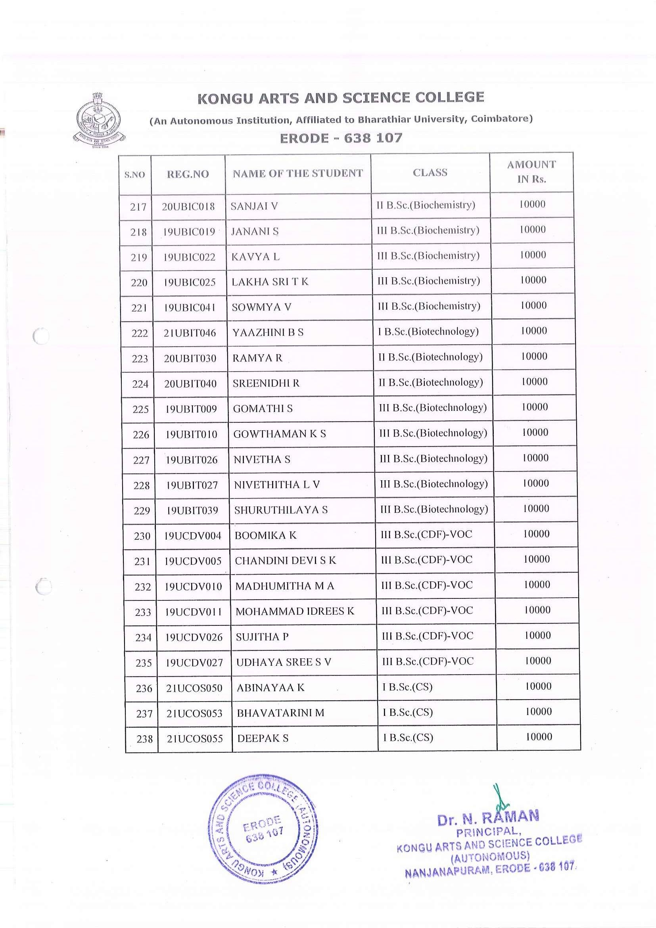

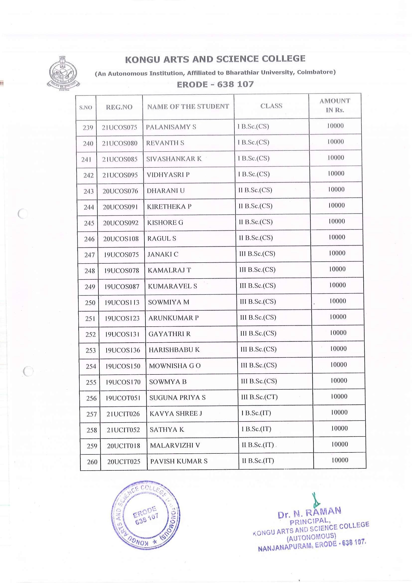

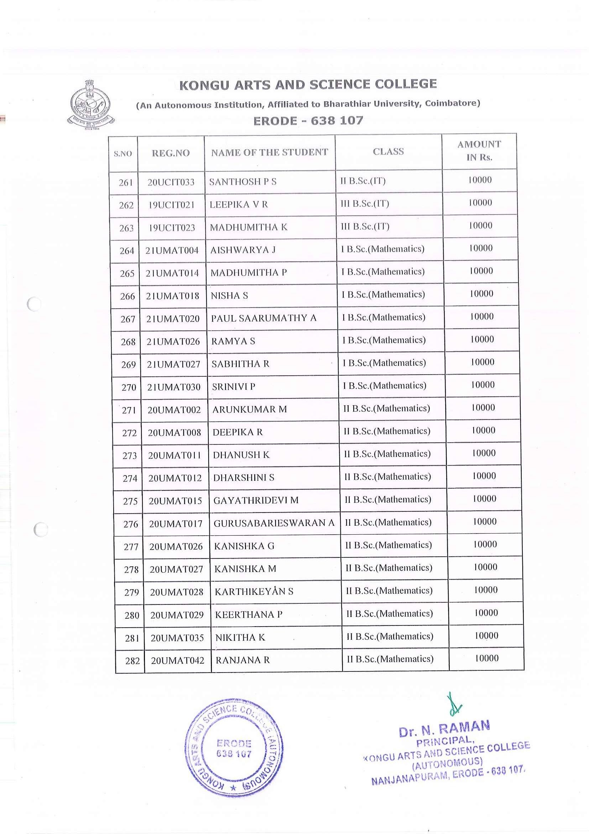

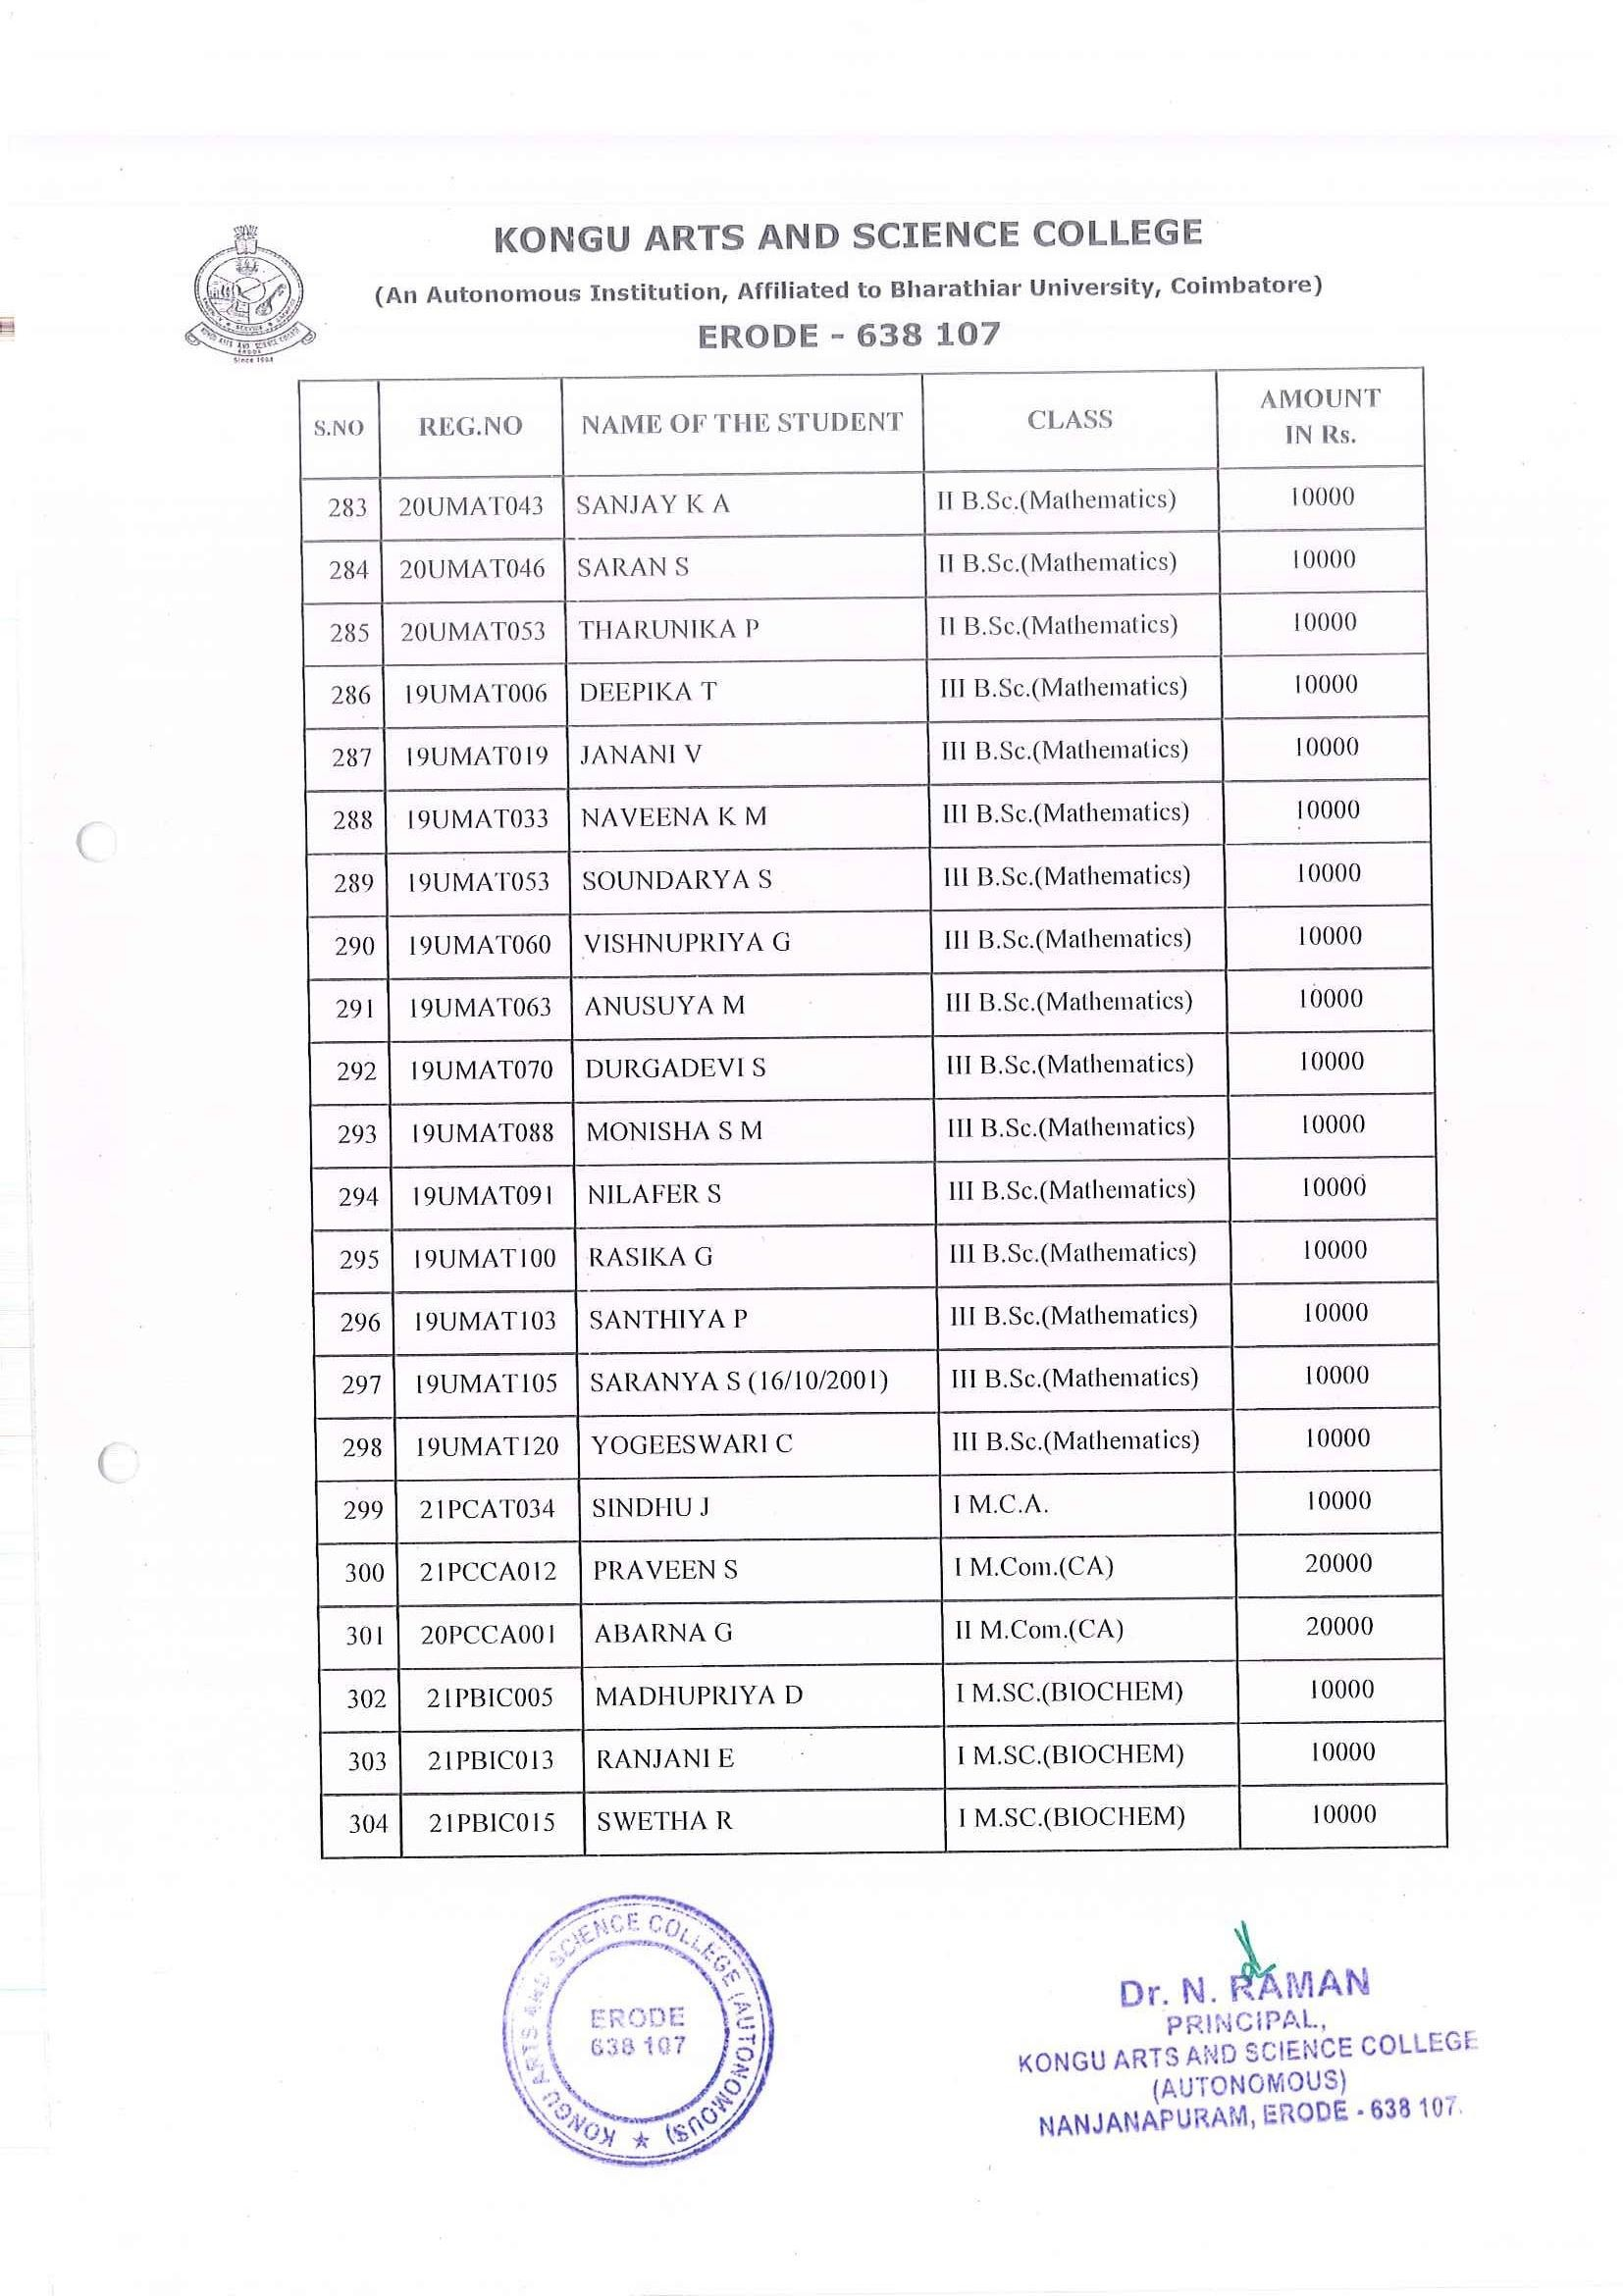

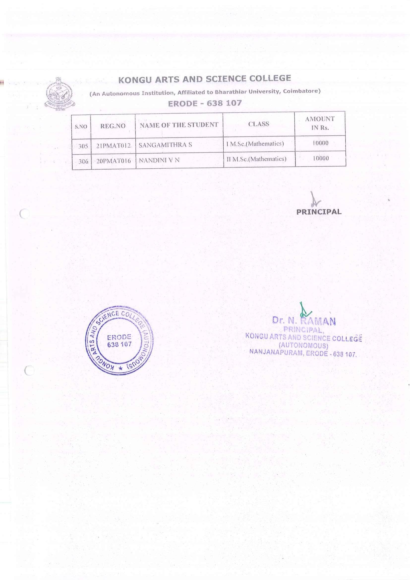

UGC/AICTE – POST GRADUATE INDRA GANDHI SCHOLARSHIP FOR SINGLE GIRL CHILD

PG INDRA-NL

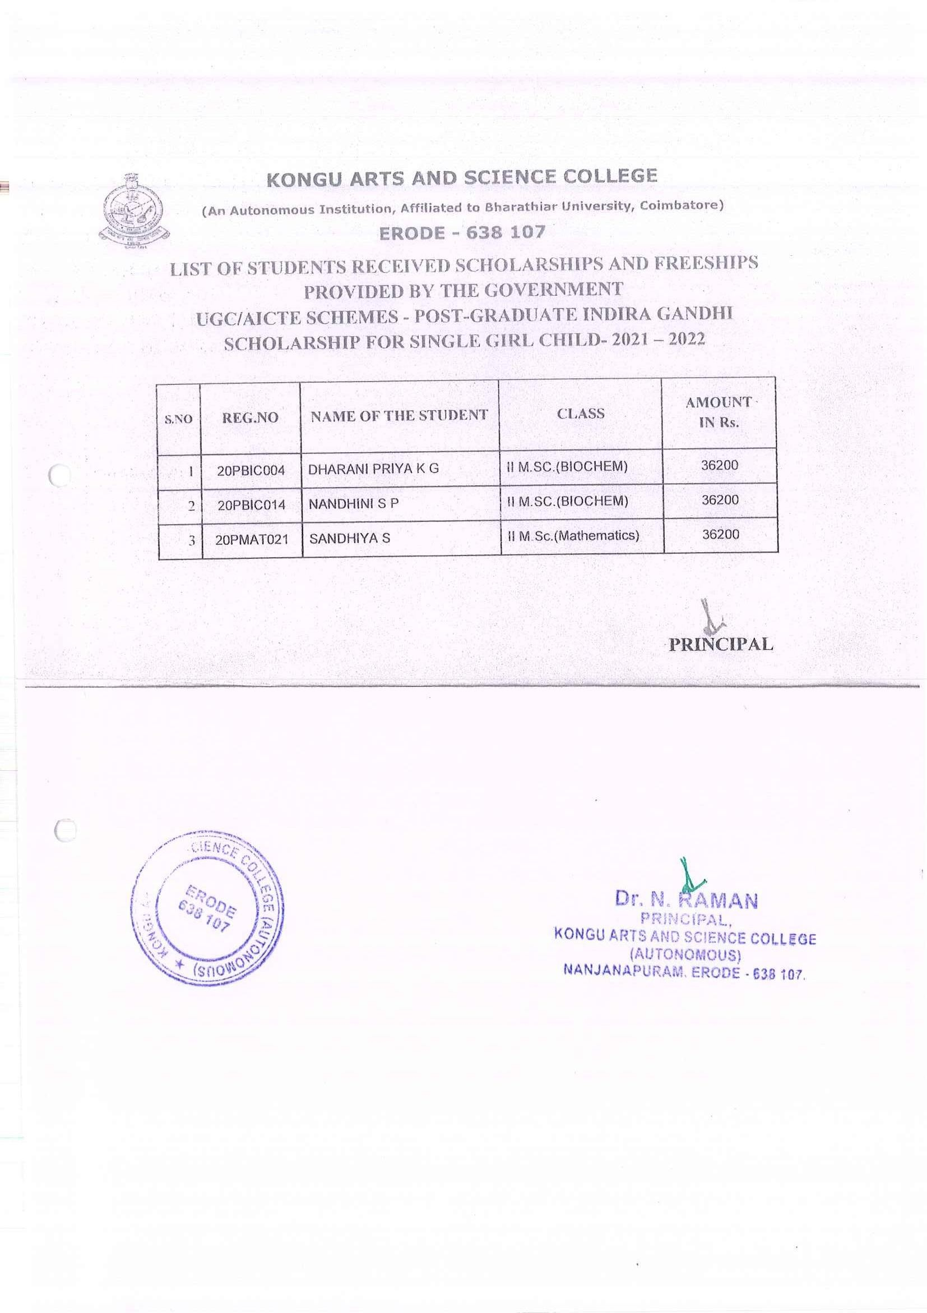

NPTEL - NL
SWAYAM NPTEL
FEE WAIVER
SCHOLARSHIP

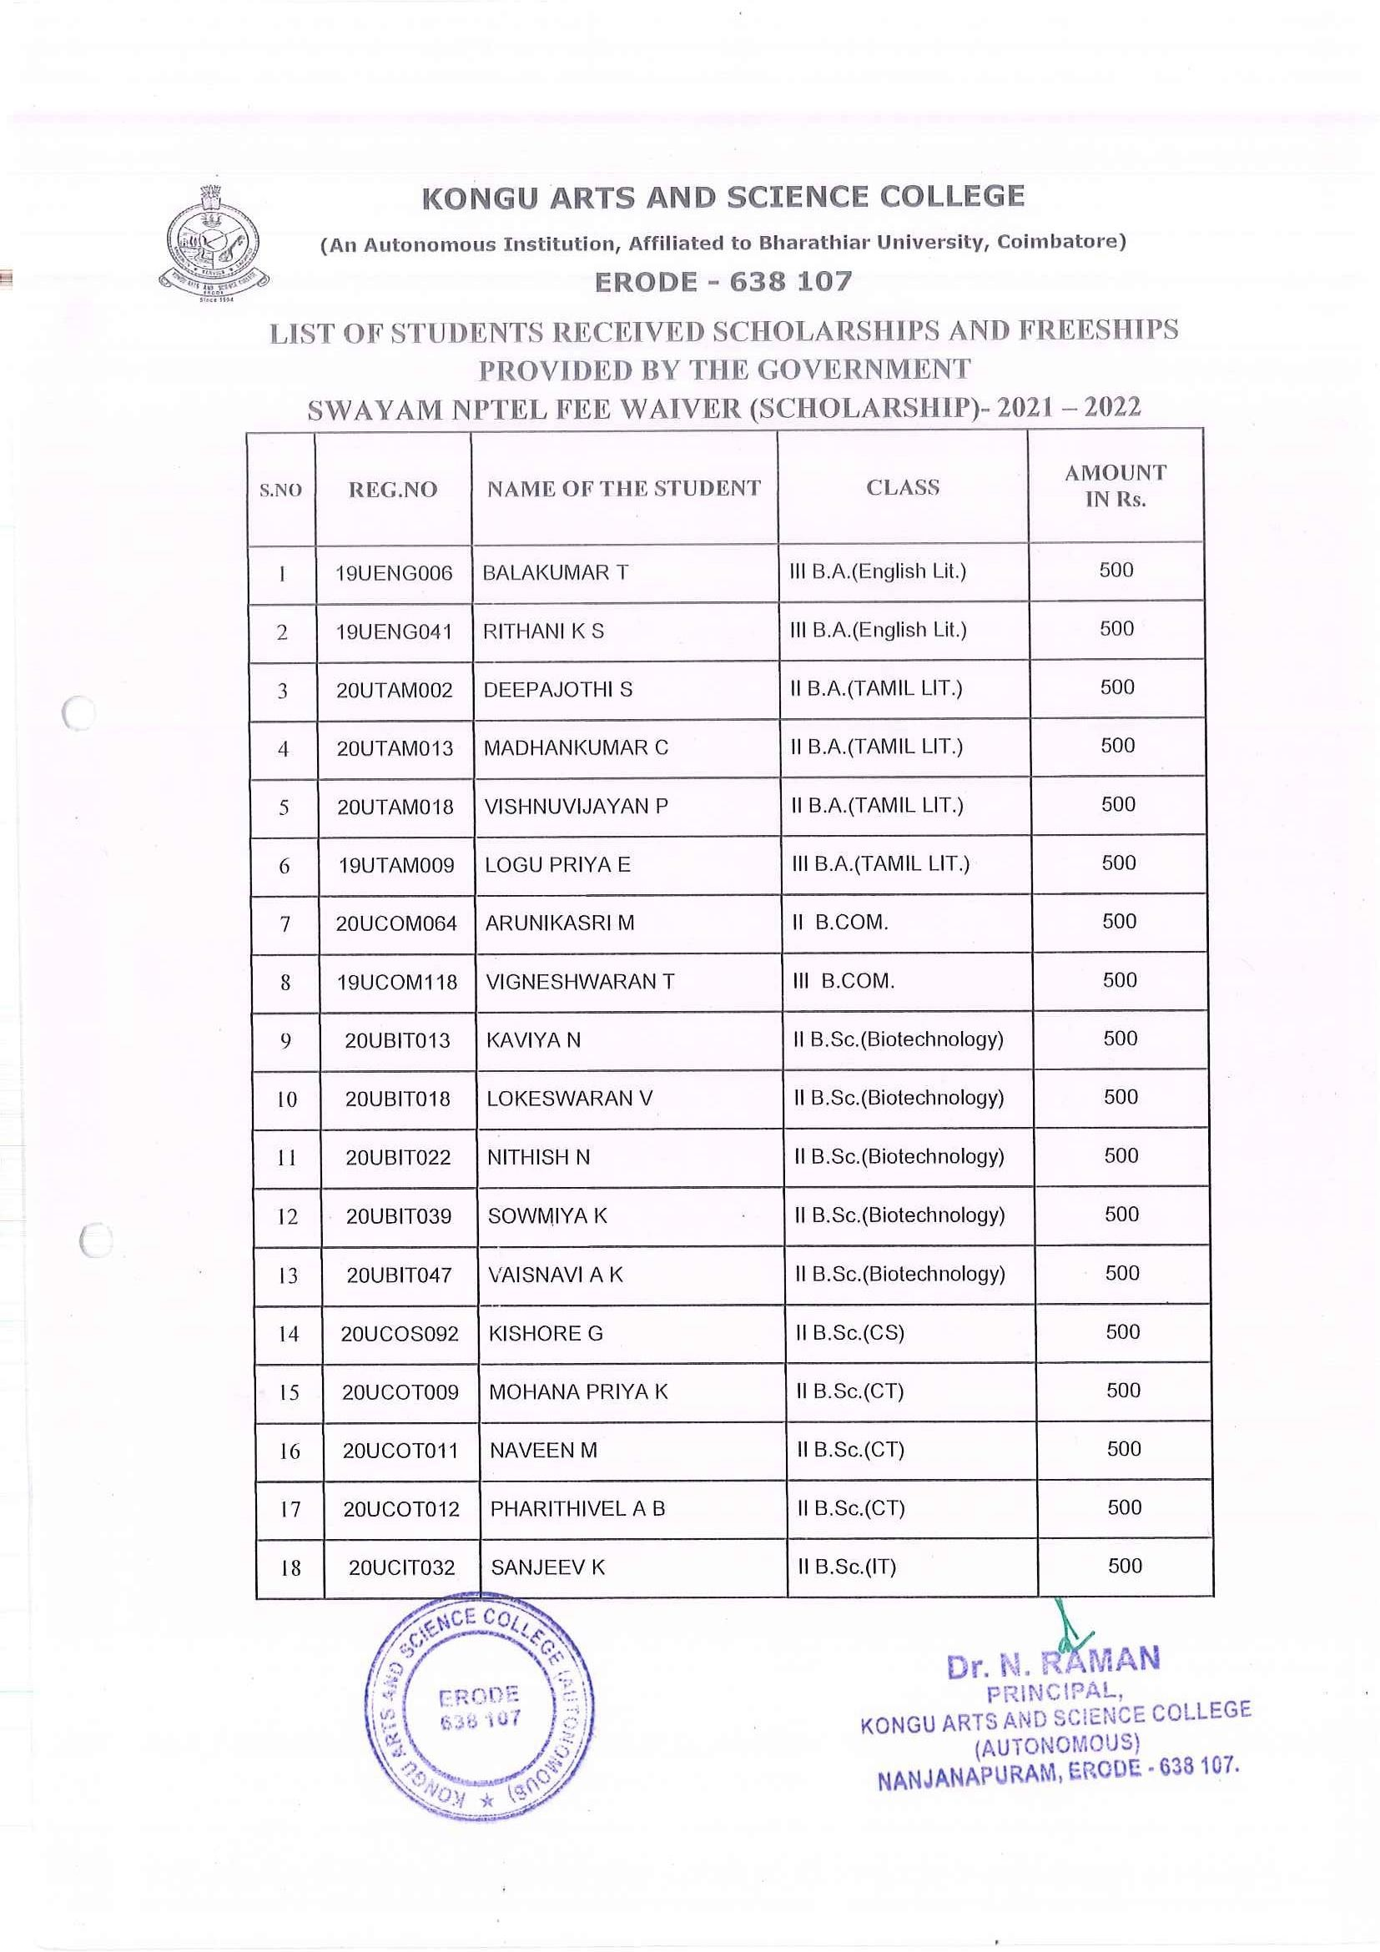

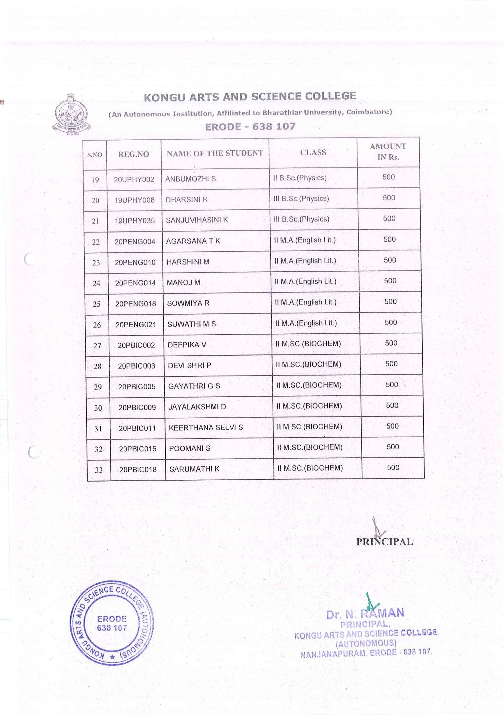

PRIME MINISTER’S SCHOLARSHIIP SCHEME

PMSS - NL

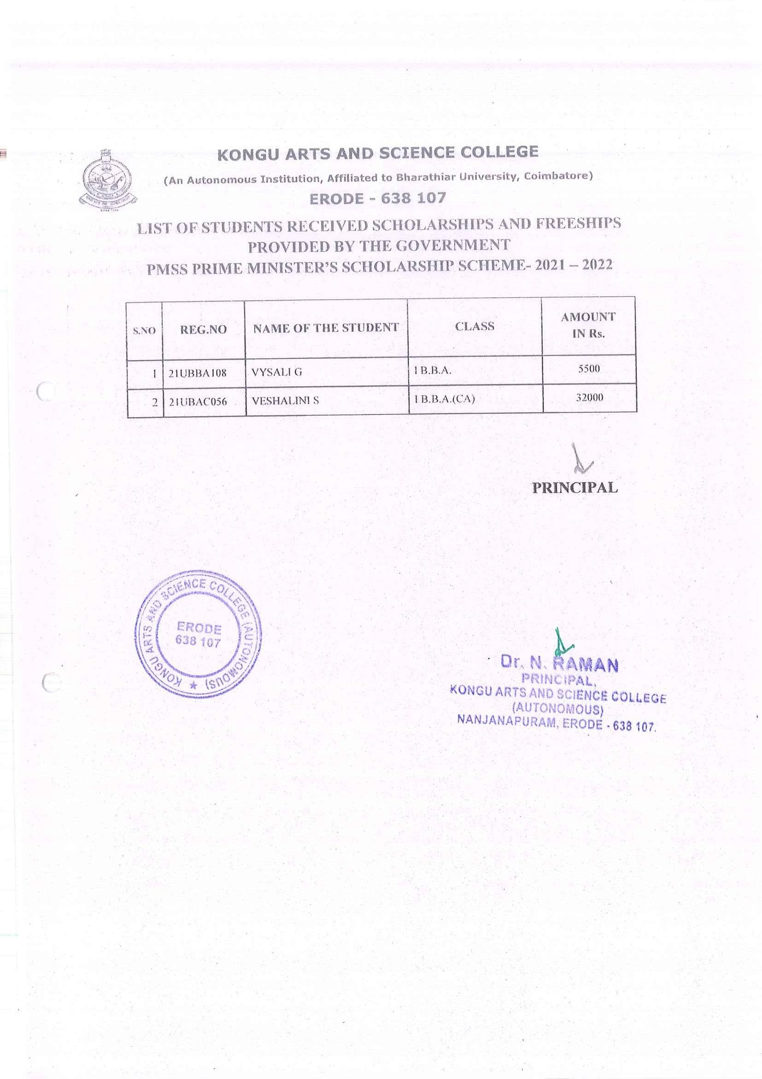

POST MATRIC SCHOLARSHIP FOR MINORITY STUDENTS

Postmatric-NL

