2019-2020

NAMELIST OF STUDENTS RECEIVED SCHOLARSHIPS AND FREESHIPS PROVIDED BY THE GOVERNMENT– 2019-2020

S.NO. | PARTICULARS | TOTAL NUMBER OF STUDENTS BENEFITED | LINK TO THE PAGE
1. | ADI DRAVIDAR AND TRIBAL WELFARE SCHOLARSHIP | 33 | View Document
2. | CENTRAL SECTOR SCHEME OF SCHOLARSHIP FOR COLLEGE AND UNIVERSITY STUDENTS | 356 | View Document
3. | BC / MBC SCHOLARSHIP | 04 | View Document
TOTAL NUMBER OF STUDENTS BENIFITED THROUGH FREESHIPS AND SCHOLARSHIPS PROVIDED BY THE GOVERNMENT |  | 393*

*One Student benefited by more than one scheme has been counted as one only

ADI DRAVIDAR AND TRIBAL WELFARE SCHOLARSHIP

ADW-Namelist

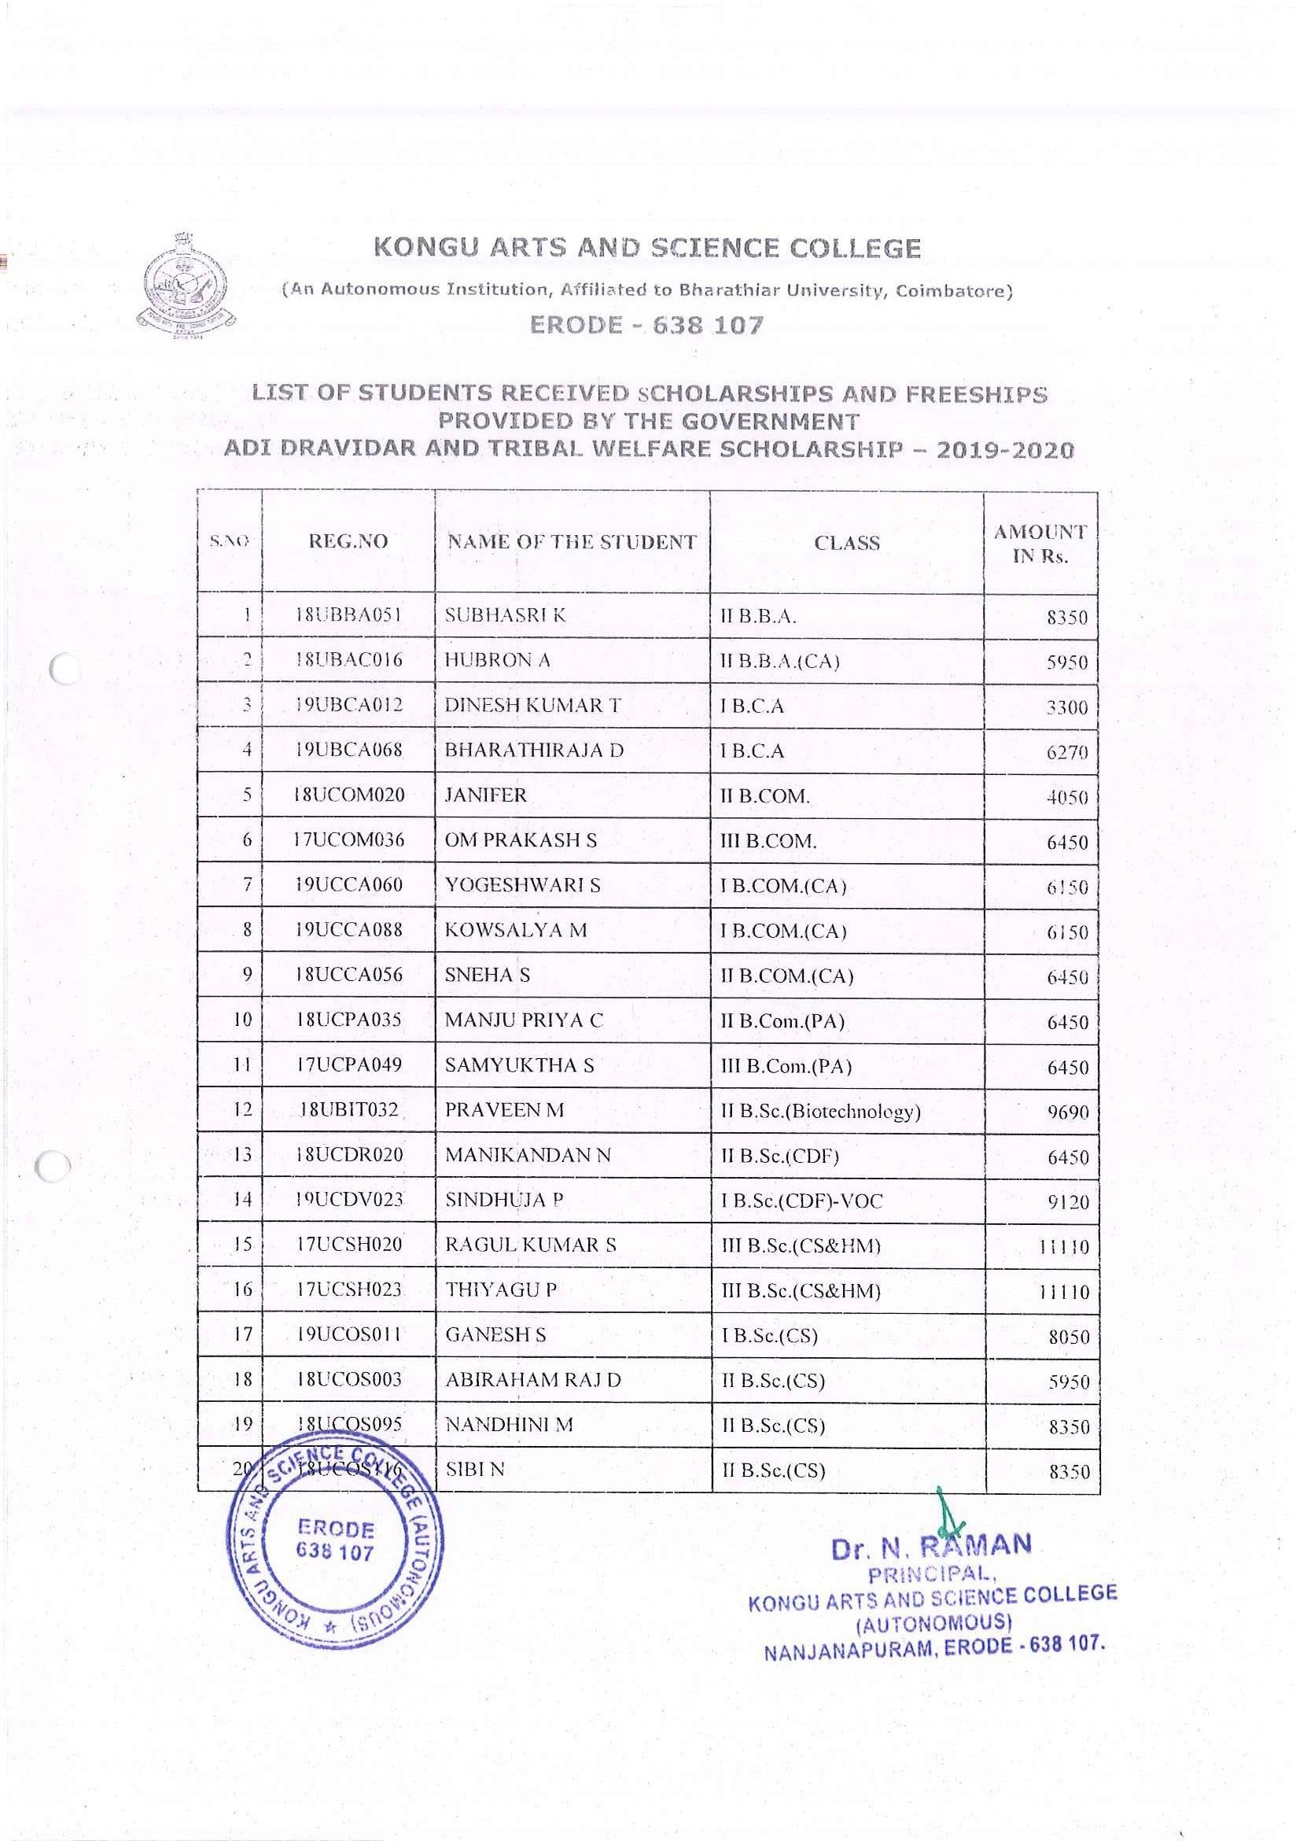

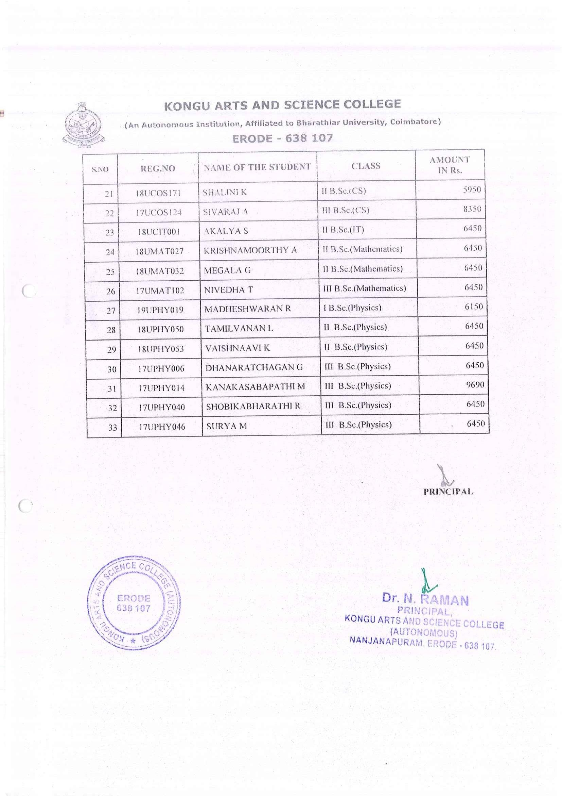

CENTRAL SECTOR SCHEME OFSCHOLARSHIP FOR COLLEGE AND UNIVERSITY STUDENTS

CSSS-NL
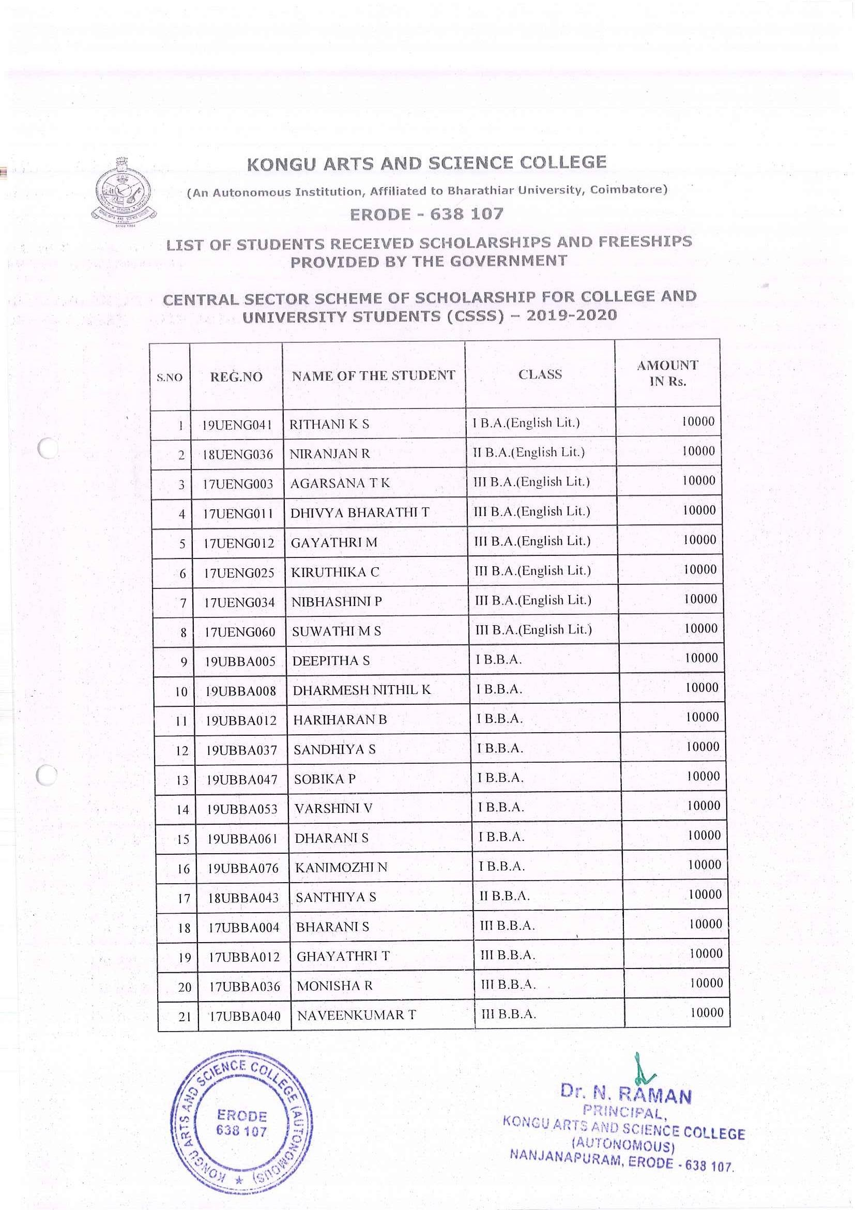

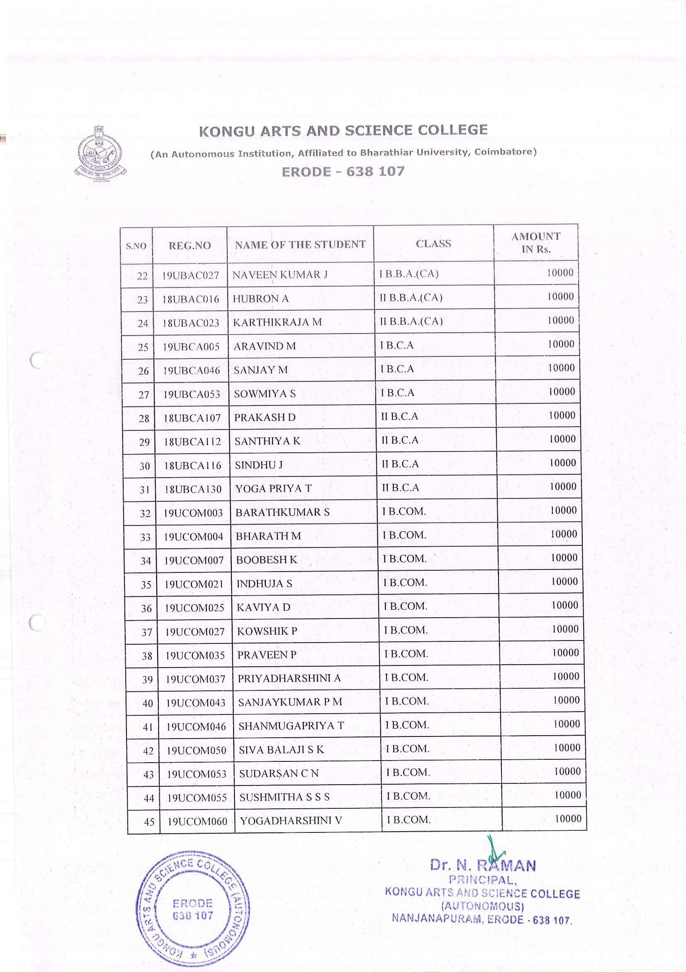

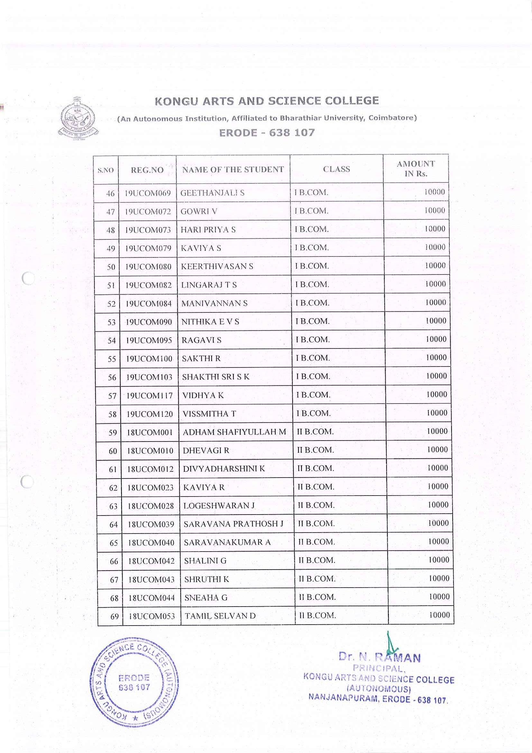

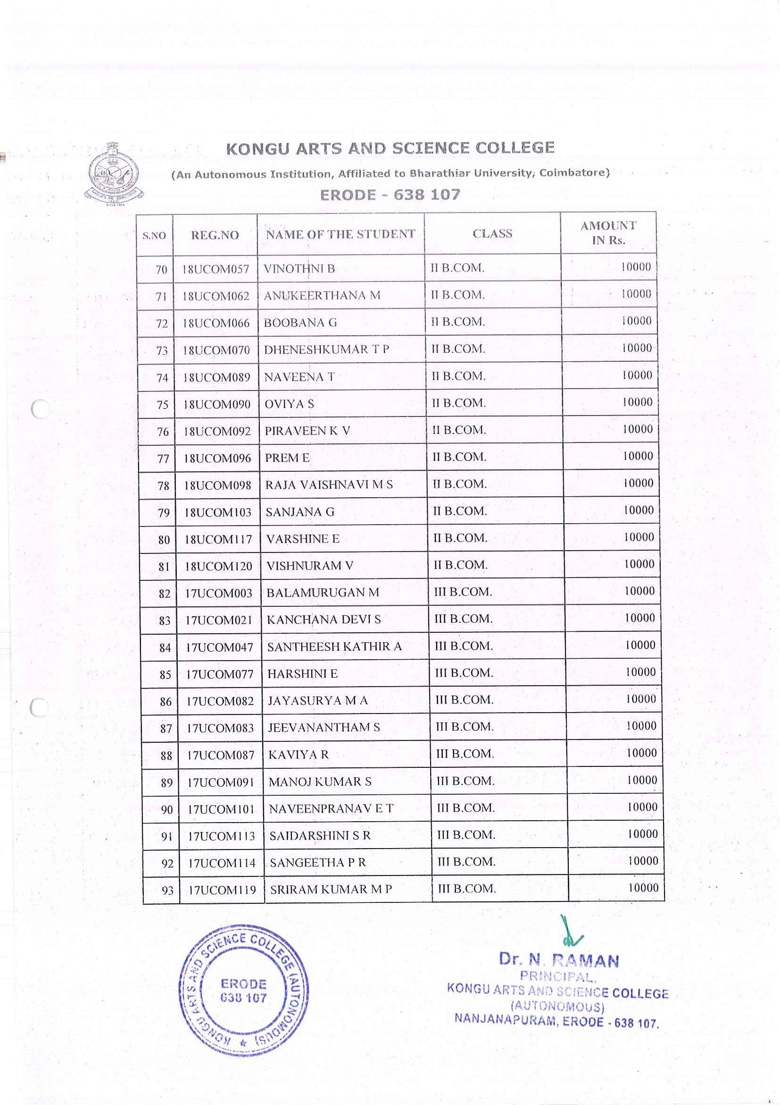

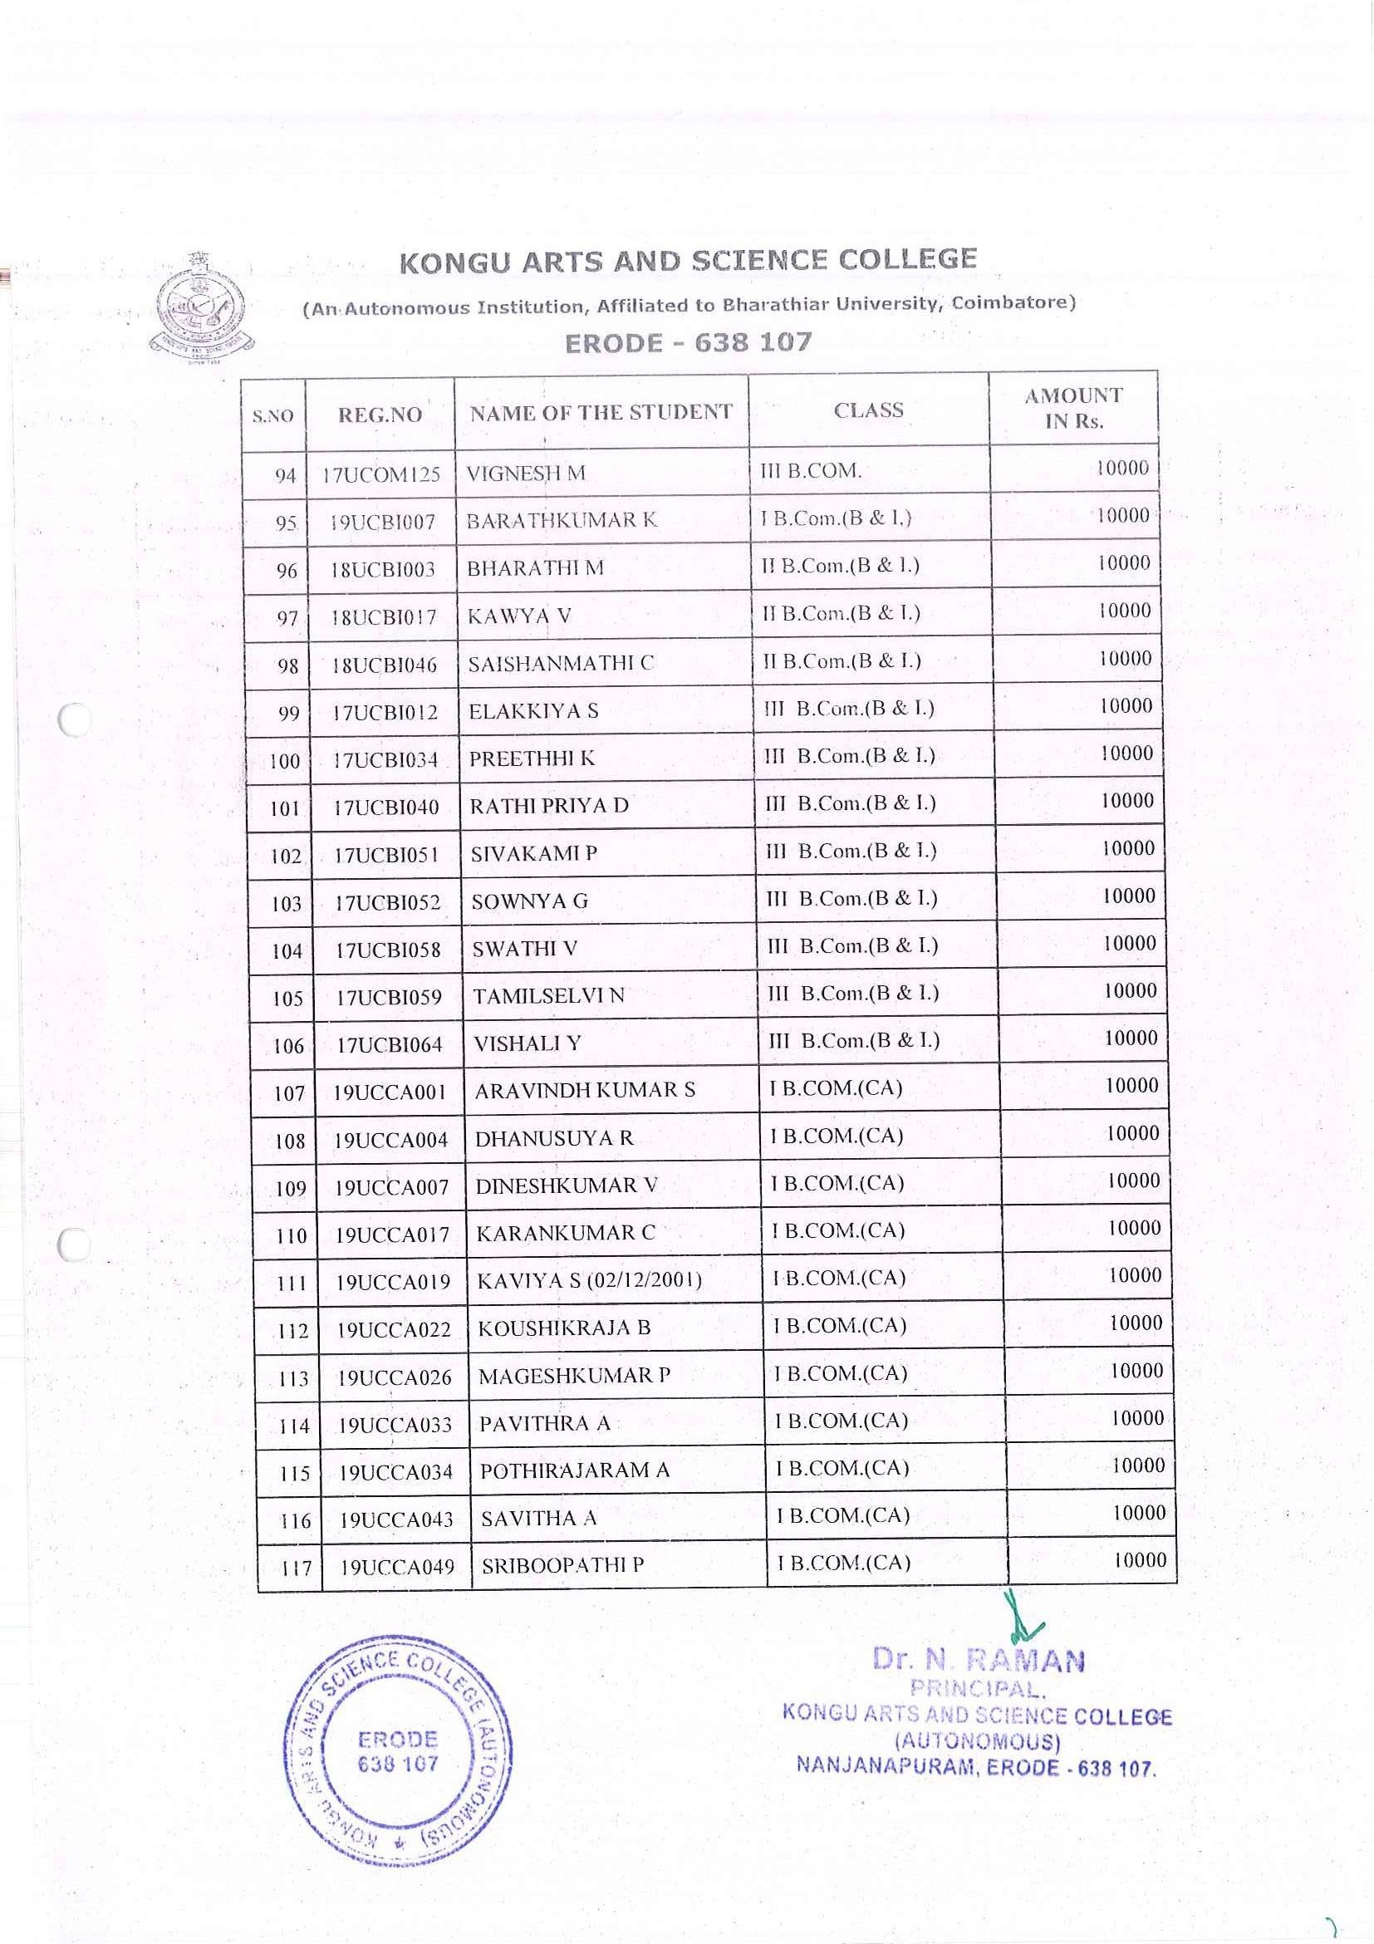

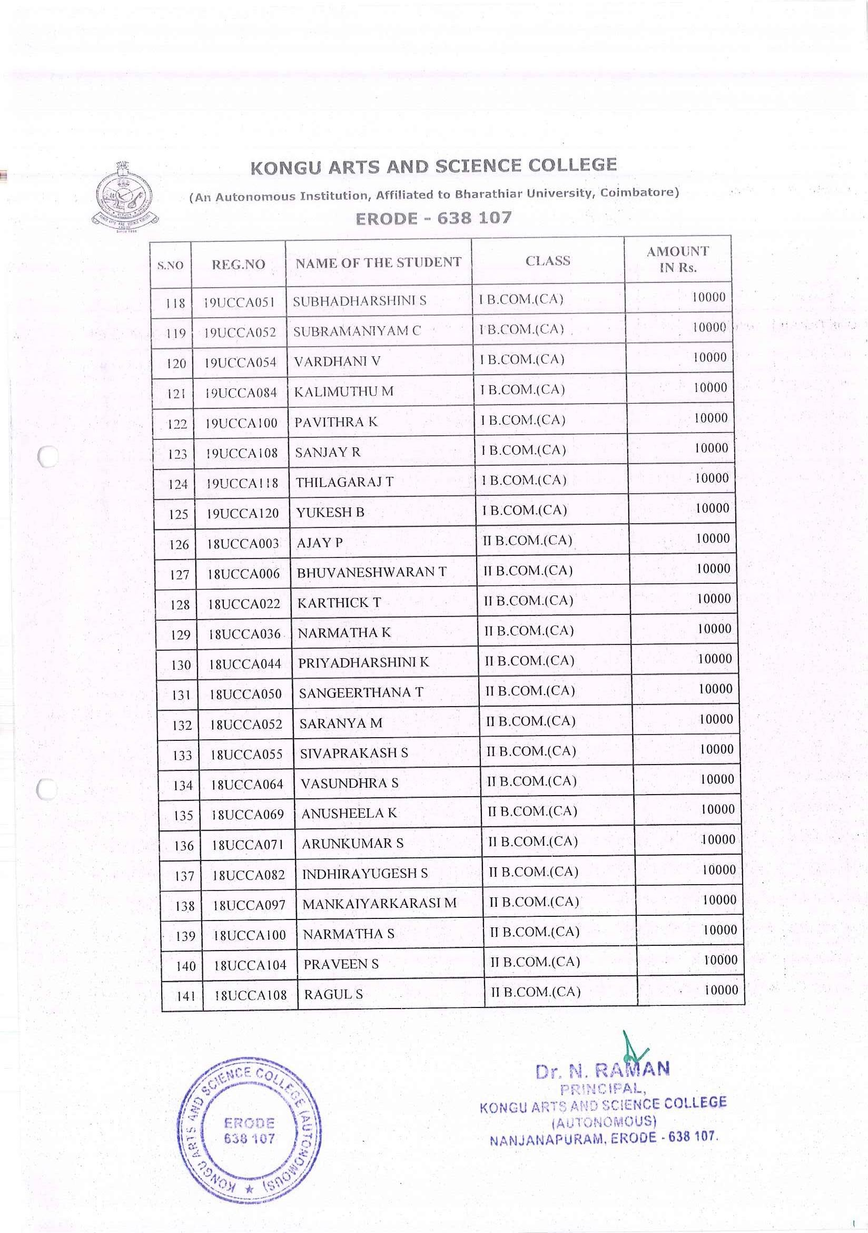

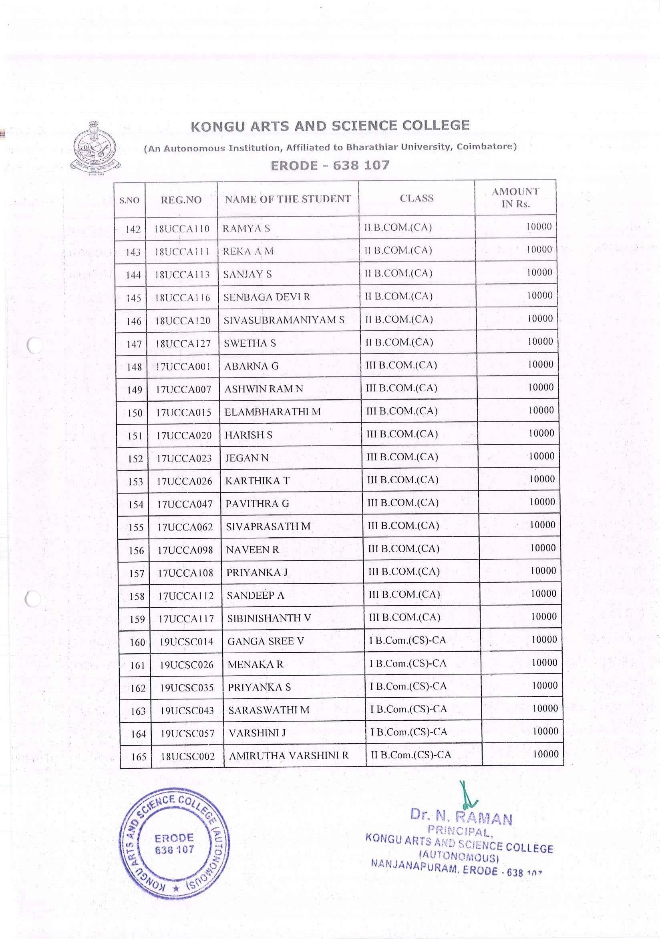

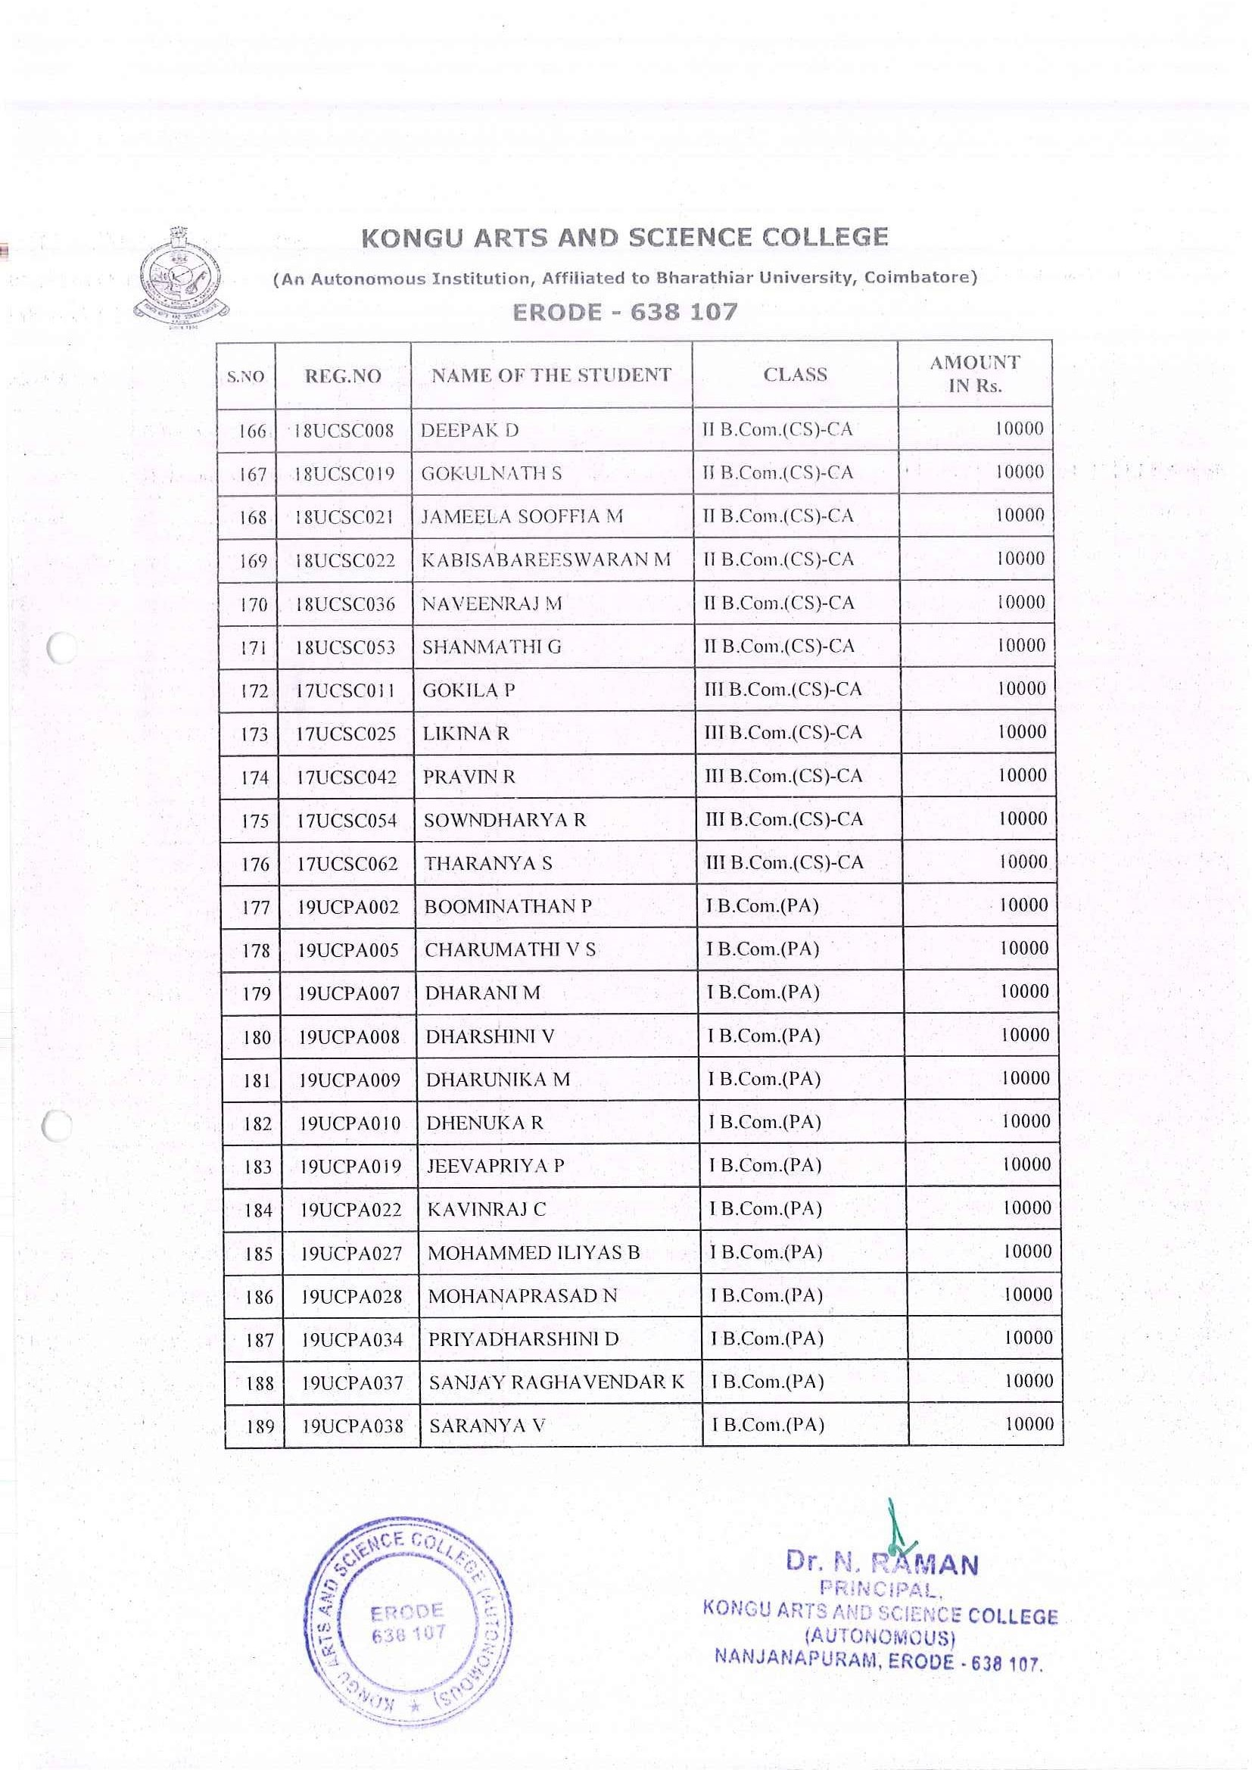

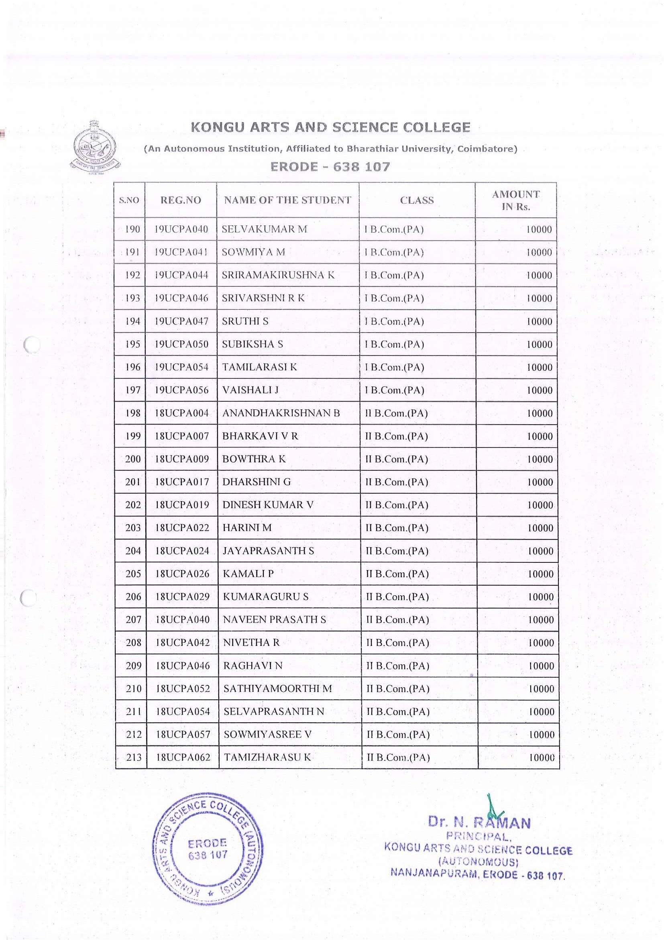

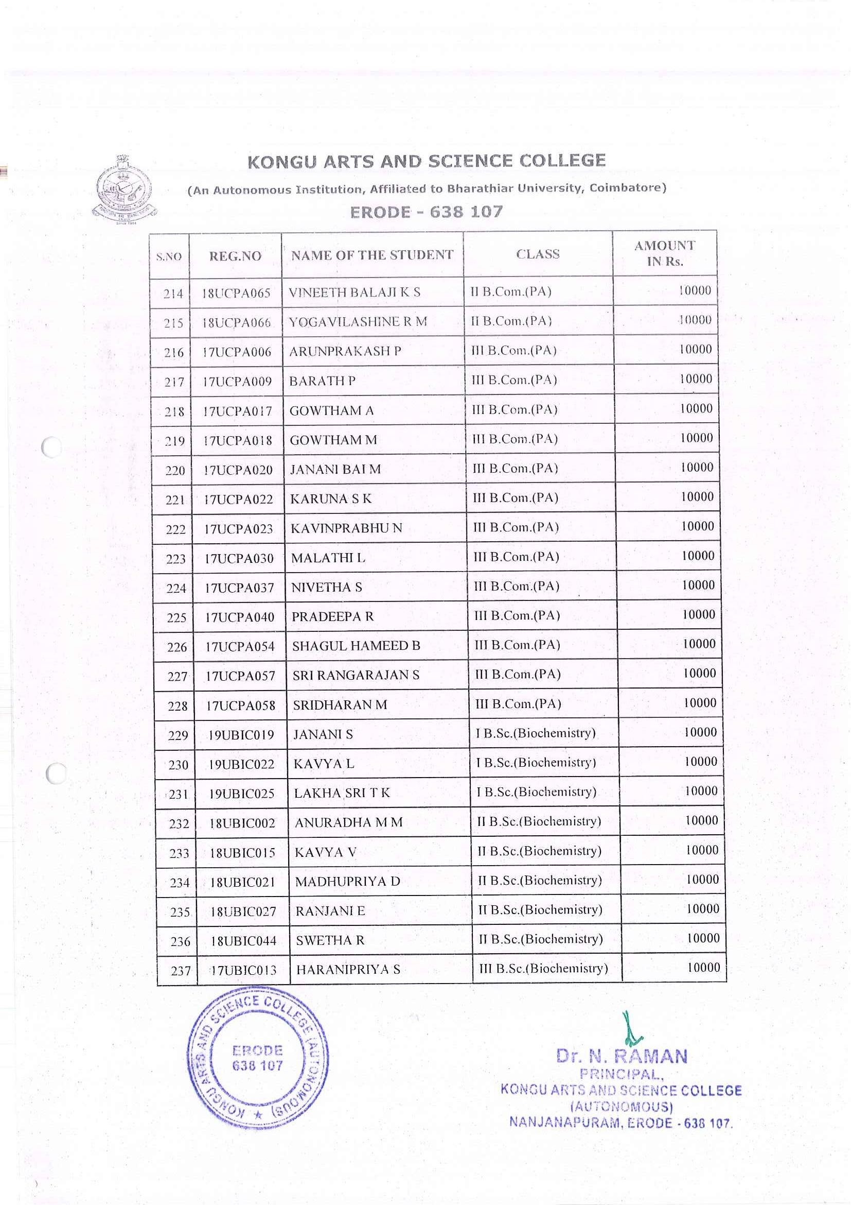

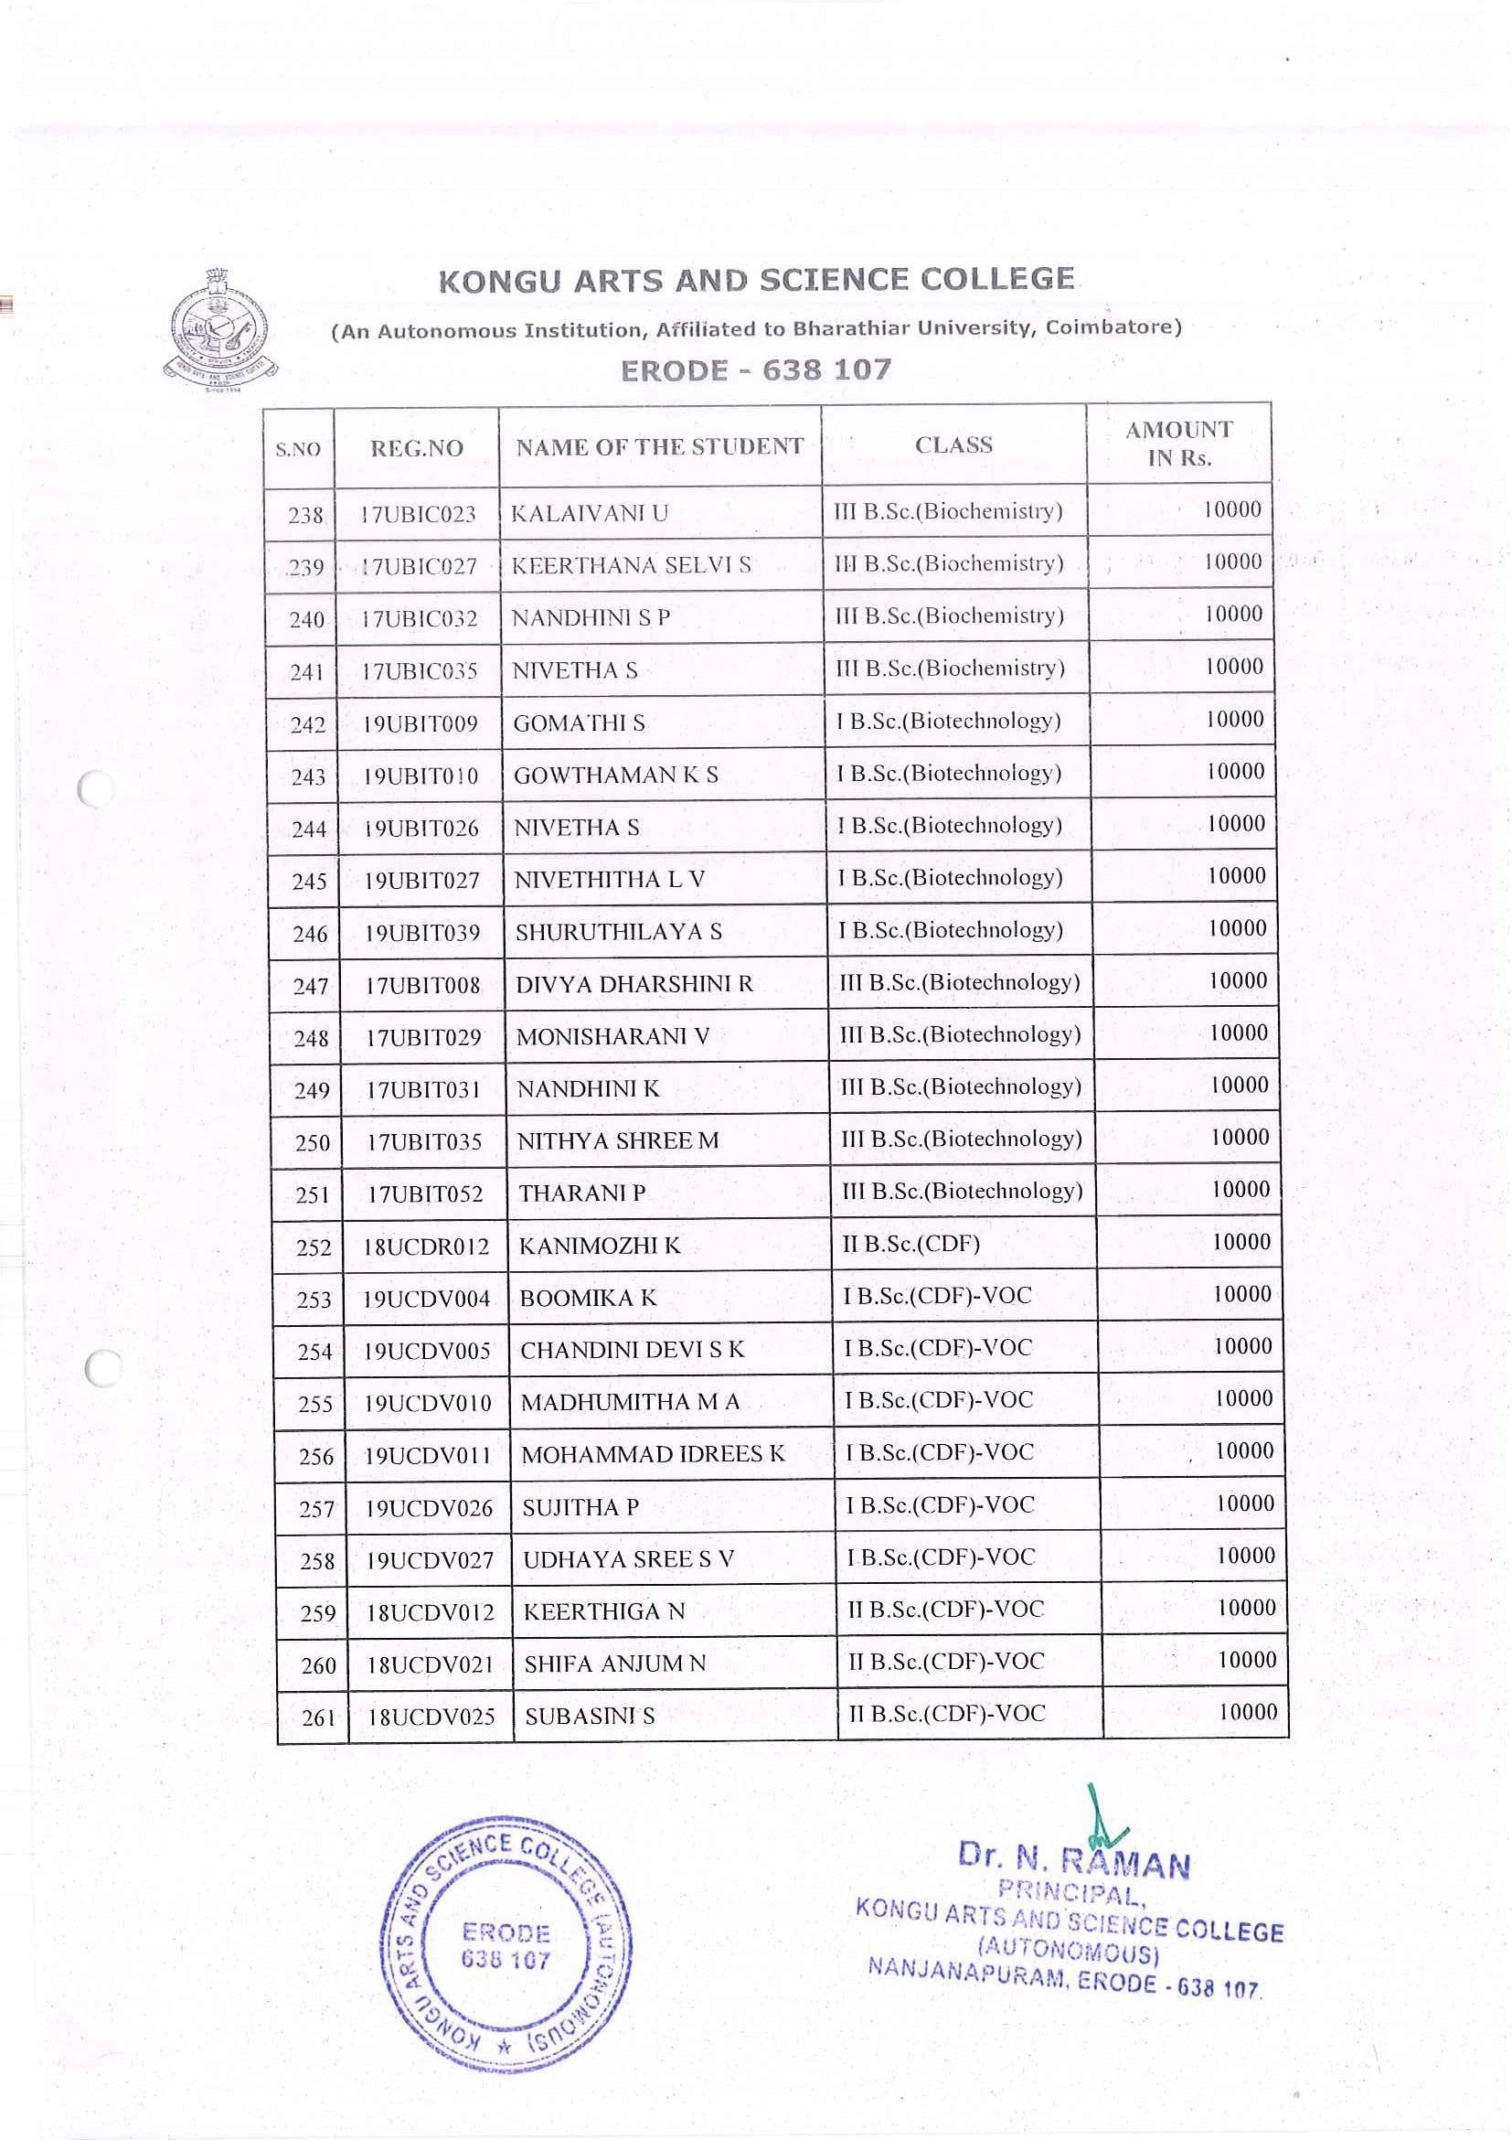

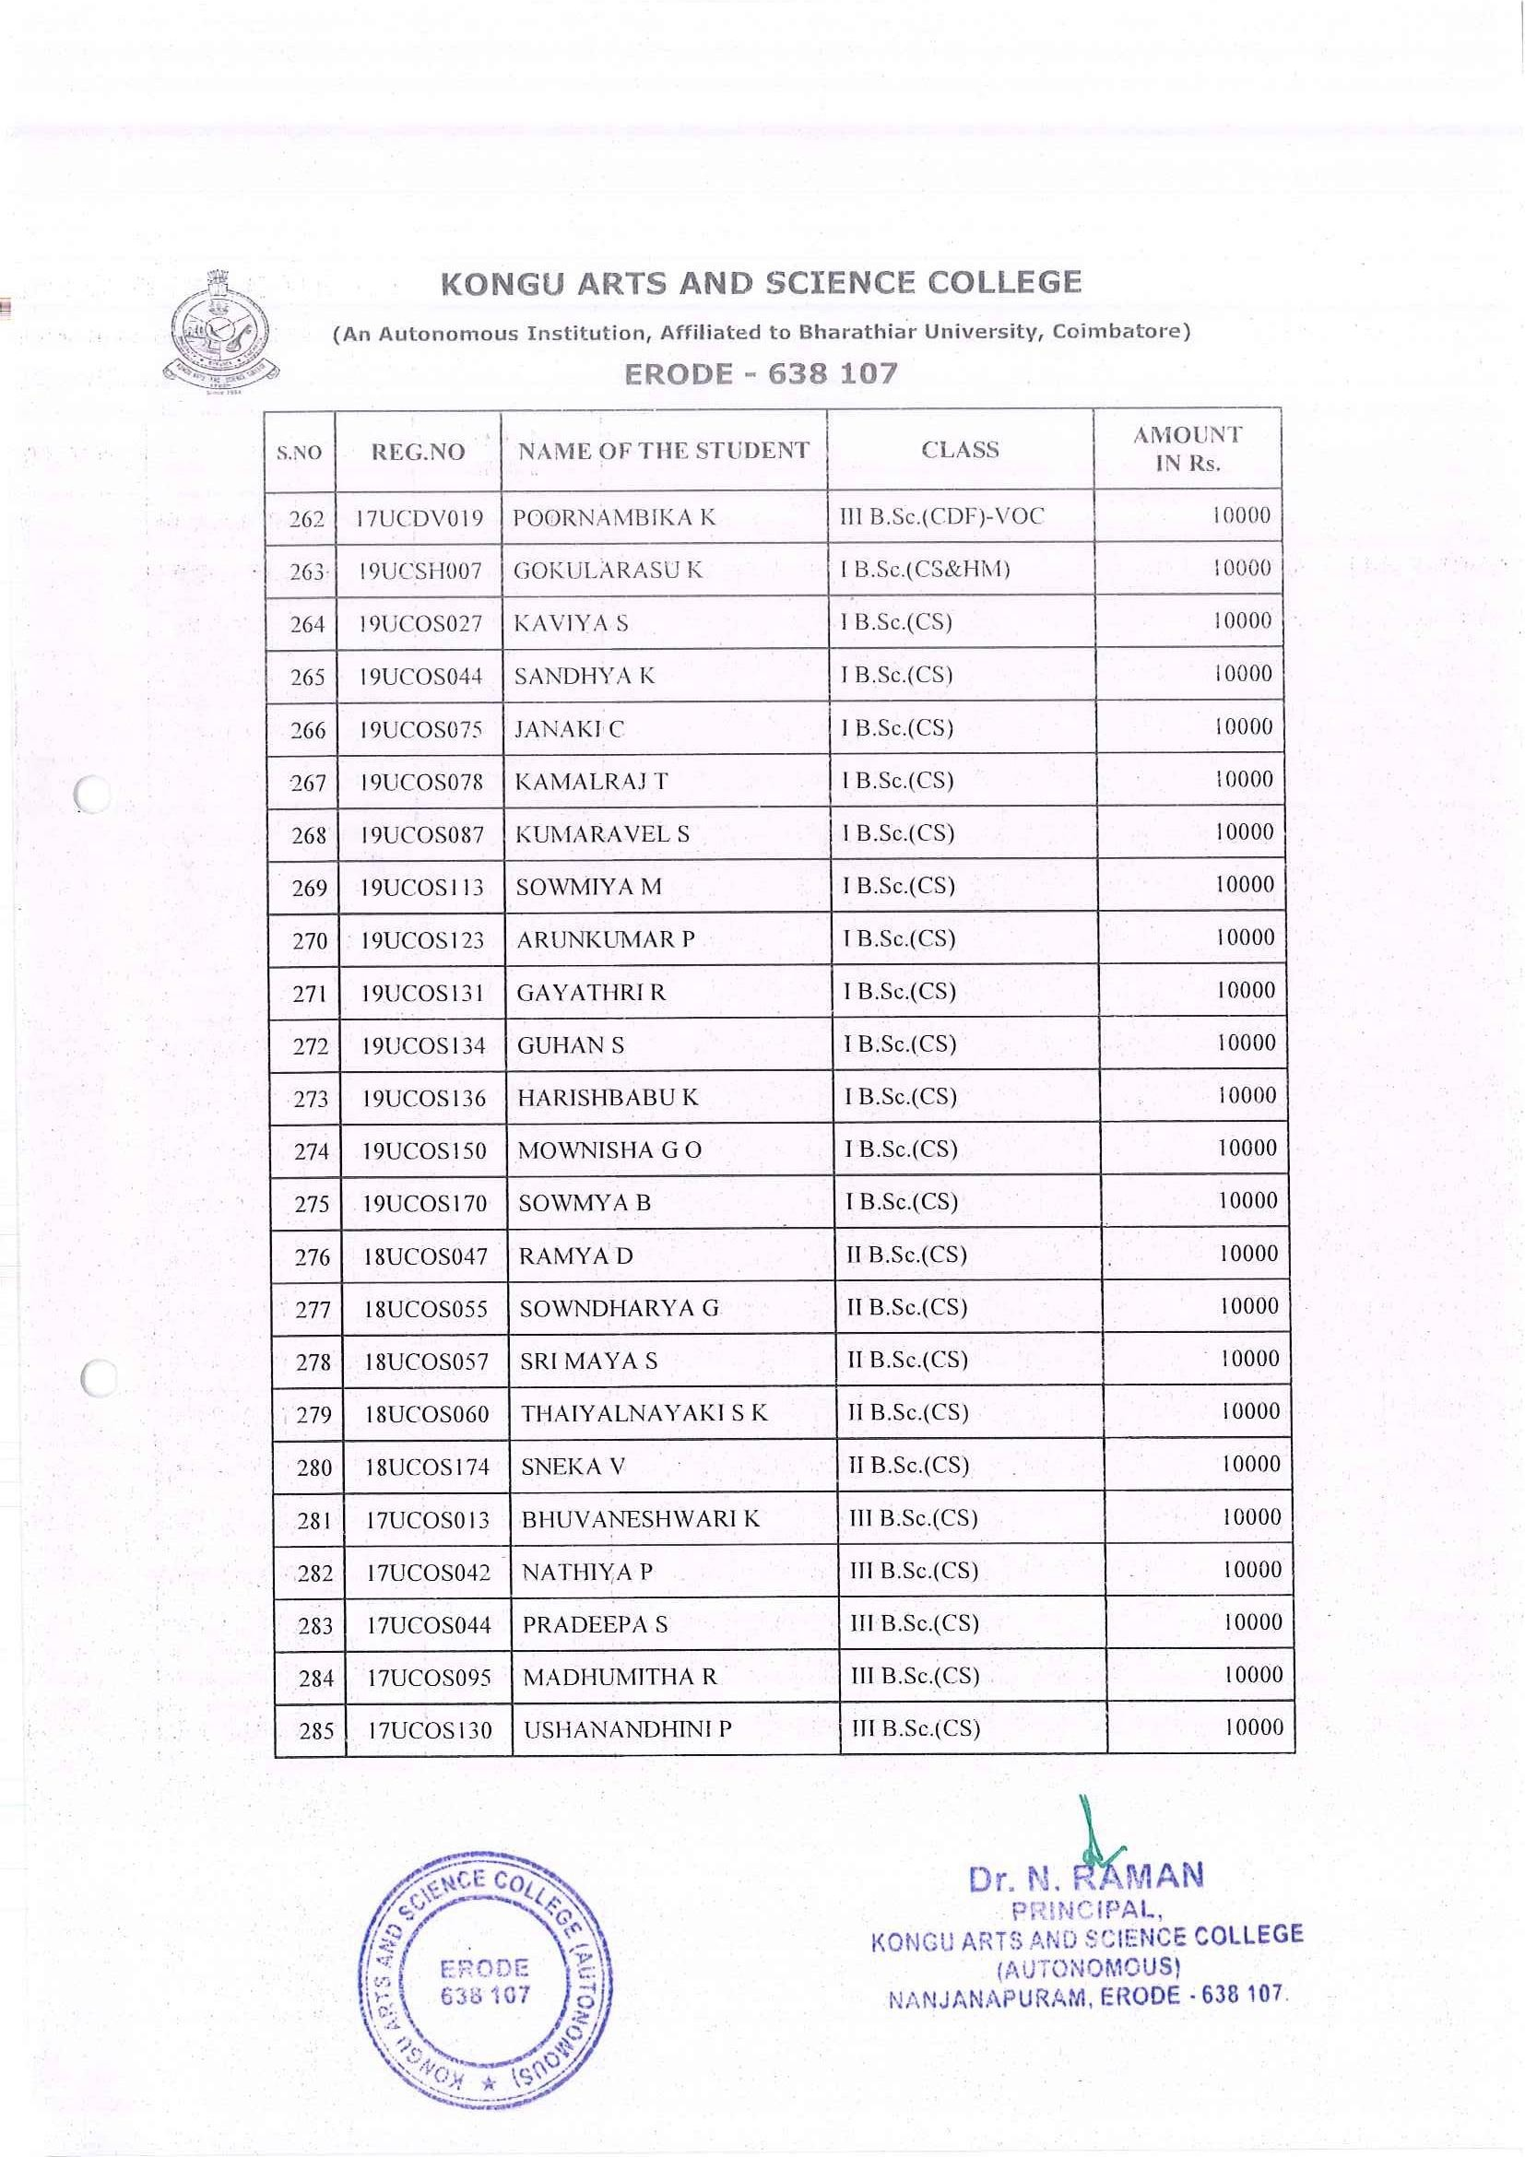

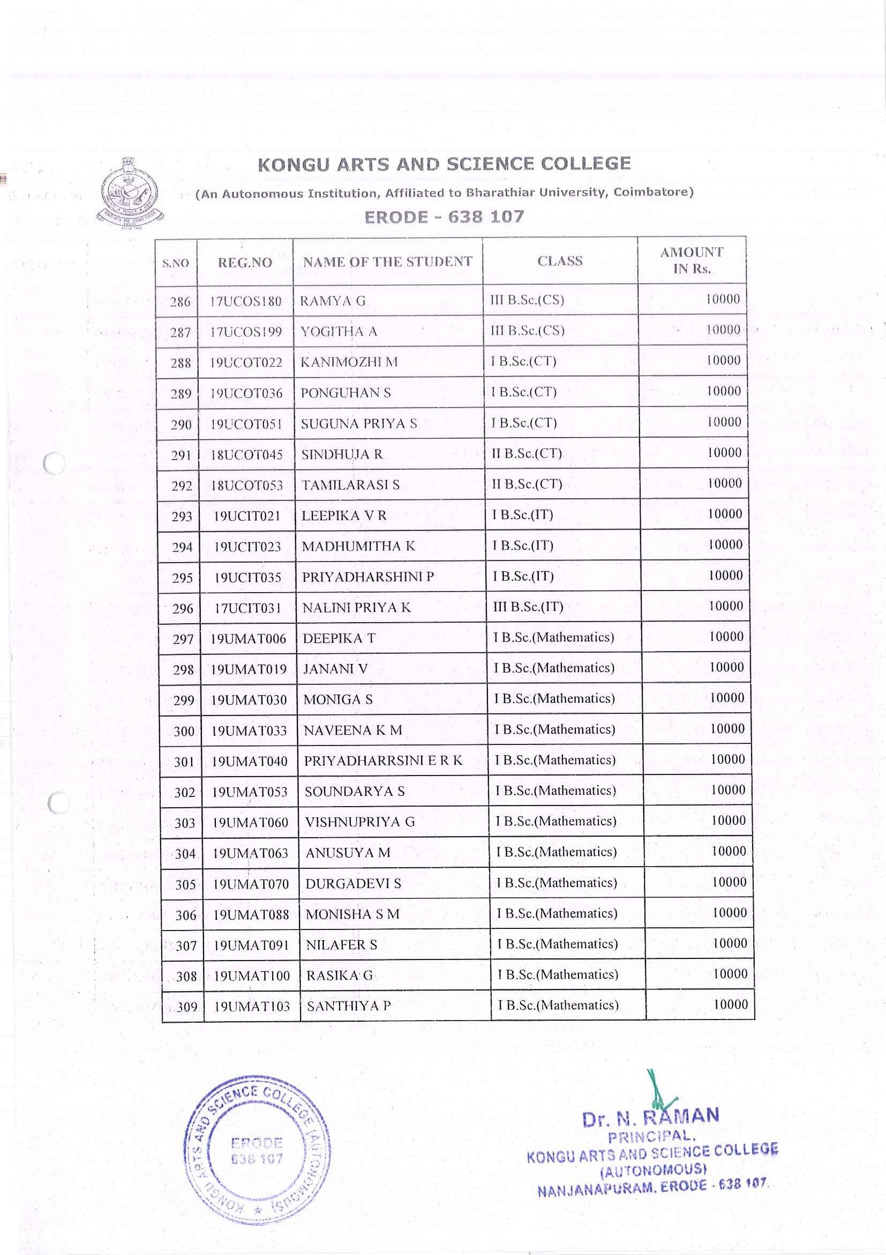

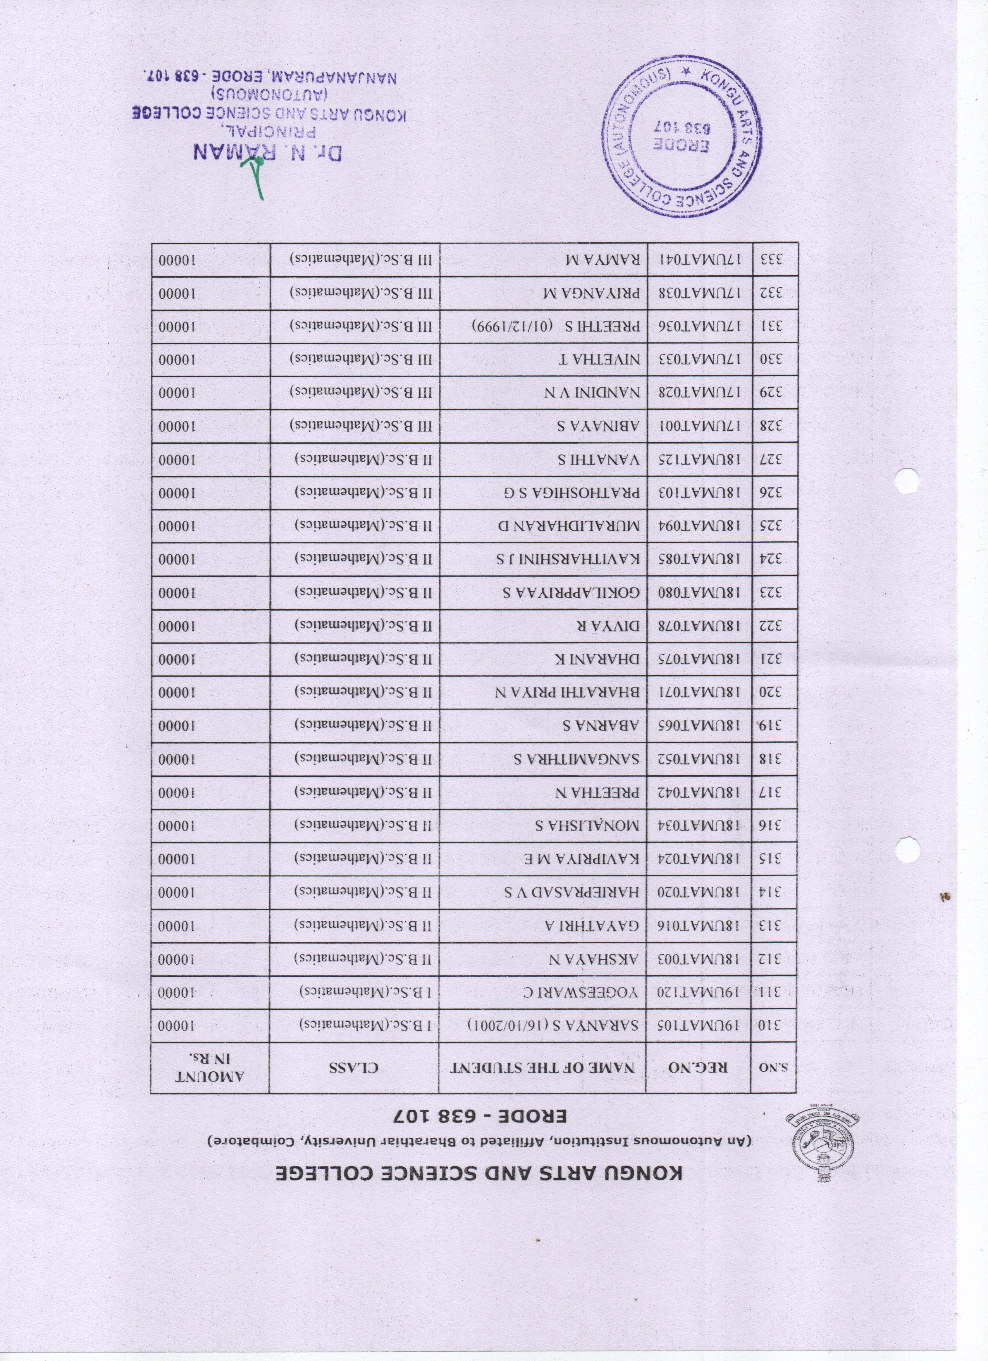
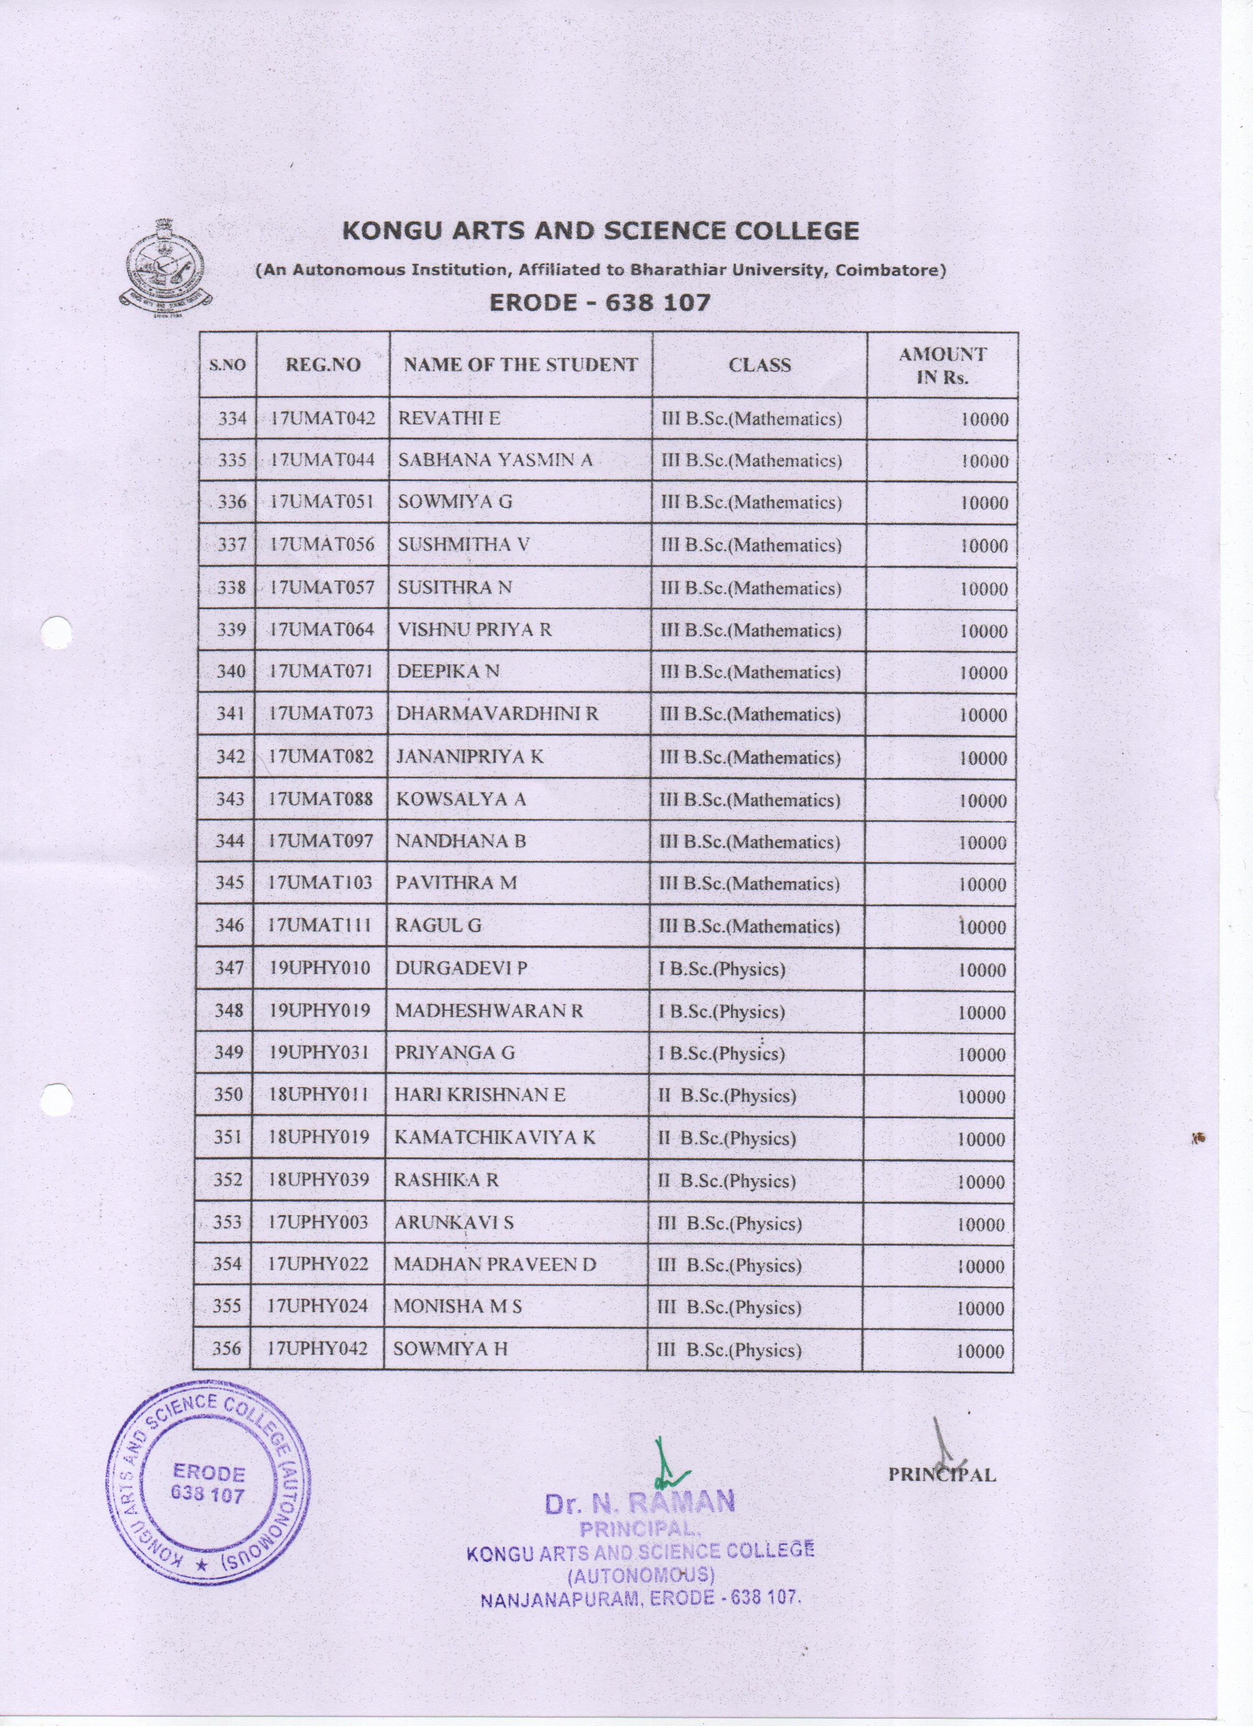

BC / MBC
SCHOLARSHIP

BC/MBC-Namelist

