2018-2019

NAMELIST OF STUDENTS RECEIVED SCHOLARSHIPS AND FREESHIPS PROVIDED BY THE GOVERNMENT – 2018-2019

S.NO. | PARTICULARS | TOTAL NUMBER OF STUDENTS BENEFITED | LINK TO THE PAGE
1. | ADI DRAVIDAR AND TRIBAL  WELFARE SCHOLARSHIP | 39 | View Document
2. | CENTRAL SECTOR SCHEME OF SCHOLARSHIP FOR COLLEGE AND UNIVERSITY STUDENTS | 311 | View Document
3. | POST MATRIC SCHOLARSHIP FOR MINORITY STUDENTS | 1 | View Document
TOTAL NUMBER OF STUDENTS BENIFITED THROUGH FREESHIPS AND SCHOLARSHIPS PROVIDED BY THE GOVERNMENT |  | 351*

*One Student benefited by more than one scheme has been counted as one only

ADI DRAVIDAR AND TRIBAL WELFARE SCHOLARSHIP
ADW-NL
ADW-NL

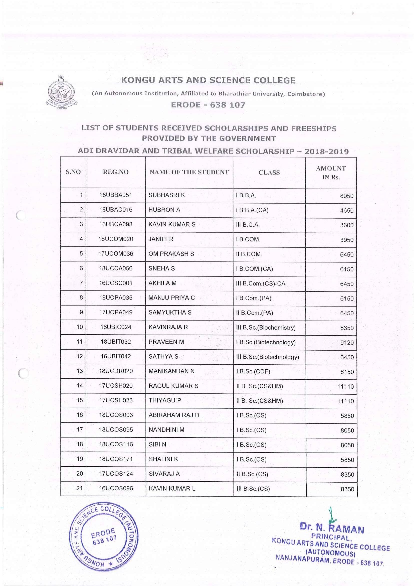

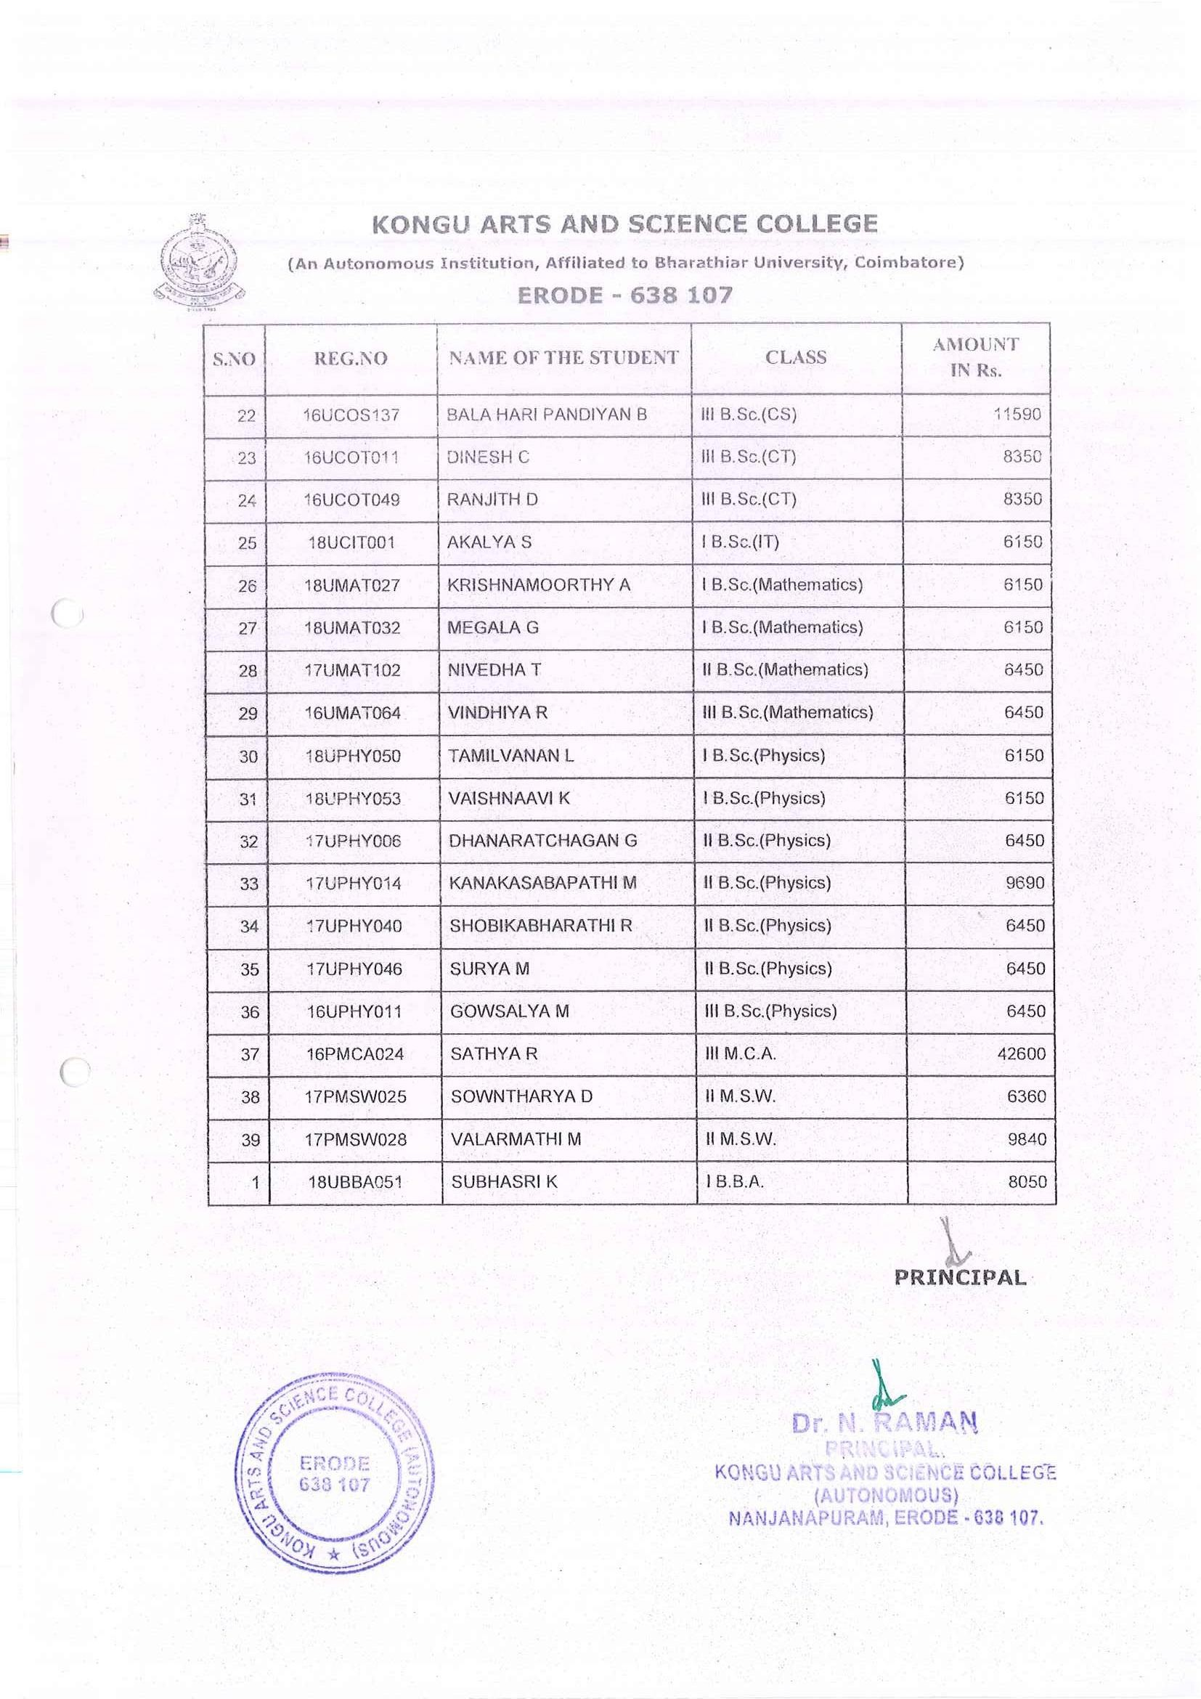

CENTRAL SECTOR SCHEME OF SCHOLARSHIP FOR COLLEGE AND UNIVERSITY STUDENTS

CSSS-NL
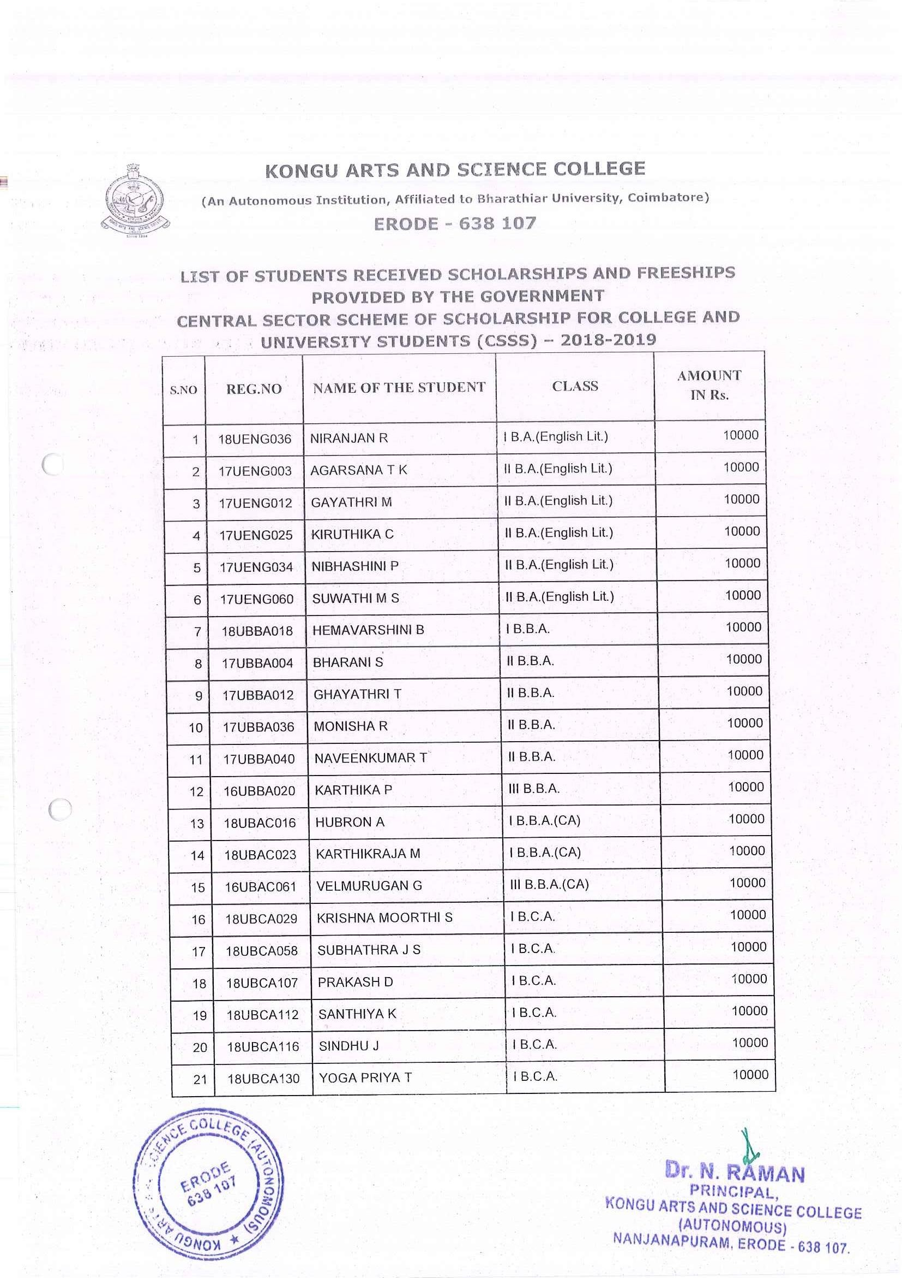

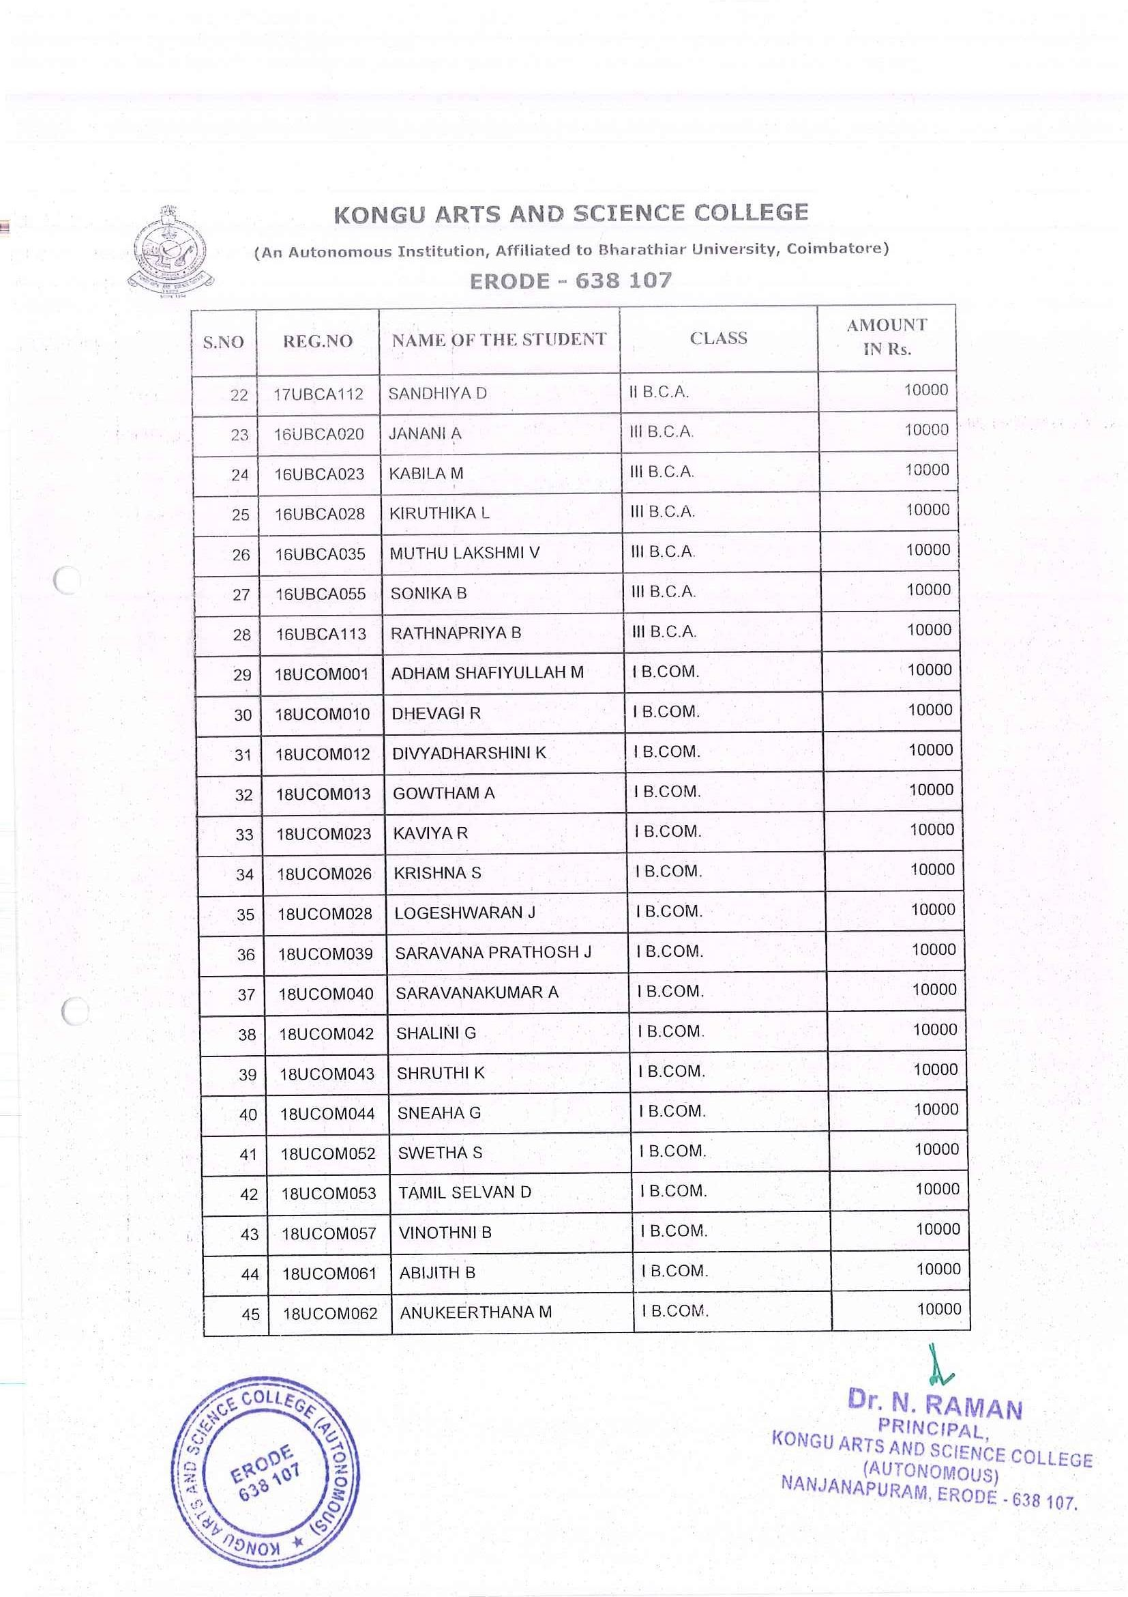

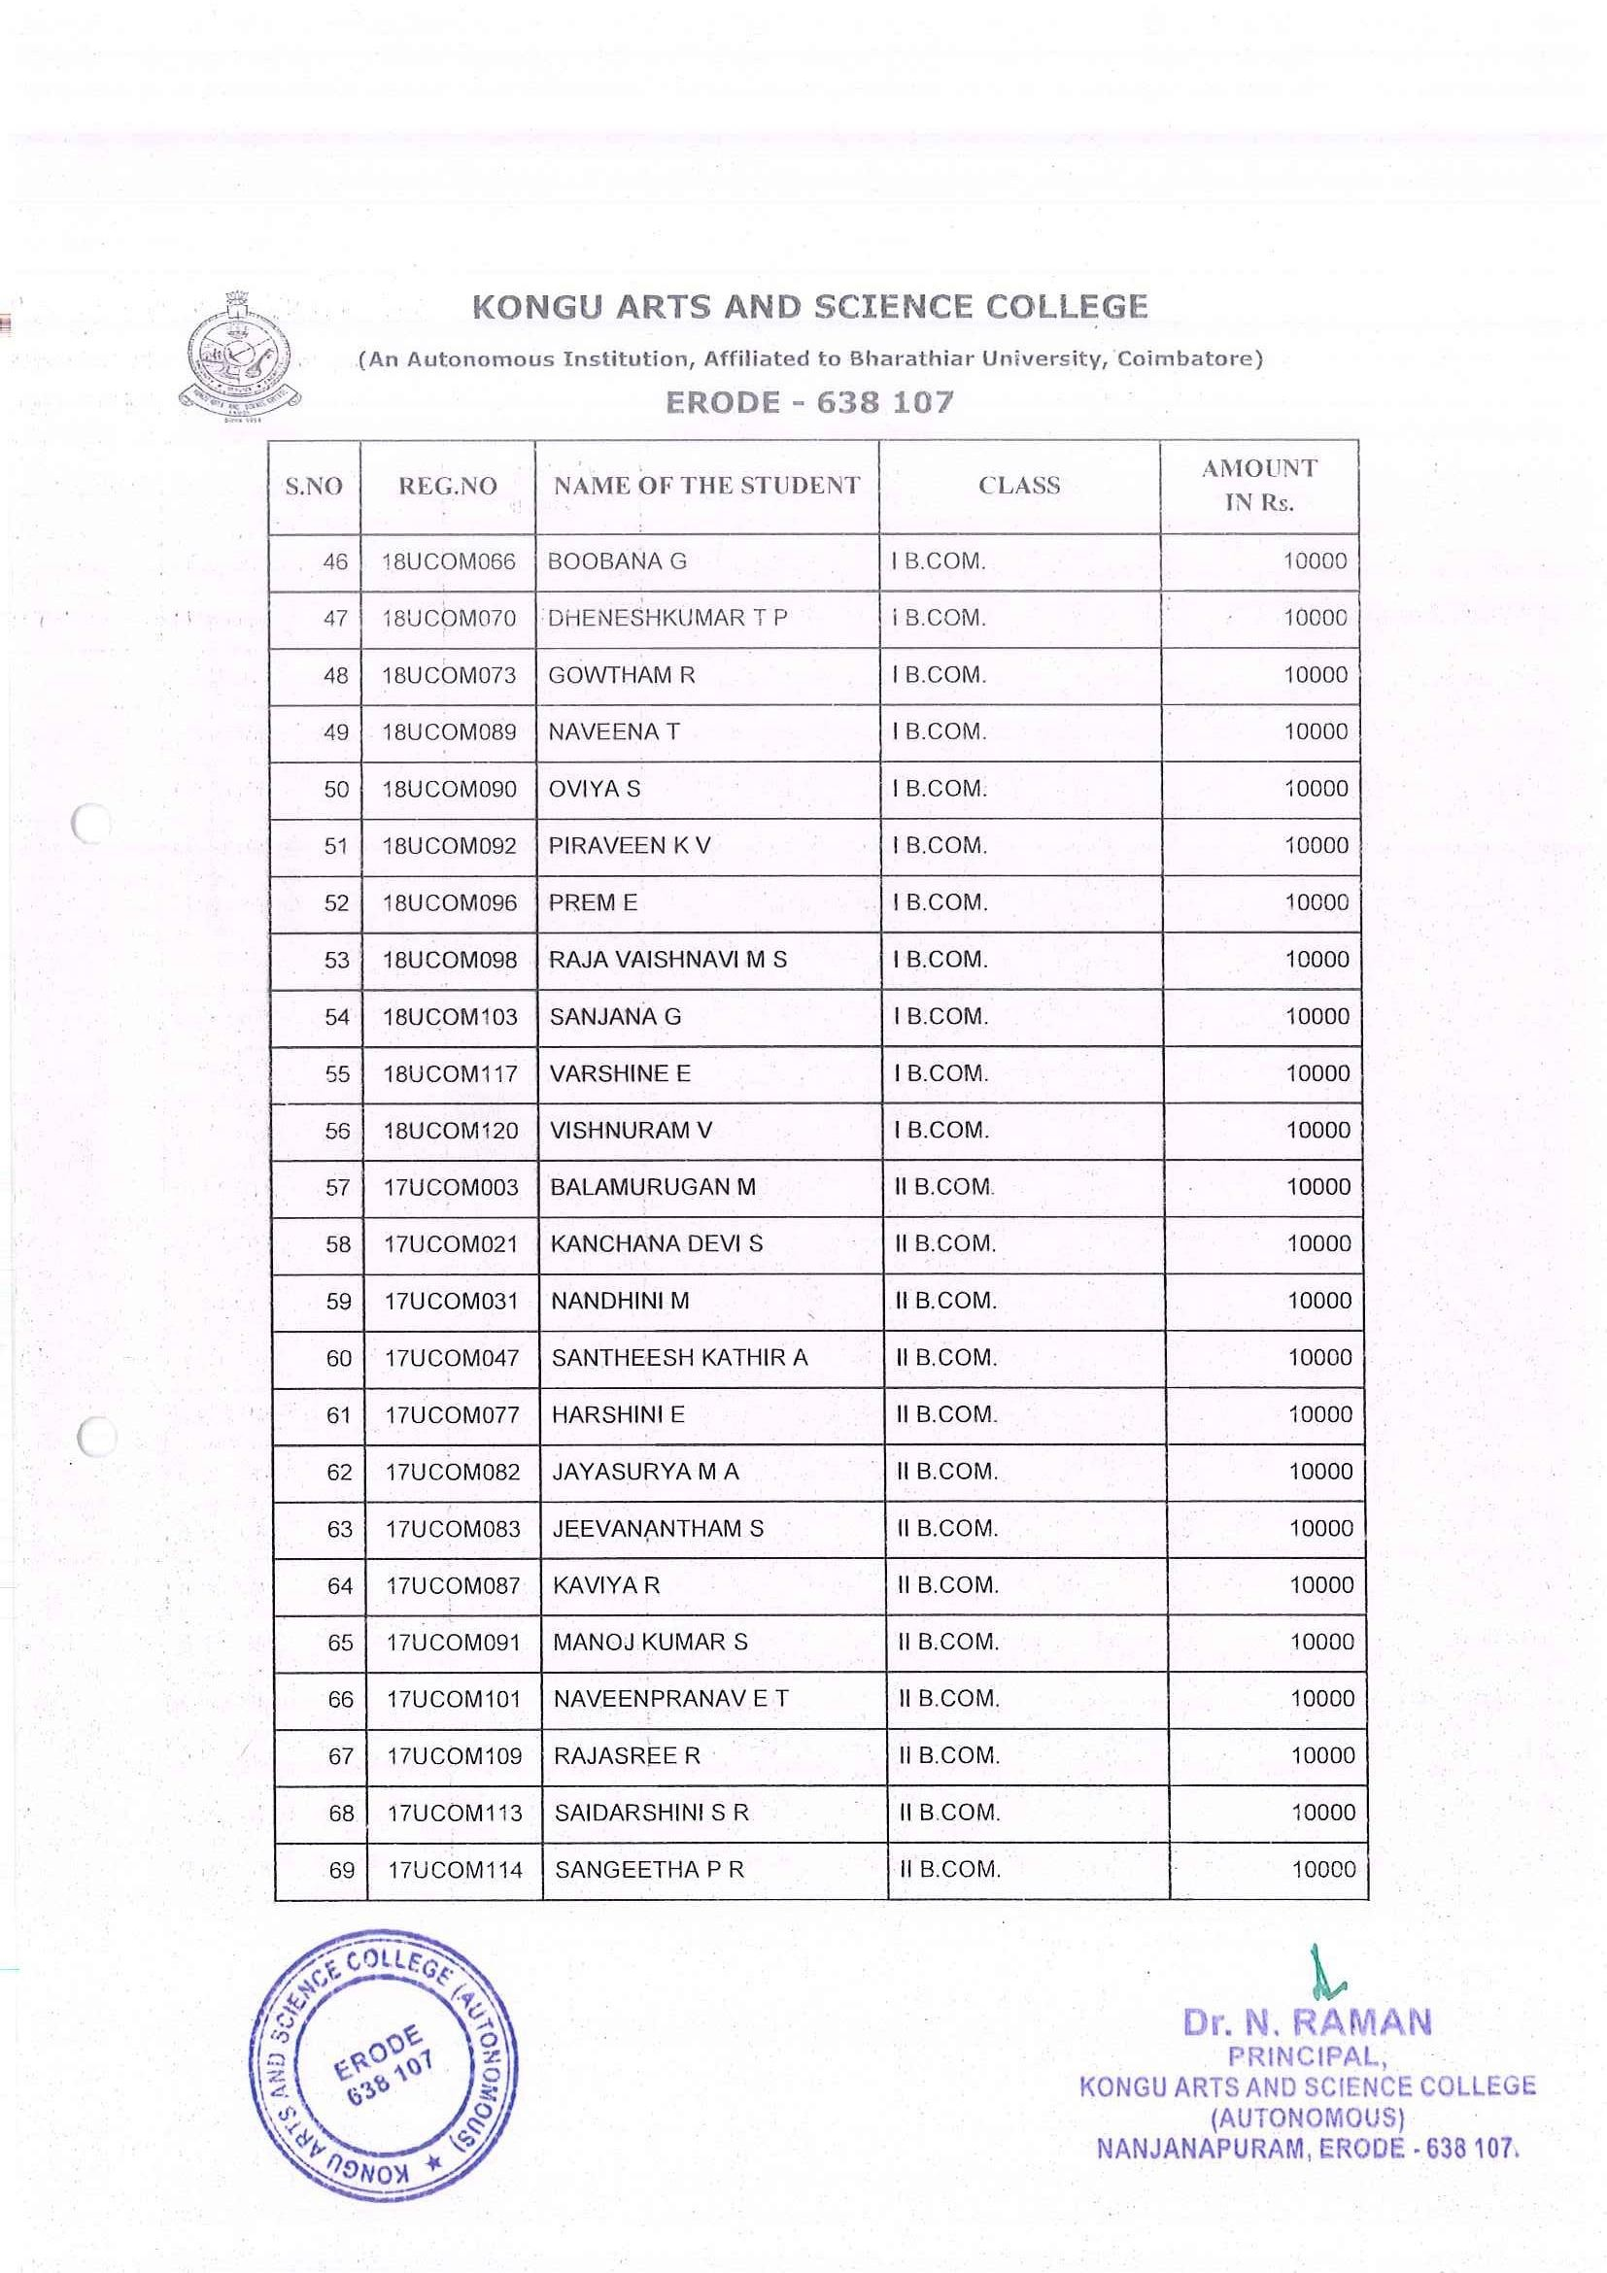

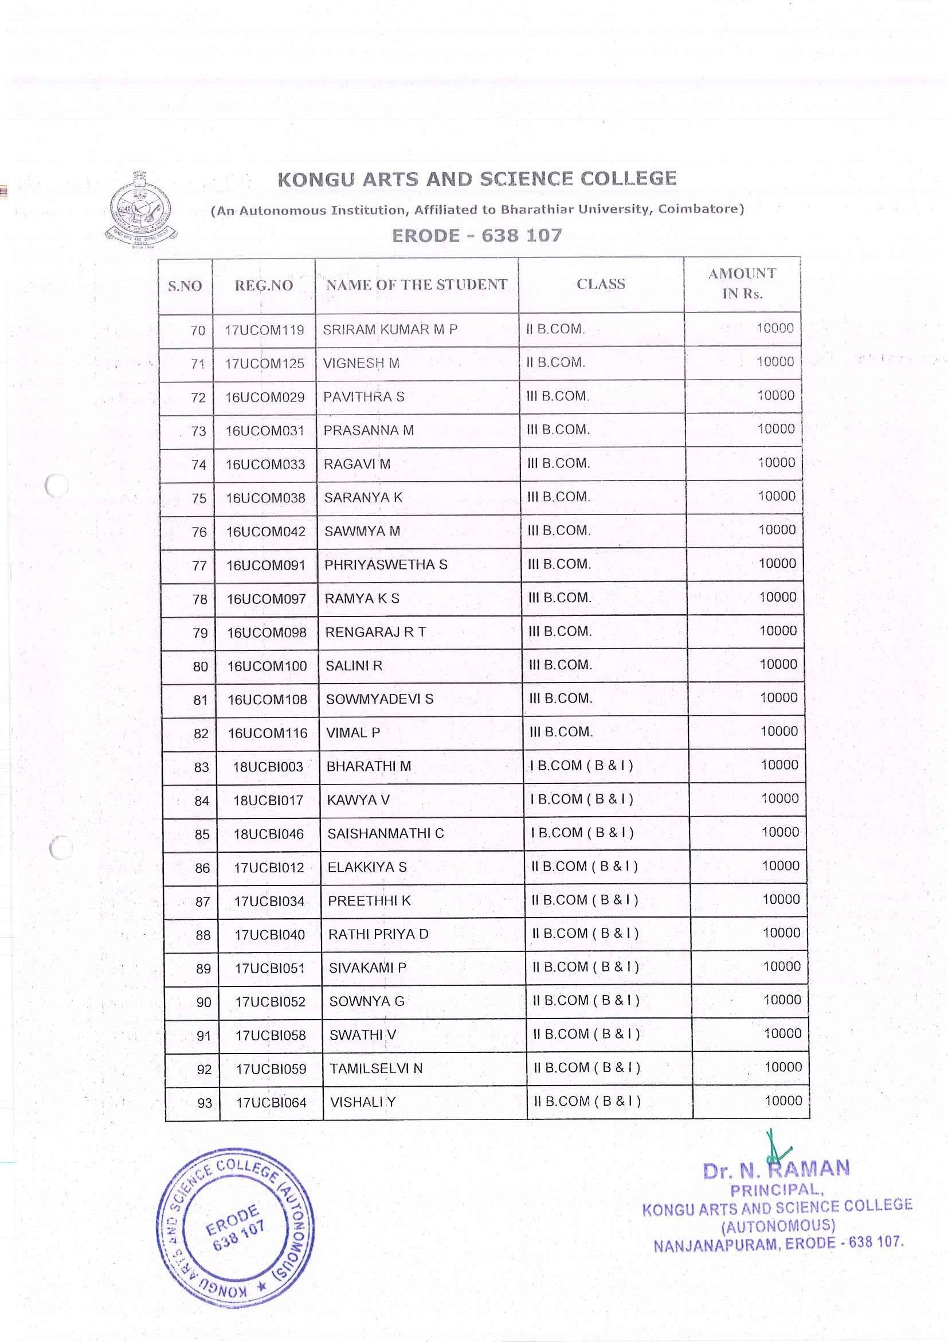

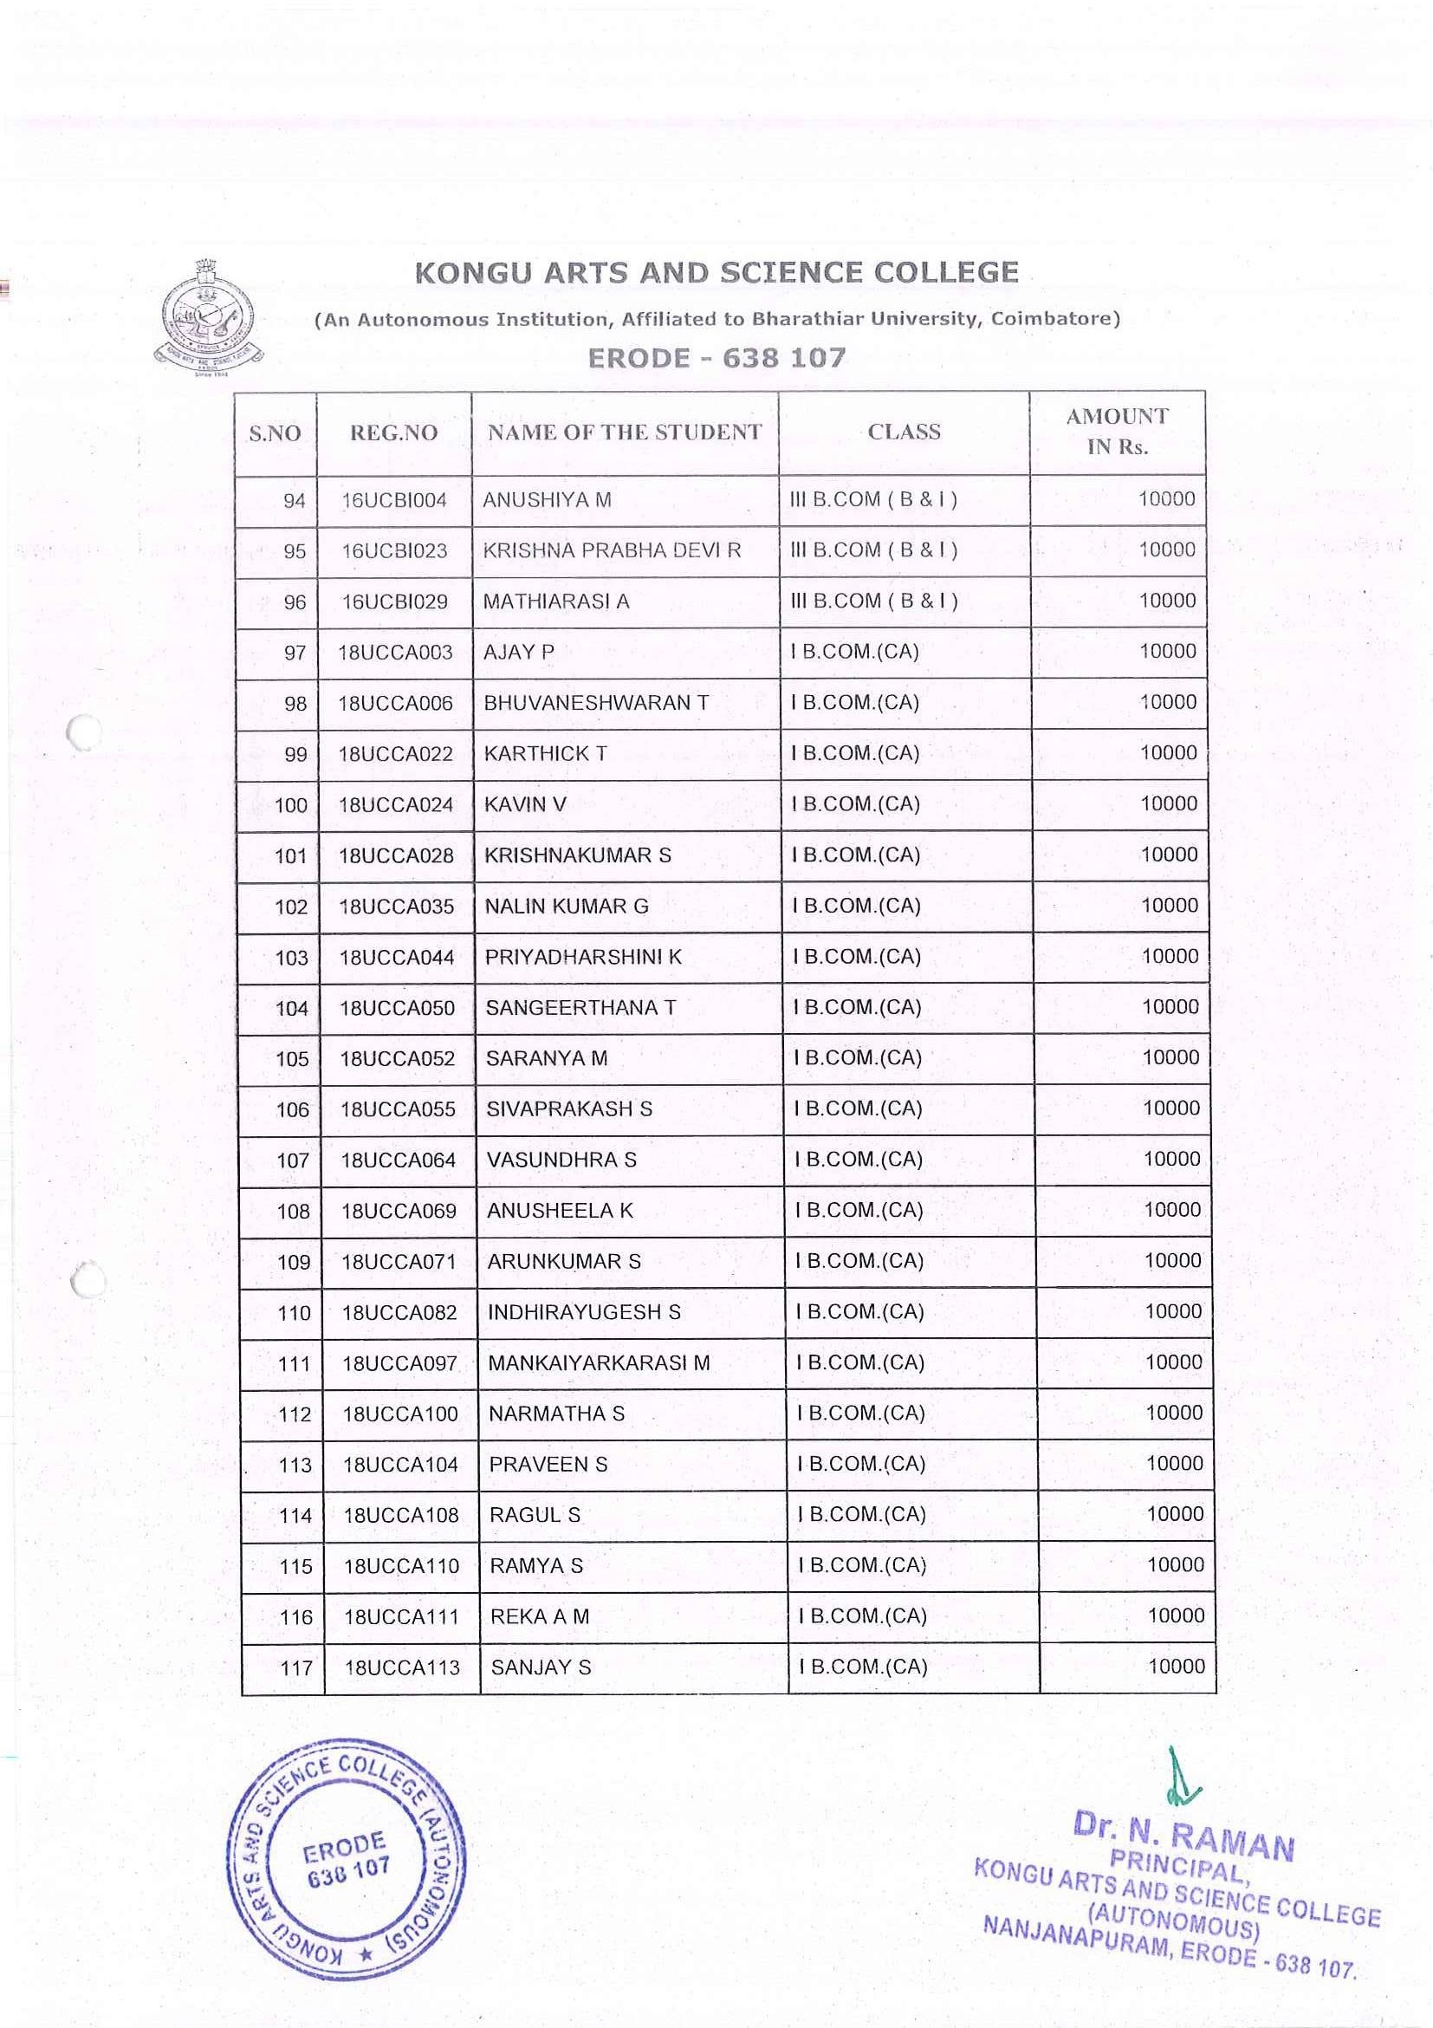

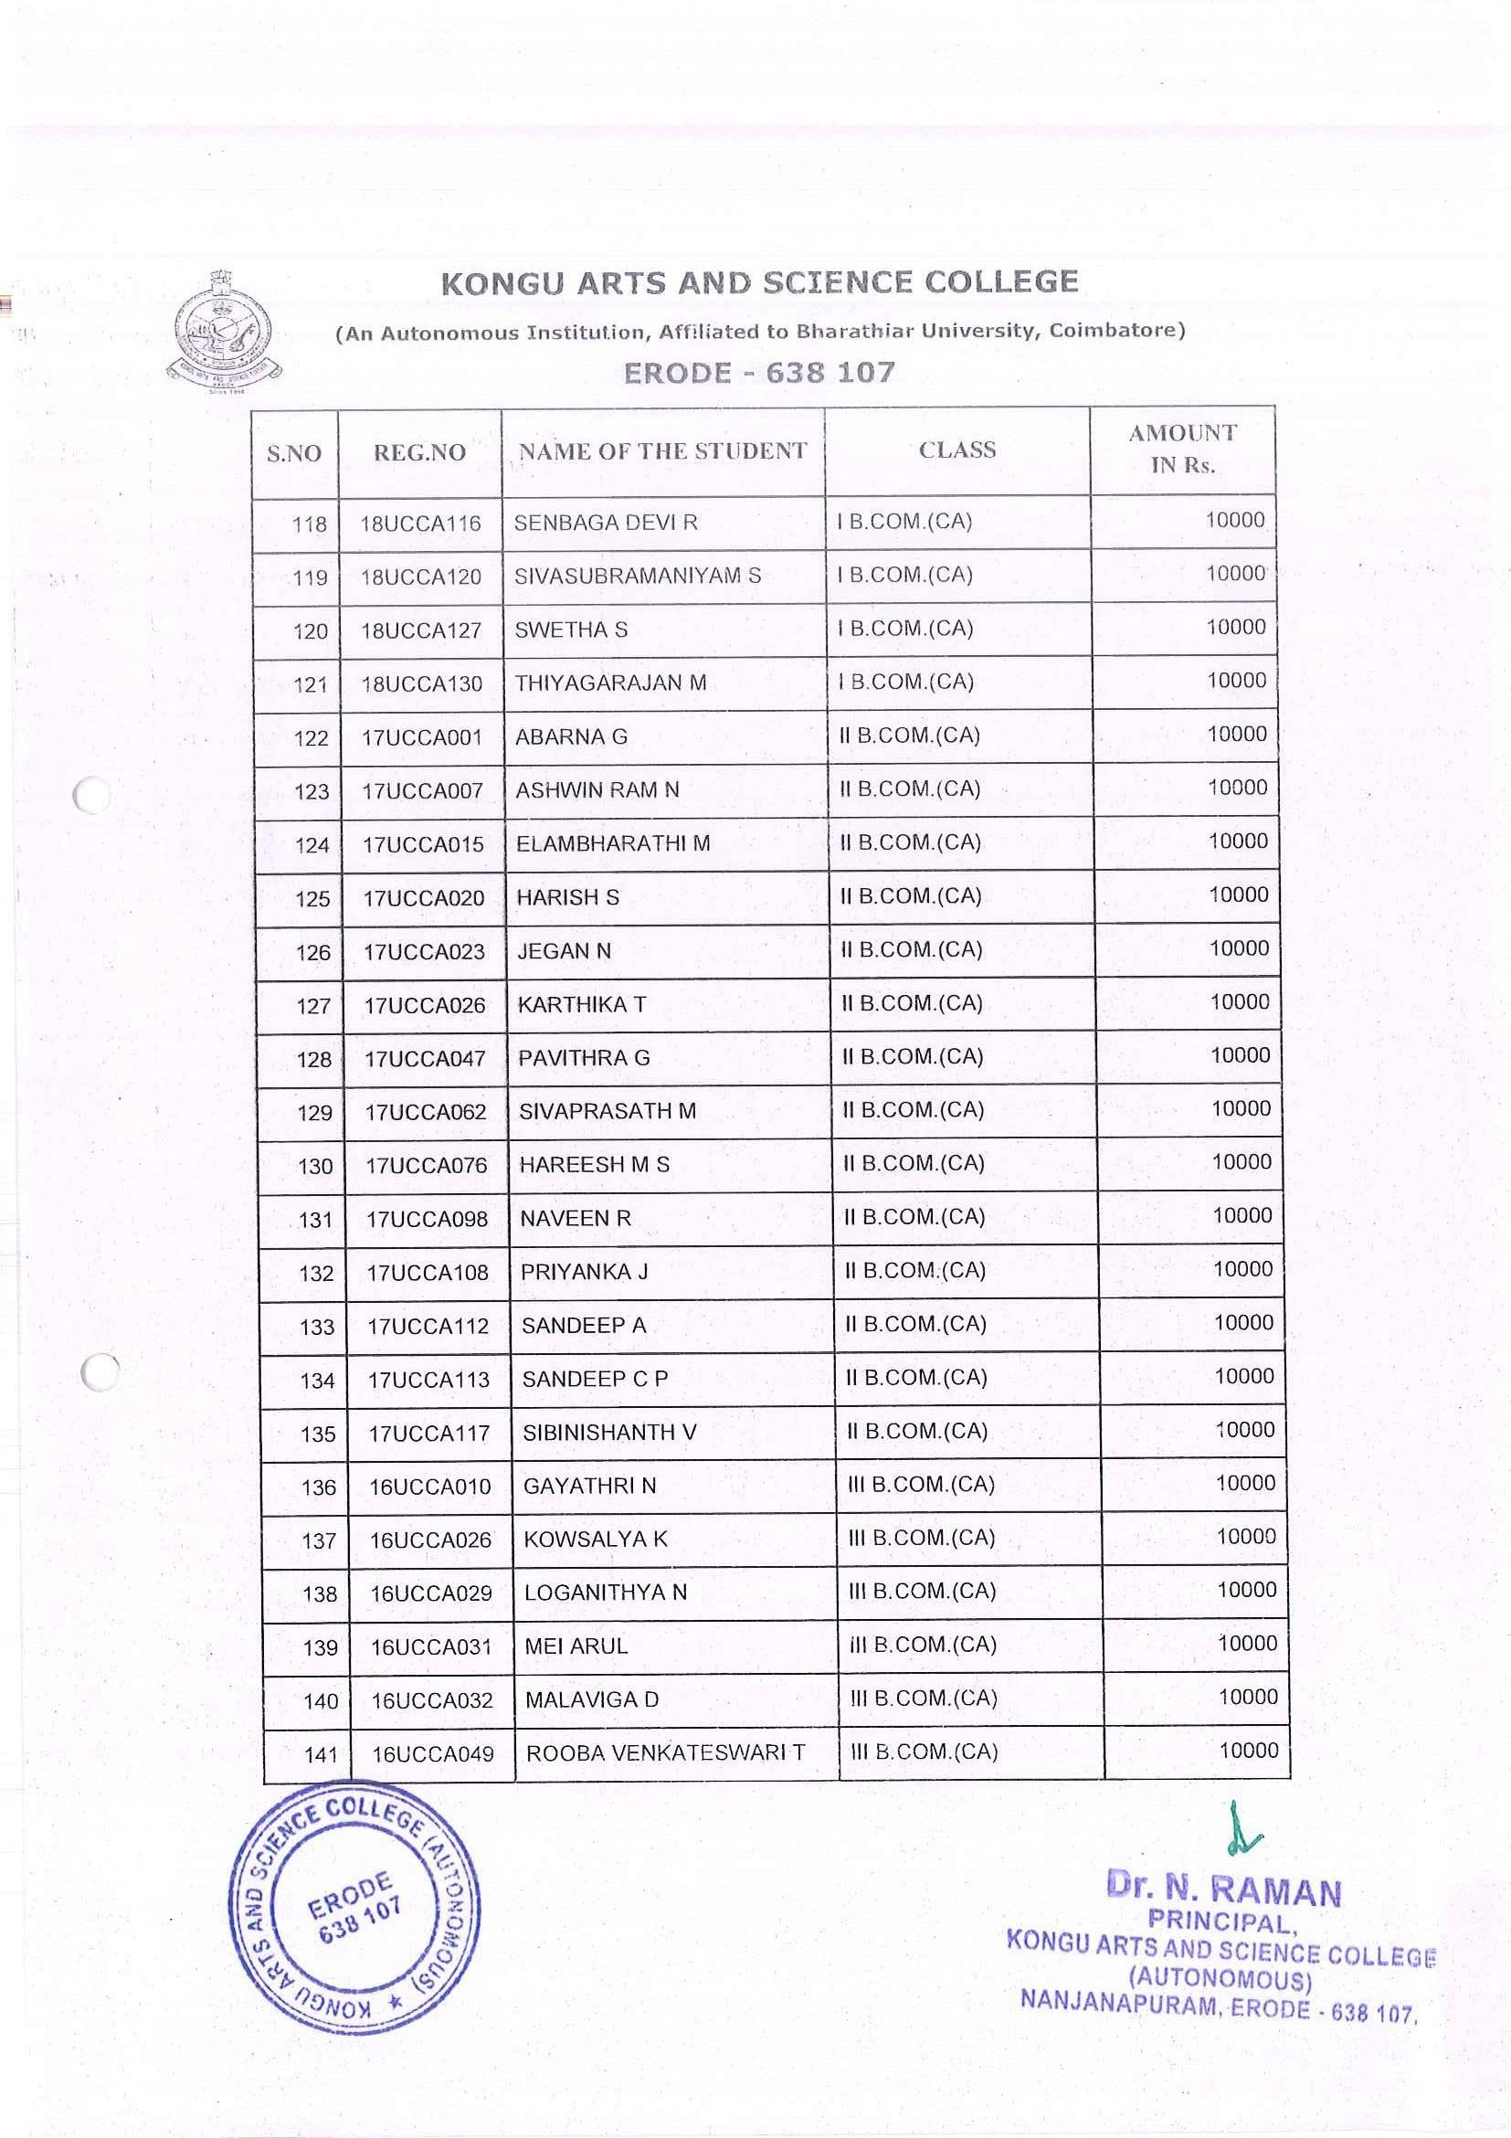

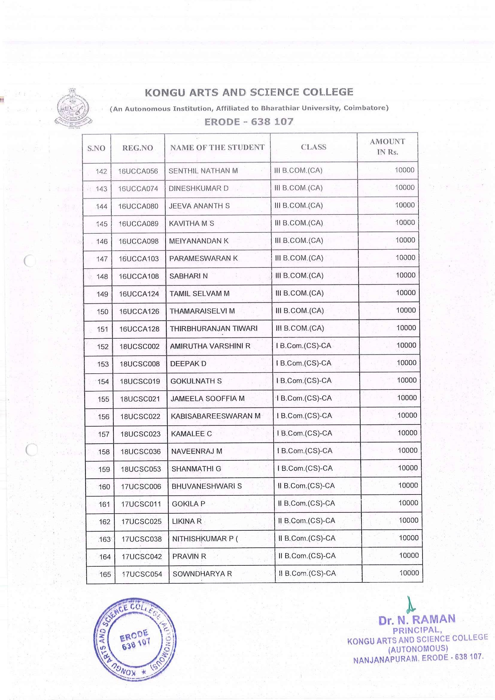

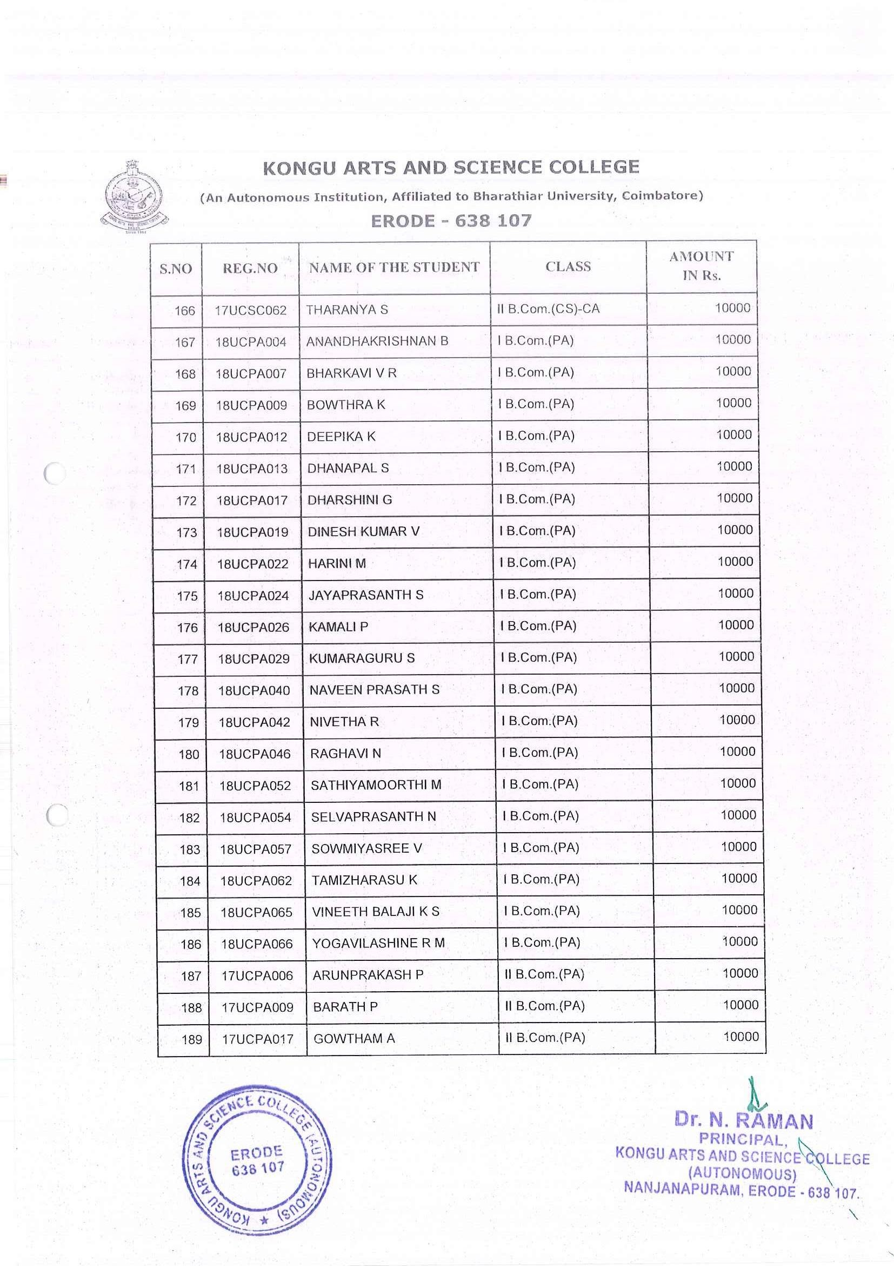

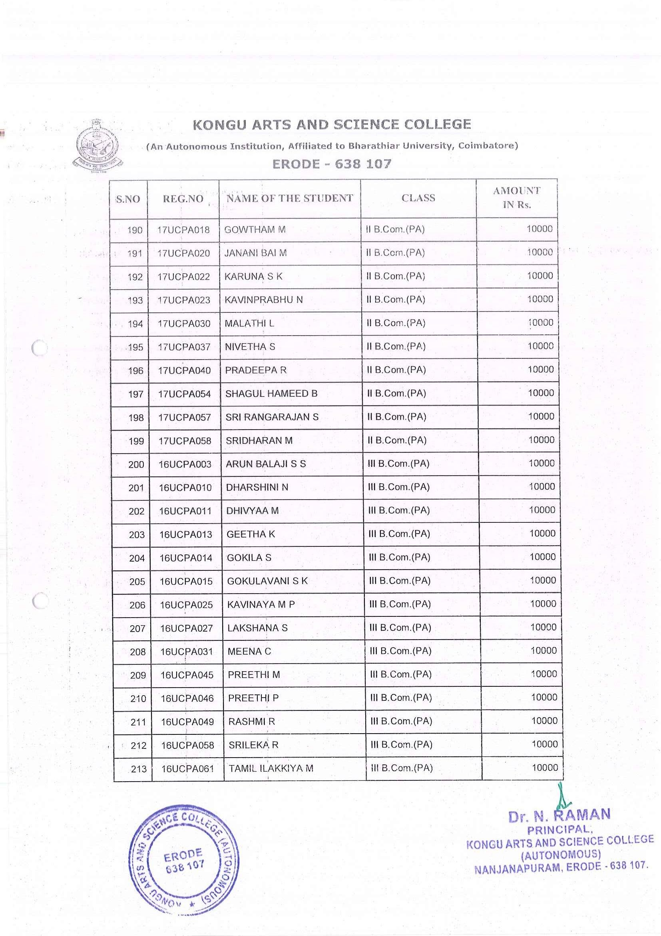

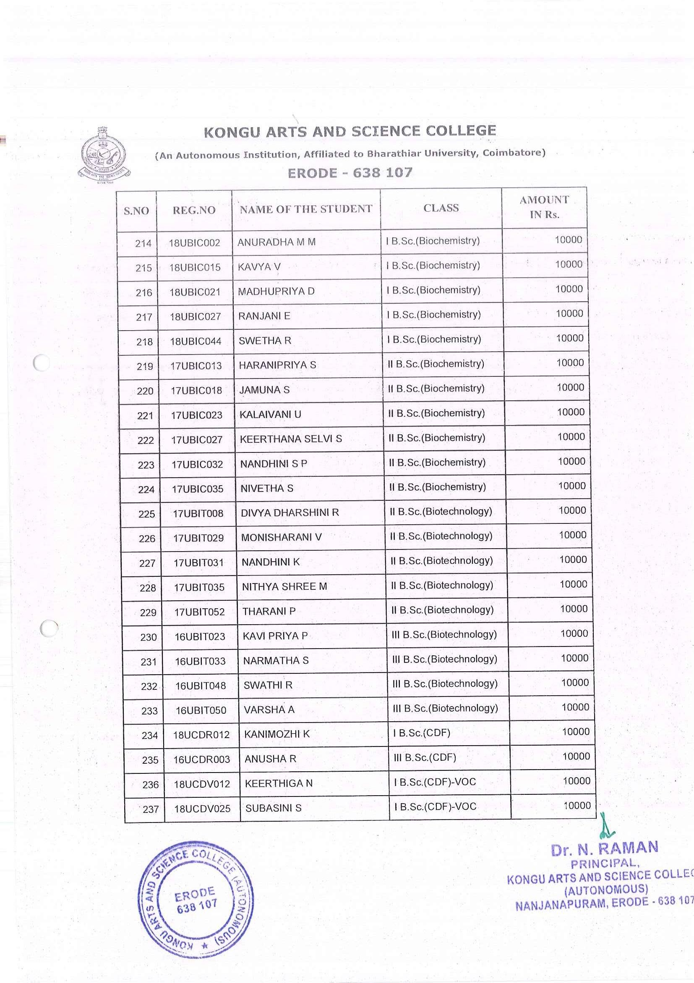

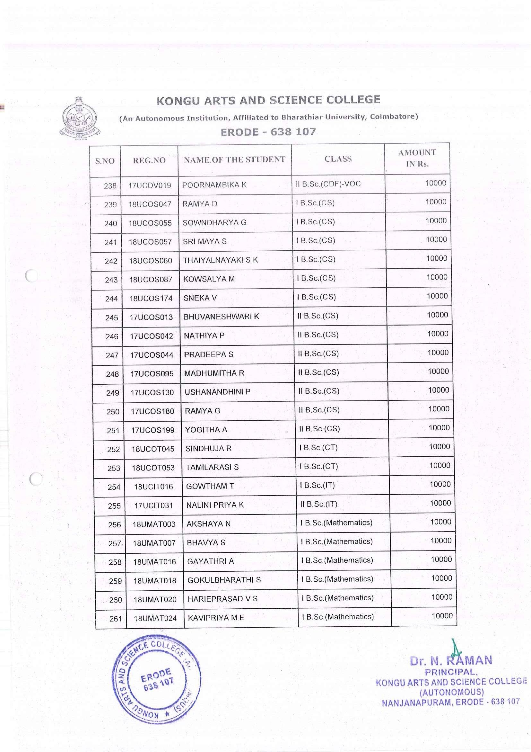

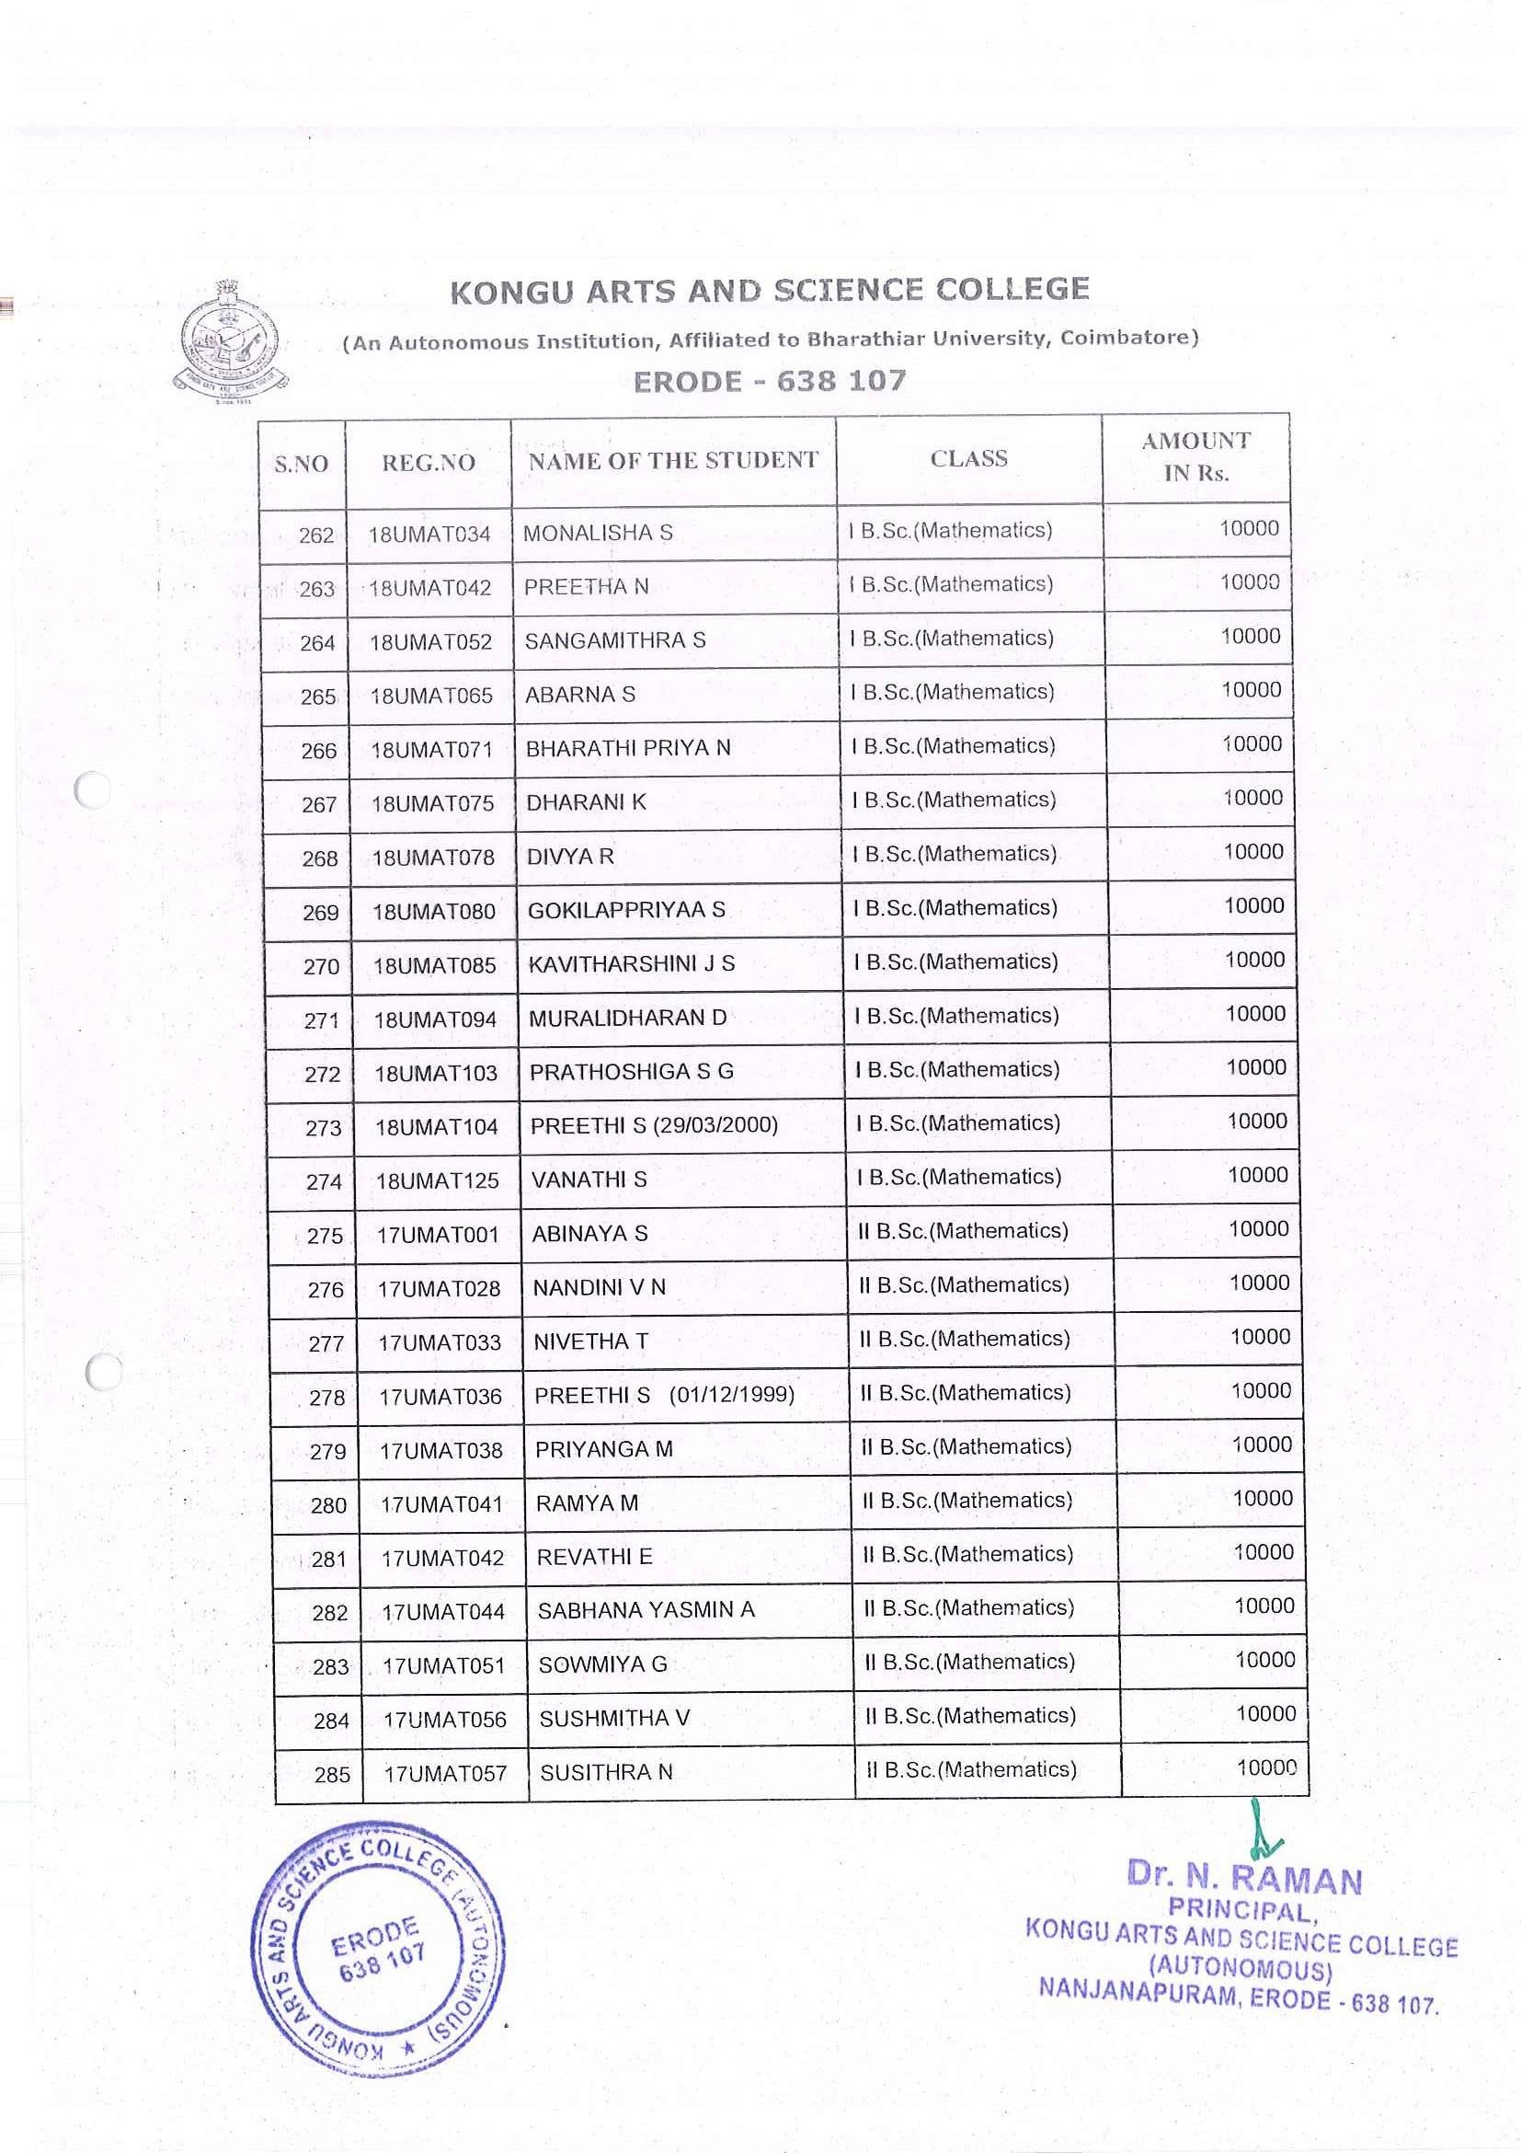

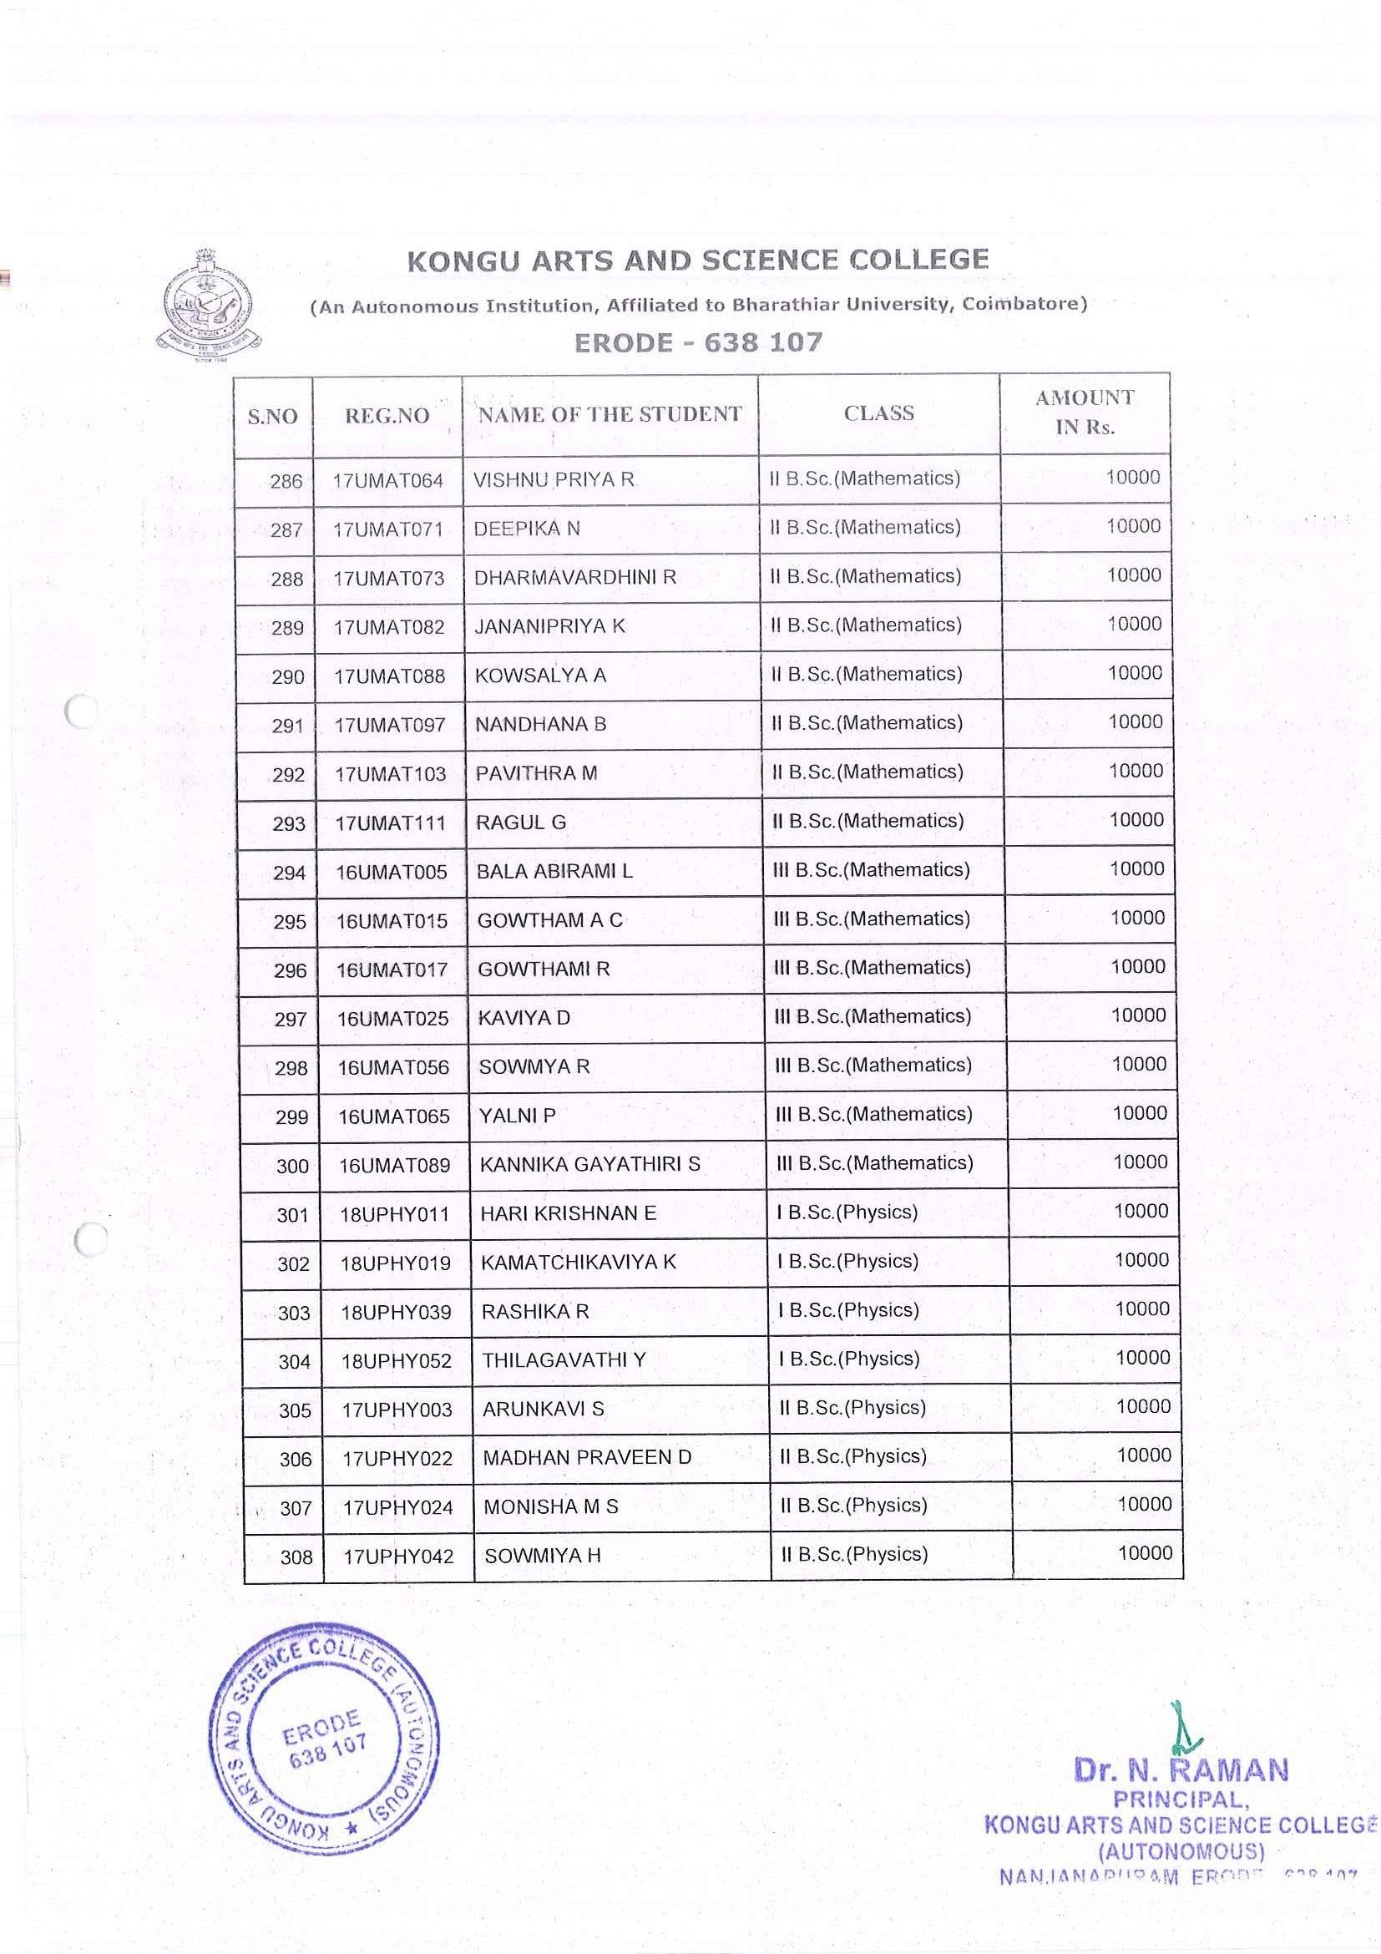

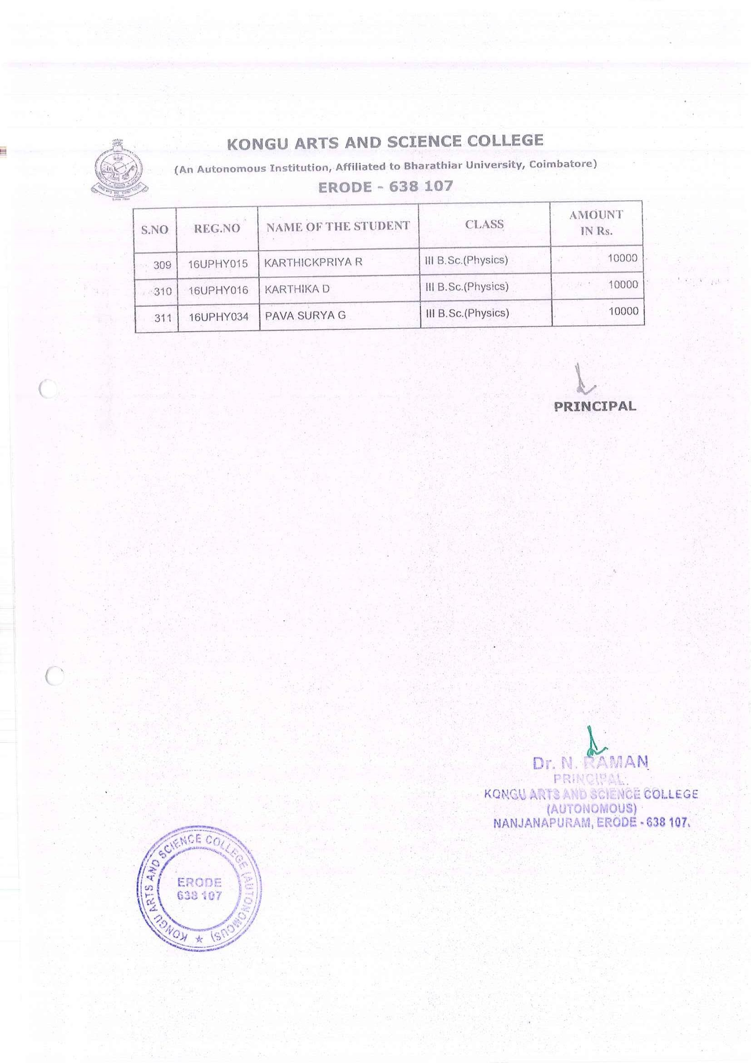

POST MATRIC SCHOLARSHIP FOR MINORITY STUDENTS

PM-NL
