2019-2020

LIST OF EVIDENCE FOR STUDENTS RECEIVED SCHOLARSHIPS AND FREESHIPS PROVIDED BY THE GOVERNMENT – 2019-2020
S.NO. | PARTICULARS | TOTAL NUMBER OF STUDENTS BENEFITED | LINK TO THE PAGE
1. | ADI DRAVIDAR AND TRIBAL WELFARE SCHOLARSHIP | 33 | View Document
2. | CENTRAL SECTOR SCHEME OF SCHOLARSHIP FOR COLLEGE AND UNIVERSITY STUDENTS | 356 | View Document
3. | BC/MBC SCHOLARSHIP | 04 | View Document
TOTAL NUMBER OF STUDENTS BENIFITED THROUGH FREESHIPS AND SCHOLARSHIPS PROVIDED BY THE GOVERNMENT |  | 393*

*One Student benefited by more than one scheme has been counted as one only

ADI DRAVIDAR AND TRIBAL WELFARE SCHOLARSHIP
ADW - EVI

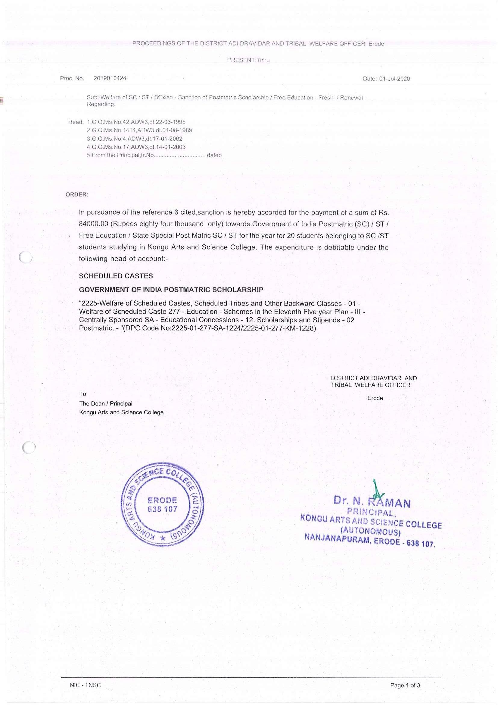

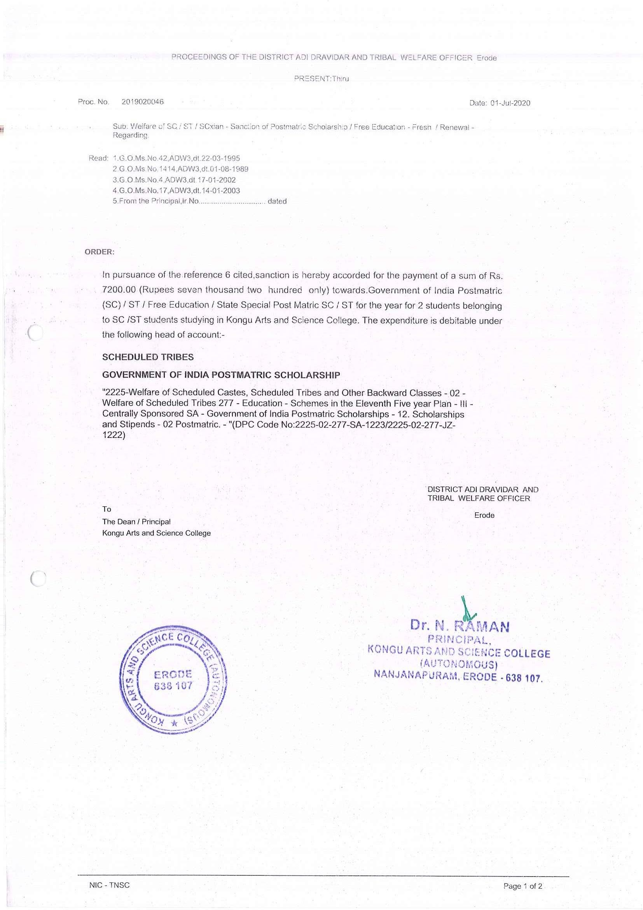

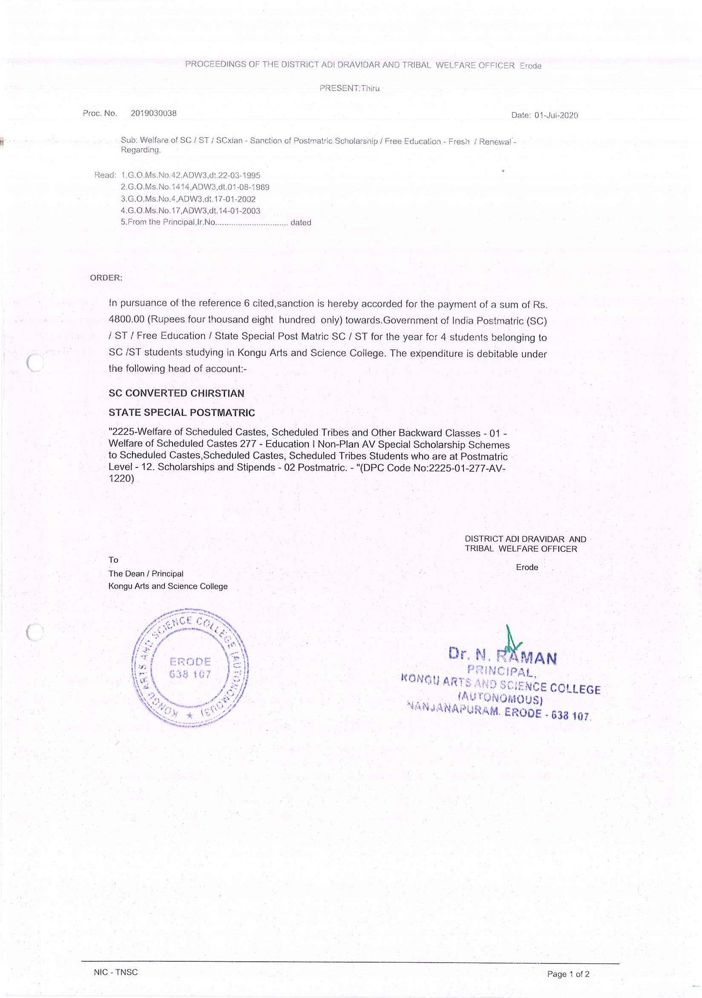

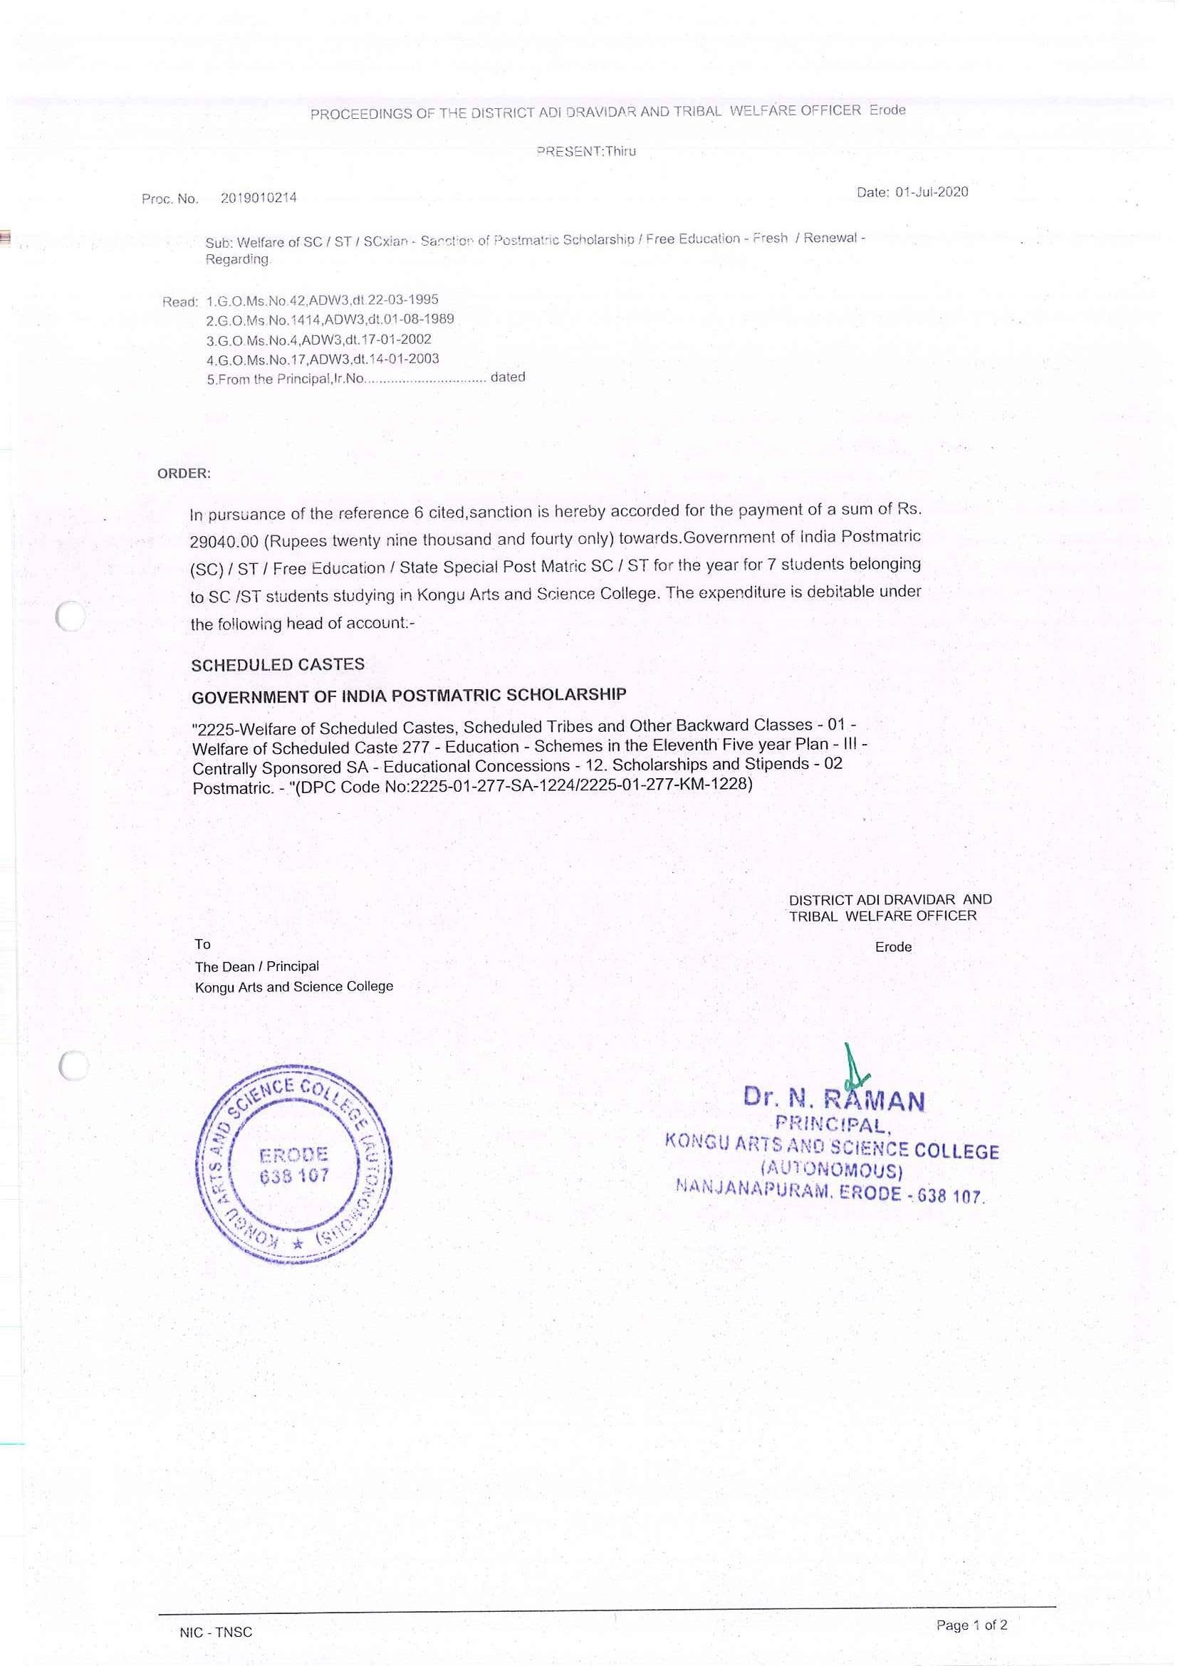

CENTRAL SECTOR SCHEME OF SCHOLARSHIP FOR COLLEGE AND UNIVERSITY STUDENTS
CSSS - EVI

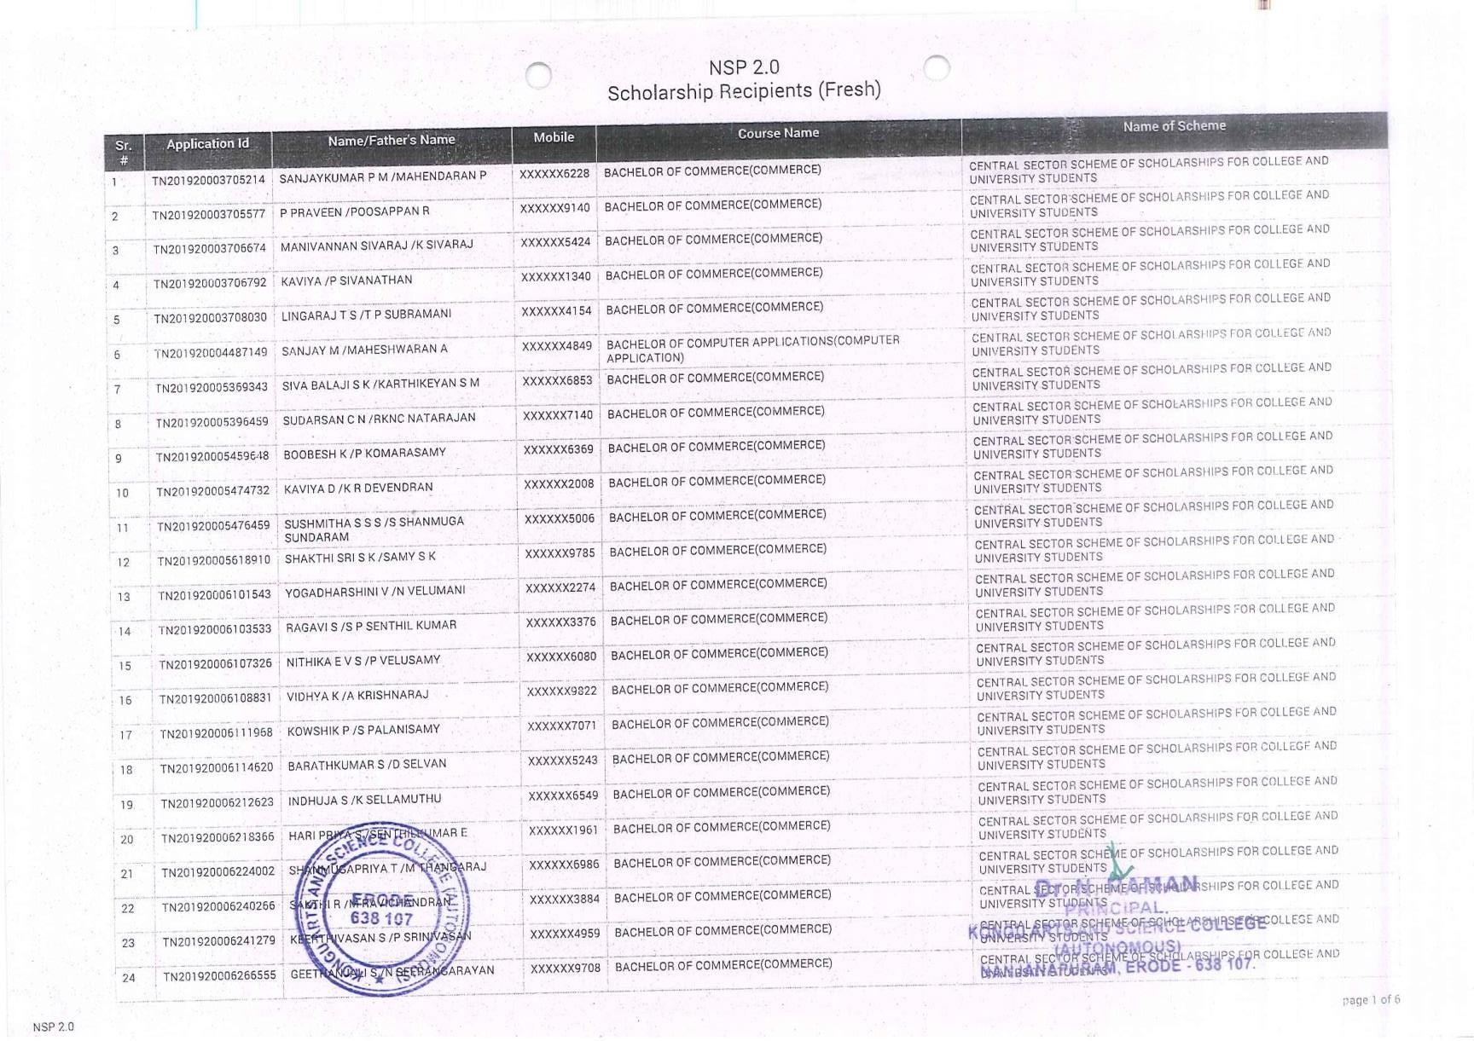

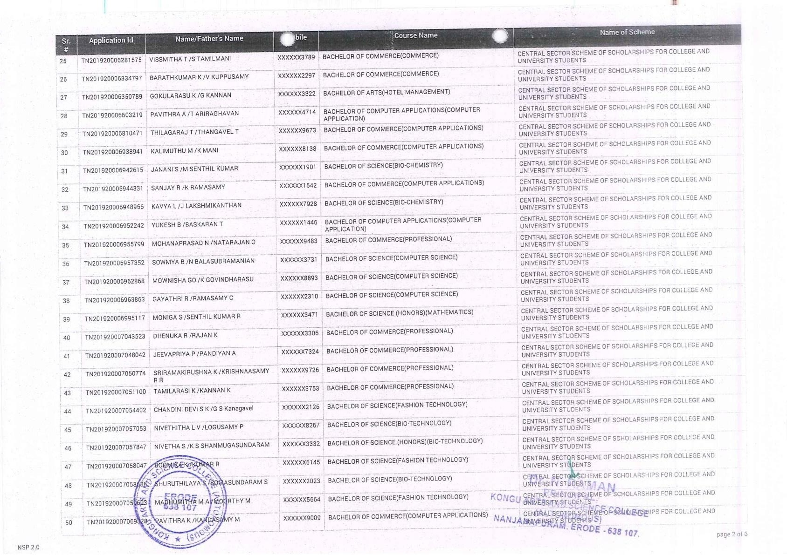

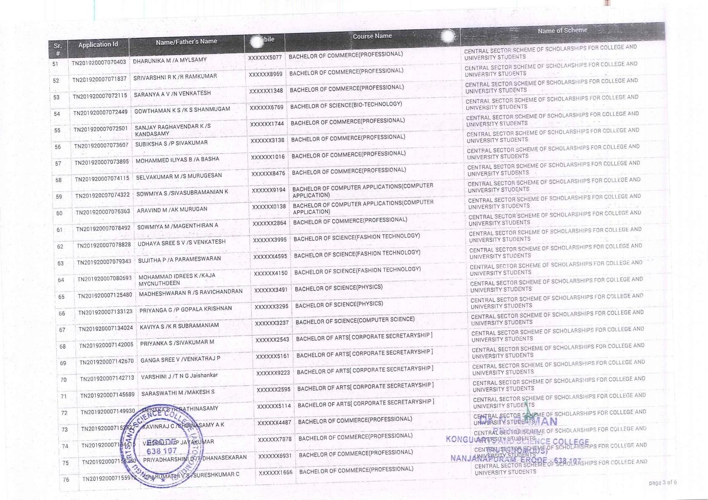

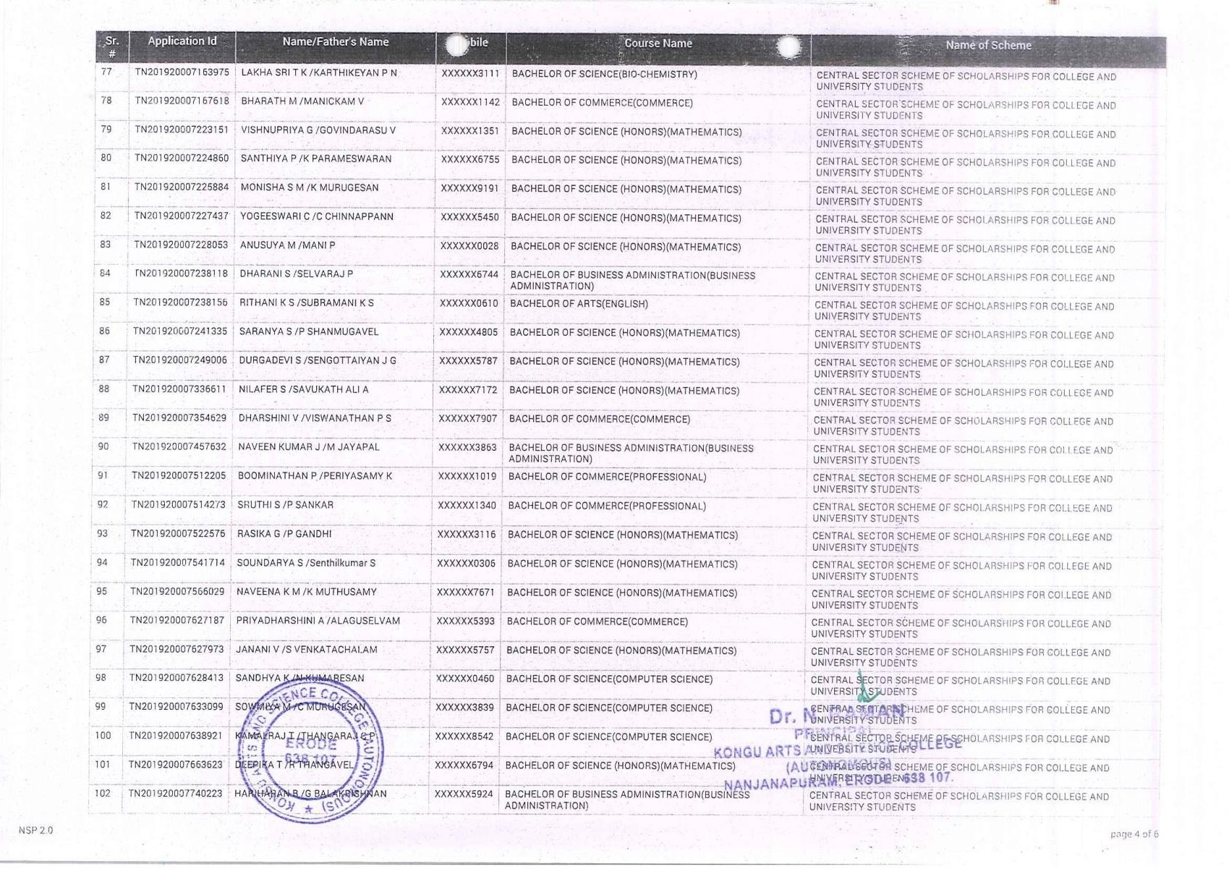

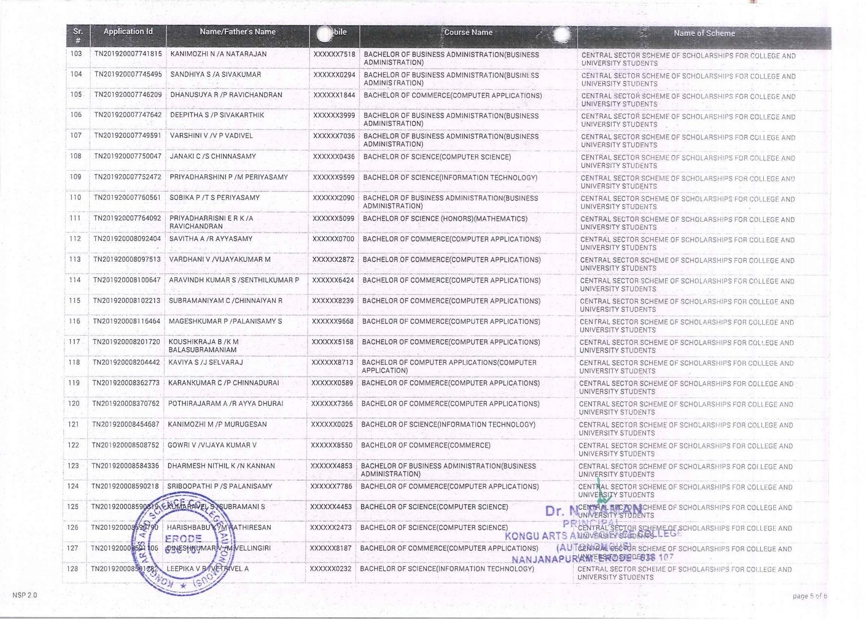

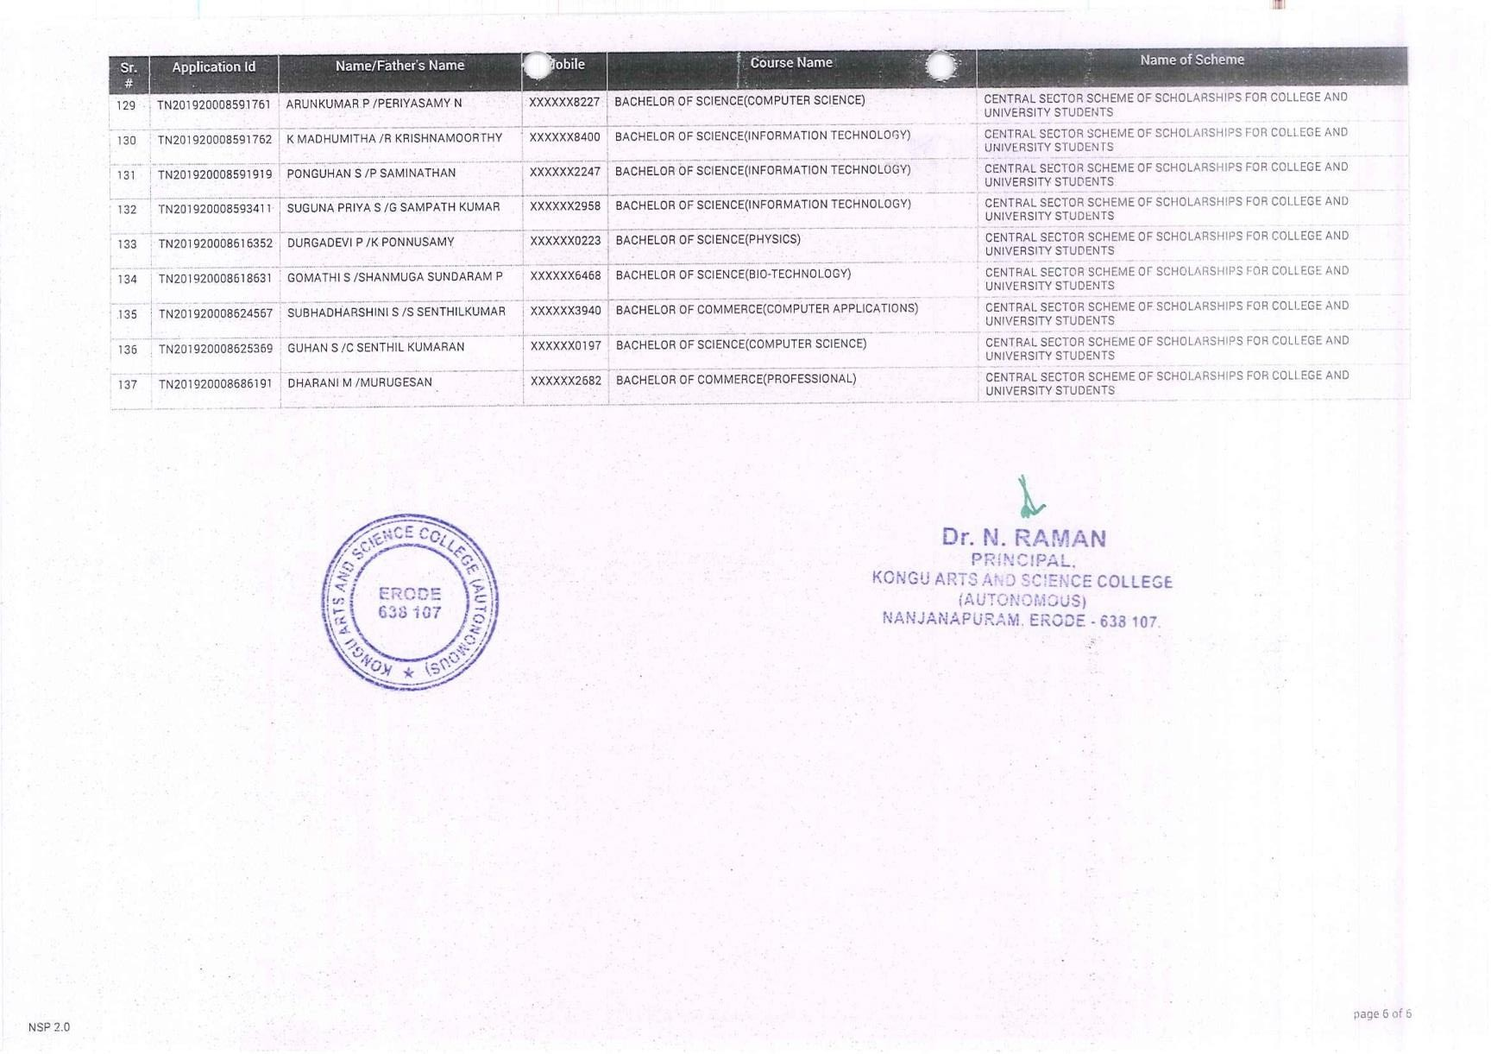

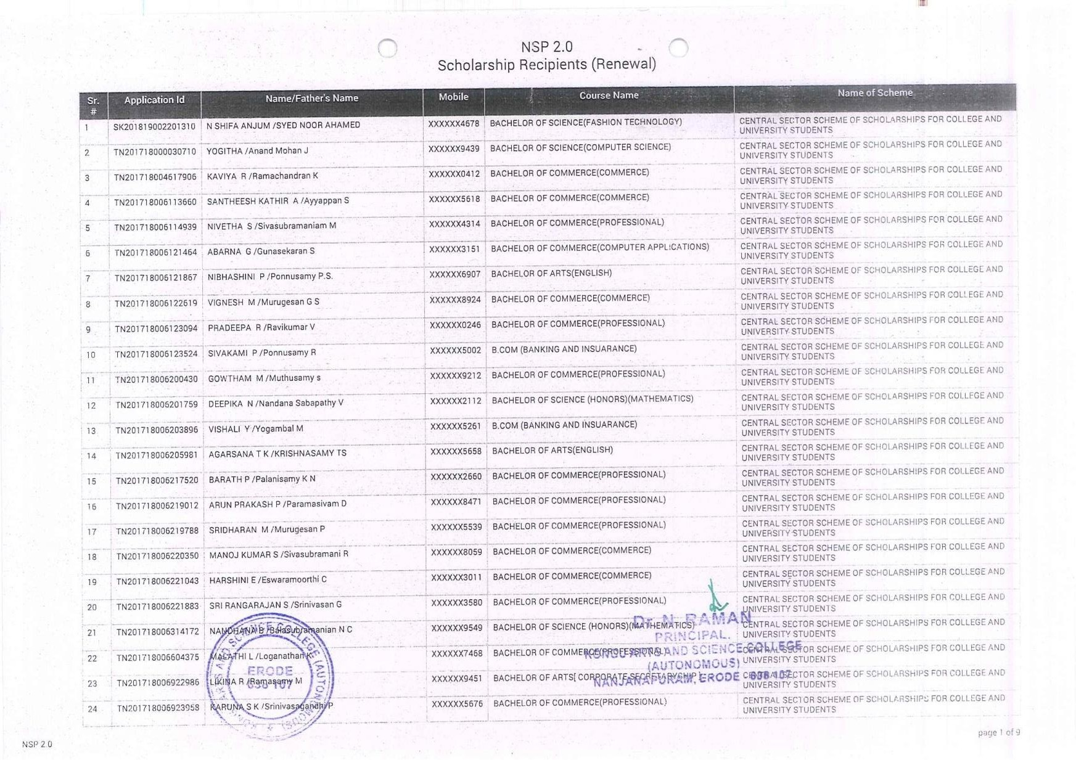

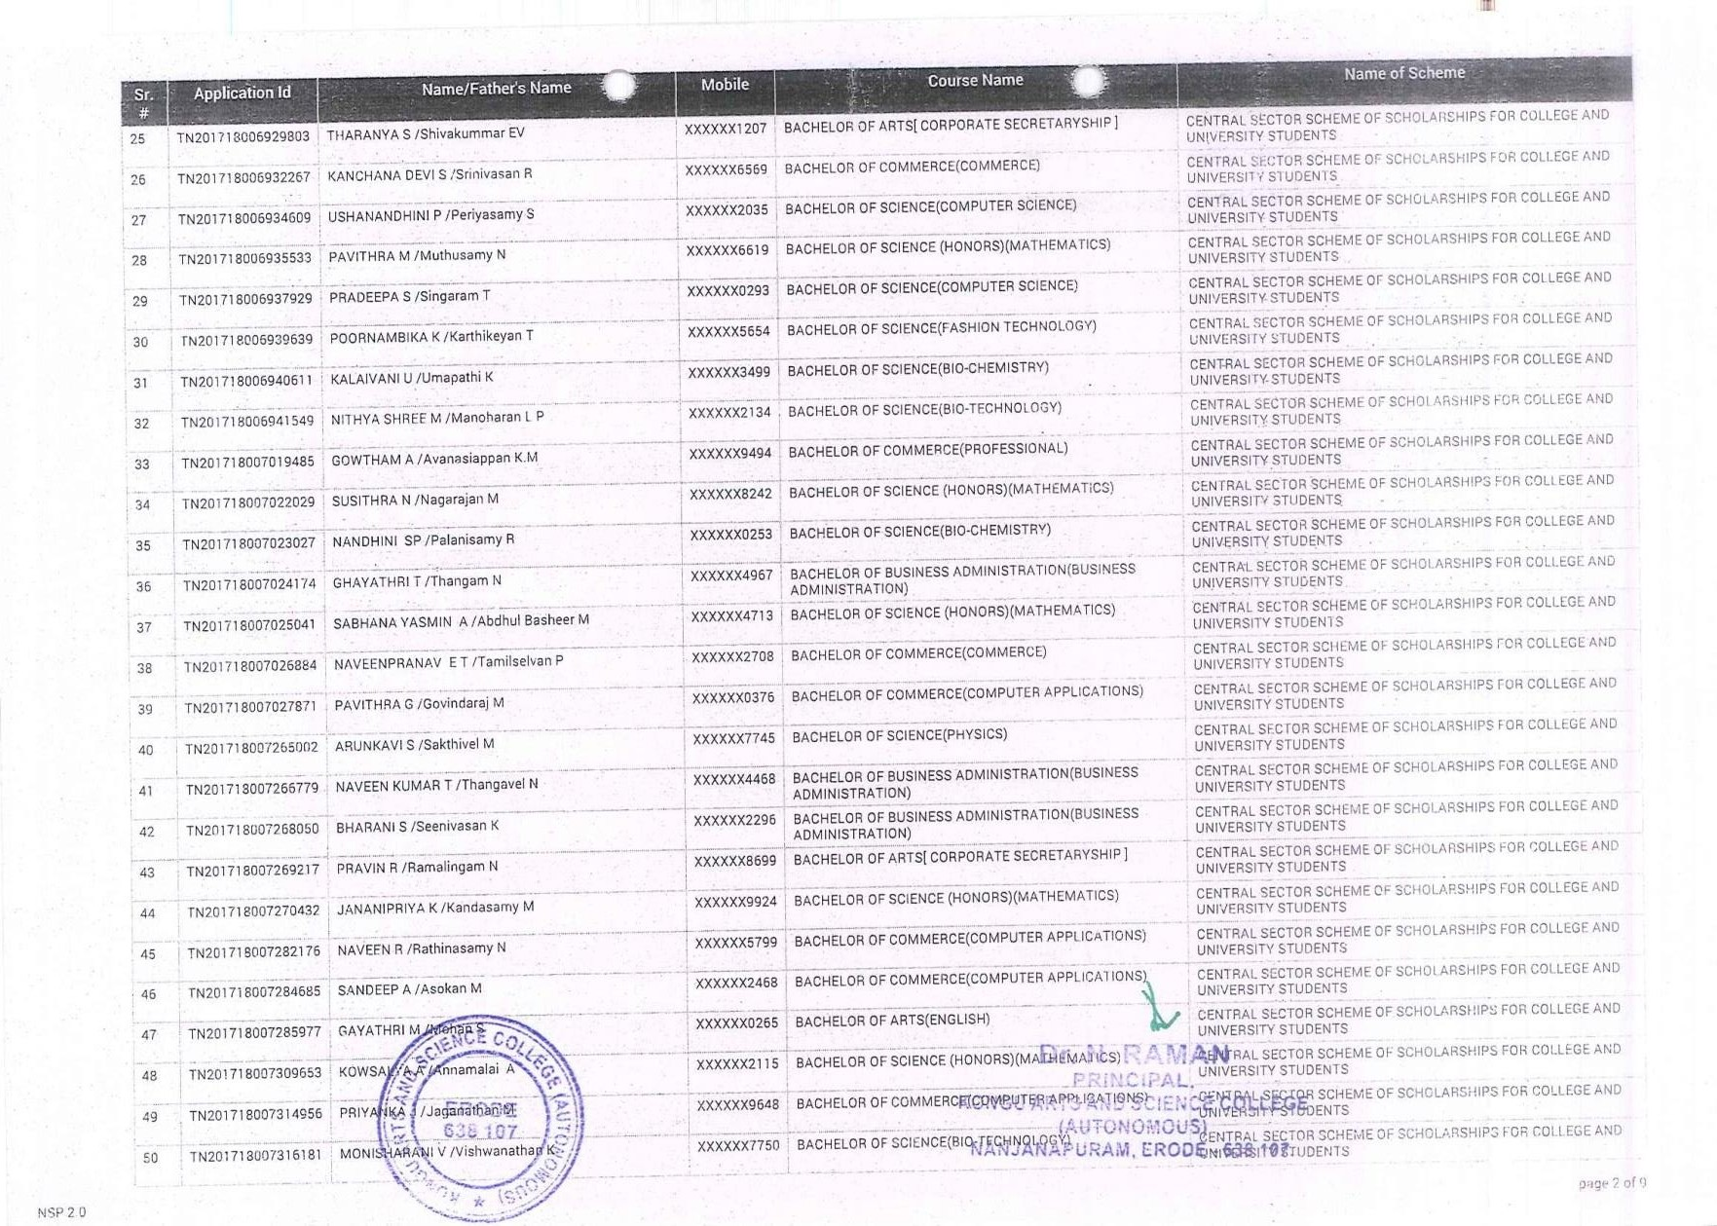

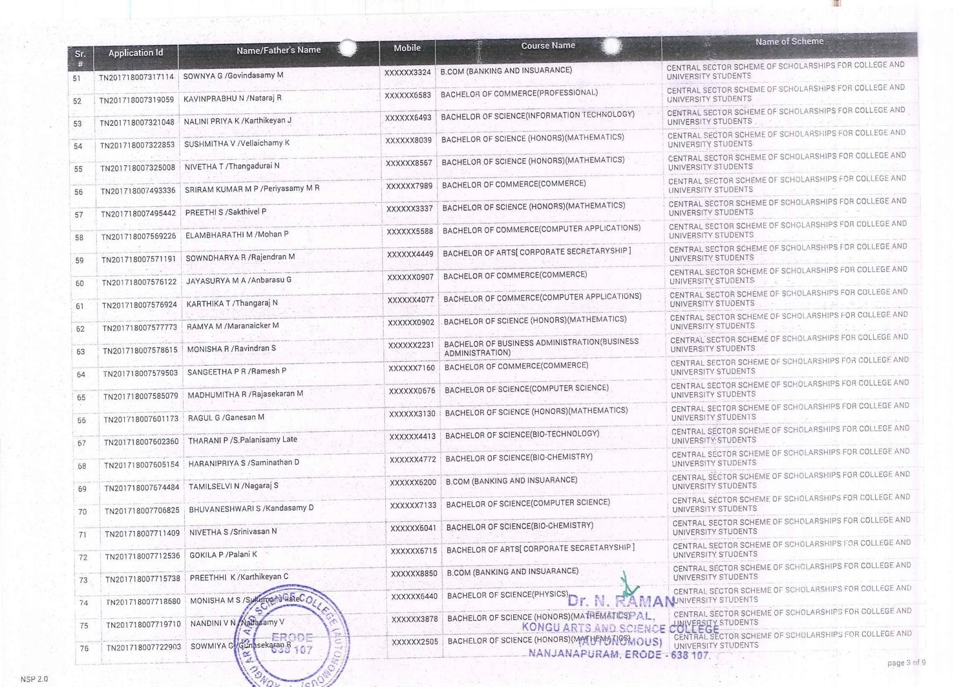

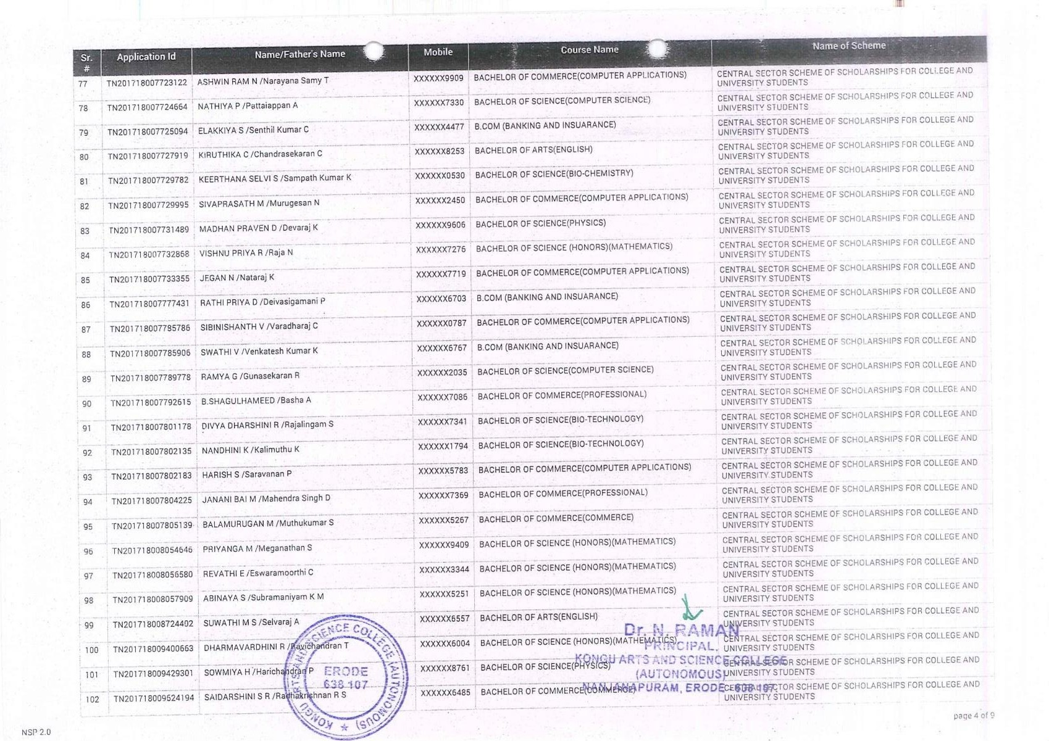

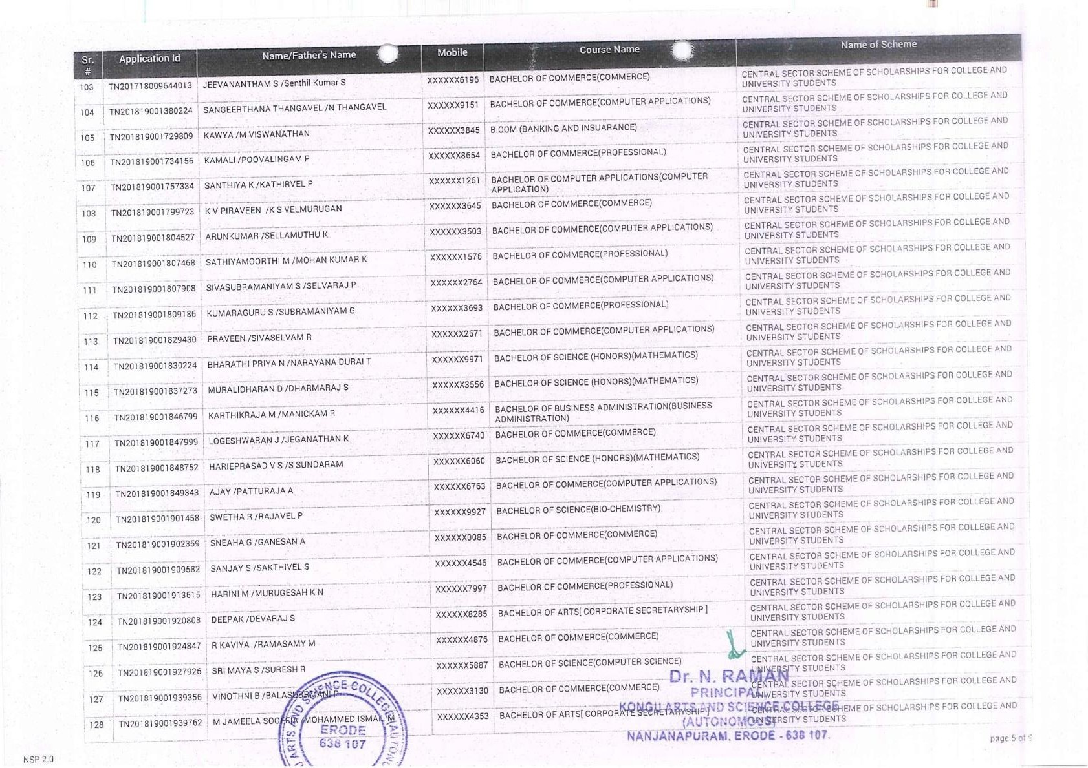

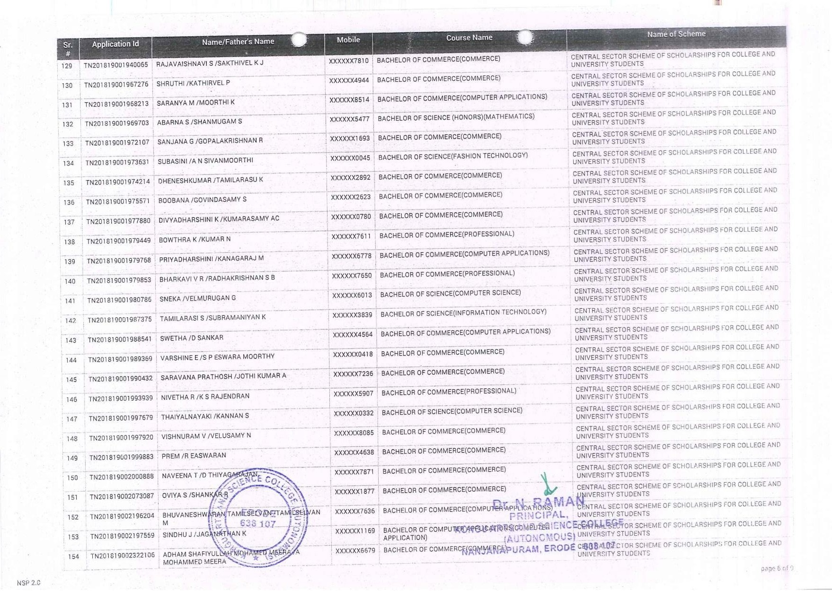

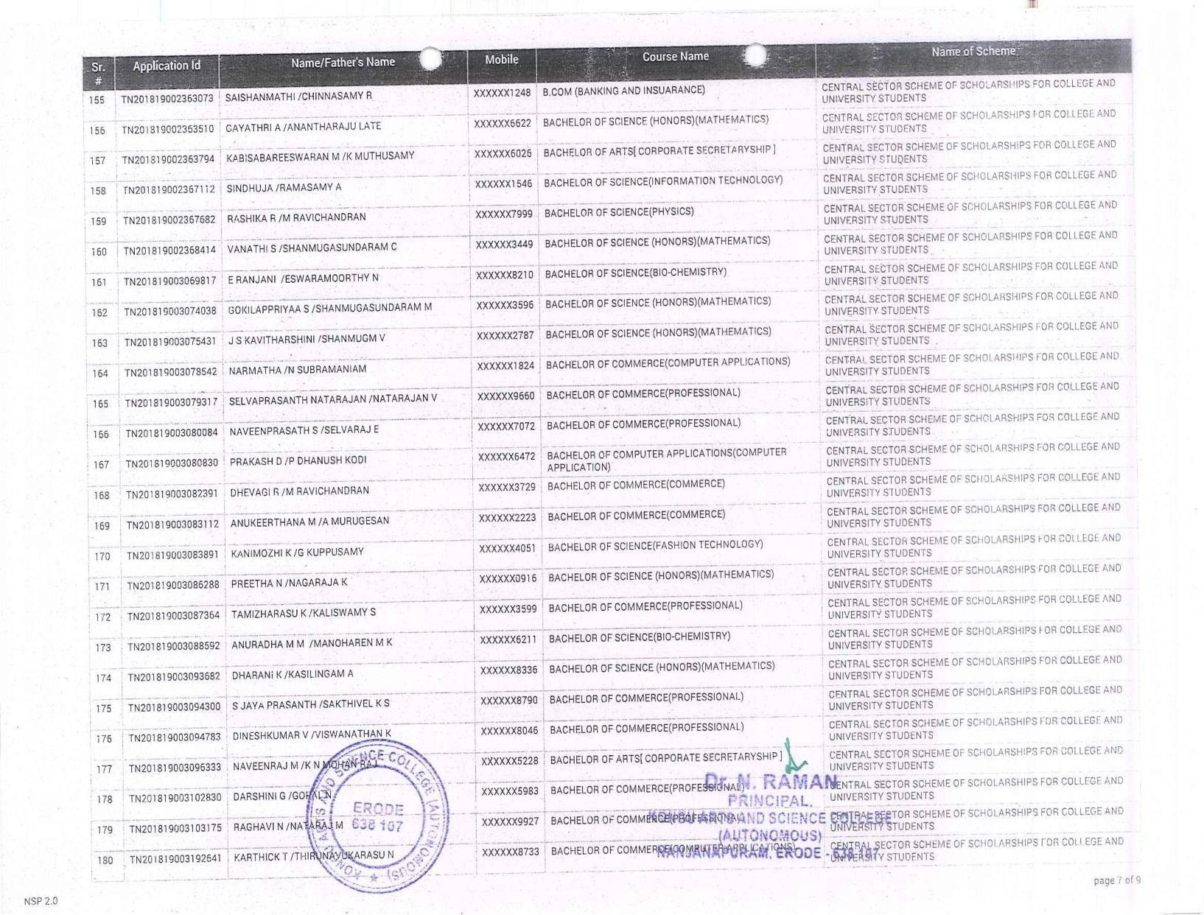

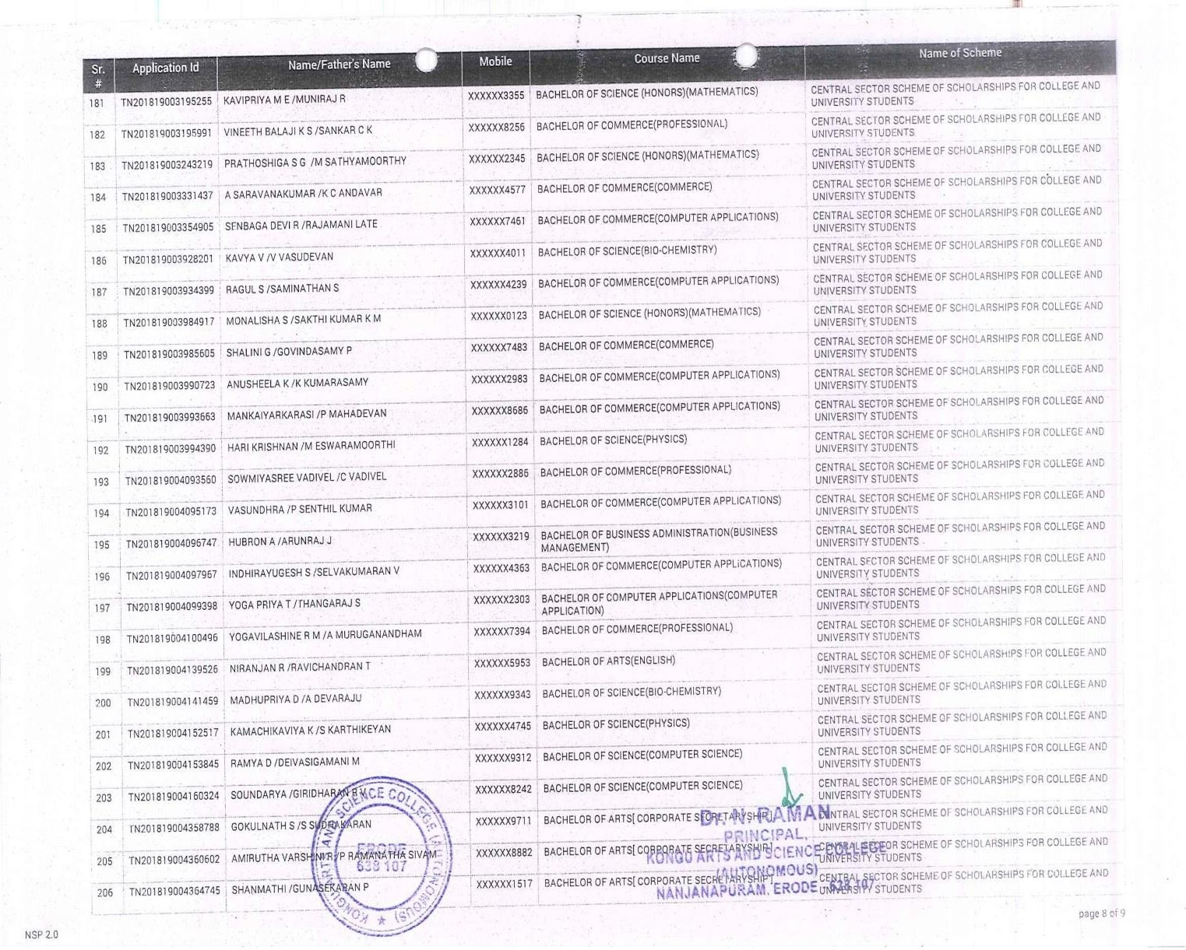

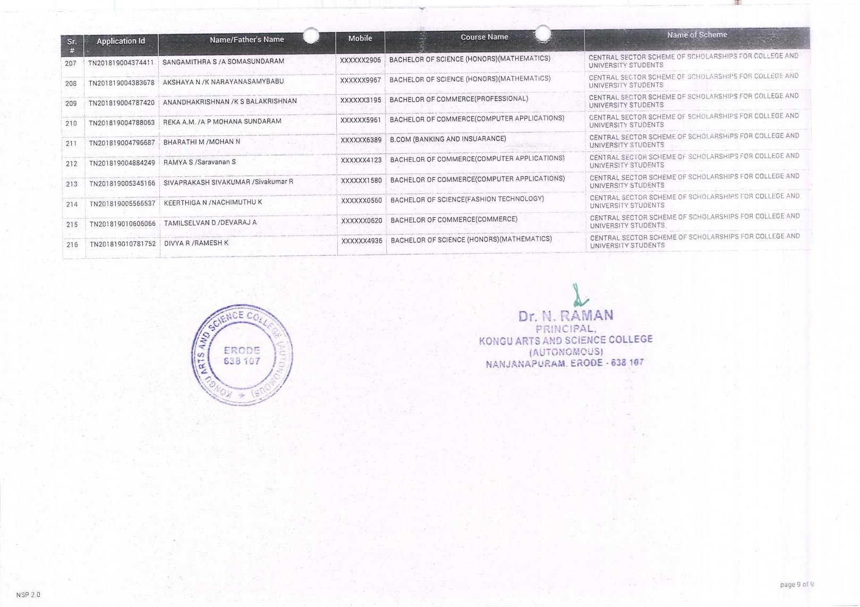

BC/MBC
SCHOLARSHIP
BC/MBC SCHOLARSHIPS

