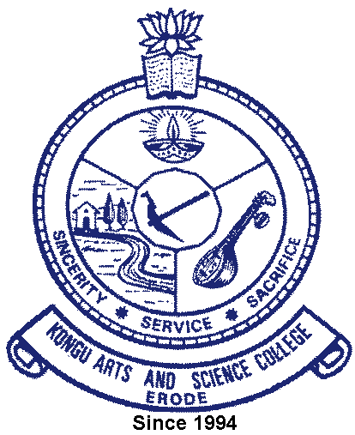
KONGU ARTS AND SCIENCE COLLEGE
(An Autonomous Institution, Affiliated to Bharathiar University, Coimbatore)
ERODE – 638 107

3.3.1 Eco system for Innovations, Creation and Transfer of knowledge

S.No | Particulars | Link to the Document
1 | Funding Development Cell | View Document
2 | Entrepreneurship Development Cell | View Document
3 | Intellectual Property Rights Cell | View Document
4 | KASC Science Forum | View Document
5 | Institution’s Innovation Council | View Document

