**2.6.2 Attainment of programme outcomes and course outcomes are evaluated by the institution.**

Outcome-Based Curriculum has been introduced for all the programmes since the year 2017-2018. Seven POs and five PSOs have been framed for each programme of Arts and Science streams separately. Besides, five COs have been drafted for each course, and their relationship mappings with POs and PSOs are measured.

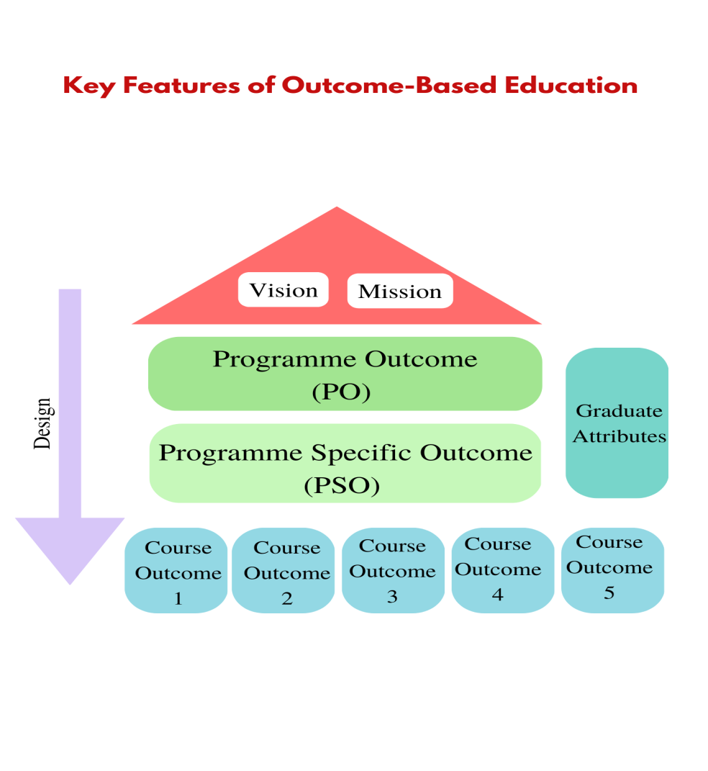

To measure the attainment of COs, the question papers for both Continuous Internal Assessments (CIA) and End Semester Examinations (ESE) are framed as per the guidelines of the revised Bloom's Taxonomy. The marks secured by the students in both the components are recorded and evaluated. The performance of the students in all the semesters provides the overall outcomes by the end of the programme.

OBE is implemented in the Institution with direct Assessment method and the procedures are as follows:

1. Method of measuring attainment of COs
2. Method of measuring attainment of POs and PSOs
3. Action Taken Report

**PROCESS OF OBE IMPLEMENTATION**

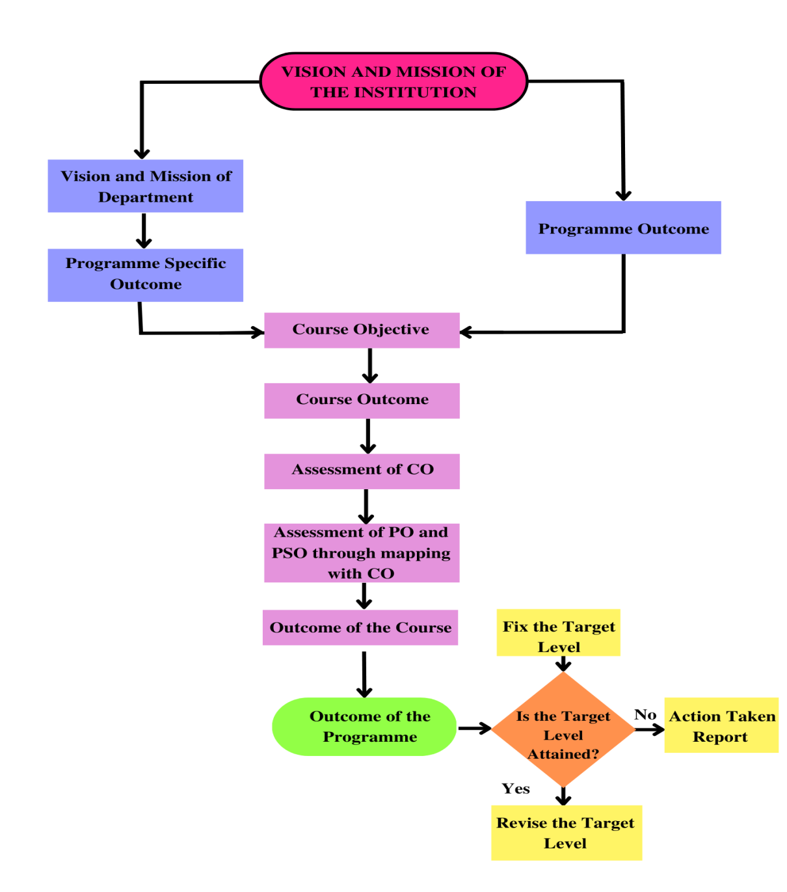

**Method of measuring attainment of Cos**

The course instructor knows the target of course outcome to be attained for the particular course which are being taught. Questions are set at the appropriate Bloom’s levels in the internal, model and end-semester examinations. Bloom’s levels are indicated for each question in CIA Test I, CIA Test II, Model and End-Semester Examinations. Recorded data which are arrived at examination results are analysed to check the level of outcome attained by each course. Rubrics for direct assessment are framed by the OBE monitoring committee and disseminated to the faculty members for the follow-up. In direct assessment, the formative and summative evaluation is assessed on the basis of 25:75 ratios respectively. From the academic year 2021-2022, the ratio has been changed as 50:50. The formative assessment consists of two internal exams, one model exam and two assignments for UG / two seminars for PG students.

**Method of measuring attainment of POs and PSOs**

The course outcome attainment enables the assessment of POs and PSOs attainment. The attainment of each of the PO and PSO from the course outcomes have been measured by means of a relationship matrix mapping method.

All the outcomes are measured for each programme and the attainment level is graded as high, medium and low. Mapping of COs with POs and PSOs provides the correlation in which the level **3** signifies the **high** attainment level, whereas **2 and 1** signifies **moderate** and **low levels** respectively. Efforts are ensured to move towards high scaling till the fixed attainment level. The assessment grades are further revised in the case of attainment of high level at the end of the programme for the constant pursuit of betterment.

The Institution adopts the following assessment methodology to evaluate the outcomes and the relationship matrix of COs, POs and PSOs.

**Action Taken Report**

Based on the attainment level, Action Taken Report (ATR) is planned as follows:

* If attainment is less than the target level, then improvement actions are planned.
* If attainment meets the target level, then the cut-off percentage will be increased.

Thus, through the attainment of COs, POs and PSOs, an evidence based demonstration is presented that the concerned programme has achieved better attainments in the outcomes and strive to continuously improve the attainment for the succeeding batch of students.

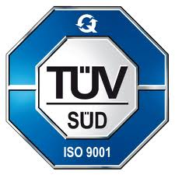KONGU ARTS AND SCIENCE COLLEGE

(AUTONOMOUS)

ERODE- 638 107

**OUTCOME BASED EDUCATION MONITORING COMMITTEE**

**DETAILS OF RELATIONSHIP MATRIX FOR COURSE OUTCOMES, PROGRAMME**

**OUTCOMES AND PROGRAMME SPECIFIC OUTCOMES FOR UG/PG PROGRAMMES**

**Relevant POs and PSOs Scales assigned for the course:**

|  |  |  |  |  |  |  |  |  |  |  |  |  |  |  |
| --- | --- | --- | --- | --- | --- | --- | --- | --- | --- | --- | --- | --- | --- | --- |
| **Semester:** | **Course Code :** | | | | **Course:** | | | | **Hours:** | | | **Credits:** | | |
| **Course Outcomes (COs)** | **Programme Outcomes (POs)** | | | | | | | | **Programme Specific Outcomes (PSOs)** | | | | | |
| **PO**  **1** | **PO**  **2** | **PO**  **3** | **PO**  **4** | | **PO**  **5** | **PO**  **6** | **PO**  **7** | **PSO**  **1** | **PSO 2** | **PSO 3** | | **PSO 4** | **PSO**  **5** |
| **CO1** |  |  |  |  | |  |  |  |  |  |  | |  |  |
| **CO2** |  |  |  |  | |  |  |  |  |  |  | |  |  |
| **CO3** |  |  |  |  | |  |  |  |  |  |  | |  |  |
| **CO4** |  |  |  |  | |  |  |  |  |  |  | |  |  |
| **CO5** |  |  |  |  | |  |  |  |  |  |  | |  |  |

**Correlation Levels:**

|  |  |
| --- | --- |
| High | 3 |
| Medium | 2 |
| Low | 1 |
| No Correlation | - |

**Score for the Course :**

|  |  |  |  |  |  |  |  |  |  |  |  |  |  |
| --- | --- | --- | --- | --- | --- | --- | --- | --- | --- | --- | --- | --- | --- |
| **Course Outcomes (COs)** | **Programme Outcomes (POs)** | | | | | | | **Programme Specific Outcomes (PSOs)** | | | **Mean Score** | | |
| **PO1** | **PO2** | **PO3** | **PO4** | **PO5** | **PO6** | **PO7** | **PSO**  **1** | **PSO2** | **PSO**  **3** | **Total of Relevant**  **POs and PSOs** | **%** | **Scale** |
| **CO1** |  |  |  |  |  |  |  |  |  |  |  |  |  |
| **CO2** |  |  |  |  |  |  |  |  |  |  |  |  |  |
| **CO3** |  |  |  |  |  |  |  |  |  |  |  |  |  |
| **CO4** |  |  |  |  |  |  |  |  |  |  |  |  |  |
| **CO5** |  |  |  |  |  |  |  |  |  |  |  |  |  |
| **Overall Mean Score of Outcomes** | | | | | | | | | | |  | | |

**Result: The Score for the course is ______ (High / Medium / Low Relationship)**

**Score Attainment Level for COs :**

|  |  |  |  |  |  |
| --- | --- | --- | --- | --- | --- |
|  | SPLIT UP | MARKS | PERCENTAGE | MARGIN MARKS (60%) | TOTAL |
| CIA I | CO I  CO II | 34  16 | 68  32 | 20  10 | 25% |
| CIA II | CO II  CO III | 16  34 | 32  68 | 10  20 |
| MODEL | CO I  CO II  CO III  CO IV  CO V | 15  15  15  15  15 | 20  20  20  20  20 | 9  9  9  9  9 |
| SEMINAR I | CO I  CO II | 2.5  2.5 | 50 | 1.5 |
| SEMINAR II | CO III  CO IV  CO V | 1.7  1.7  1.6 | 33.5  33.5  33 | 1.02 |
| END SEMESTER |  | 75 |  |  | 75% |

**Score for POs/ PSOs through Mapping:**

|  |
| --- |
| PO/PSO = CO Attained x PO/PSO Assigned / 3 (Maximum Level) |

**Values Scaling:**

|  |  |  |  |
| --- | --- | --- | --- |
| **Mapping** | **1 % to 60 %** | **61% to 80%** | **81% to 100%** |
| **Scale** | **1** | **2** | **3** |
| **Relation** | **0.0 to 1.0** | **1.1 to 2.0** | **2.1 to 3.0** |
| **Quality** | **Low** | **Medium** | **High** |

**Calculation:**

**Mean Score of Outcomes**

|  |  |
| --- | --- |
| **% = $\frac{Totalofvalues}{Totalno. of relevant POsandPSOs}$ X100** | **Overall Mean Score for COs = $\frac{TotalofScale}{Totalno. ofCOs}$** |