2.6.1 **Programme and course outcomes for all Programmes offered by the institution are stated and displayed on website and communicated to teachers and students.**

**Outcome Based Education**

The Institution caters to all sorts of contemporary updations notably the Outcome Based Education in the effective way. In accordance with OBE’s vision to assess the graduate attributes, social, regional and national interests of the learning community, the institution frames its own Programme Outcomes (PO). The Departments exclusively frame Programme Specific Outcomes (PSO) and Course Outcomes (CO) based on the demands of academic and career challenges. All outcomes are placed in the Statutory Bodies meet for approval through Curriculum Development Cell and for further approval in Board of Studies of the respective Departments. Outcome Based Curriculum has been introduced in the Institution for all the programmes from the year 2017-2018 onwards. Seven POs and five PSOs have been framed for each programme of Arts and Science disciplines separately. Besides five COs for each course, their relationship matrices with POs and PSOs are also formulated.

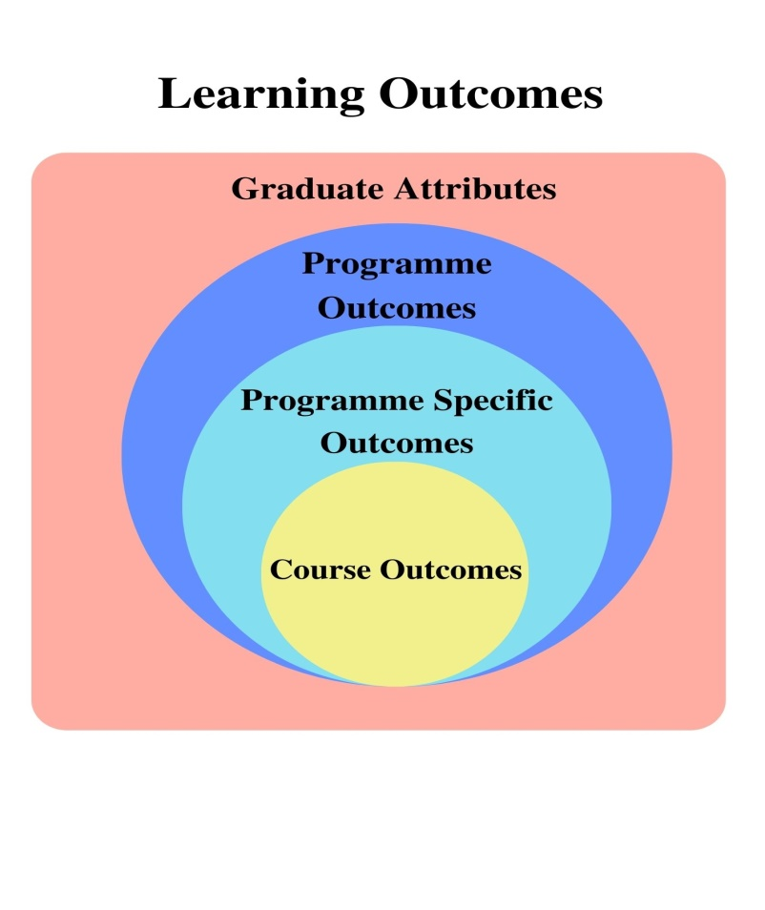

**Figure 2.6.1 (a) Graduate Attributes**

**Framing of Outcomes**

**Programme Outcomes** of the college are designed distinctly for Arts and Science streams at both UG and PG level based the suggestions of Academic experts. Several Graduate Attributes notably Critical Thinking, Effective Communication, Social Interaction, Effective Citizenship, Ethics, Environmental Sustainability and Self Directed Life Long Learning have been prescribed to be the POs of all the Programmes.

**Programme Specific Outcomes,** the expected efficiency over specific skills with relevant to the domain area of individual Departments are formulated at the unified efforts of Head of the Department and Faculty Members

**Course outcomes** are designed based on the expected productive applicability through the implementation of knowledge in particular course. The COs are drafted in relevance with the syllabus by the faculty members in discussion with the Head of the Department, which is then adopted in the curriculum with the concurrence of the Board of Studies.

**OBE Monitoring Committee**

OBE Monitoring Committee has been constituted to monitor the implementation of OBE in the Institution. The OBE Monitoring Committee reviews the PSOs, POs and COs on a regular basis through discussions. It analyses the improvement in the attainment of each programme, suggests improvement action plans and revises level of targets by means of Action Taken Report (ATR). It also monitors the successful implementation of the ATR to ensure further efficiency. The teachers are encouraged to participate actively in seminars, FDPs, workshops and curriculum meetings, related to outcome based education organized through IQAC in association with OBE Monitoring Committee.

**Implementation and Mode of Dissemination of OBE**

Students are engaged in several skill oriented activities in the classroom. Question papers are structured based on revised Bloom’s Taxonomy and students are assessed accordingly. Communications regarding the course outcomes are detailed in the classroom by the course teachers to ensure its attainment among the students. All the POs, PSOs and COs are displayed in the notice boards of Departments and Classrooms for better proximity of OBE among students and are also uploaded in the college website to propagate the same to Parents and Public globally.

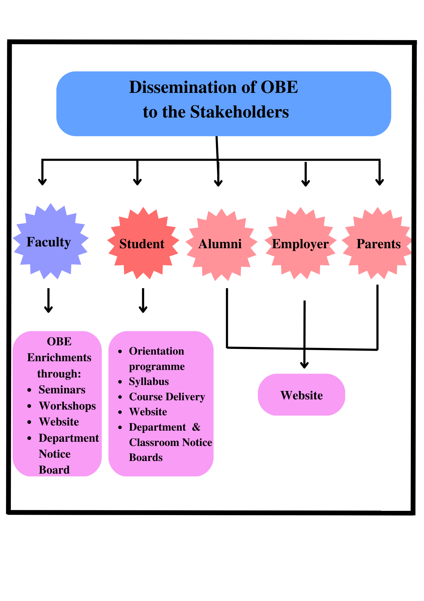

**Figure 2.6.1 (b) Dissemination of OBE in the Institution**