**2.3.4 Teaching Plans by the Institution**

The institution ascends the summit of pedagogic excellence through strategic planning and standardized execution of all its academic endeavors. Well structured academic calendar, curriculum design and lesson plan exemplify prompt planning and effective execution.

**Planning**

**Academic Calendar**

College calendar for the forthcoming Academic Year is always planned well in advance as the outcome of discussions and decision of the Council headed by the Principal, IQAC CO-ordinator, the Heads of the Departments and Council Members.

College calendar is not a mere schedule but an instruction manual that governs students in all behavioural and academic aspects, having been enclosed with the details of KVIT Trust and the Trustees, the Programmes offered by the college, the details of all the staff members, functions of several clubs and forums, schedule of day order with holiday notifications, observance of important days and a clear guidance over Attendance Proforma.

Execution of examination related activities along with the time line for hall ticket application and issue, the commencement of Internal Examinations, Model and Semester Examinations are circulated in advance by the Controller of Examinations.

**Curriculum Design**

Strong curriculum lays the foundation for academic excellence. With regard to this, curricular aspects are planned expeditiously before the commencement of semester, subjected to scrutiny under Curriculum Development Committee at several levels notably Board of Studies, Standing Committee on Academic Affairs and Academic Council and is fine tuned exceptionally well at the time of its provision to students.

Syllabus framework is standardized in accordance with the regulations of University, AICTE, UGC and TANSCHE norms, feedback from eminent stakeholders and the syllabus reference of reputed peer institutions.

**Execution**

The institution ensures prompt execution of all its academic planning. Further, all sorts of pedagogic plans and its execution are monitored consistently. Allocation of course is made at the assessment of experience and effectiveness of the faculty members. All the courses are designed with regularity to the maximum of 6 hours and minimum 2 hours based on their part of contribution as Core, Allied, Skill based, 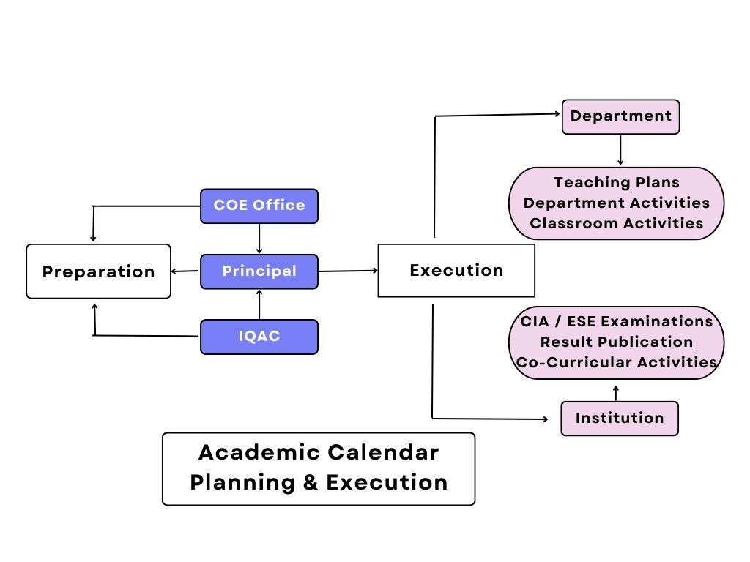NME and Value Education.

**Figure 2.3.4. Academic Calendar Planning and Execution**

Timetable with 5 hours and 6 hours per day are designed for Odd and Even semester respectively. Proper execution of plan is evident through the correlation among timetable, class attendance and individual lesson plan maintained by the faculty members. Continuous Internal Assessment, Model and End Semester Exams are scheduled, executed and followed up promptly in grooming the individual efficiency of the students.

**Lesson Plan**

Execution of every classroom activities is registered in lesson plan. It exists to be the directory of courses handled, unit allotment and syllabus completion statement. As a record of pedagogical strategy, the faculty members are asked to write the topic title, books used for reference and the methods of pedagogy used for deliberation along with the date and time. Column of Bloom’s Taxonomy specified in lesson plan evidences the levels of approach upon the topic. Implementation of OBE is evident with CO mapping of each topic. Qualitative teaching learning process is further ensured through the activities column registered with innovative activities given to students during the class hours. Lesson plan is monitored by the HoD and the Principal periodically.