**2.3.1 Student Centric Activities**

Every student cannot learn in the same way. Efforts of the faculty members foster student centric methodologies that implement hands on, minds on and hearts on contribution in students through several experiential, participative and problem solving activities. Students are trained to be emotionally stable and to be competent enough intellectually, socially and physically.

**CBCS & OBE**

Existence of CBCS and OBE system of pedagogy and assessment lays the foundation for Student- Centric Activities in the academic sphere. CBCS undoubtedly instills learning of one’s own choice among the students and offers academic flexibility. Implemented OBE system ensures clarity in curriculum framework based on real life, flexibility in deliberation, learning out of self- involvement among the student community and an exact evaluation of outcomes attained.

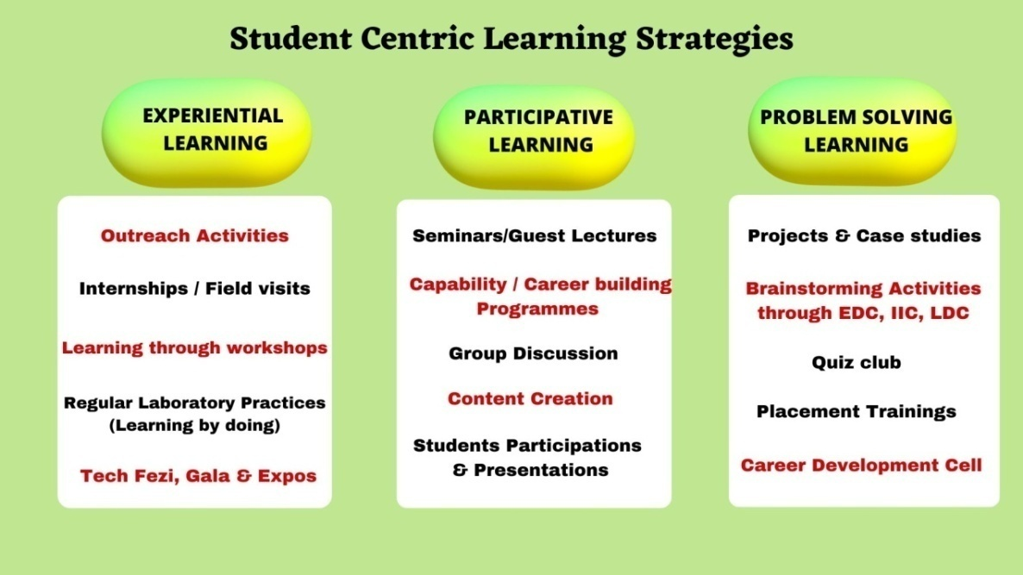

**Figure 2.3.1. Student Centric Learning Methodologies**

**Experiential learning** among students grooms their empirical skill and practical implementation of theoretical knowledge discussed in classroom

* Community outreach programmes to rural public and school children enhance students’ academic skills, leadership qualities and managerial skills
* Field visits bring students in direct contact with the society and industrial sphere to understand the industrial demands and to elevate them to meet its needs
* Industrial Training for a month trains students’ survival competence in industries and workplace
* Students of Commerce and Management Studies organize KASCO and FEST, a commercial exhibition within the premise that literally tend them to experience all sorts of managerial functions in reality
* Well equipped laboratories facilitate effective learning through first hand experimentation.

**Participative learning** promotes collaborative skill and team spirit among students.

* Engaging the students in activities like group discussions, debates and presentation kindles their active participation to investigate, to analyse and to evaluate the opportunities before arriving at a decision
* The activities like role plays and skits build academic as well as emotional etiquette among students
* Motivation to participate in several inter- collegiate competitions boosts students’ self- confidence in encountering new atmosphere without fear
* The institution is keen in organizing several workshops and orientation programmes that provide opportunities to explore current topics and to implicate practical applications
* The institution being funded under DBT Star College Scheme creates a supportive ambience for procurement of additional equipment and undertaking of advanced research
* Skill development activities direct students to walk in the unique path of creativity and easy learning

**Problem solving learning** strengthens analytical skill and sharpens critical thinking among the learners.

* Brainstorming sessions at the end of every lecture refine the comprehension ability
* Project works are the outcome of students’ exposure towards societal problems and its counter measures
* Students from science discipline create prototype devices based on the theoretical knowledge and present it practically
* Students are given GK and aptitude tests periodically to tend them realize the significance of constant updation and lateral thinking respectively
* Case studies are done by students on several critical issues in the society which nurtures their collective responsibility for social welfare
* Soft skills trainings are provided to students to enrich their value education and personality development
* Activities through IIC witness their organizing caliber and upgrade their leadership qualities
* Initiatives through EDC provide space for innovative startups and entrepreneurial skills