CRITERION II: TEACHING, LEARNING AND EVALUATION

2.5: Evaluation Process and Reforms
2.5.2 Additional Information
S. No | PARTICULARS | LINK
Revaluation Application (Samples)
 | 2021-2022 | 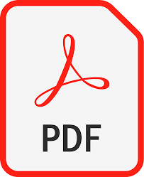
 | 2020-2021
 | 2019-2020
 | 2018-2019
 | 2017-2018

