CRITERION II: TEACHING, LEARNING AND EVALUATION

2.5: Evaluation Process and Reforms
2.5.1 Additional Information
S. No | PARTICULARS | LINK
Academic Schedule
 | Academic Year 2021-2022 | 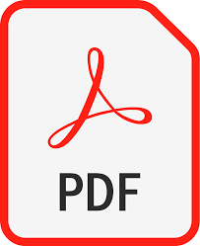
 | Academic Year 2020-2021
 | Academic Year 2019-2020
 | Academic Year 2018-2019
 | Academic Year 2017-2018

