**2.3.2 ICT in teaching and learning**

In the prospect of student digital competence, the premise is well built technically with sufficient number of smart classrooms in all the departments. The interactive white board with internet accessibility and the traditional chalk and talk set up facilitates blended learning and a better comprehensive learning environment

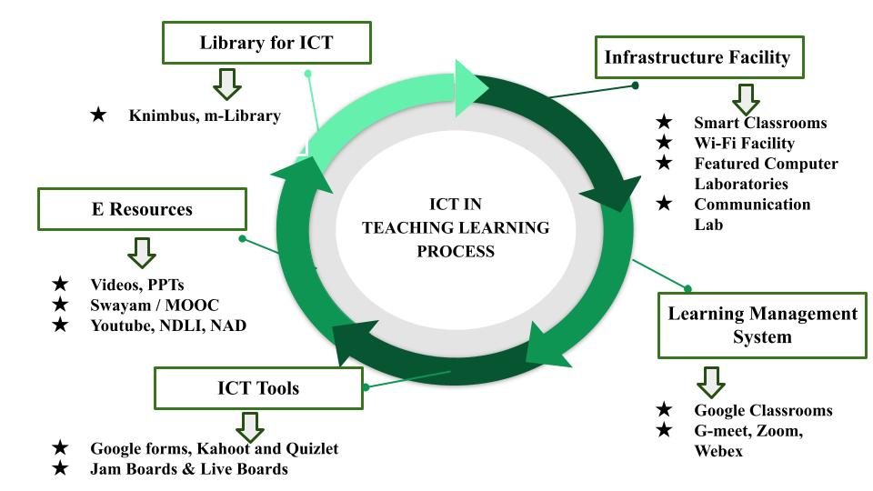

**Figure 2.3.2. ICT in Teaching – Learning Process**

**Infrastructure Facility for ICT integrated Teaching**

* ICT-enabled teaching-learning process is facilitated by 47 smart classrooms, 12 smart Laboratories and 4 seminar halls in the premise
* Campus is equipped with 24 x7 Wi-Fi facilities
* Computer laboratories are featured with high speed internet connection with adequate software to offer curriculum in effective manner

**Learning Management System**

* Google classroom exists to be a prominent Learning Management System that assists in sharing of study materials, video tutorials and assignment to students which actually saves time, reduces paper wastage and ensures better efficiency
* Tech meeting apps notably G-meet, Zoom, Webex, Teams and many have been used to organize interactive lectures and meetings in virtual mode especially in inter-disciplinary aspects for the benefit of students from different programmes

**ICT Tools**

* Google forms, Kahoot and Quizlet are used to conduct objective tests and act as good e-learning platforms to train the students in entrance and competitive examination aspects
* Digital Jam boards and Live boards serve as online teaching tools for conducting problem oriented courses

**E-Resources**

* Video tutorials, PPTs and Video lectures are consistently created and shared by the faculty members via google classroom to offer theoretical concepts in lucid manner
* NPTEL, SWAYAM and Youtube lectures are employed to promote learning beyond classroom.

**Library for ICT based teaching and learning Process**

* Library facilitates users’ access to innumerable e- resources through user friendly software KNIMBUS with the facility to access through mobile app “m- library” at single touch of their screen any time instantly

**COMMUNICATION LABORATORY**

* Communication lab implemented with Orell Talk software grooms language proficiency among the students

**NATIONAL DIGITAL LIBRARY OF INDIA (NDLI) AND REPOSITARIES**

* Students are encouraged to sign up for membership in the NDLI and are being taught to obtain information for their projects and research articles by using INFLIBNET, Shodhganga, Google Scholar, and a number of other research resources
* **National Academic Depository (NAD)** enables students to deposit certificates and academic awards

ICT enabled pedagogical practices within the premise foster learner centric methodologies and facilitate two way communications at better efficiency inside the classroom.