CRITERION II: TEACHING, LEARNING AND EVALUATION
2.1: Student Enrolment and Profile
2.1.1 Additional Information

S. No | PARTICULARS | LINK
Consolidated Students Admission List (For 5 Years)
 | Academic year 2021-2022 | 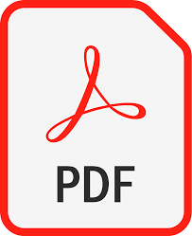
 | Academic year 2020-2021
 | Academic year 2019-2020
 | Academic year 2018-2019
 | Academic year 2017-2018

