**7.1.9 Constitutional Obligations**

The initiatives taken by the Institution towards constitutional obligations during academic year 2021-2022 are as follows:

**CERTIFICATE COURSE IN HUMAN RIGHTS EDUCATION STRENGTH DETAILS**

|  |  |  |  |
| --- | --- | --- | --- |
| **S.No.** | **Academic Year** | **Batch** | **Strength** |
| 1 | 2021-2022 | 2021 | 57 |

**VALUE EDUCATION STUDENTS STRENGTH**

|  |  |  |  |  |
| --- | --- | --- | --- | --- |
| **S.No.** | **Academic Year** | **Batch** | **Course Code** | **Strength** |
| 1 | 2021-2022 | 2021 | 21VE01 | 1096 |

**VALUE EDUCATION SYLLABUS**

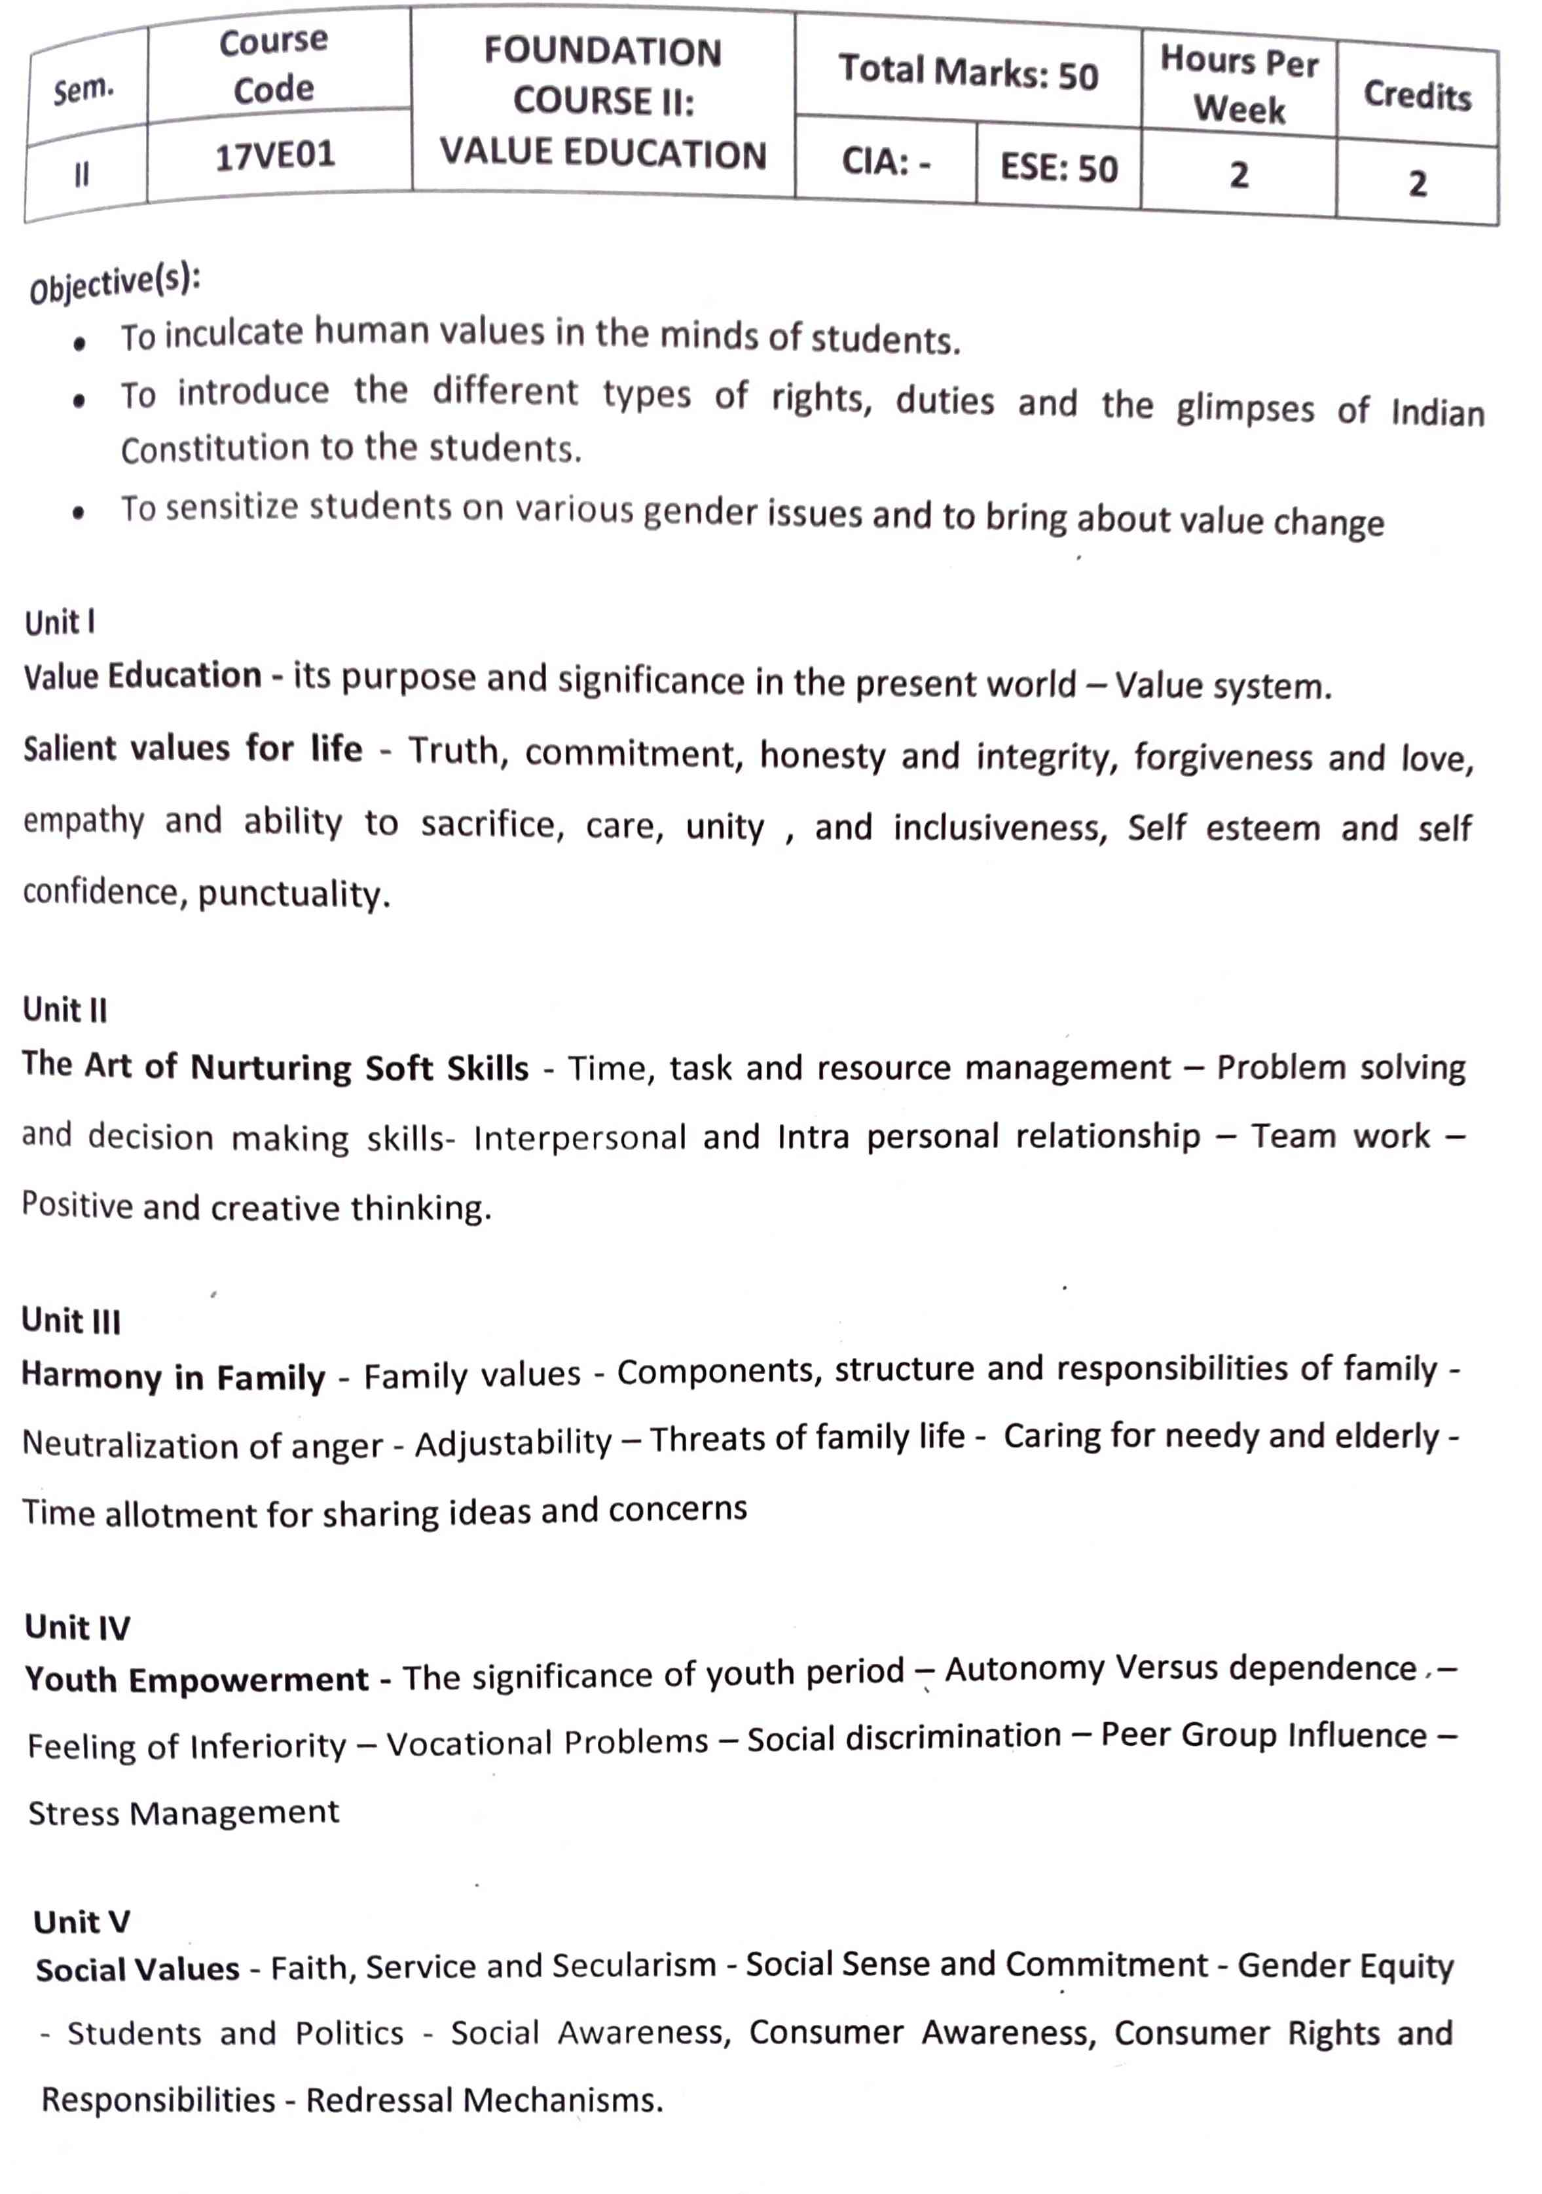



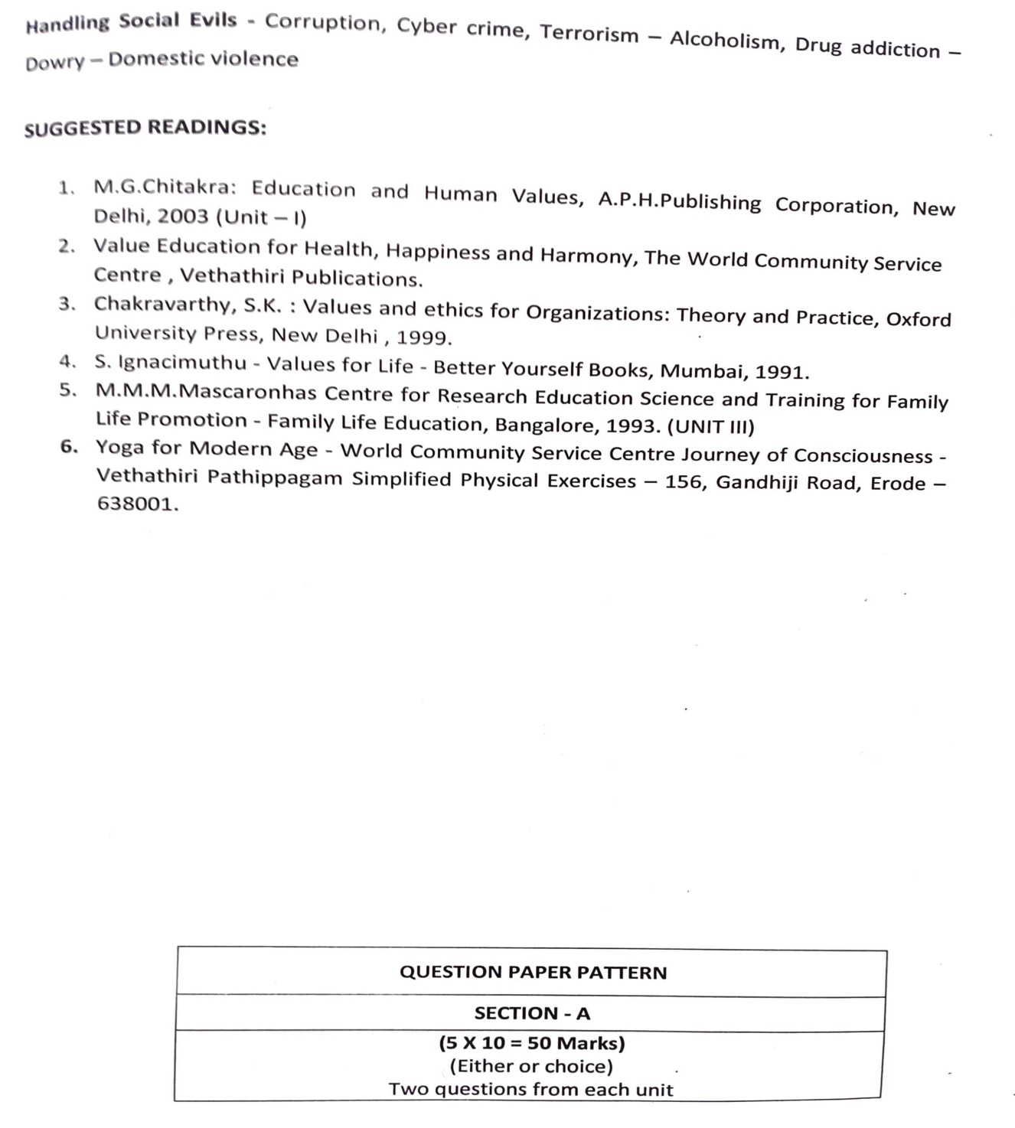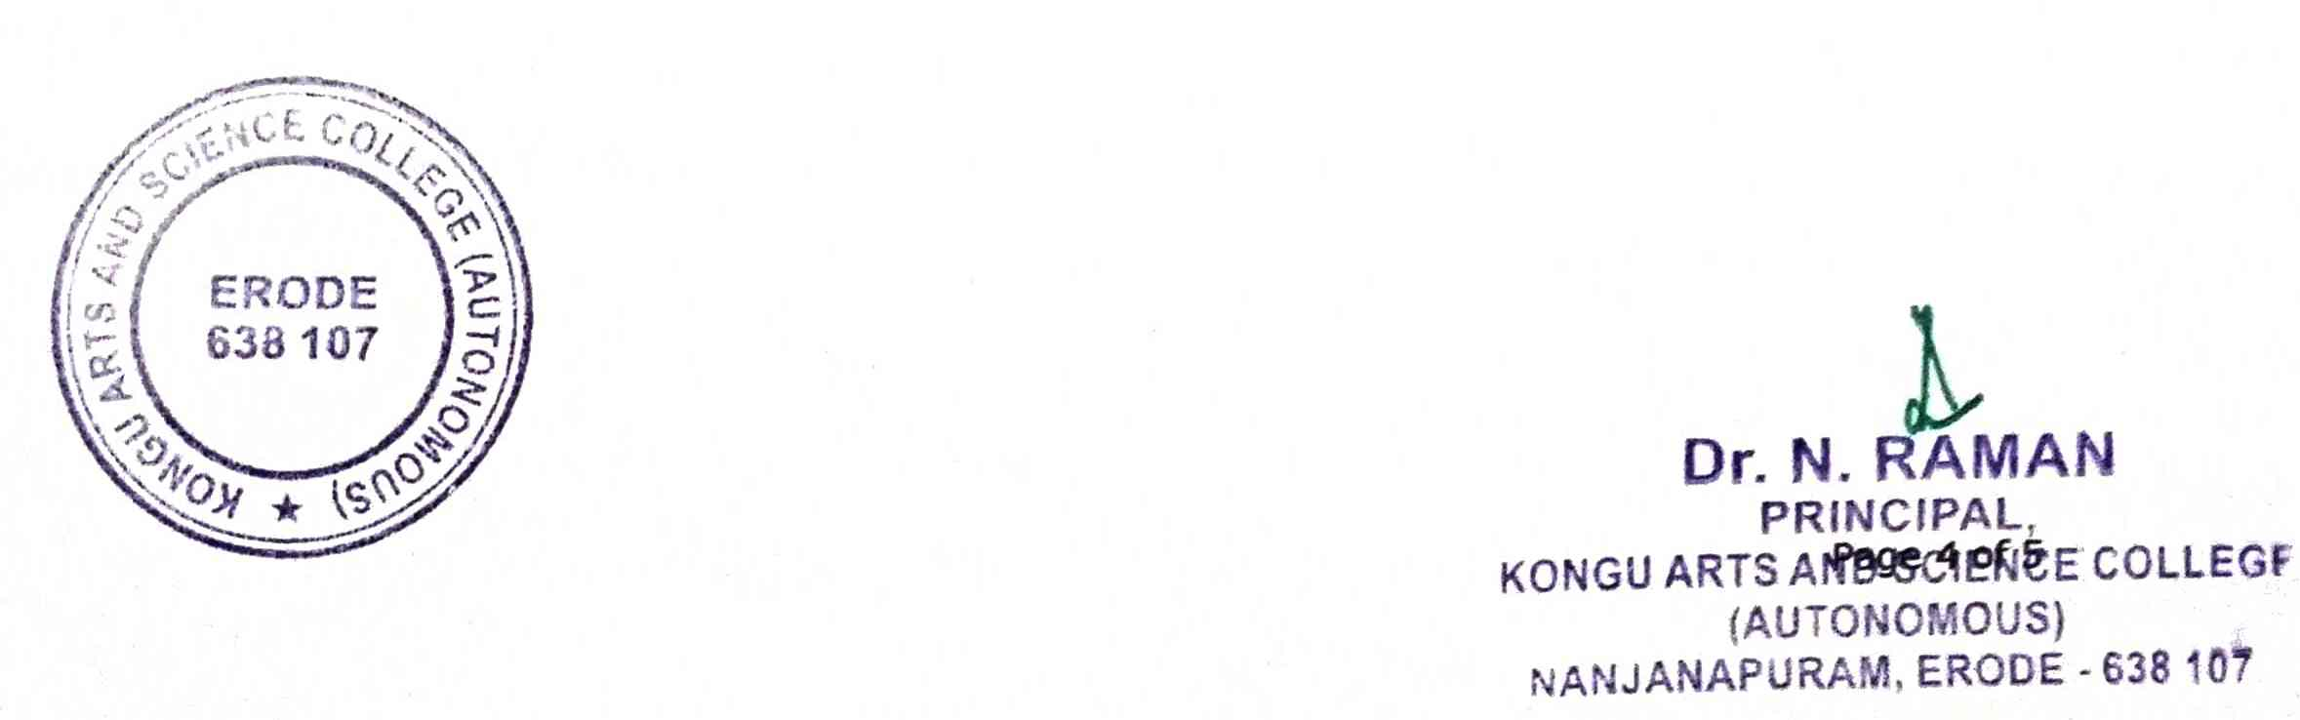

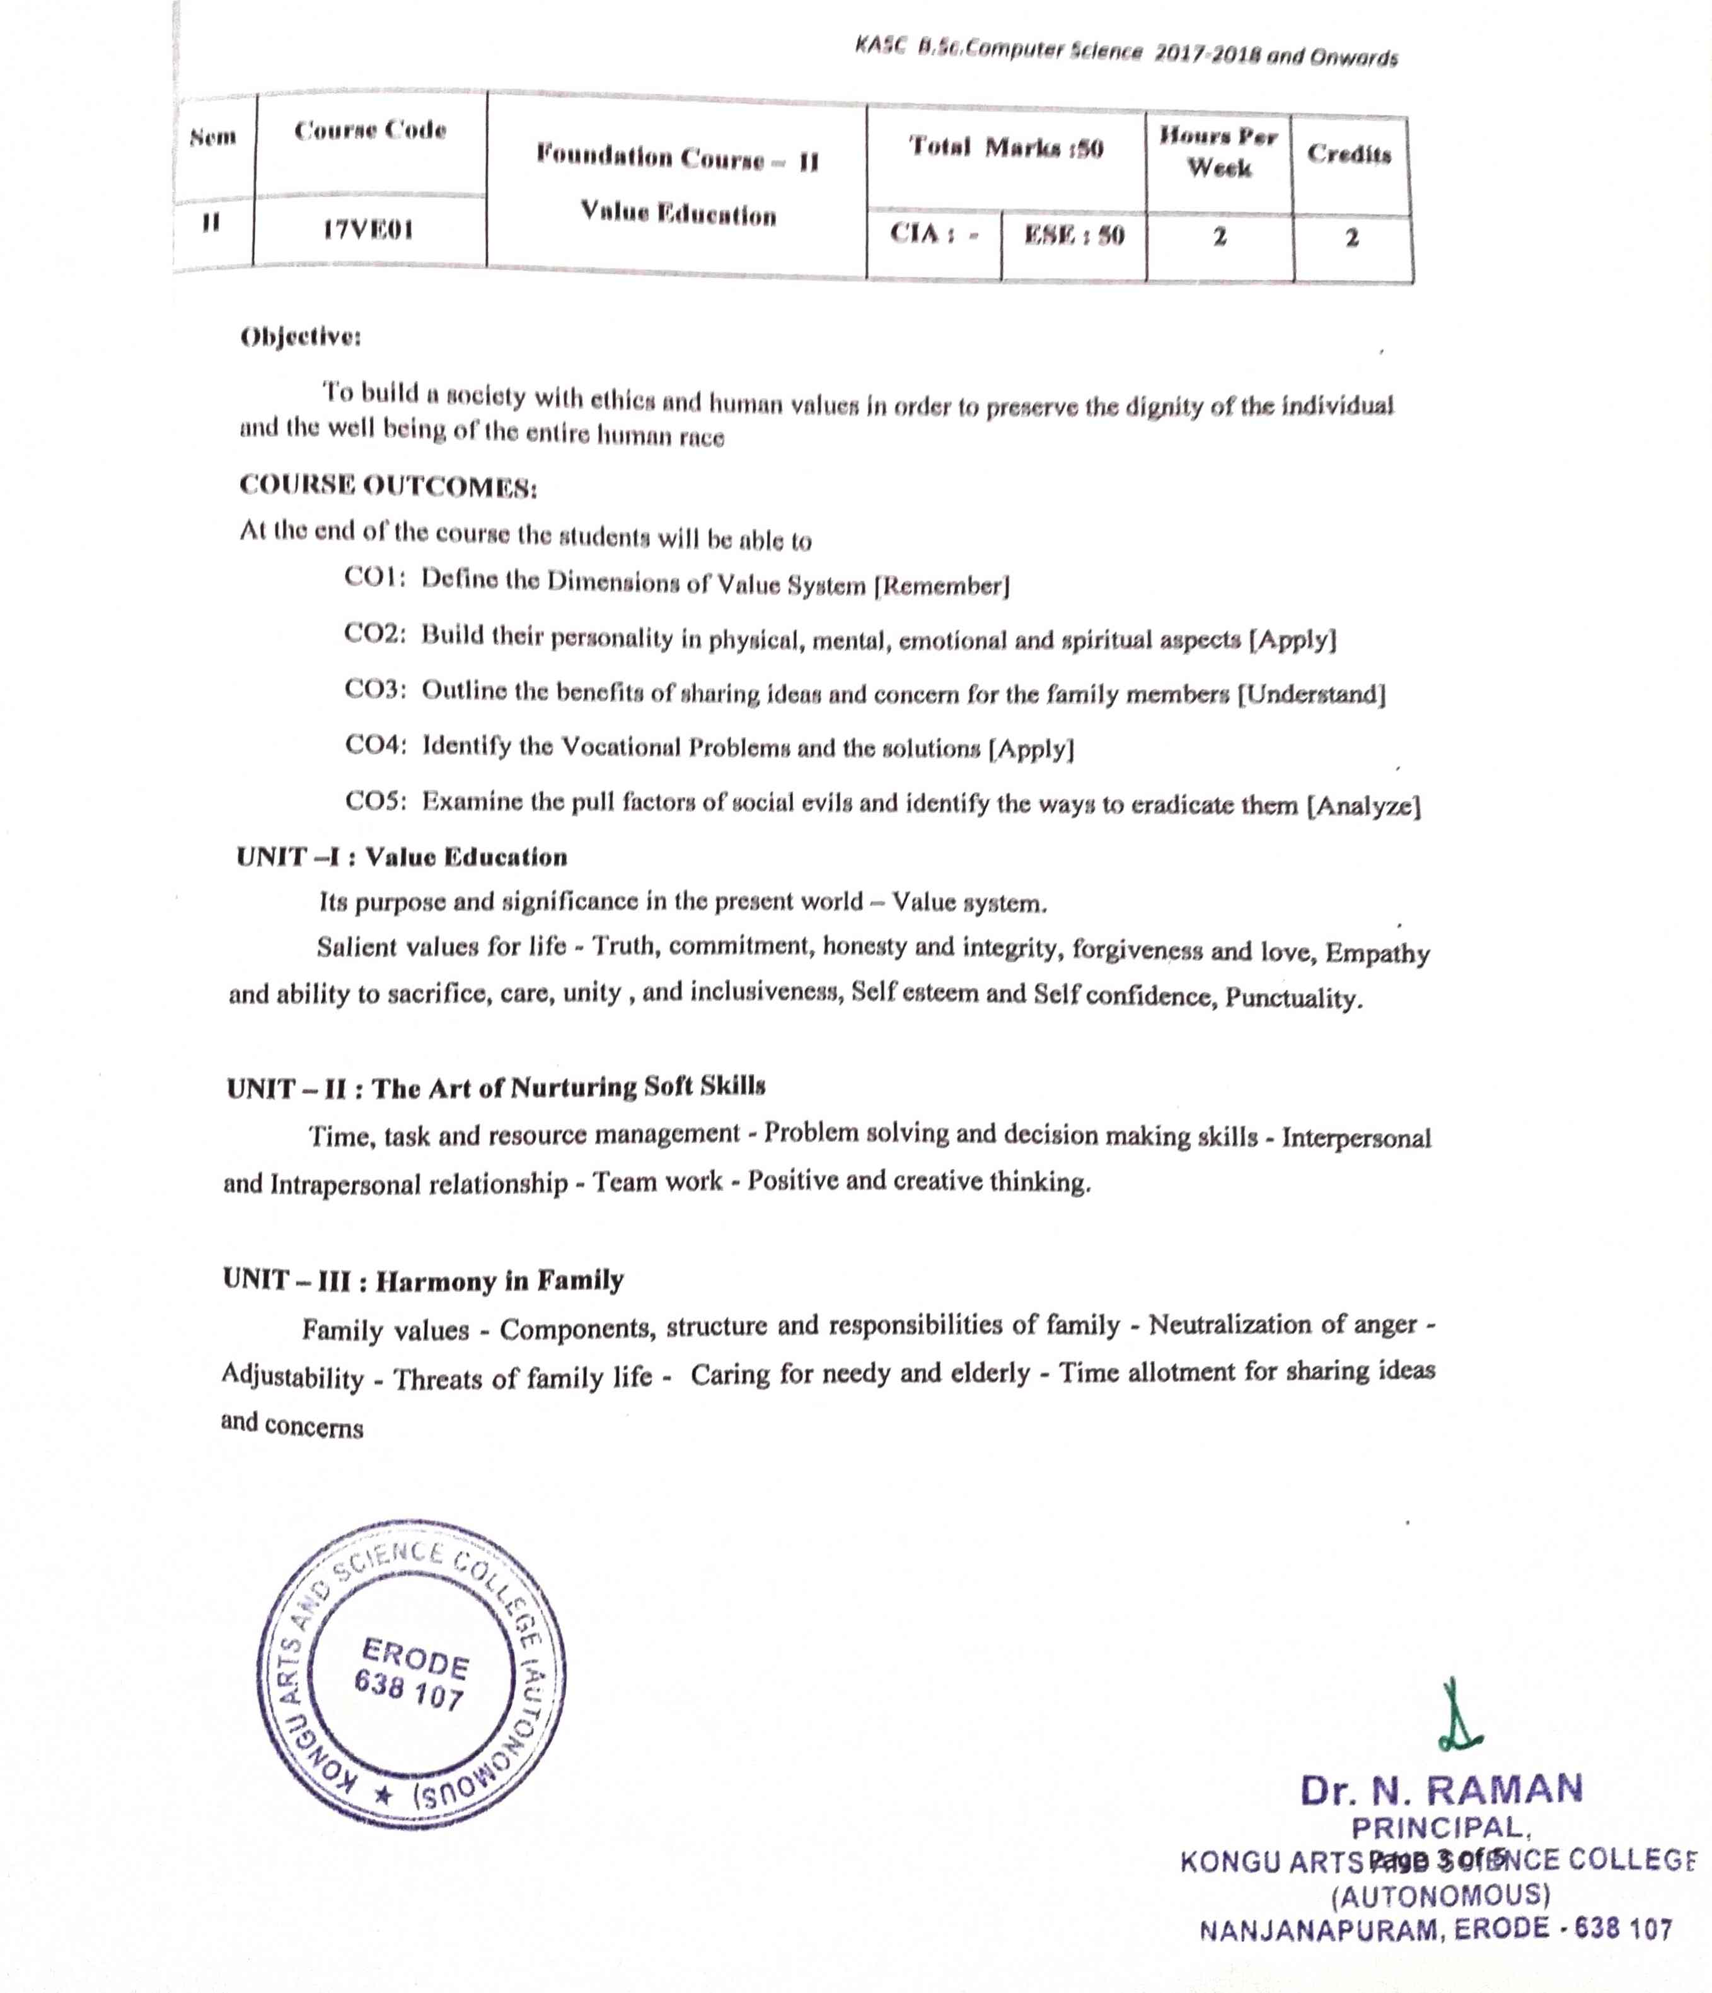

**CERTIFICATE COURSE IN HUMAN RIGHTS EDUCATION**

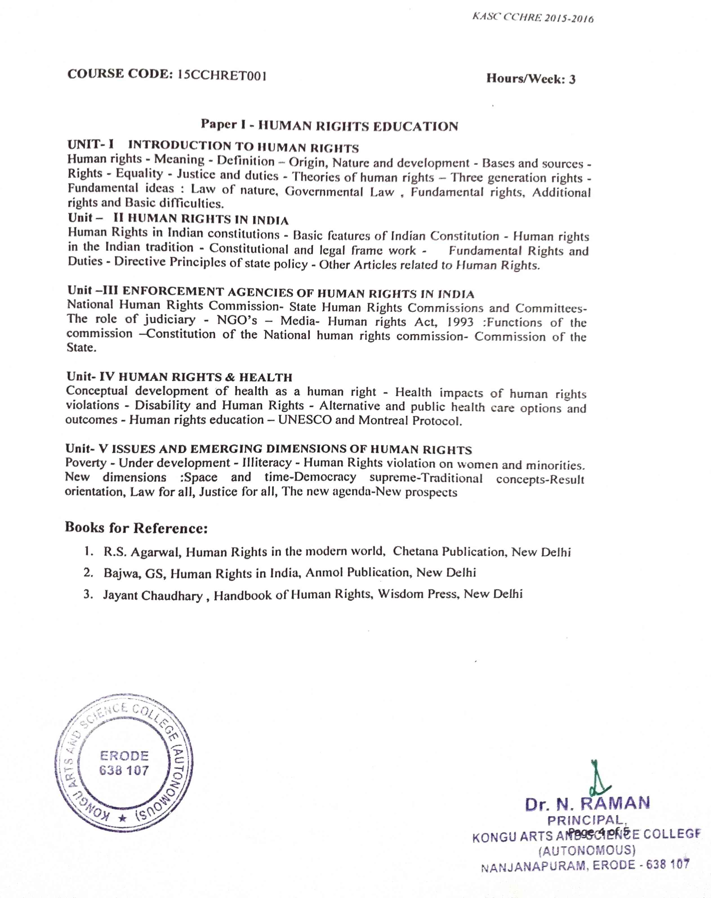

**CERTIFICATE COURSE IN HUMAN RIGHTS OF WOMEN**

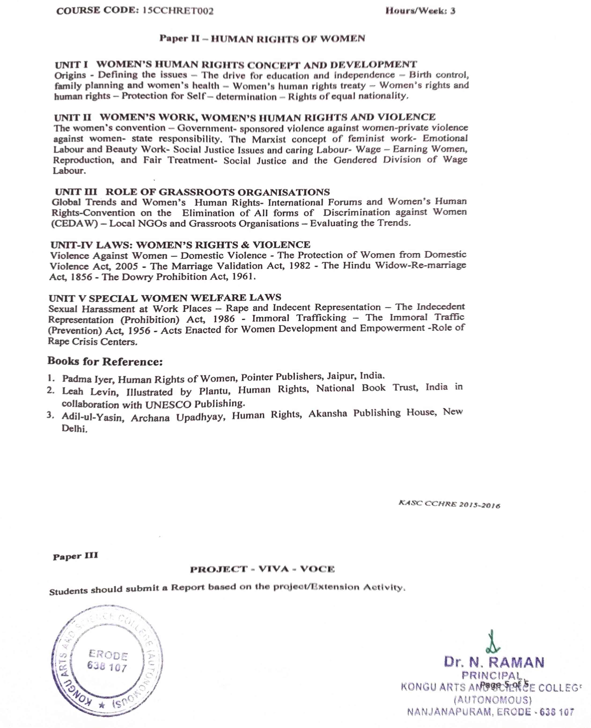

**Sample Document for Academic Year 2021-2022**

**SADBHAVANA DIWAS**

