**KONGU ARTS AND SCIENCE COLLEGE (AUTONOMOUS), ERODE-638107**

**ECO CLUB**

**ECO CLUB ACTIVITIES (2020-2021)**

|  |  |  |  |  |
| --- | --- | --- | --- | --- |
| **S.No** | **Date** | **Name of the Event** | **Chief Guest** | **No .of Beneficiaries** |
| 1 | 26.06.2020 | Intercollegiate Webinar on “Effects of Afforestation on Biodiversity”  (Virtual mode) | Rtn.G.Karthikeyan, President, Rotary Club or Erode North & Erode Thulirgal Trust.- | 132 Participants  National Level |
| 2 | 27.11.2020 – 30.11.2020 | Online Quiz Contest on ENVIRO MINDS – 2020 (On line mode) | -. | 741 Participants |

|  |  |  |  |  |
| --- | --- | --- | --- | --- |
| **S.No** | **Date** | **Name of the Event** | **Chief Guest** | **No .of Beneficiaries** |
| 1 | 26.06.2020 | Intercollegiate Webinar on “Effects of Afforestation on Biodiversity”  (Virtual mode) | Rtn.G.Karthikeyan, President, Rotary Club or Erode North & Erode Thulirgal Trust.- | 132 Participants  National Level |

An Intercollegiate Webinar on “Effects of Afforestation on Biodiversity”was organized on 26.06.2020. Afforestation helps to reduce the carbon emissions of the planet by trapping carbon in the form of carbondioxide and utilizing it in photosynthesis to produce oxygen. The need and importance of planting trees was insisted through this webinar. Nearly 132 participants attended the webinar.

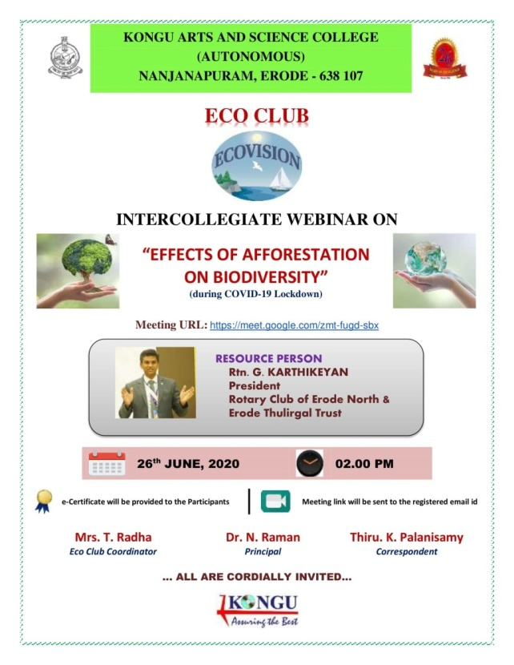

Webinar on 26.06.2020

|  |  |  |  |  |
| --- | --- | --- | --- | --- |
| **S.No** | **Date** | **Name of the Event** | **Chief Guest** | **No .of Beneficiaries** |
| 2 | 27.11.2020 - 30.11.2020 | Online Quiz Contest on ENVIRO MINDS – 2020 (On line mode) | -. | 741 Participants |

Online Quiz Contest on ENVIRO MINDS – 2020 was conducted from 27.11.2020 - 30.11.2020 to motivate the students to participate beyond academics and to make them familiar current affairs. Quizzes present information in a different perspective way of thinking. 741 actively participated in it.

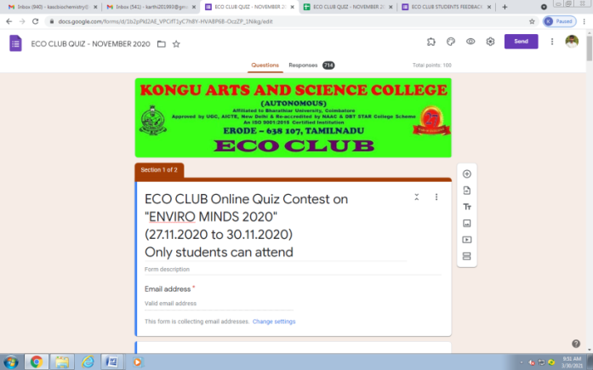 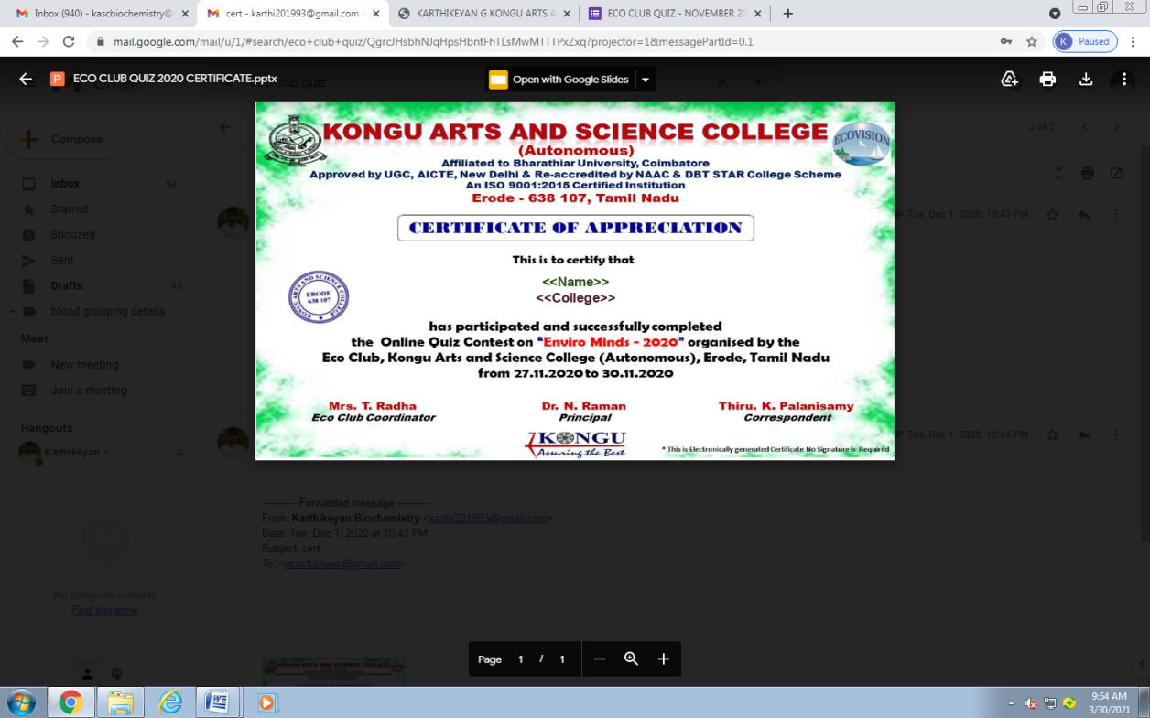

Online Quiz Contest on ENVIRO MINDS – 2020 from 27.11.2020 - 30.11.2020