**7.1.8 Describe the Institutional efforts /initiatives in providing an inclusive environment i.e. tolerance and harmony towards cultural, regional, linguistic, communal socioeconomic and other diversities (within 500 words).**

**2020-2021**

**Supporting Documents**

The institution celebrates the birth anniversary of former President Dr. Sarvepalli Radhakrishnan as Teachers Day on 05.09.2020 to express gratitude for the immense contribution by teachers.

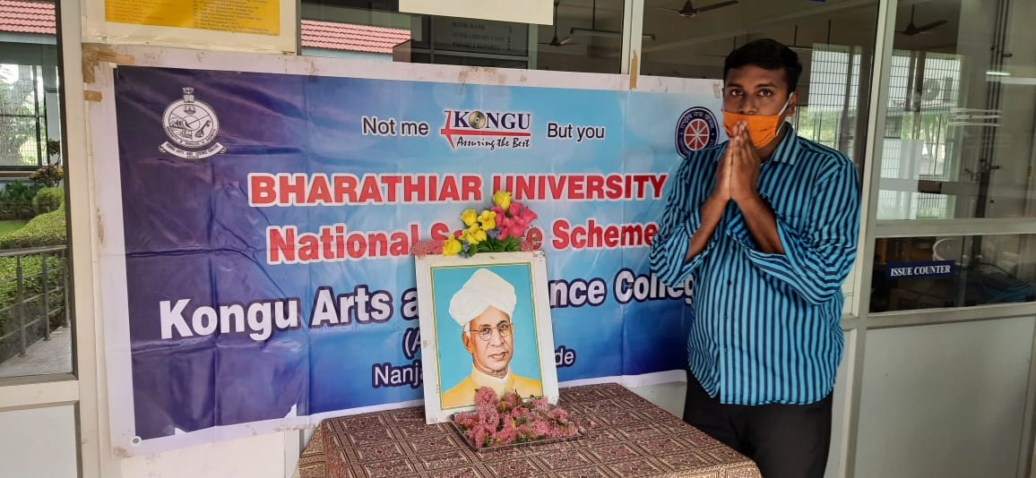

Gandhi Jayanthi was celebrated on 02.10.2020 to mark the birth anniversary of Mohandas Karamchand Gandhi as the Father of the Nation.

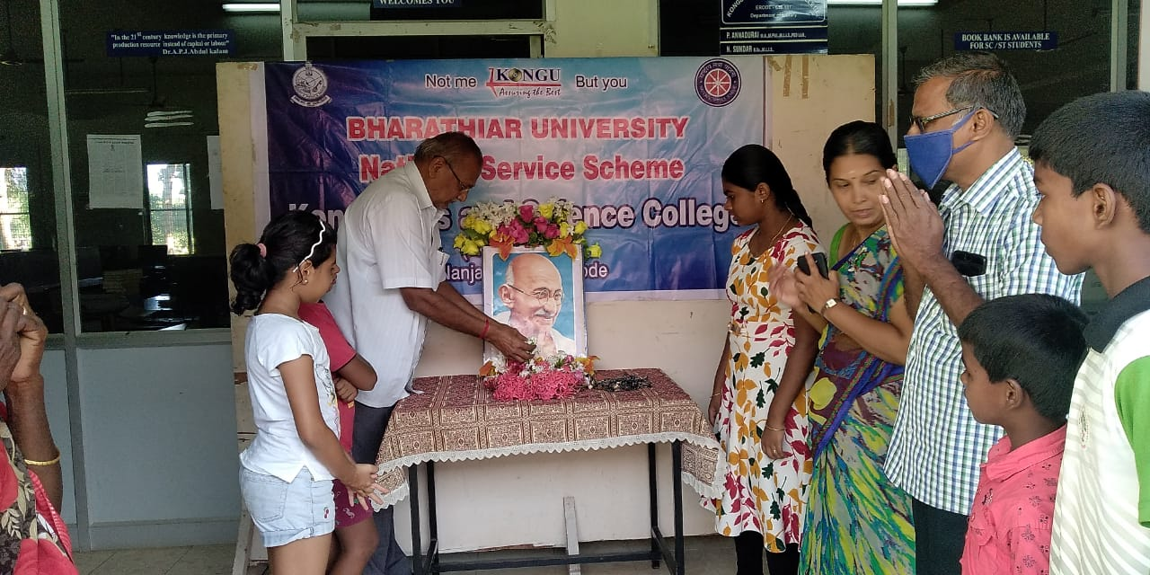

Dr.A.P.J Abdul Kalam Birth Anniversary was celebrated on 15.10.2020 to educate the contribution of Dr.A.P.J. Abdul Kalam as a politician, a scientist and a teacher.

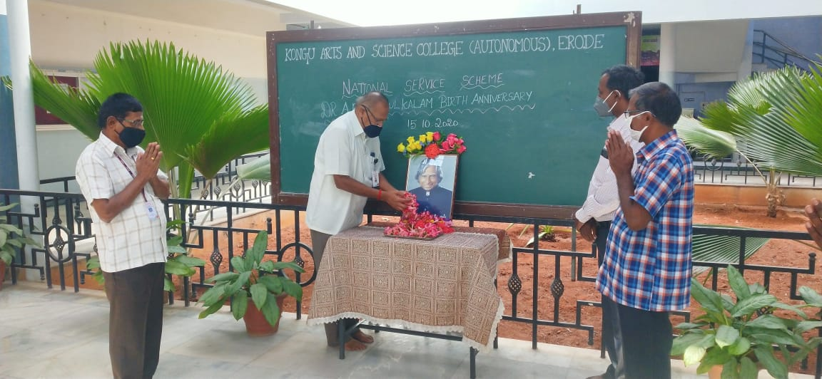

Swami Vivekanandar Birth Anniversary Celebration was celebrated on 12.01.2021 who is one of India's greatest leaders and believers of youth power.

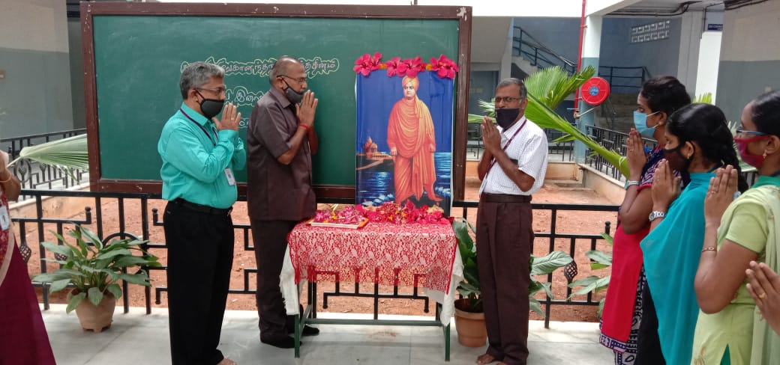

Nethaji Subash Chandra Bose Birth Anniversary was celebrated on 23.02.2021 to honour his boundless courage and valour. 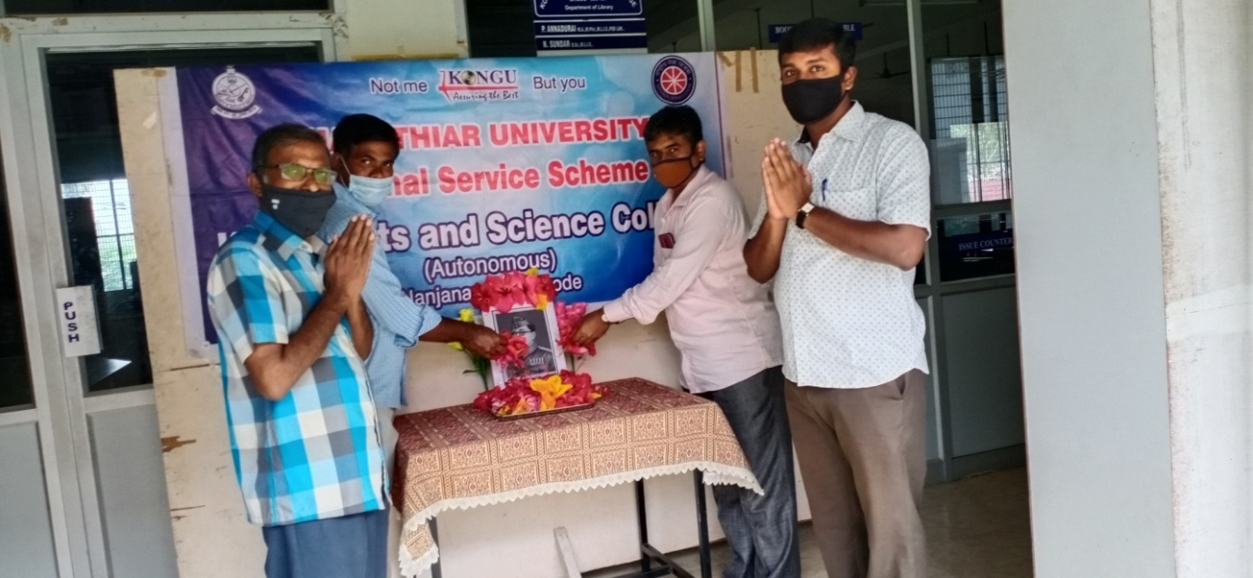

The Department of Hindi and Other languages was organized the Intra-department competitions on the eve of Hindi Divas Celebration (Hindi day) on 14.09.2020, Matrubhasha Divas ‘Mother Language day’ was celebrated on 22.02.2021 and Online quiz programme organised on the eve of Guru Tej Bahadur ‘400th birth anniversary’ on 18.04.2021. The Department of Biochemistry organised Skill development programme for Tribal people at Donbosco School, Kadambur on 22.03.2021. The Department of Biochemistry students conducted the awareness programme on Covid-19 to create awareness on vaccination to rural people of Nanjanapuram village. Department of Commerce (CA) organized Yoga Training titled “YOGA FOR IMMUNITY” for students via online on 27.07.2020.

Eco Club organised the Intercollegiate Webinar on “Effects of Afforestation on Biodiversity” (Virtual mode) on 26.06.2020 and Online Quiz Contest entitled ENVIRO MINDS - 2020 from 27.11.2020 to 30.11.2020. The Ethics Club organized the session on ‘Manitha Ni Mahathanavan’ on 06 .07 .2020 towards the values of human and the session on ‘Bharathamum Panpadhum’ on 13. 03. 2021 to nurture values of rich culture and heritage of our country. Quiz Club organized the National Level Online Quiz Competition on ‘COVIDIMAGE’ for Students and Teaching Fraternity on 27.05.2020 to create the awareness on COVID-19.

NCC of our Institution conducted the various programmes such as awareness programme on Cancer on 09.11.2020 among the public.

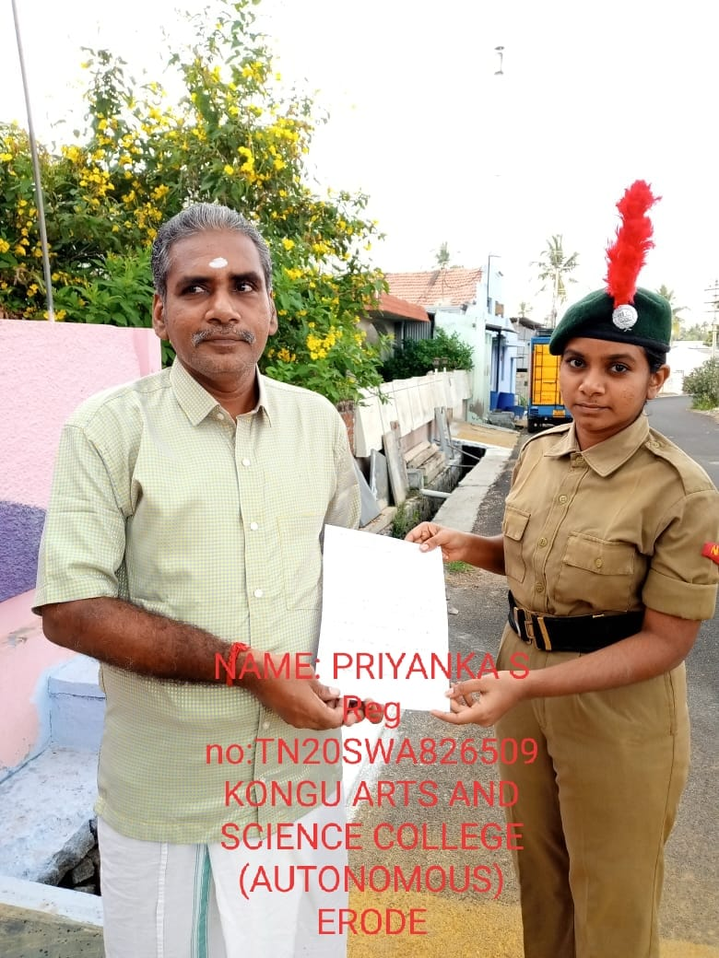

52 NCC Cadets organized the Clean India activity on 02.10.2020 to promote the cleanliness.

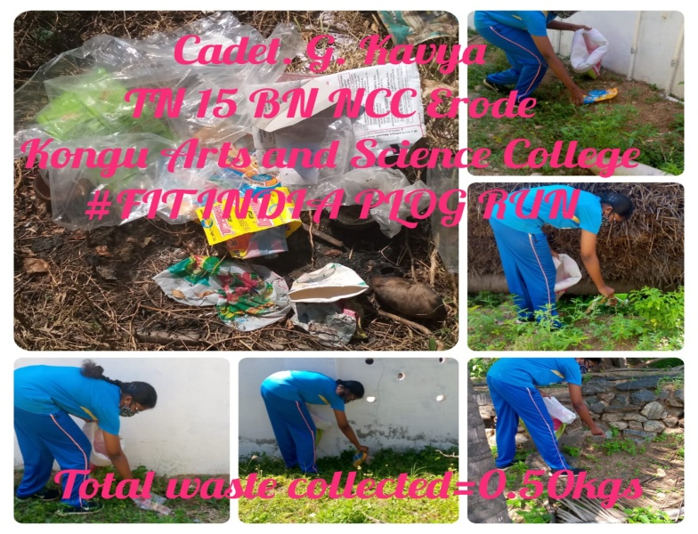

National Level Webinar was conducted on Plastic waste management on 14.12.2020 to reduce the plastic usage and waste management.

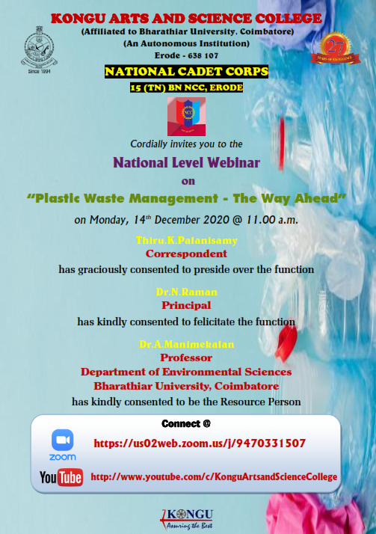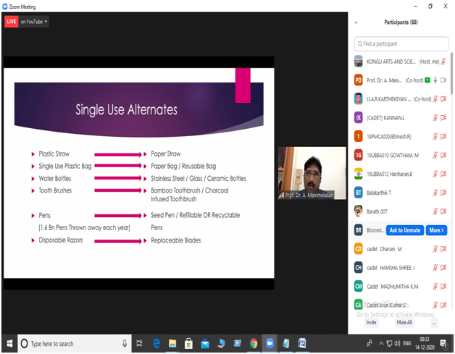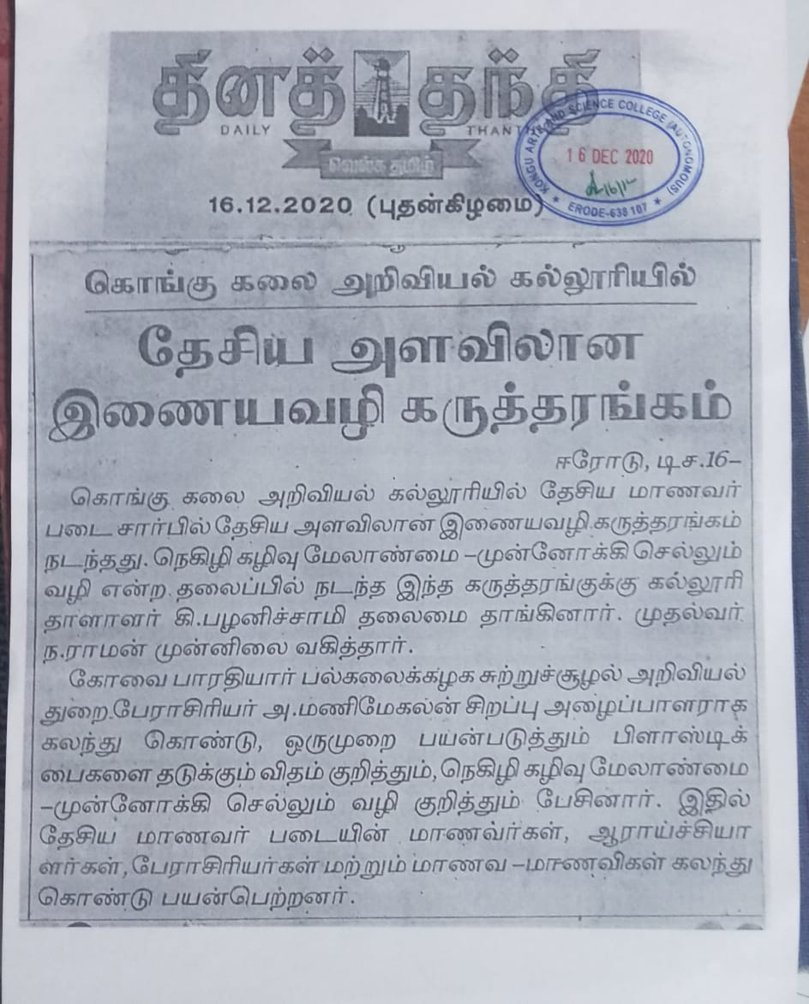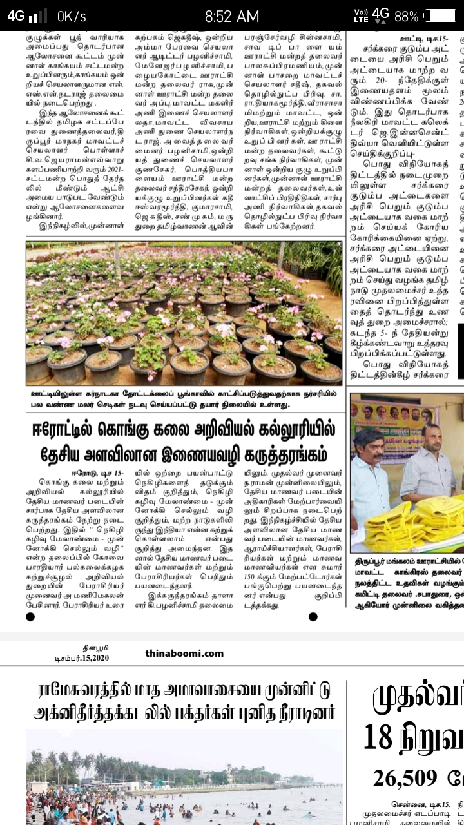

Annual Training camp III for 208 cadets was conducted by 15 (TN) BN NCC Erode in our institution from 21.02.2021 to 25.02.2021.

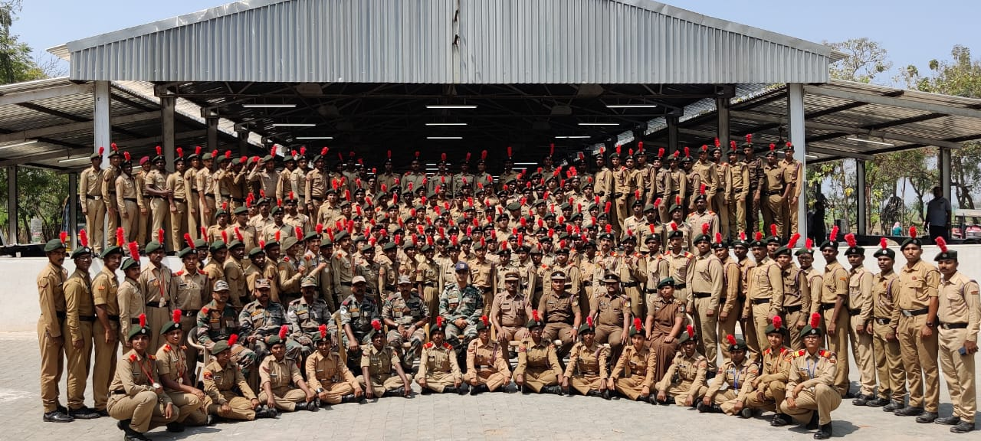 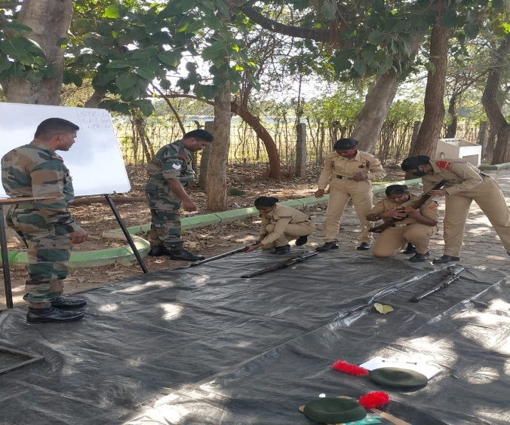

PLOG run on India’s Freedom Struggle Jallianwala Bagh Remembrance Day at Chennimalai, the birth

place of Tiruppur Kumaran on 13.03.2021.

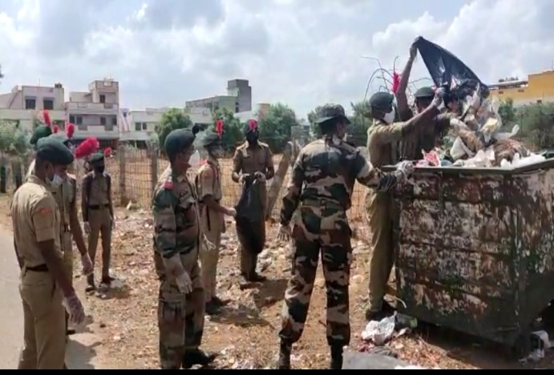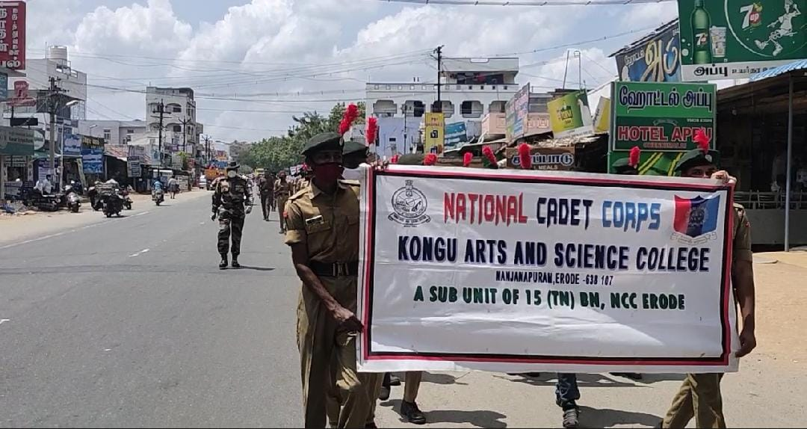

34 NCC Cadets of our College conducted statues cleaning activity on 23.02.2021.

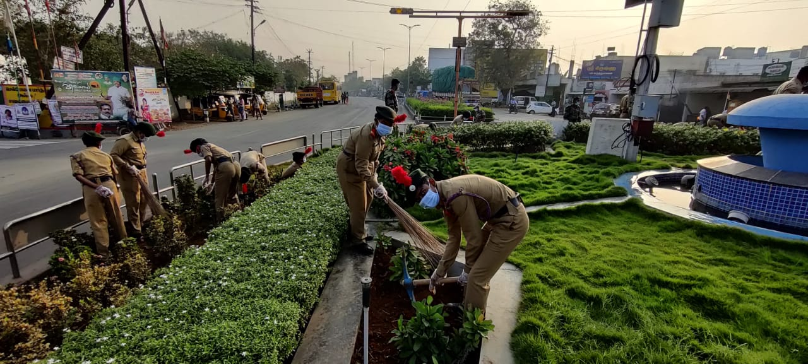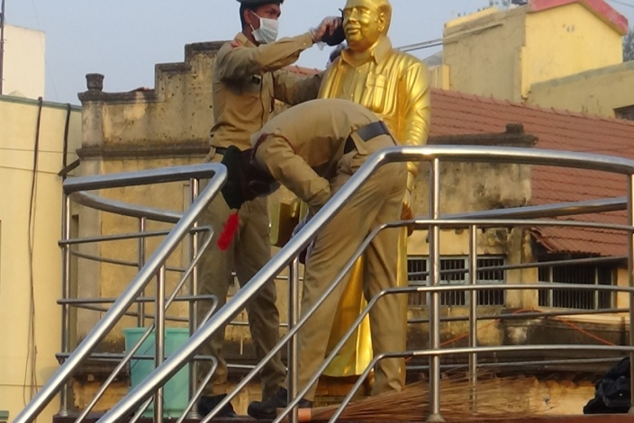

52 NCC Cadets was taken SWACHH BHARAT Pledge on 10.11.2020 to create awareness on Clean India.

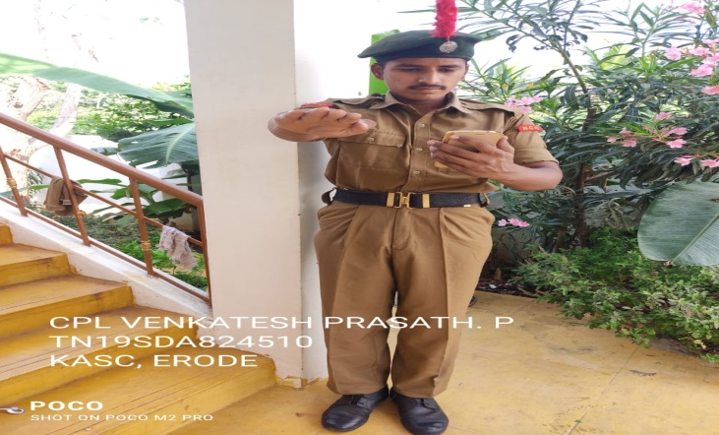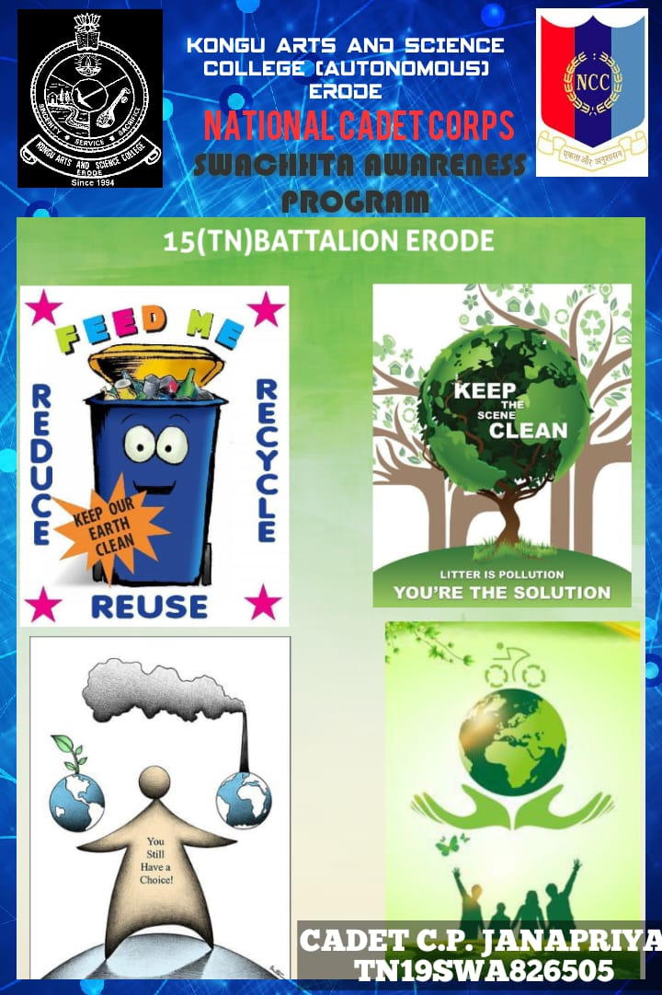

Tree Plantation was done by 30 NCC Cadets of our college planted 45 saplings in their respective places on 16.07.2020.

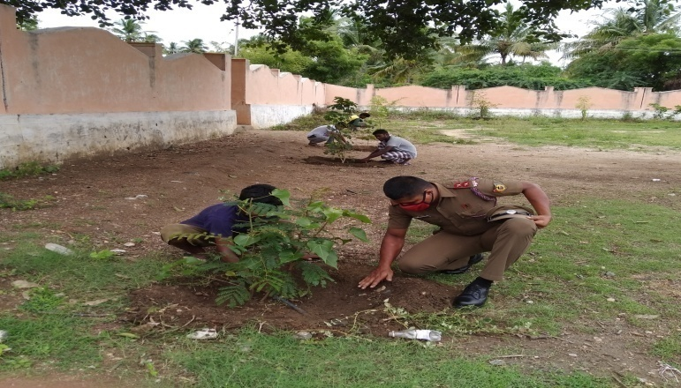 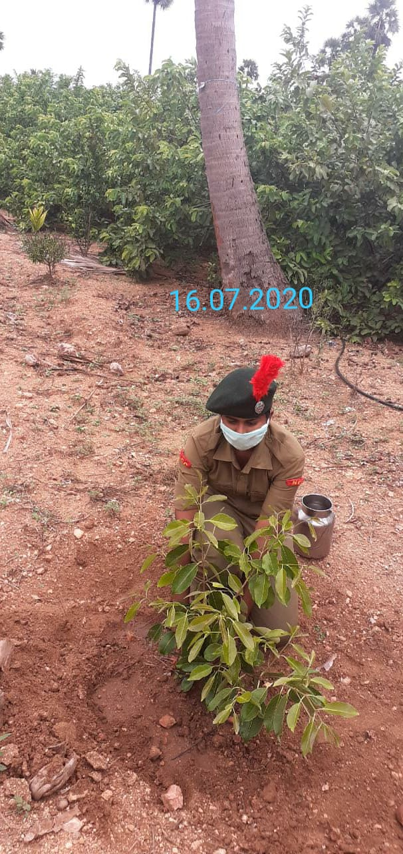

NSS of our Institution conducted the various programmes such as Vigilance Awareness Week pledge on 28.10.2020 to encourage all stakeholders to collectively participate in the prevention of corruption and fight against corruption.

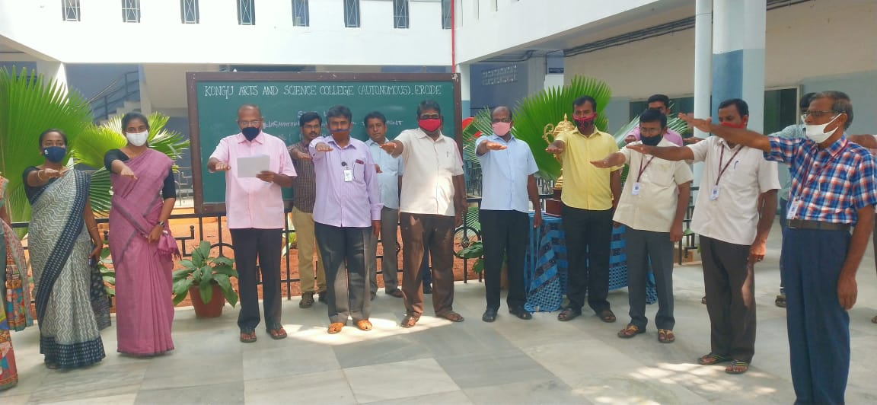

Constitution Day pledge was taken by NSS students on 26.11.2020 to observe Constitution Day with the pledge to uphold the spiral of the Indian Constitution,

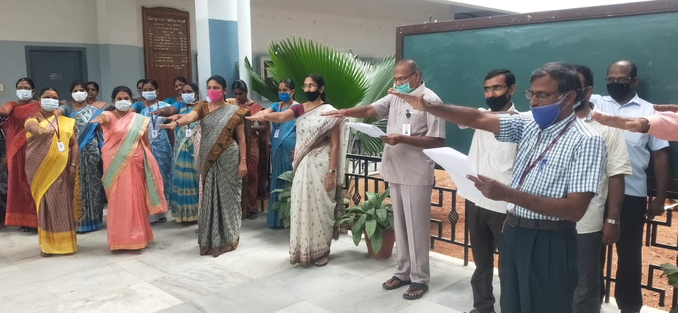

National Voters Day Pledge was taken on 25.01.2021 by NSS Students to Making Our Voters Empowered, Vigilant, Safe and Informed during the COVID-19 pandemic.

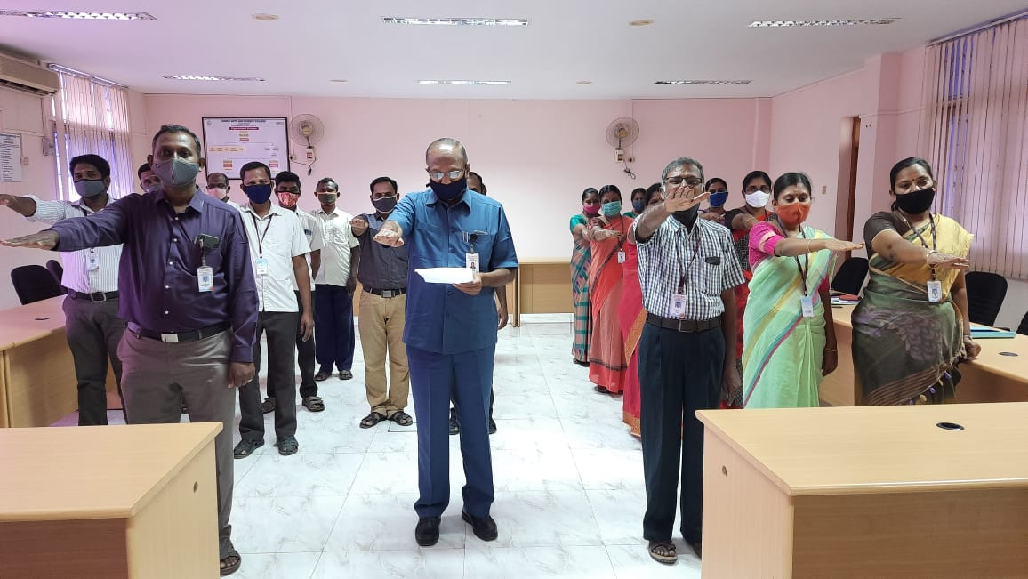

Road Safety Awareness Pledge was taken by our NSS students on 11.02.2021 to create awareness

about the road safety.

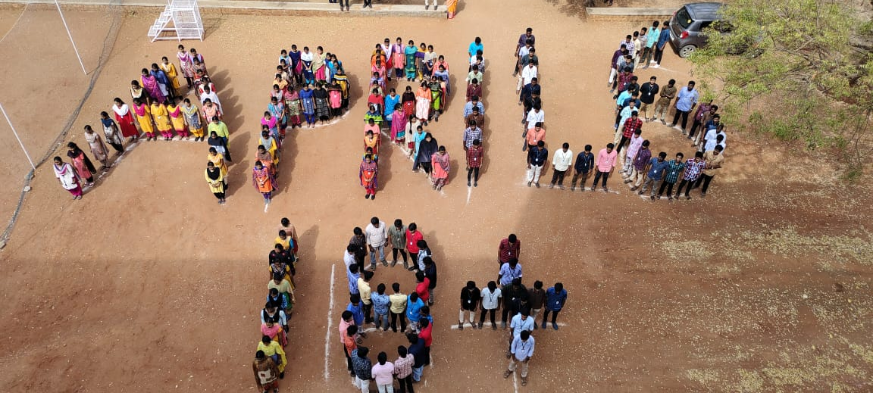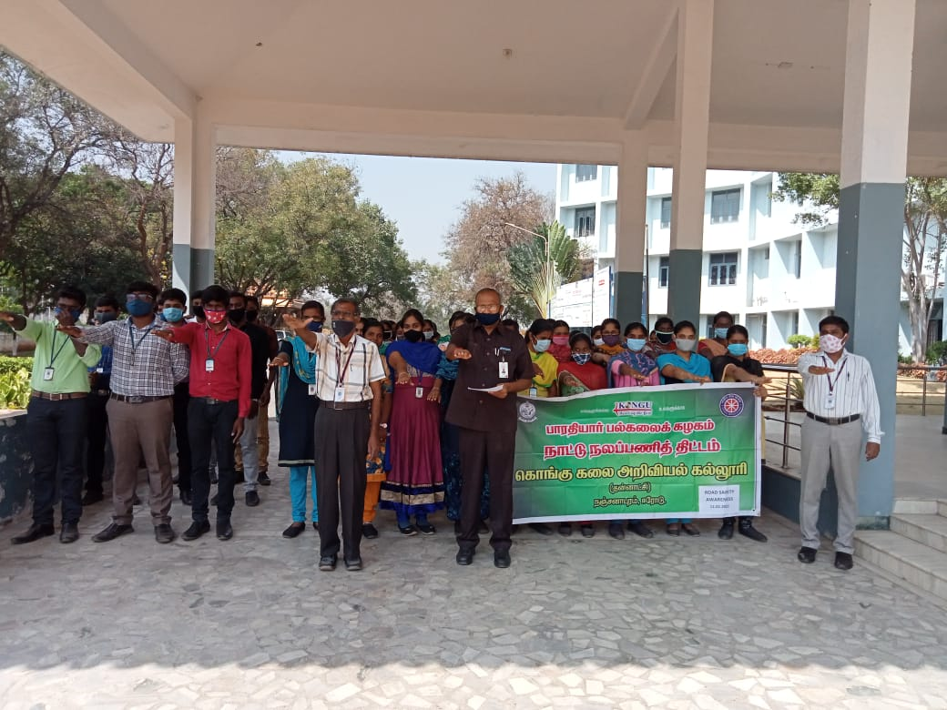

Voters Awareness Pledge and Signature Campaign were organized on 12.03.2021 by NSS students to create awareness about voting and **participating in the signature campaign.**

