KONGU ARTS AND SCIENCE COLLEGE (AUTONOMOUS), ERODE – 638 107

ACTIVITIES 2020 – 2021

Blood donation camp on 30.01.2020

|  |  |  |  |  |
| --- | --- | --- | --- | --- |
| **S.NO** | **DATE** | **HOSPITAL NAME** | **NO.OF UNITS DONATED** | **TOTAL NO.OF BLOOD UNITS DONATED** |
| **5** | 30.01.2020 | 1.Lions Club Blood Bank | 117 | 325 |
|  | | 2.Tamil Nadu voluntary Blood Bank & Research centre | 95 |
| 3. Government Hospital, Erode | 62 |
| 4. PMCH Perundurai | 51 |

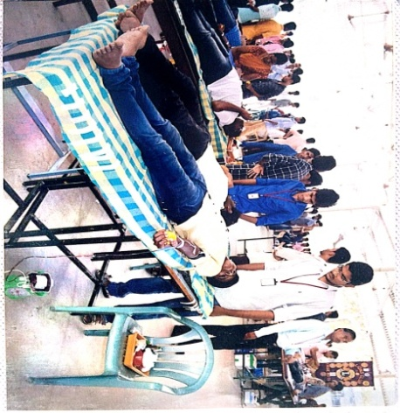 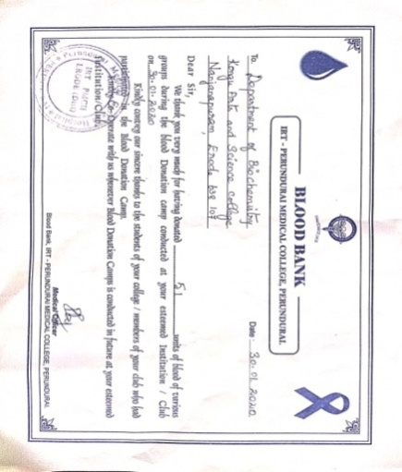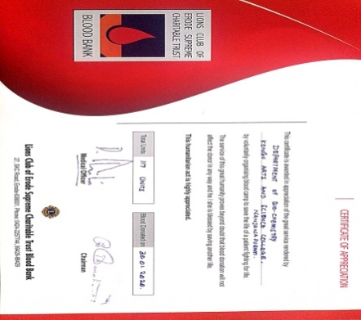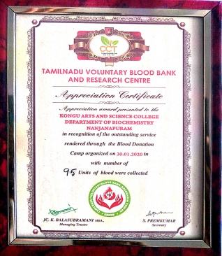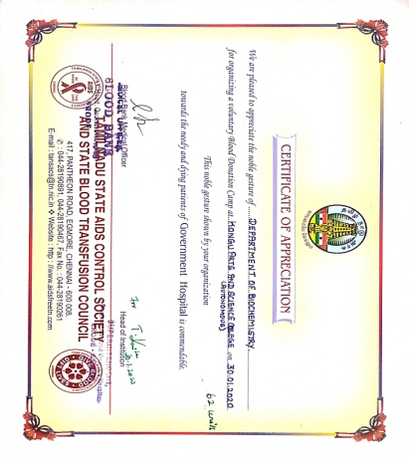

Skill development programme on 22.03.2021

|  |  |  |  |  |
| --- | --- | --- | --- | --- |
| **S.No** | **Date** | **Name of the Event** | **Location** | **No .of beneficiaries** |
| 1 | 22.03.2021 | Skill development programme for Tribal people | Donbosco school Kadambur | 30 |
| 2 | Every year | Blood group identification of I UG and I PG  Students of KASC and Blood group directory maintenance | UG Biochemistry Lab | I UG and I PG  Students of KASC |

Skill development programme for Tribal people was conducted to elevate the tribals from the state of ignorance illiteracy and poverty. The objective of the programme was to create educational awareness among the tribes. Education is an input not only for economic development of tribes but also for inner strength of the tribal communities which help them in meeting the new challenge of life.

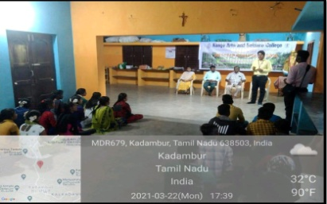

**Blood group identification for I UG and PG Students of KASC**

Every year, Blood group identification is done to the fresher’s entering the College. A blood group directory is maintained by the Biochemistry department to help the needy people during emergency situations. This particular work s assigned to the students of II B.Sc Biochemistry and the respective class in-charge every year.

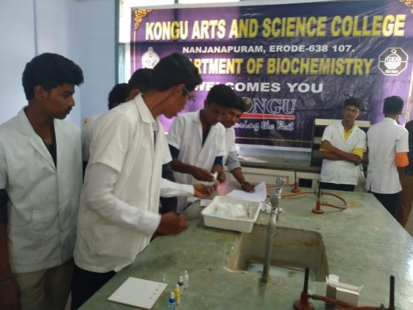TREE PLANTATION ON 16.07.2020

|  |  |  |  |  |
| --- | --- | --- | --- | --- |
| S.No | Date | Name of the Activity | Beneficiary | Number of Participation |
| 1 | 21.02.2021 to 25.02.2021 | Annual Training camp III | NCC Cadets under 15(TN) BN NCC Erode | 208 NCC Cadets from various institution around Erode. |

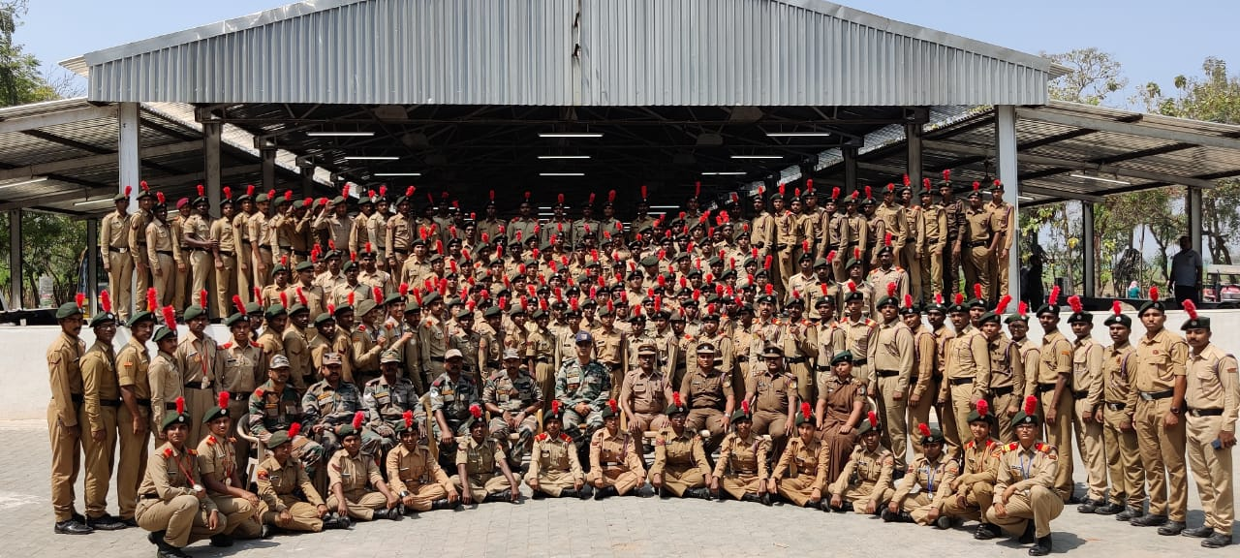 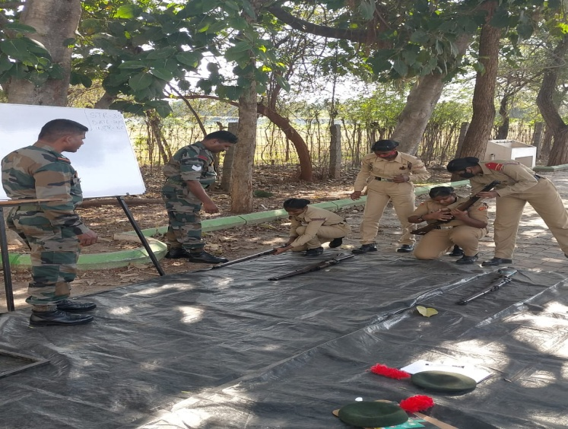

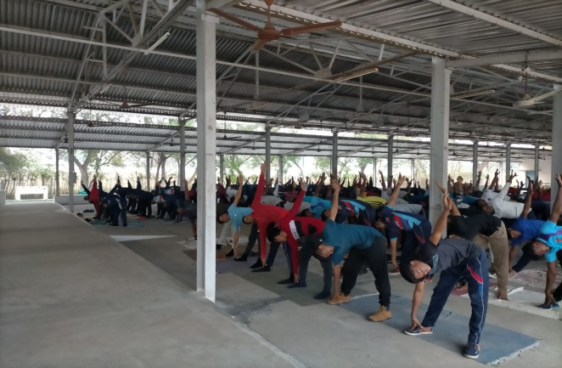

Annual Training camp III was conducted by 15 (TN) BN NCC Erode at Kongu Arts and Science College (Autonomous), Erode from 21.02.2021 to 25.02.2021.

Total No of Cadets were participated in the camp is 208

National Level Webinar on 14.12.2020

|  |  |  |  |  |
| --- | --- | --- | --- | --- |
| S.No | Date | Name of the Activity | Beneficiary | Number of Participation |
| 1 | 14.12.2020 | SWACHH BHARAT Pledge | KASC NCC Cadets | 52 KASC, NCC Cadets |

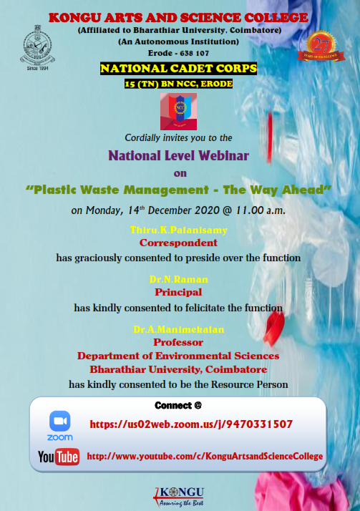 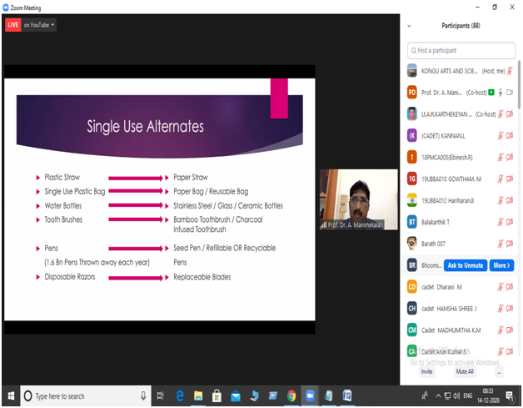

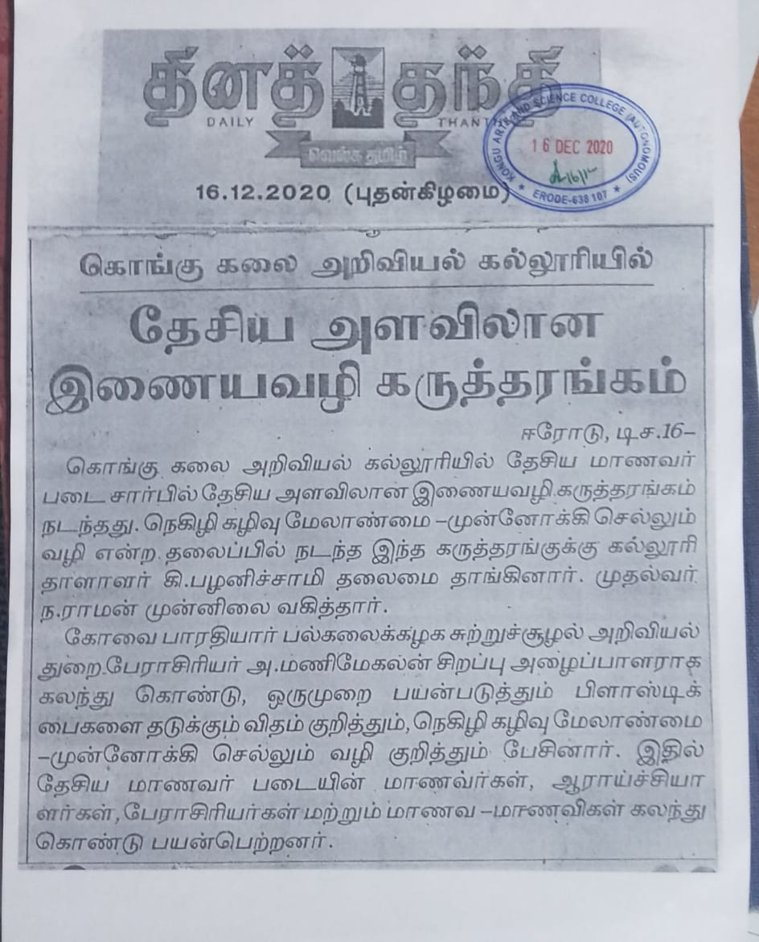 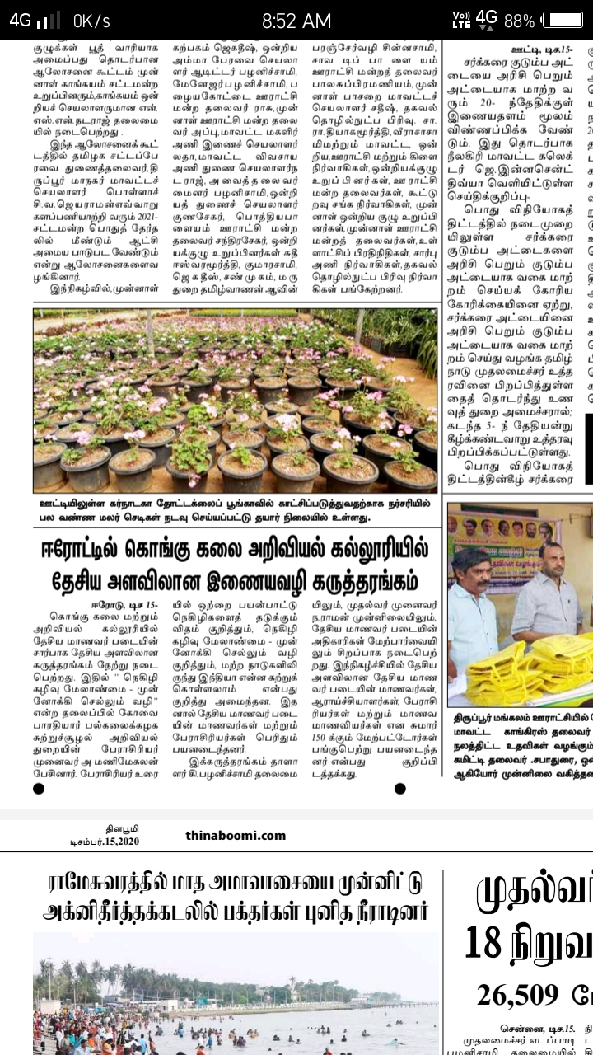

National Level Webinar was conducted on Plastic waste management on 14.12.2020. Chief guest: Dr.A.Manimegalan, Professor, Department of Environmental Science, Bharathiar University, Coimbatore.