# 7.1.3 Facilities in the Institution for the management of the following types of degradable and non degradable waste:

# WASTE HANDLING & MANAGEMENT

###### : Solid Waste Management System:

Different types of wastes generated inside the college premises are represented in the block diagram given below.

**Solid Wastes**

**Bio-Degradable**

**Non-Bio-Degradable**

* **Food Waste**
* **Vegetable Waste**
* **Fruit Peels**
* **Garden Waste**
* **Dead Plants & Leaves**
* **Paper Waste**
* **Plastics**
* **Aluminium Cans**
* **Metals**
* **Construction Wastes**
* **E-Wastes**
* **Used Oils**

###### Process of Waste Management:

The college management practised some methods to treat the waste generated and Table-14 shows the process of treating the solid waste generated inside the college campus.

**Table-14: Process of Waste Management**

|  |  |  |
| --- | --- | --- |
| **S. No.** | **Waste Type** | **Waste Treatment** |
| **Bio-Degradable Waste Management** | | |
| 1. | Food and Vegetable Waste | Collected and fed to digester for bi-gas  generation |
| 2. | Garden Wastes and Plant Leaves | Daily collected and dumped in a yard |
| 3. | Paper Waste | Collected and stored in a separate place. |
| Sale to third party for recycling |
| **Non-Bio-Degradable Waste Management** | | |
| 4. | Plastics | Banned in the college campus (Welcome step).The chemical/salt storage  plastic containers are disposed to 3rd party. |
| 5. | Construction Wastes | Mostly used by their own construction and  used for internal land filling |
| 6. | Metals | Construction metals or metals from any other sources are stored in a separate place. |
| Used for sale to third party for recycling |
| 7. | Transport Oil + Tyres | Stored in a separate place and used for sale to 3rd party. |
| 8. | Transport Vehicle and Computer  Batteries | Procuring new batteries with buyback offer  (old battery replacement) |
| 9. | Used edible oil | Almost zero waste. Mostly used for internal  cooking and frying. |
| 10. | E-Waste Management | Separately given below. Used for Sale to thirty party for recycling |
| * Most of the furniture items are repaired and reused. * Waste collection procedure: A common circular is given to all the Heads of the Departments stating to identify and quantify the amount of waste generated. * As per the circular, all the departments collected the waste and handed over them to the waste management committee. * Based on the highest quotation (among the three quotation) the party is authorized to take the waste in the vehicle. Empty vehicle weight is checked first and then the wastes are loaded in the vehicle. The weight of the fully loaded vehicle is also noted in order to quantify the amount of waste disposed. * Equipment, meters and measuring instruments if found to be waste; it would be approved by supplier/service persons/trust people. | | |

###### : List of Approved E Wastes**:**

|  |  |
| --- | --- |
| **E-Waste – Electrical** | **E-Waste – IT & Communication** |
| * Motors and Starters * Fans, Lamps and Luminaries * Electrical Drives * Heater Coils * Broken/Fired Cables * Air Conditioning System * Power Distribution Panels * Electronic Music Instruments * Electronic GYM Equipment’s * Electronic Attendance System * Analog & Digital Measuring Instruments | * Copier/Printers & Fax Machines * Power Stripes & Power Supplies * UPS/Servo Stabilizers/Inverters * Batteries * Wi-fi-Modems, Routers, Toggle * Network Cables, Switches, Hubs * Phone, Intercom & PBX * Audio & Video Equipments/Remote Controls, Projectors * Printed Circuits Boards * Barcode/QR scanners |

***: General Note:***

* + - Prepare a flow chart for collection of E-waste from Generation to Disposal and paste it on appropriate places
    - An electronic weighing scale (with suitable capacity) must be installed in the storage yard and should be properly calibrated.
    - One emergency lamp (with UPS supply) must be installed along with suitable fire extinguisher. Ensure proper ventilation in the yard.
    - Form rule for declaring the waste as E-Waste & Assign the singing authorities
    - Identify a third party vendor to procure the E-waste from the college.
    - Establish MoU with that party. Disseminate the following information at appropriate places i) E-Waste Policy, ii) Process Methodology, iii) Copy of MoU with third party vendor,

iv) Contact persons mobile number and E-mail.

* + - Identify certain vehicle to carry the waste from generation to storage yard.
    - Provide training to the man power who are handling the waste.
    - Maintain separate Delivery Challan, Billing, Weighing mechanism for handling the E-Waste.
    - Update the status of E-waste (through digital circular) to all the concerned management representatives, faculty members and staff at regular intervals (month wise is good).

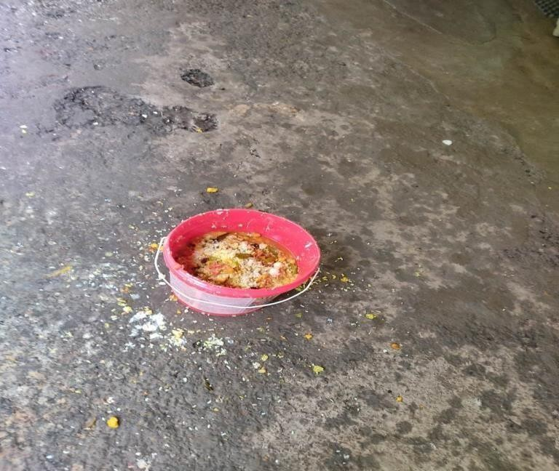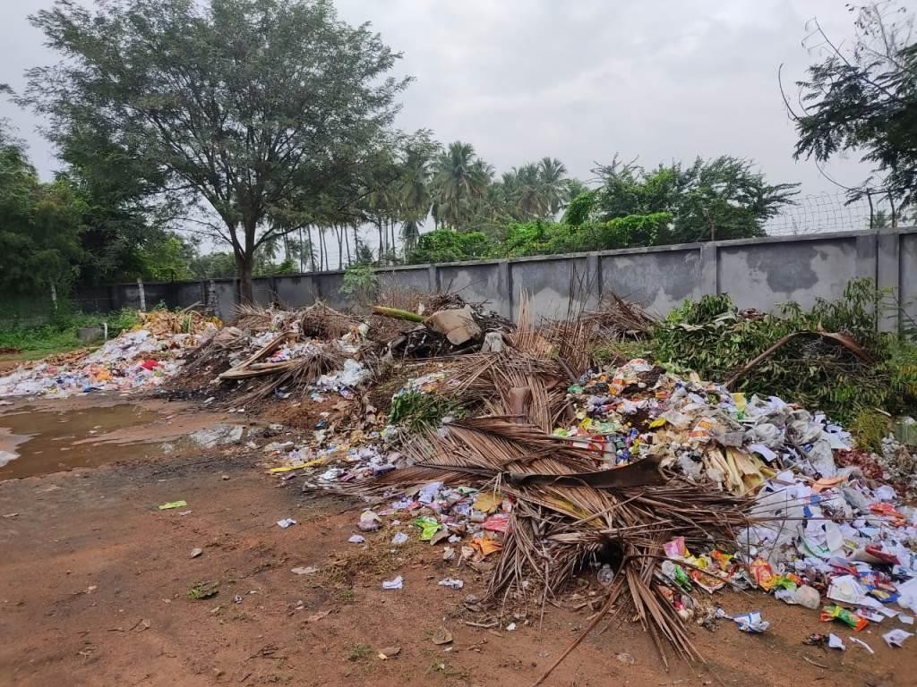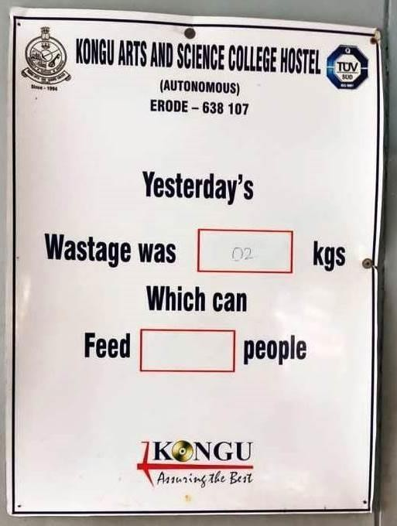

|  |  |
| --- | --- |
| **Food Waste Collection Bins** | **Food Waste Display System** |
| **Paper Wastes** | |

**Fig.8: Snap shots of Solid Waste Management (SWM)**

###### : Policy of Chemicals/Salts/Acids used in the Laboratory:

The science departments use chemicals for experimental applications and are having strict safety rules of thumb for handling and storage as follows.

* + - * Well trained faculty and lab assistants who have knowledge about the hazardous nature of each and every chemical are only allowed to handle the chemicals safely.
      * Strictly following the manufacturer’s instruction on the container in order to prevent accidents.
      * Volatile or highly odorous chemicals, fuming acids are stored in a ventilated area
      * Chemicals are stored in eye level and never on the top shelf of storage unit
      * All stored chemicals; especially flammable liquids are kept away from heat and direct sunlight. Reactive chemicals are not stored closely
      * Hazardous and corrosive chemicals are kept on sand platform to avoid corrosion
      * First aid box and fire extinguishers are readily available in the laboratory

###### : Storage of Chemicals/Salts/Acids:

Less concentrated chemicals, salts and acids are stored in proper racks, cupboards and high concentrated acids are stored in separate area filled with sand. Storage practices are represented below in Fig. 5 & 6.

**Fig.5: Chemicals, Salts and Agents are separately placed for laboratory application**

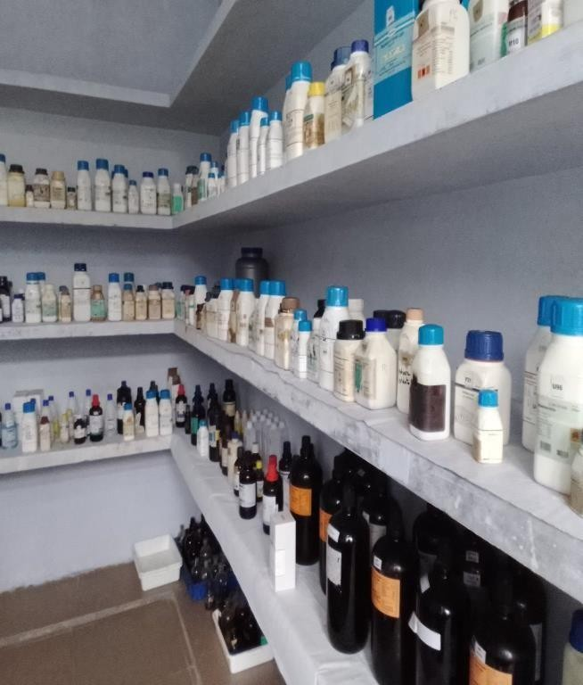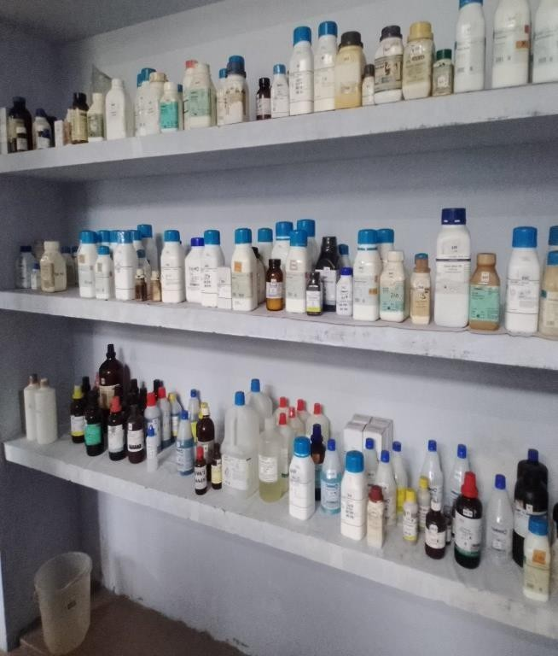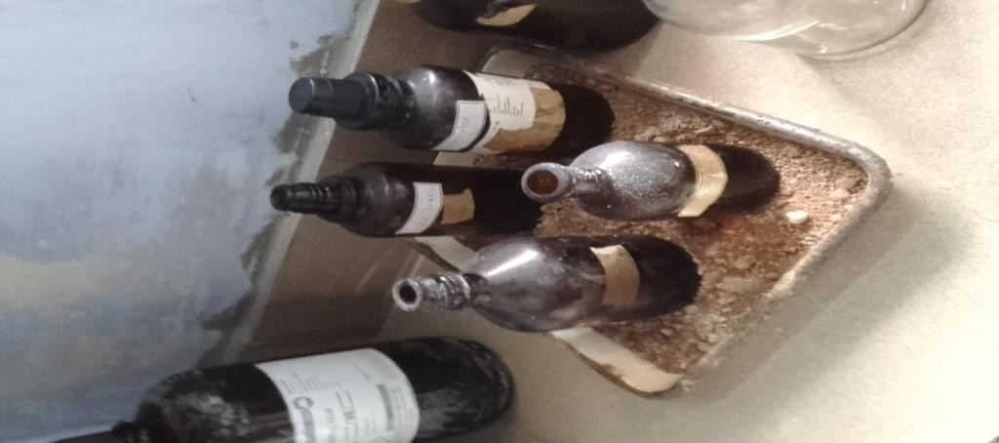

|  |  |
| --- | --- |
| **Practice-1** | **Storage and Handling of Chemicals** |
| **Best Practices Adopted** | |
| * Most of the chemical, salts and acids used in the science department are inorganic in nature and no harmful effects are created during the experiment process. * However after completion of each experiment, the wastes are washed in the water sink and are rooted to common STP. * Only trained teaching and non-teaching staffs are handling the chemicals and also they are well trained to handle any abnormal situations. * Laboratories with chemicals are well ventilated with proper emergency exits. Adequate and correct sequence of fire extinguishers are placed near all the laboratories. * LPG Gas used for laboratory application is properly distributed through manifold necessary safety precautions. After completion of the day; the technical staffs are instructed to close the main valve and avoid unnecessary flow of gas during   non- working period of the college.   * As a part of best practices; some of the chemicals required for most of the experiments are prepared by the respective departments which reduces the chemical inventory. * One more best practice; the chemical/acid outcome of some of the experiments is used as input for other experiments which also reduces the annual requirement of the chemicals/acids. | |
| **Best Practices to be Adopted** | |
| * After completion of each experiment, the wastes are washed in the water sink and are rooted to sewage treatment plant which is designed to handle only sewage; not the effluent. * It is recommended to create a **separate policy for Chemical handling and usage** indicating various measures involved starting from **procurement of chemical to disposal (Cradle to Grave approach).** Ascertain that the chemicals/salts/acids used in the college campus for their academic/research application do not pollute the mother earth. * The policy must be approved by any regularly convened apex committee (may be Governing Council) and must be disseminated to all stakeholders. Also paste the content of the policy in vulnerable points inside the college campus. * Though the quantity of the chemical wastes generated in an annum is small, it is appropriate to divert and treat this effluent to some other means. * One of the best ways to treat this is;   1. Design a dedicated system and collect the chemical wastes in a separate tank with suitable backup facility. Once the tank fills; then transfer the effluent to nearby authorised Effluent Treatment Plant (ETP). An agreement may be made between the College and the ETP authorities over a certain period of time. | |

###### : Cleaning Agents (Soap & Powders) used for Vessels & Floor Cleaning:

In order to maintain hygiene in the College campus; the administration regularly cleans the floors and restrooms. In addition to this; the hostel management has to monitor i)the cleaning of vessels, kitchen floor, dining hall, store room and gas station. Table-13 shows the cleaning agents used to clean the above area;

##### Table-13: Cleaning Agents used for Floor and Vessel Cleaning

|  |  |  |
| --- | --- | --- |
| **S. No.** | **Cleaning Agent** | **Application** |
| 1. | Cleaning Powder & Vessel Cleaning Soap | Vessel Cleaning |
| 2. | Soap Oil & Bleaching Powder | Floor Cleaning |

###### : Recommendations: Eco Friendly – Green Cleaning Agents:

* + - On an average; the cleaning agents used today have about 62 harmful chemicals like Paraben, Phosphates or Chlorides. A lot of them come from multi-purpose cleaners.
    - It is recommended to use natural ingredients like orange peel extract & vinegar. It leaves a mild and pleasant fragrance after use. The formula is free from all harmful chemicals & toxins. It is pH-neutral, gentle on the skin as well as on the surface where it is used.
    - Also these products are **IGBC GreenPro** certified. GreenPro is a mark of guarantee that the product is environment friendly throughout its life cycle.
    - Fig. 7 shows the sample eco-friendly Green Pro certified cleaning agents.



|  |  |  |
| --- | --- | --- |
|  |  |  |
|  |  |  |

**Fig.7: Green Pro Certified Eco Friendly Cleaning Agents (ZERODER)**

###### Summary of Waste Management:

* + - Cotton, Syringe, Needles are to be kept separately as these are treated as Bio-Medical wastes.
    - **Yellow dust bins** must be placed to collect these bio-medical wastes.
    - After COVID; mask, sanitizer bottles, gloves and other medical items must be trashed only through the yellow bins.
    - This must be informed to all the students and stakeholders. Suitable steps have to be taken to disseminate this information.
    - All the solid wastes are to be properly stored in a separate place and should be maintained as a record mentioning its quantity.
    - Fix flow meter in bio-gas output and continuously measure the gas output.
    - The food waste must be weighted and marked in a record before keeping into the digester unit. This must be checked with the amount of gas generated using suitable calculation and check with the designed output.
    - Any waste items given to trust office or to the 3rd party must have a record of the respective department.
    - **Reduction of Paper:** Workout a policy to move towards paperless office. Present system of paper usage may be reviewed and wherever possible; digitalize the activities and reduce the paper
    - Use bar code scanning to identify the location, row and seat number of candidates during examination and avoid paper information pasted in the notice board.
    - Publish the internal marks, model examination marks through student ERP.
    - Make attendance report, feedback, payments, salary slip may be converted to digital platform and if necessary take prints (only office copy).
    - Adopt College Management System (CMS) and try to automate.
    - Automation saves energy, saves man power, saves paper, leads to better transparency, efficient man power utilization and thus saves cost.