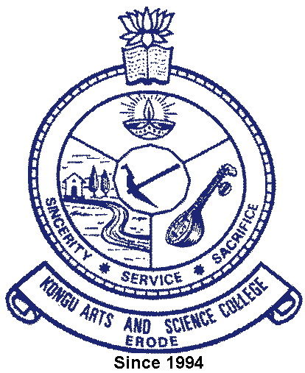 | Kongu Arts and Science College  (Autonomous)
 | Erode – 638 107

6.3.4 Additional Information

Number of teachers who have undergone online/face-to-face Faculty Development Programmes during the year
Faculty Development Programmes Attended | Link
E copy of Certificates | 

