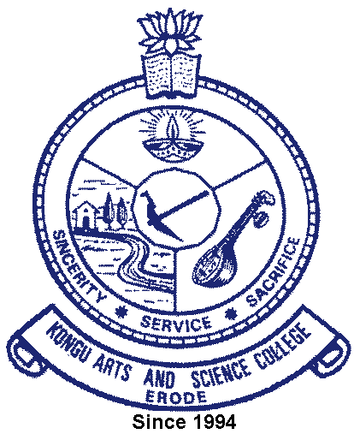 | Kongu Arts and Science College  (Autonomous)
 | Erode – 638 107

6.3.1 Additional Information
The institution has effective welfare measures for teaching and non-teaching staff and avenues for career development/progression
Welfare Measures for teaching and non-teaching staff | Link
Mandatory Benefits
ESI Documents | 
EPF Documents
Gratuity
Maternity Leave
Leave Benefits
Medical Leave
Monetary Benefits
List of faculty Members receiving Special Pay for Ph.D/NET/SET
List of faculty Members received incentives for publications
Free Boarding and Lodging for Deputy and Residential Wardens
Free uniforms for class IV employees
Other Benefits
Accidental Insurance
Awareness Programme
Internet and Computing facility
Avenues for Career Development/Progression
Staff Members permitted for Higher Studies
Faculty Exchange Programmes
Best Teacher Award

