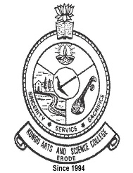 | KONGU ARTS AND SCIENCE COLLEGE (AUTONOMOUS) | 
 | CRITERION 2 – TEACHING – LEARNING & EVALUATION
KEY INDICATOR 2.6
STUDENT PERFORMANCE AND LEARNING OUTCOMES

2.6.1 Programme Outcomes and
Course Outcomes
1 | Course Outcome Programme Wise - 2017 Onwards | www.kasc.ac.in/iqac/aqar2020-21/Criterion-II/2.6/2.6.1_01.pdf
2 | Course Outcome Programme Wise – 2021 Onwards | www.kasc.ac.in/iqac/aqar2020-21/Criterion-II/2.6/2.6.1_02.pdf



