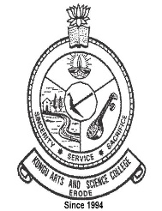 | KONGU ARTS AND SCIENCE COLLEGE (AUTONOMOUS) | 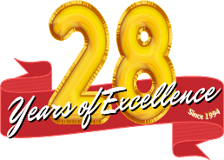
 | CRITERION 2 – TEACHING – LEARNING & EVALUATION
KEY INDICATOR 2.4
TEACHER PROFILE AND QUALITY

2.4.1 Full Time Teachers (2020 -2021)
1 | List of Faculty Members (Authenticated by the Head of the HEI) | www.kasc.ac.in/iqac/aqar2020-21/Criterion-II/2.4/2.4.1_01.pdf



