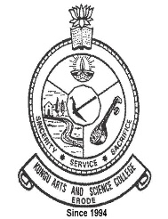 | KONGU ARTS AND SCIENCE COLLEGE (AUTONOMOUS) | 
 | CRITERION 2 – TEACHING – LEARNING & EVALUATION
KEY INDICATOR 2.4
TEACHER PROFILE AND QUALITY

2.4.2 Full time Teachers with Ph.D.
1 | Ph.D. Awarded Certificates | www.kasc.ac.in/iqac/aqar2020-21/Criterion-II/2.4/2.4.2_01.pdf
2 | Ph.D. Guide Approval | www.kasc.ac.in/iqac/aqar2020-21/Criterion-II/2.4/2.4.2_02.pdf



